Project Details

Online Test application in one form or the other is becoming a general requirement for most applications. Some examples are surveys, mock tests, self-evaluation, and tests. Angular 2 will help you create an Online Test application with minimal or no modification in the code.

The Online Test consists of mainly 3 Phases

views: registration

views: Quiz

View, Review, Result.

This Application will help a developer to create your Online Test application in Angular 2 in just a few lines of code. The Online Test application accepts the questions in JSON format. So, you can easily send the JSON from the server in the pre-defined format, and the Angular 2 Online Test application will render the Online Test at the client side. The Online Test also has “review and display result” section. If you wish to declare the result immediately, you can simply call another JSON with the answers in it and evaluate and display the results immediately. Alternatively, you can submit the answers to the server

Notes: The JSON data is available in assets folder which has answers JSON data and question JSON data which will help you to create the application

As stated above it should have 3 phases

1)Registration where you can register with name and Email name and email should have proper validation and should not be empty if these fields are empty then show message accordingly as shown in fig 1.0 and should have a submit button which should redirect to the quiz page, on click of submit button validation should happen

**Note** :

* name input field should have an id="**name**"
* email input field should have an id="**email**"
* submit button should have an id="**submit**"
* if name is invalid then span/div(any) should have id=”**valid-name**”
* if email is invalid then span/div(any) should have id=”**valid-email**”

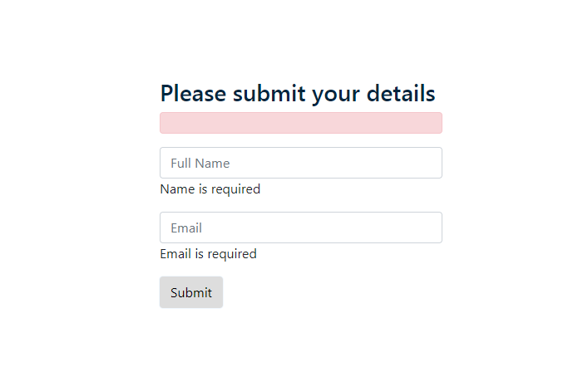

**Fig 1.0**

2) The quiz should show the name of the user on the top as shown in fig 1.1 and a list of questions which are provided in the assets folder

Note:

* name can be in any tag and it should have id=”**user-name**” example; <h3 id="user-name">**Welcome** username</h3>
* Each question should be in a box and Should have a class =”**question**” I.e., If there are three questions then then there should be 3 question classes

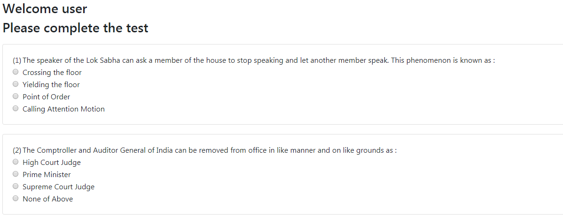

Fig 1.1

3) Result page should show the correct and wrong answers as shown in fig: 1.2

Note:

* If no answer is selected then Selected option should show “No answer selected” else it should show selected option
* Selected option should have class=”result” example Selected Option: <span class="result"> No answer selected </span>
* If answer is correct it should have class=”**greenClass**” else it should have “**redClass**” and should contain Wrong answer or correct answer based on option chosen refer fig 1.2

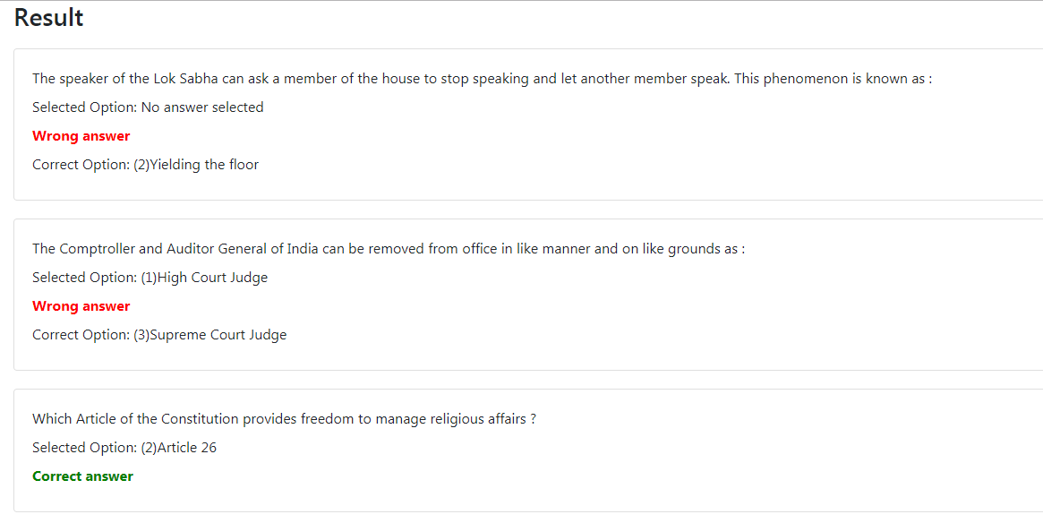

Fig 1.2