Melvin Mathews

57181142

Assignment 1

Elec 461

# 1. Problems

Please find the completed Chapter 4 problems starting on the next page.

# 2. Numerical Solution to the Finite Well

The Matlab code developed to perform a numerical simulation of the finite well with varying parameters is included in this submission.

## 2.1 Methods

The following 4 files were developed and utilised to complete the assignment and obtain the desired results:

* finite_well.m: contains a function finite_well that when provided with a well potential (eV), a well width (nm) as well as the distance away from an infinite potential (denoted b) will numerically calculate and return the eigenstate energies of the system.
  + Effective mass 0.067 times that of the mass of an electron at rest
  + Mesh spacing of 0.1*10^-9. Smaller spacings were used to confirm that the results achieved did indeed converge but this spacing was finalized to reduce simulation runtime.
* calc_optimal_b.m: executes the finite_well function for all combinations of varying parameters while incrementing b and outputs the lowest b value that meets the arbitrarily set 1E-5 error bound for all possible parameter combinations (b_final). A second variable (b_vals) is displayed that lists the minimum b value for each of the 9 well width and well potential combinations.
* finite_well_sim.m: executes the finite_well function for all combinations of varying parameters and generates the graphs seen in **Figure 1**, **Figure 2**, and **Figure 3**. These graphs represent the various well configurations with their respective wave functions superimposed.
* En_n: executes the finite_well function for all combinations of varying parameters and plots the relationship between eigenstate energy and eigenstate number. The plots can be seen in **Figure 4**.

## 2.2 Results

The results can be summarized into 4 major sections: determining an optimal b value, generating wavefunctions and the potential profile, graphing the relationship between eigenstate number and energy and comparing results with an infinite well.

### 2.2.1 Optimal b

A b had to be chosen such that the eigenstates no longer vary sufficiently. An arbitrary error bound of 1E-5 was chosen and the procedure described in the methods section was executed. **Table 1** below details the output.

**Table 1.** Summary of results from calc_optimal_b.m



A value of 15nm for b was arrived at by selecting the largest value of b to meet the error bounds. Of course, an arbitrarily large value of b could also have been selected but this would dramatically increase simulation time. The selected value allowed for the appropriate error bounds while still being computationally conservative.

### 2.2.2 Wavefunctions and Potential Profile

The three subsequent figures illustrate the various potential wells, eigenstate energies and wavefunctions for the varying parameters. It is important to note that the superimposing of the wave functions onto the potential well were done for the sake of compactness and overall visual clarity. The actual amplitudes of the wavefunctions cannot be determined on the following figures as the units of the potential well and eigenstate energies are not that of the wavefunction. Every wavefunction has also been normalized and thus a scaling factor was applied to minimize overlapping wavefunctions.

**Figure 1.** 2nm well (black solid line) with eigenstates (black dashed line) and respective wavefunctions (blue, red and yellow lines) superimposed. Going from left to right, the first graph represents a potential of 0.3eV, the second a potential of 1eV and the third graph represents a potential of 10eV.

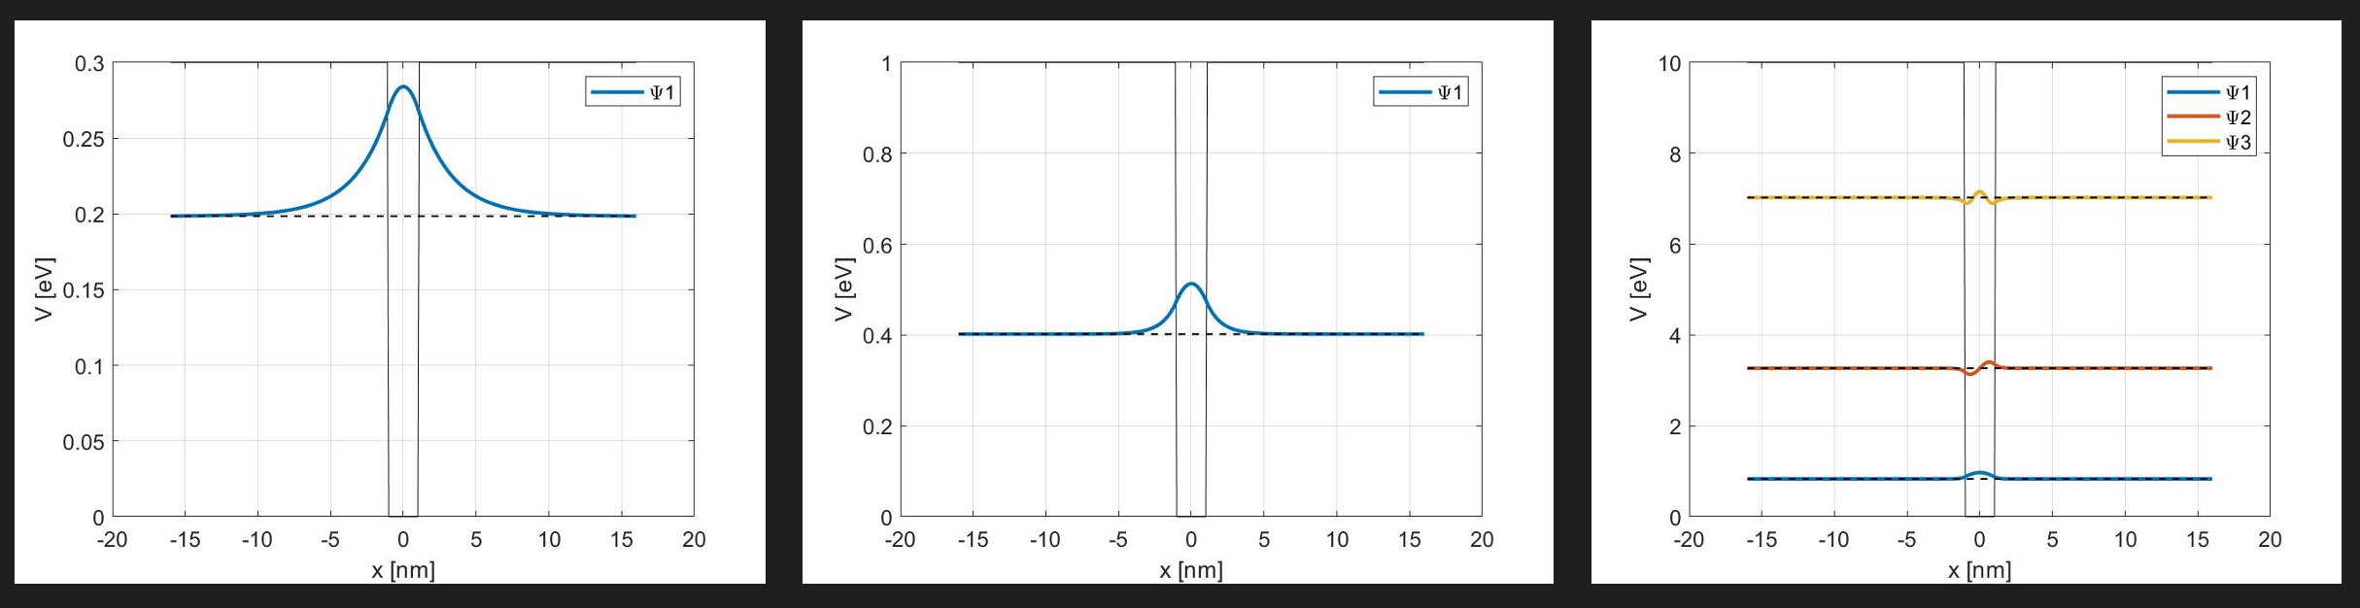

**Figure 2.** 5nm well (black solid line) with eigenstates (black dashed line) and respective wavefunctions (blue, red and yellow lines) superimposed. Going from left to right, the first graph represents a potential of 0.3eV, the second a potential of 1eV and the third graph represents a potential of 10eV.

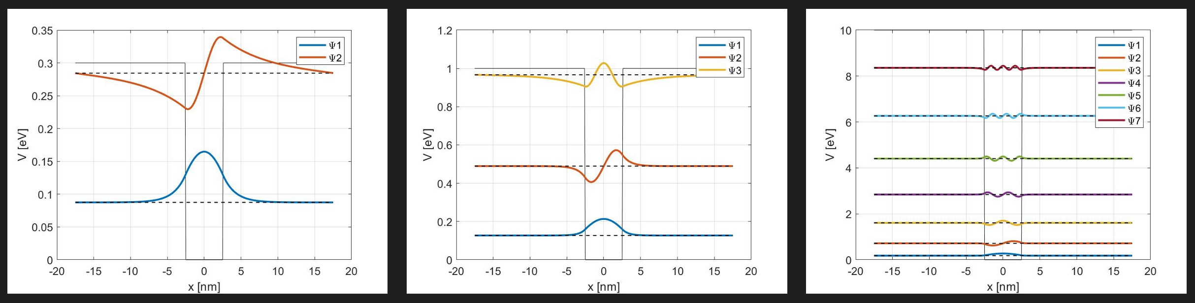

**Figure 3.** 10nm well (black solid line) with eigenstates (black dashed line) and respective wavefunctions (blue, red and yellow lines) superimposed. Going from left to right, the first graph represents a potential of 0.3eV, the second a potential of 1eV and the third graph represents a potential of 10eV.

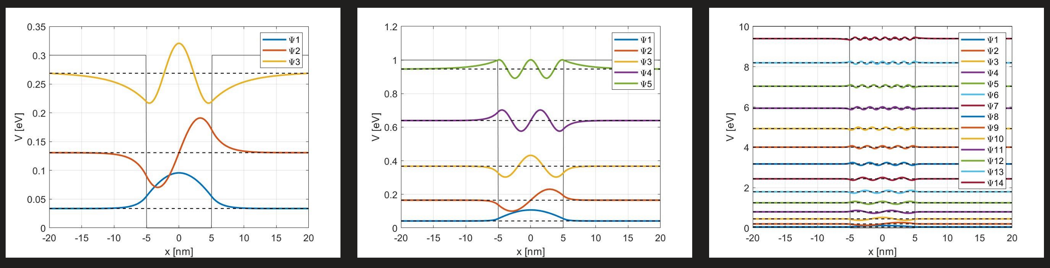

### 2.2.3 Eigenstate Number and Energy

The eigenstate energies produced by finite_well.m were plotted with respect to eigenstate number (the respective index of the energy) and the results can be seen in the graph below.

**Figure 4.** Graphs representing a relationship between eigenstate energy and eigenstate number. Moving from left to right, the first graph illustrates this relationship for a 2nm well, the second for a 5nm well and the third a 10nm well.

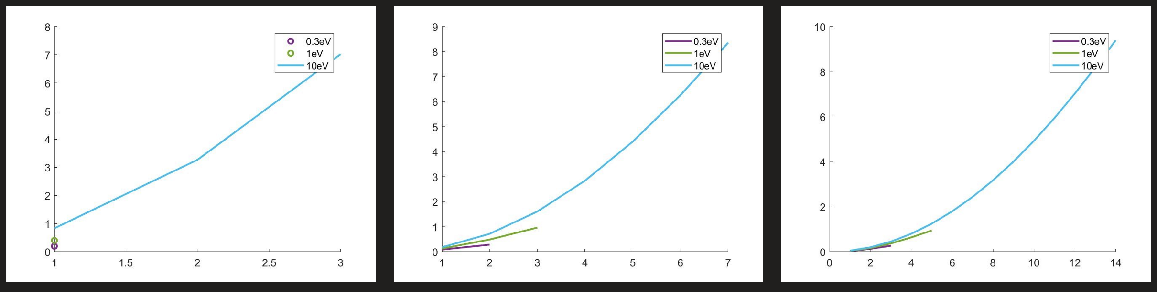

Such curves are closely matched to the quadratic relationship seen in equation 1 connecting eigenstate energies to eigenstate numbers for infinite wells. It is also clear to see in all three graphs that as the potential and width of the well increases, the curves match this relationship more closely.

### 2.2.4 Comparison to Infinite Well

The eigenstate energies were calculated numerically for the finite well using the finite.m Matlab function file. The values output are summarized in **Table 2**, **Table 3**, and **Table 4**. The tables also contain the analytically computed eigenstate energies using the following equation:

Error percentage between the numerically computed energies and the analytically computed energies can be seen in all three tables and was calculated using equation 2 below:

In cases where multiple eigenstate energies needed to be compared for the same Well Potential value, an average the Error% is listed.

**Table 2.** Summary of the eigenstate energies for a 2nm well calculated numerically for a finite well with 0.3eV, 1ev and 10eV potentials as well as eigenstate energies calculated analytically for an infinite well. Error percentage between analytical and numerical solutions is also included.

|  |  |  |  |  |  |
| --- | --- | --- | --- | --- | --- |
|  |  | Width (nm) | | | |
|  |  | 2 | | | |
|  |  | Well Potential (eV) | | | |
| Eigenvalue Energies | | 0.3 | 1 | 10 | Infinite |
| E | 1 | 0.1986 | 0.4021 | 0.834 | 1.4043 |
| E | 2 |  |  | 3.2694 | 5.6172 |
| E | 3 |  |  | 7.0256 | 12.6387 |
| Error% | | 85.857693 | 71.3665 | 42.273082 |  |

**Table 3.** Summary of the eigenstate energies for a 5nm well calculated numerically for a finite well with 0.3eV, 1ev and 10eV potentials as well as eigenstate energies calculated analytically for an infinite well. Error percentage between analytical and numerical solutions is also included.

|  |  |  |  |  |  |
| --- | --- | --- | --- | --- | --- |
|  |  | Width (nm) | | | |
|  |  | 5 | | | |
|  |  | Well Potential (eV) | | | |
| Eigenvalue Energies | | 0.3 | 1 | 10 | Infinite |
| E | 1 | 0.0875 | 0.1272 | 0.1798 | 0.2247 |
| E | 2 | 0.2845 | 0.4895 | 0.7176 | 0.8988 |
| E | 3 |  | 0.9665 | 1.6083 | 2.0222 |
| E | 4 |  |  | 2.8428 | 3.5950 |
| E | 5 |  |  | 4.4051 | 5.6172 |
| E | 6 |  |  | 6.2664 | 8.0888 |
| E | 7 |  |  | 8.3594 | 11.0097 |
| Error% | | 64.700978 | 47.0429 | 20.200289 |  |

**Table 4.** Summary of the eigenstate energies for a 10nm well calculated numerically for a finite well with 0.3eV, 1ev and 10eV potentials as well as eigenstate energies calculated analytically for an infinite well. Error percentage between analytical and numerical solutions is also included.

|  |  |  |  |  |  |
| --- | --- | --- | --- | --- | --- |
|  |  | Width (nm) | | | |
|  |  | 10 | | | |
|  |  | Well Potential (eV) | | | |
| Eigenvalue Energies | | 0.3 | 1 | 10 | Infinite |
| E | 1 | 0.0337 | 0.0416 | 0.0501 | 0.0562 |
| E | 2 | 0.1307 | 0.1653 | 0.2003 | 0.2247 |
| E | 3 | 0.2687 | 0.3676 | 0.4504 | 0.5055 |
| E | 4 |  | 0.6395 | 0.7999 | 0.8988 |
| E | 5 |  | 0.9464 | 1.2483 | 1.4043 |
| E | 6 |  |  | 1.7945 | 2.0222 |
| E | 7 |  |  | 2.4376 | 2.7524 |
| E | 8 |  |  | 3.176 | 3.5950 |
| E | 9 |  |  | 4.008 | 4.5499 |
| E | 10 |  |  | 4.9309 | 5.6172 |
| E | 11 |  |  | 5.9411 | 6.7968 |
| E | 12 |  |  | 7.0329 | 8.0888 |
| E | 13 |  |  | 8.1952 | 9.4930 |
| E | 14 |  |  | 9.3965 | 11.0097 |
| Error% | | 42.895181 | 26.5531 | 10.857272 |  |

It is interesting to note that the Error% reduces while both the Well Potential and Well Width increase. This is inline with the results found in section 2.2.3 and as expected.

## 2.3 Discussion + Conclusion

If we analyze these results from fundamental physical principles, we can provide explanation for the following results as well as make a recommendation for the most appropriate infinite well simulator:

* Narrower wells contain fewer energy states
* Narrower wells have larger differences between energy states
* Narrower wells are more sensitive to potential energy changes
* Higher potentials allow for more energy states

The first two observations are due to the inverse relationship between En and well width squared (seen in Equation 1). This means that every energy level is larger and for a given potential value, fewer of these (larger) energy levels can fit within a bound state in the well and more states escape the well to form continuum states. The third observation is seen when comparing **Table 2** and **Table 4** to see that increasing the potential for a 2nm well dramatically increases the ground state energy while the same potential increase for a 10nm well causes only a marginal increase. This can be attributed to the same idea presented for the earlier observations. Narrower wells provide solutions resulting in larger and more spaced out values. The final observation is a result of simply having more “room” for solutions to end up as bound states rather than continuum states.

Combining these observations we are left with the 10nm, 10eV well with a b value of 15nm to best approximate an infinite well.