Python Week 1 Project Documentation

1. Project Description
This project is part of Week 1 of your Python learning program. The goal is to build a simple Personal Introduction Program using basic Python concepts such as variables, input/output functions, f-strings, and sequential program flow. The program asks the user for their personal information and displays a well-formatted welcome message.

2. Setup Instructions
Follow the steps below to install Python and run your project:
- Download Python from https://www.python.org/downloads/
- Install Python and ensure 'Add Python to PATH' is checked (Windows).
- Open a code editor (VS Code recommended).
- Create the project file named personal_intro.py.
- Run the program using terminal/command prompt:
- - Windows: python personal_intro.py
- - Mac/Linux: python3 personal_intro.py

3. Screenshot
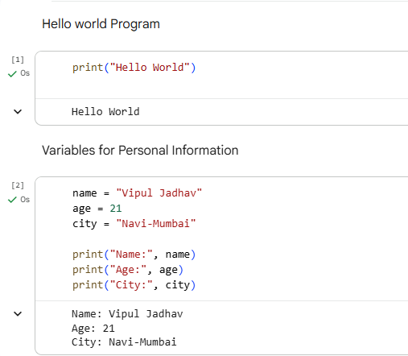
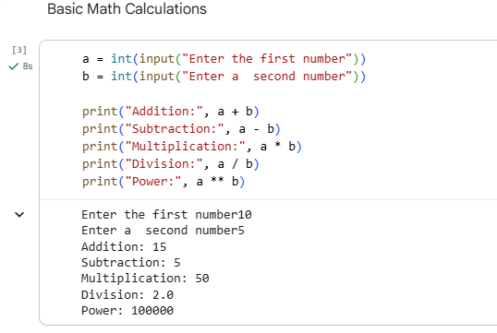
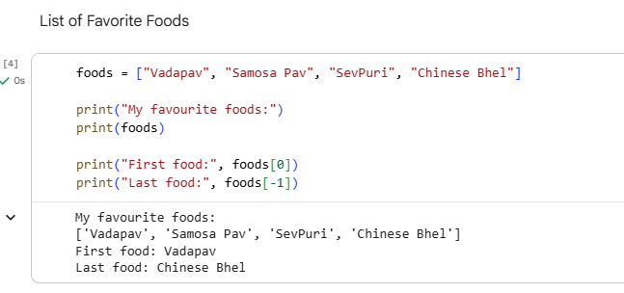
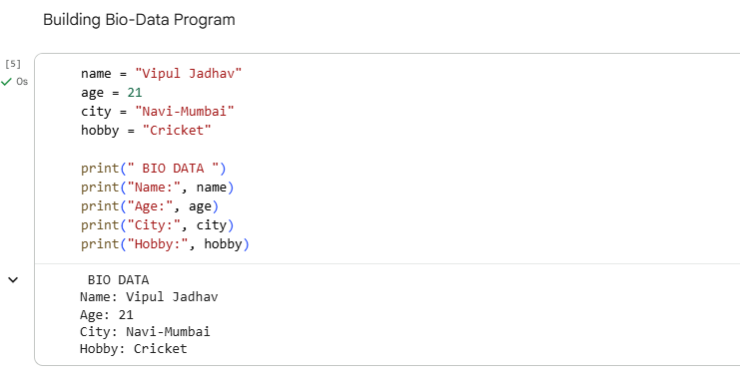
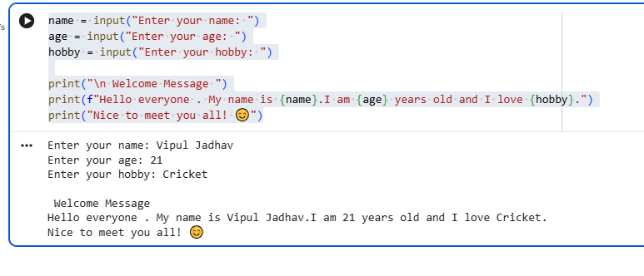

4. Explanations

4.1 What You Learned
During Week 1, you learned the basics of Python programming, including:
- Installing and setting up Python
- Running your first Python script
- Using variables to store data
- Accepting input using input()
- Formatting output using print() and f-strings
- Creating and accessing list items
- Building your first interactive script

4.2 Technical Details
This project uses the following Python components:
- input(): to collect user information
- Variables: to store user responses
- print(): to display messages on the screen
- f-strings: for neat formatted output
- Sequential program flow: Python executes code from top to bottom

4.3 Testing Evidence
Below is an example test case used to validate the program:
Input:
Name: Riya
Age: 20
Hobby: Painting
City: Pune
Expected Output:
A formatted welcome message displaying all entered details.

