Hacking

Ping Attack, besides being an action/platformer, will incorporate the ability to hack enemies and specific points within the levels.

Ping is a master of his craft and can quickly take control of robotic enemies. However, Ping’s hacking abilities come directly from his cyborg arm. In order to hack enemies on the fly successfully, he will need to have sufficient Hack Orbs. The Hack Orbs can be obtained off enemies or through the hacking mini-games which will be discussed shortly. To hack an enemy, Ping must first disable it using a stun gun. The stun gun will have a shot delay timer (aka cooldown). The player can then safely approach the enemy and press the designated “hack” button on the keyboard or controller. The player’s Hack Orb count, displayed on the HUD, will deplete accordingly and the player has control of the enemy. Each enemy will offer the player two new abilities specific to the enemies type. These will be displayed on the bottom corners of the HUD. One ability is considered an assist ability such as shields or support fire. These can be used to progress through otherwise fatal situations (the player could use the shield to assist to pass through deadly lasers that would normally obstruct his path). The other ability is a one-time offensive skill. These skills allow the user to handle numerous enemies at once as well as overcome more discrete obstacles. However, using this ability will push the hacked robots past its limits, destroying the enemy. Only one enemy can be hacked at a time. Certain enemies may be moved minimally with the keyboard of right joystick. The player may release the hacked enemy, leaving it disabled for a few seconds.

Ping will have to do more than just take control of a few measly robots. Every locked door will need to be cracked through a mini-game. Certain situations will need Ping to shut off the lights to avoid detection by the enemies. Ping may have taken some serious damage and need health; he’ll need to take advantage of his hacking skills to make a robot maintenance station restore his health.

Hacking games will vary depending on what Ping is trying to push his influence on. Opening doors will involve completing a sort of puzzle game. The player will need to line up rotating locks into the proper positions. As the player pushes a lock into place, the ones preceding will become harder (they are moving up and down and will move faster as the player progresses. There will be five locks per door. Doors further into the stage will become increasingly more difficult to crack.

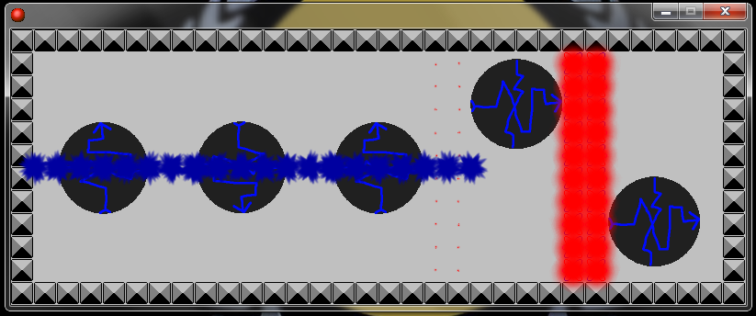

All other level hacks will involve a dodging type game. The player will have to navigate an avatar (spark particle) through a maze of firewalls. If the player leads the avatar through the level successfully, he or she accomplished the hack. Hitting a firewall will kick the player out of the mini-game and sound an alarm within the level, bringing in a swarm of enemies.

