CLOUD COMPUTING LAB - 1
NAME : Amit Prakash
CLASS : 6TH Semester “A” Section
SRN : PES1UG23AM042
A >> IAAS - Infrastructure Backend as a service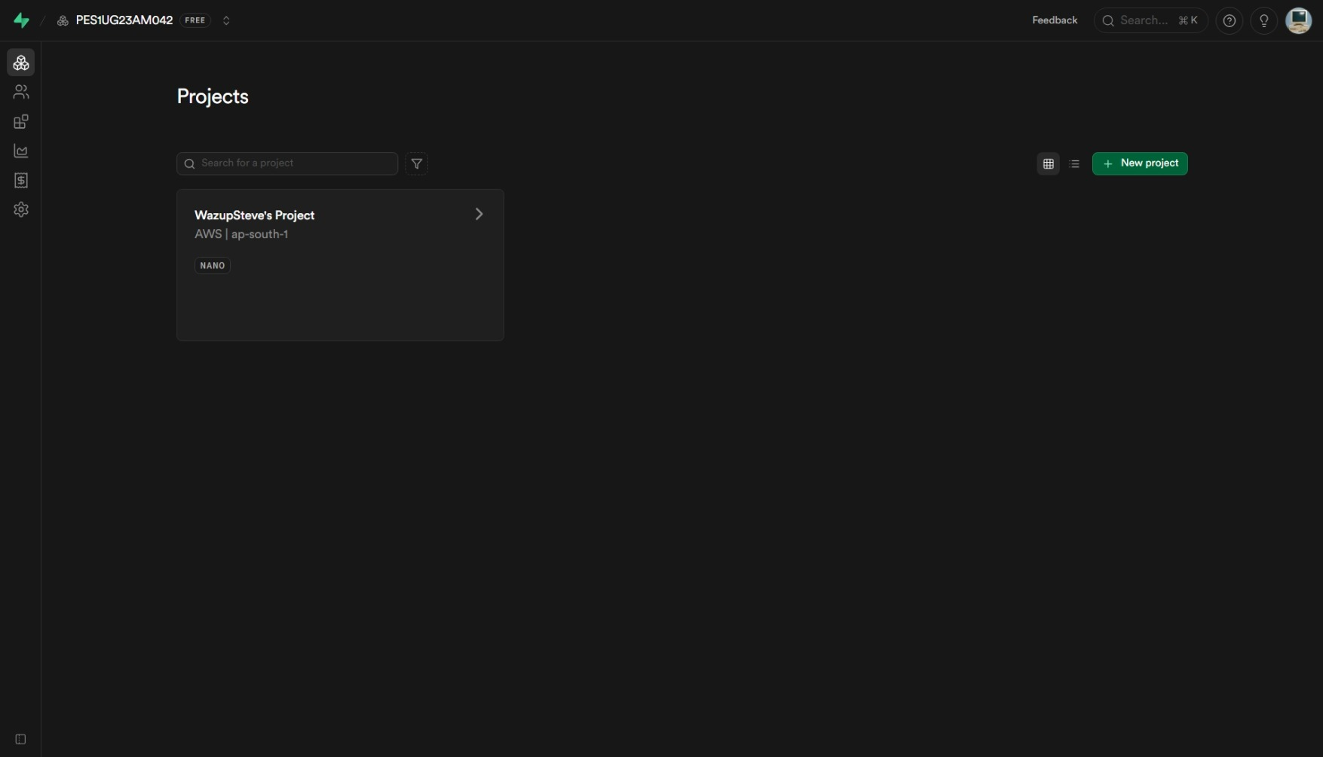
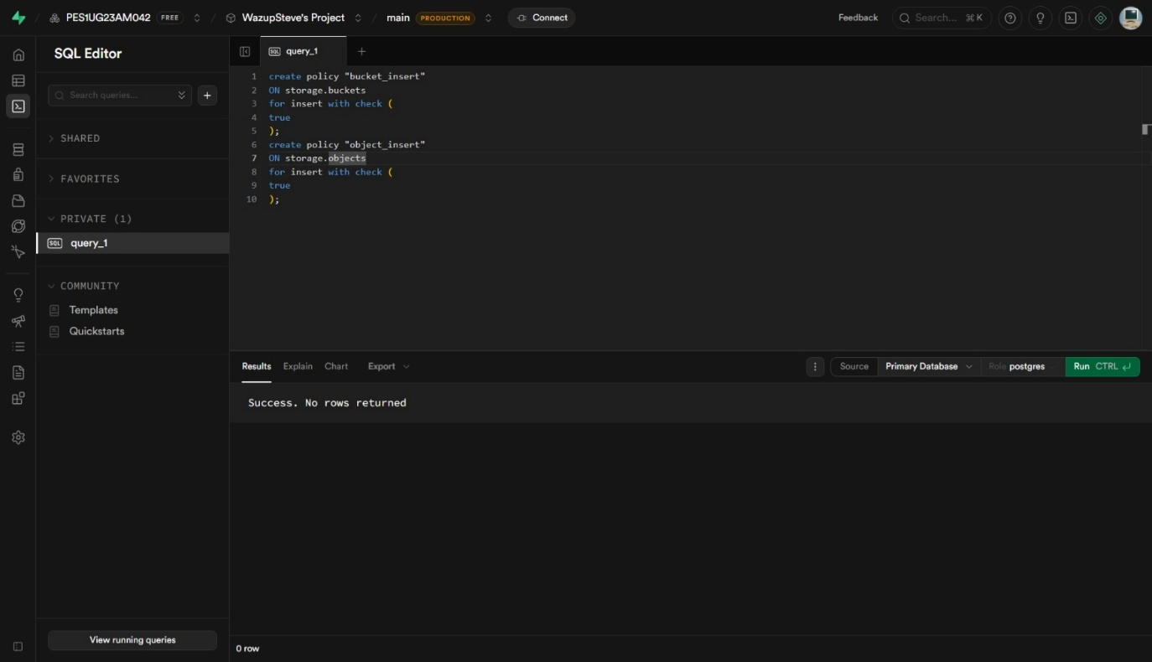

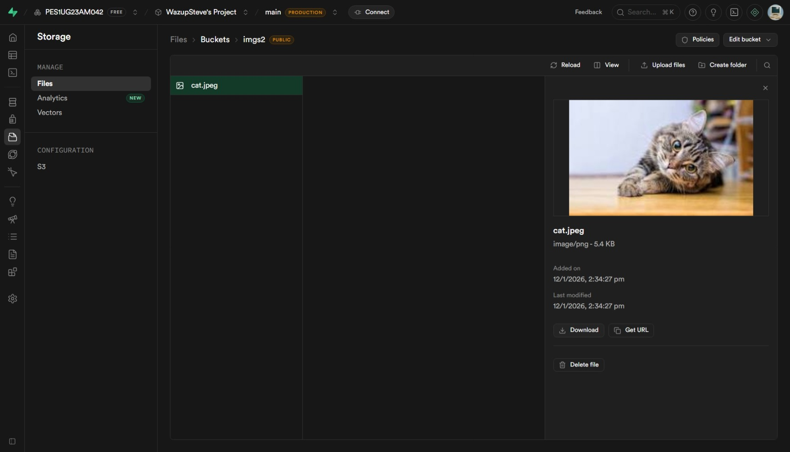

Public URL : https://koblifrsotkqzlepsquz.supabase.co/storage/v1/object/public/imgs2/cat.jpeg

B >> PAAS - Platform as a Service
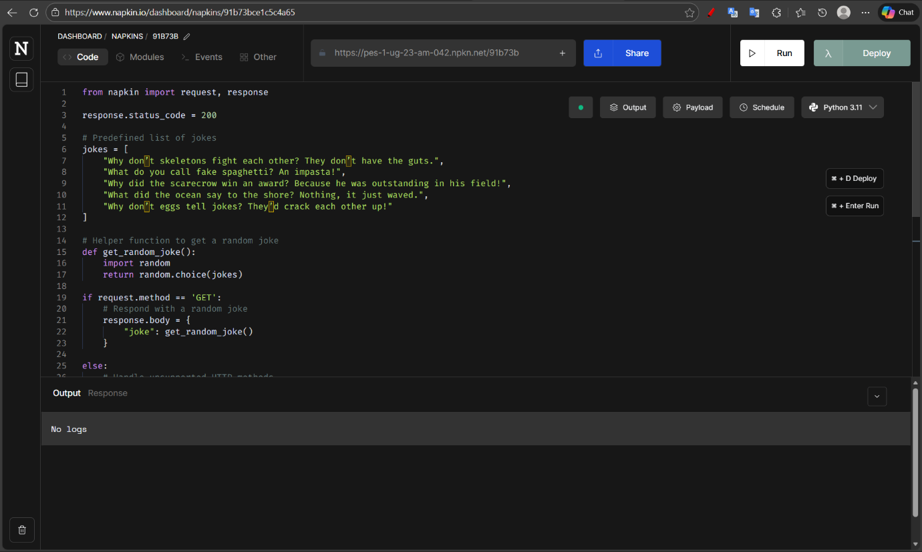
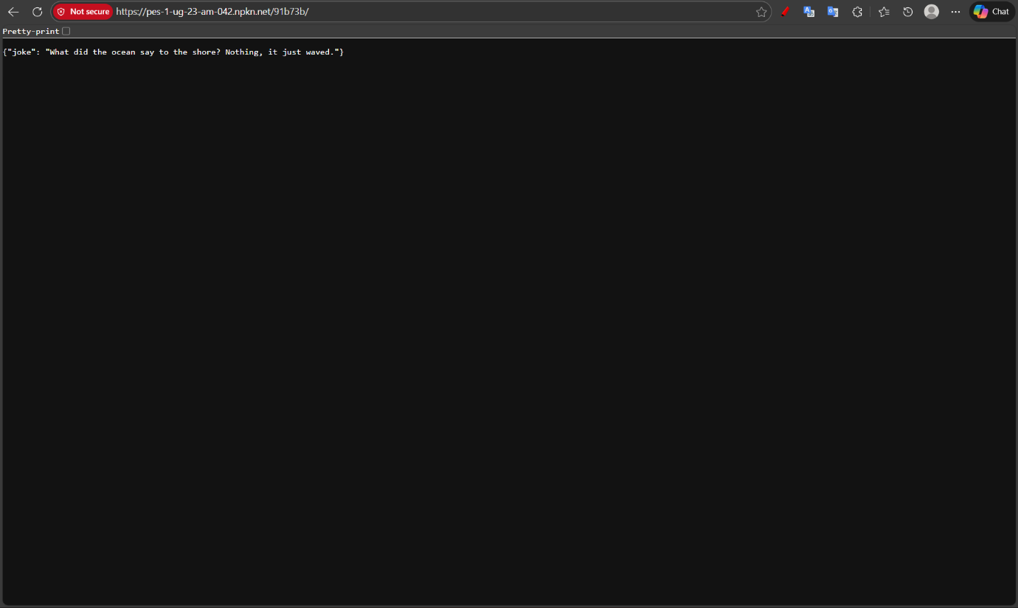

C >>Software Application deployment
Github : https://github.com/WazupSteve/Portfolio
Vercel : https://portfolio-inky-seven-z5uf7o3sl8.vercel.app/
