CLOUD COMPUTING LAB-2
NAME : Amit Prakash
SRN: PES1UG23AM042

SS-1
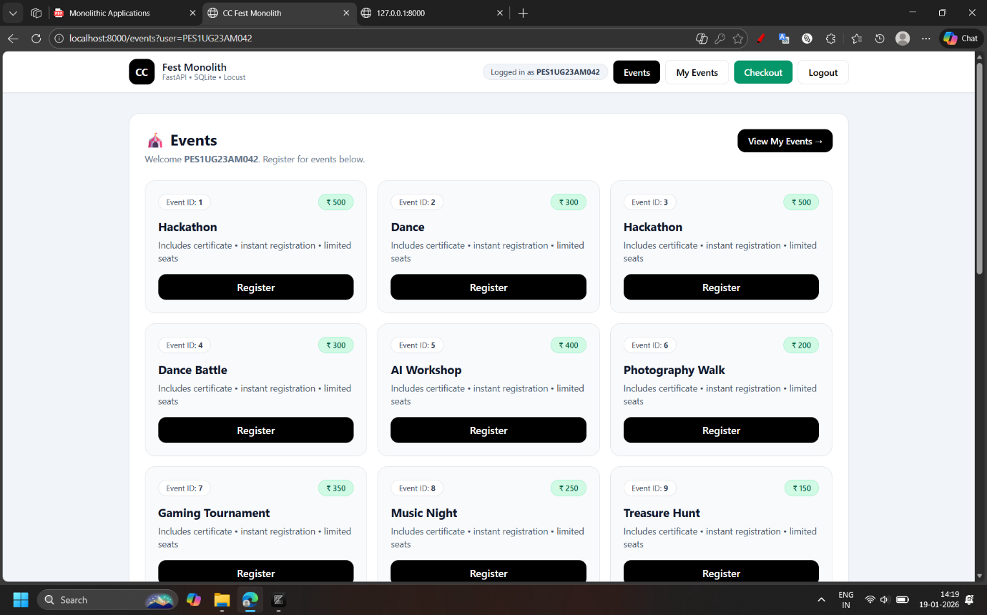
SS-2

SS3
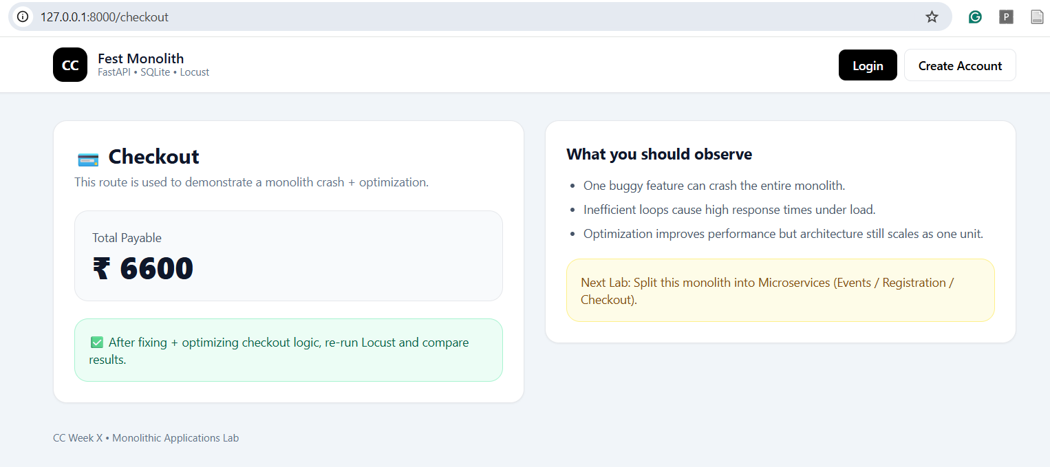

SS4:

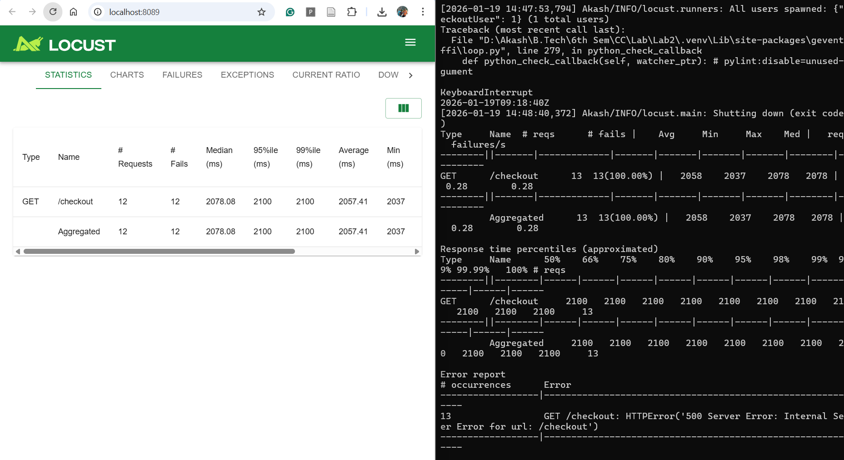
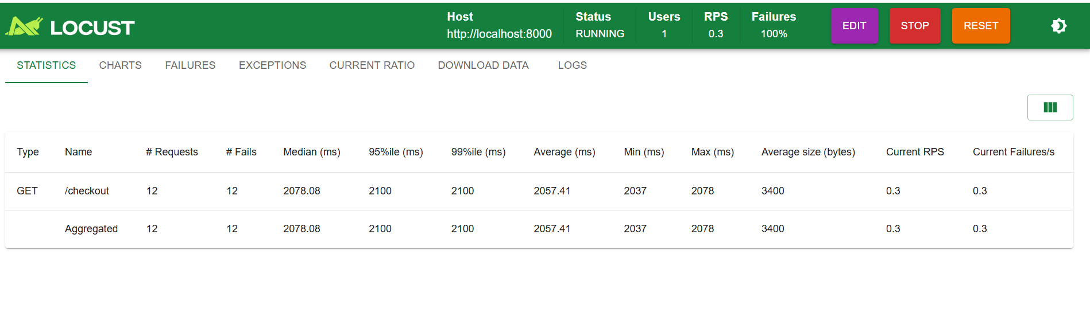SS5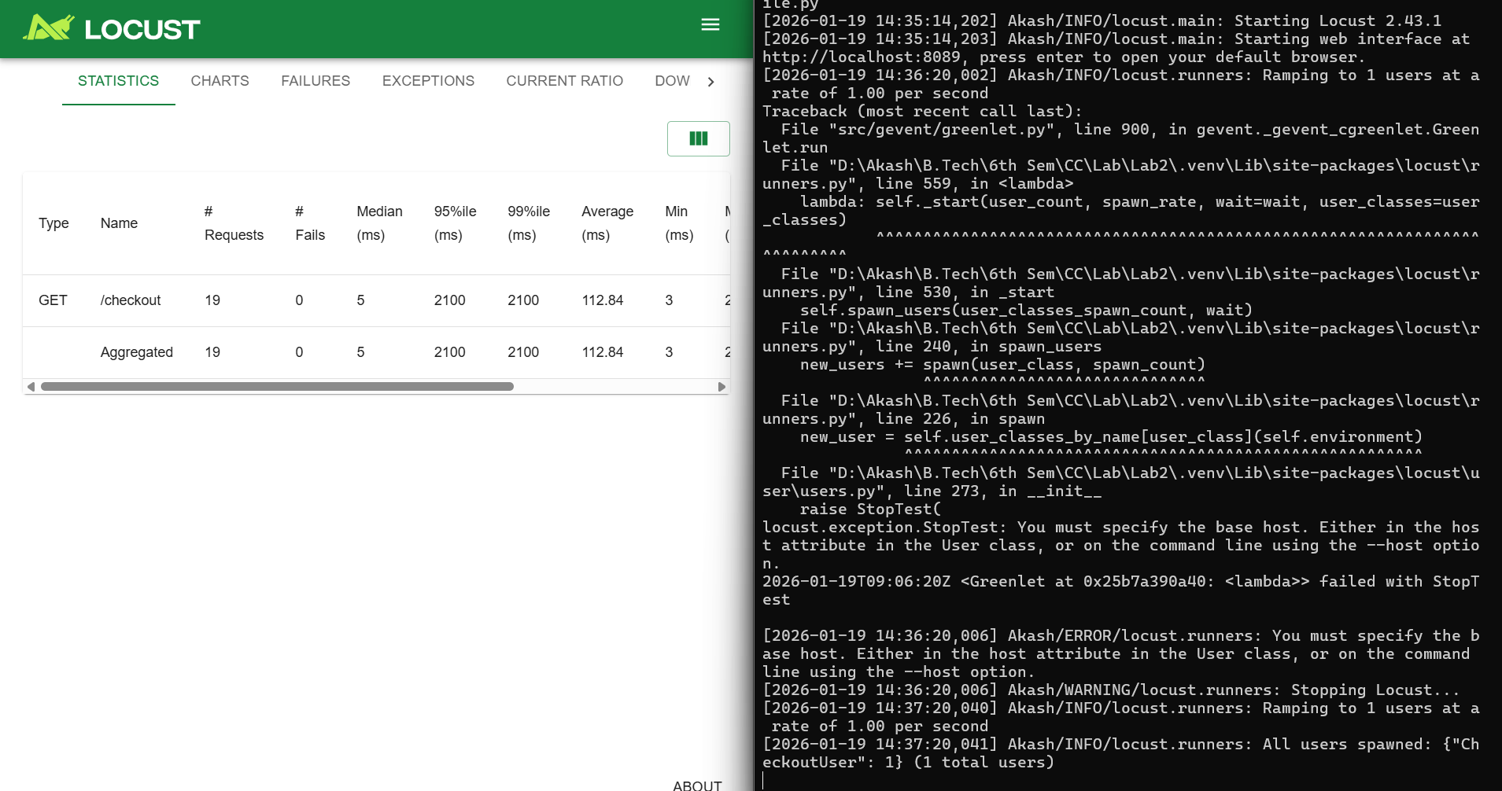

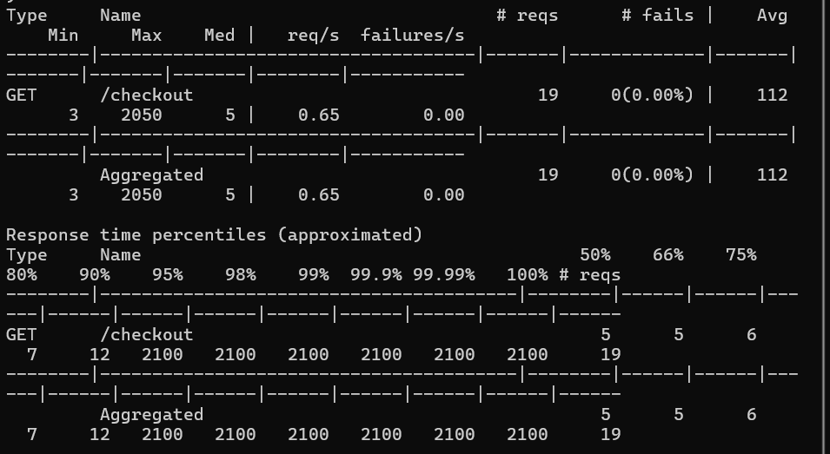
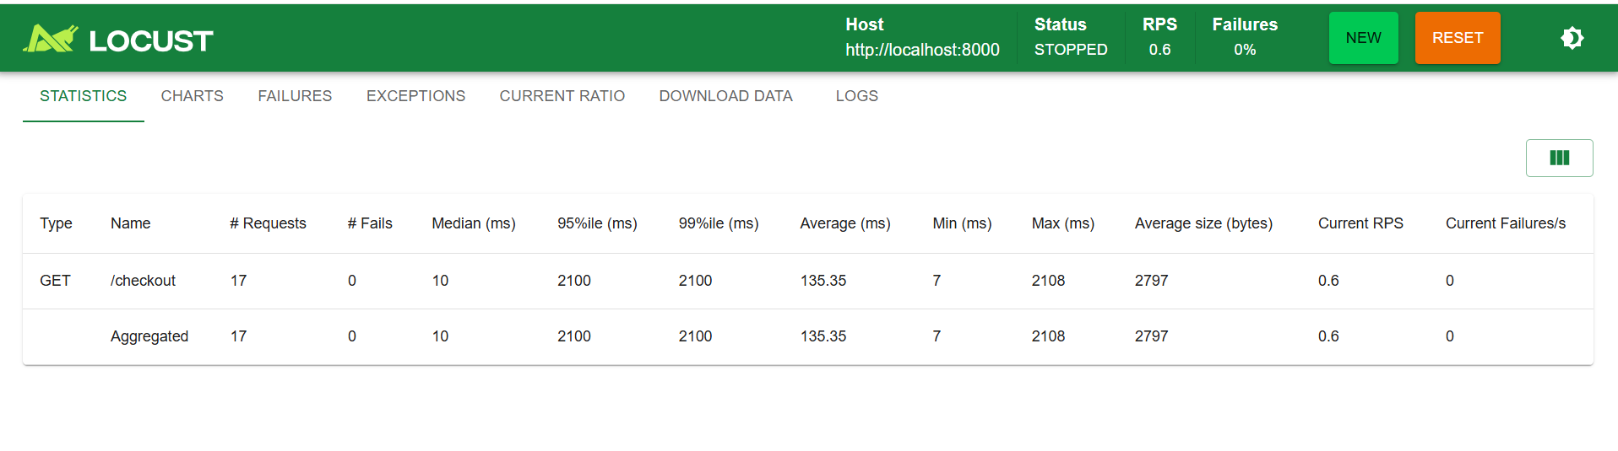

Requests per second before Optimization: 0.3
RPS after Optimization: 0.6
Average Time After Optimization: 135.35 ms
Average Time Before Optimization: 2057.41 ms

SS - 6
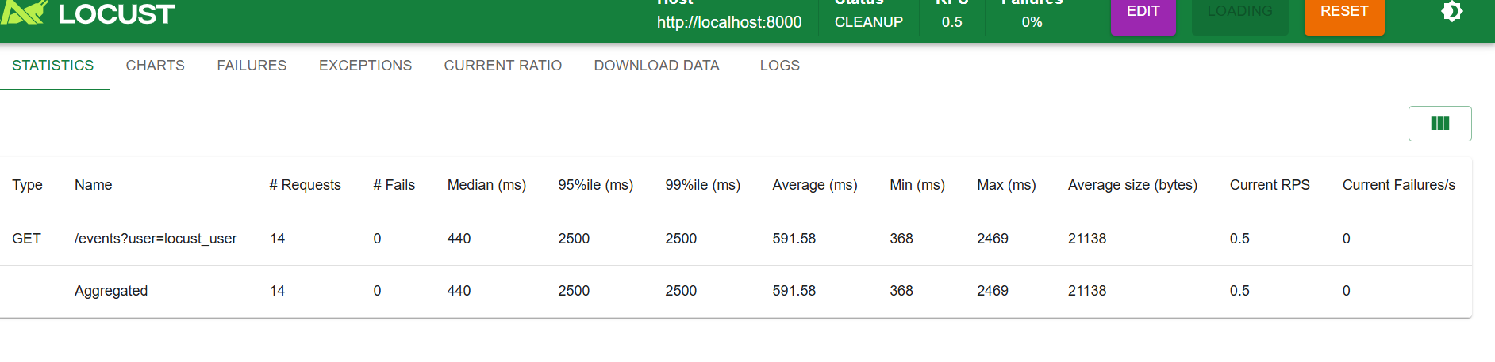
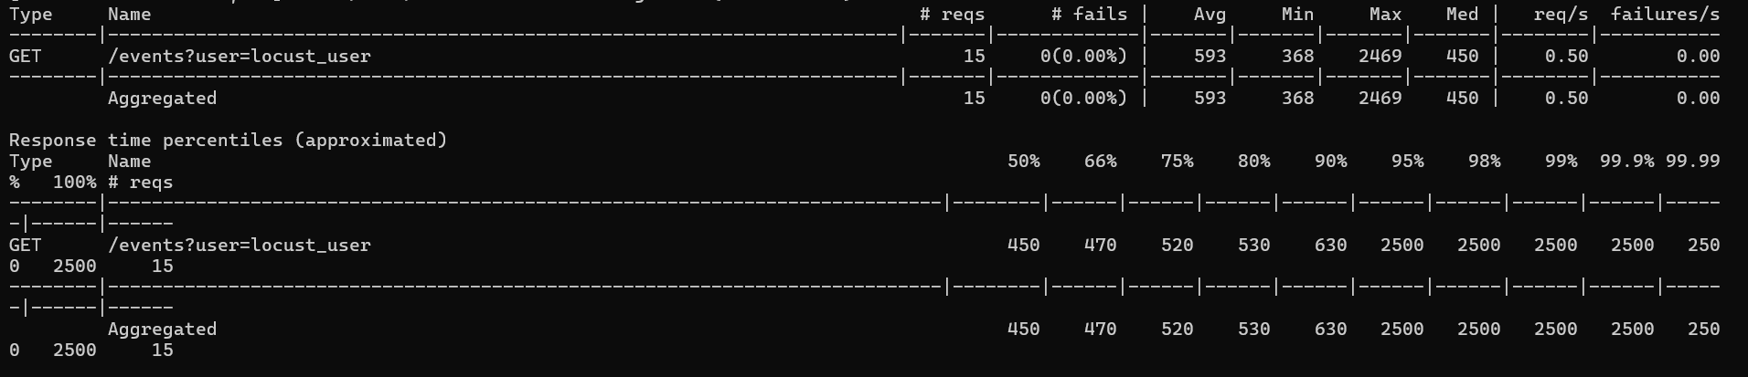

SS -7
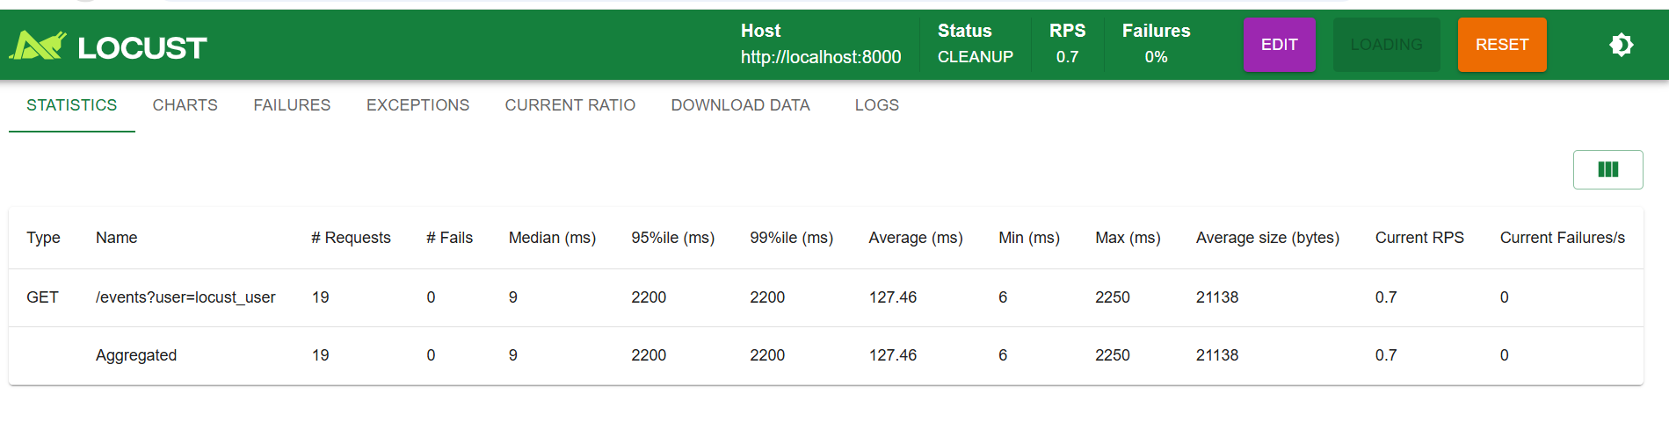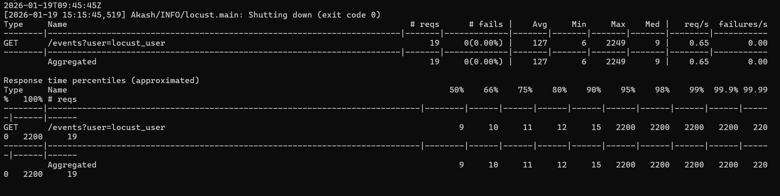

SS -8
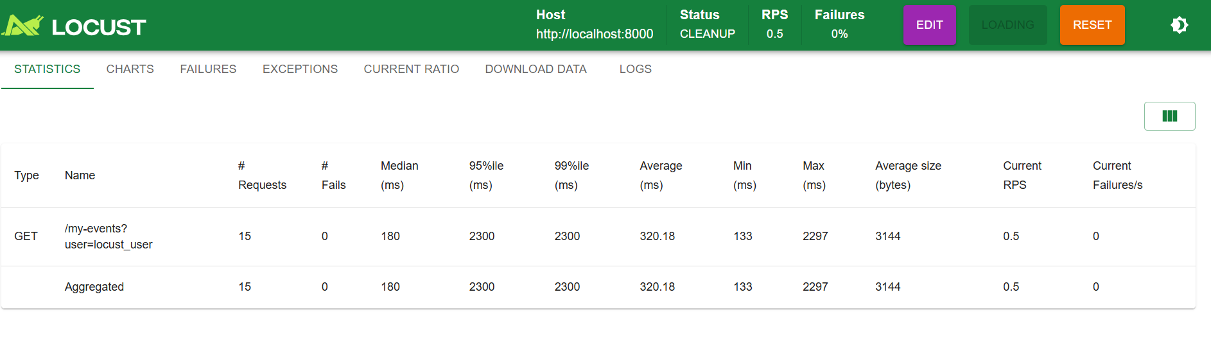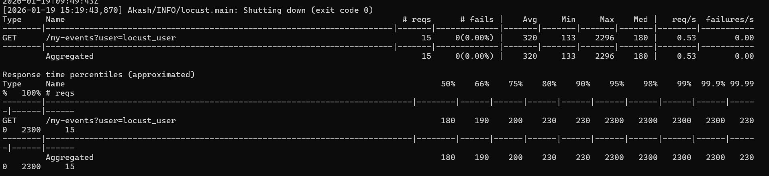

SS – 9
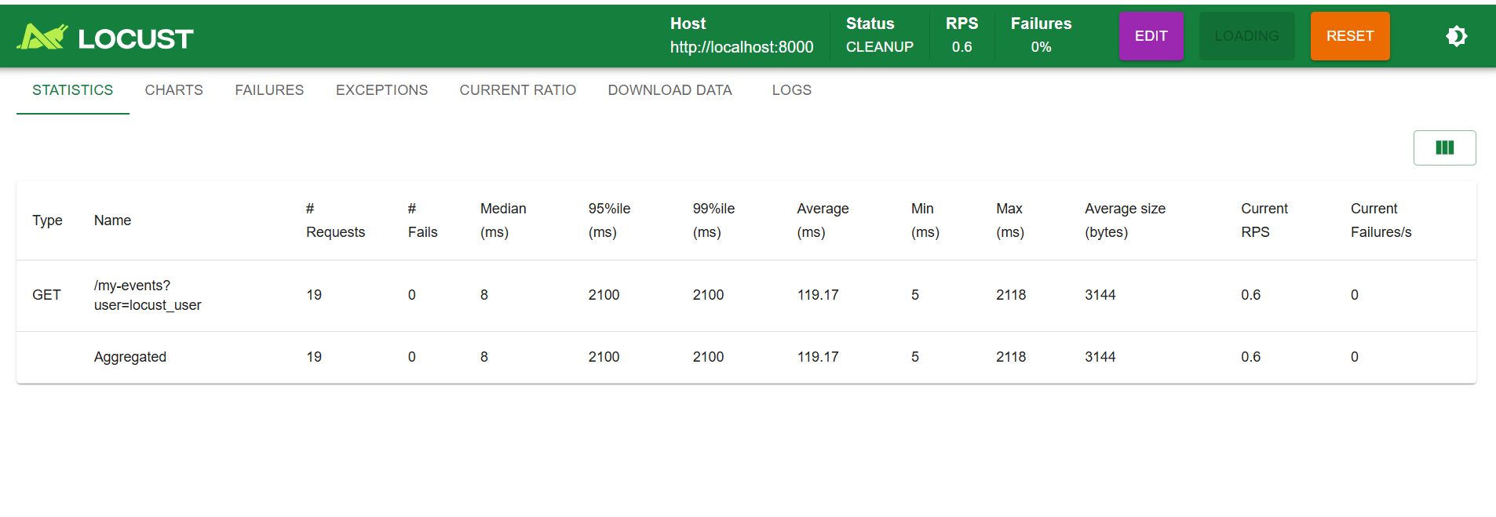
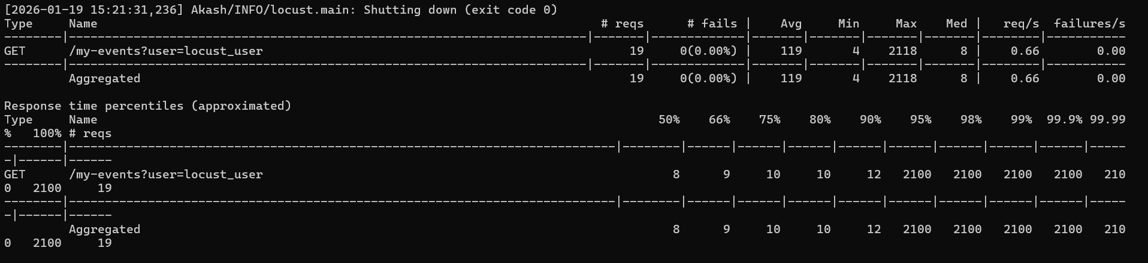

For both the routes:
- What was the bottleneck?
The bottleneck was that there were for loops in the code which were not doing any work and had a very high number like in lakhs which was causing issues
- What change did you make?
Commented both the for loops to increase the efficiency.
- Why did the performance improve?
The performance improved because there were some unwanted code blocks which were using resources and doing no work and it was consuming time so if removed perform very efficiently.

Github Repository:
Shared Repository with contents from Lab1 and Lab2 in separated directories
https://github.com/WazupSteve/cloud-computing-lab/tree/main/lab2/PES1UG23AM042

