Pictures in DattaGrids

Here is a way to use a database and webpage to show pictures.

|  |  |
| --- | --- |
|  |  |

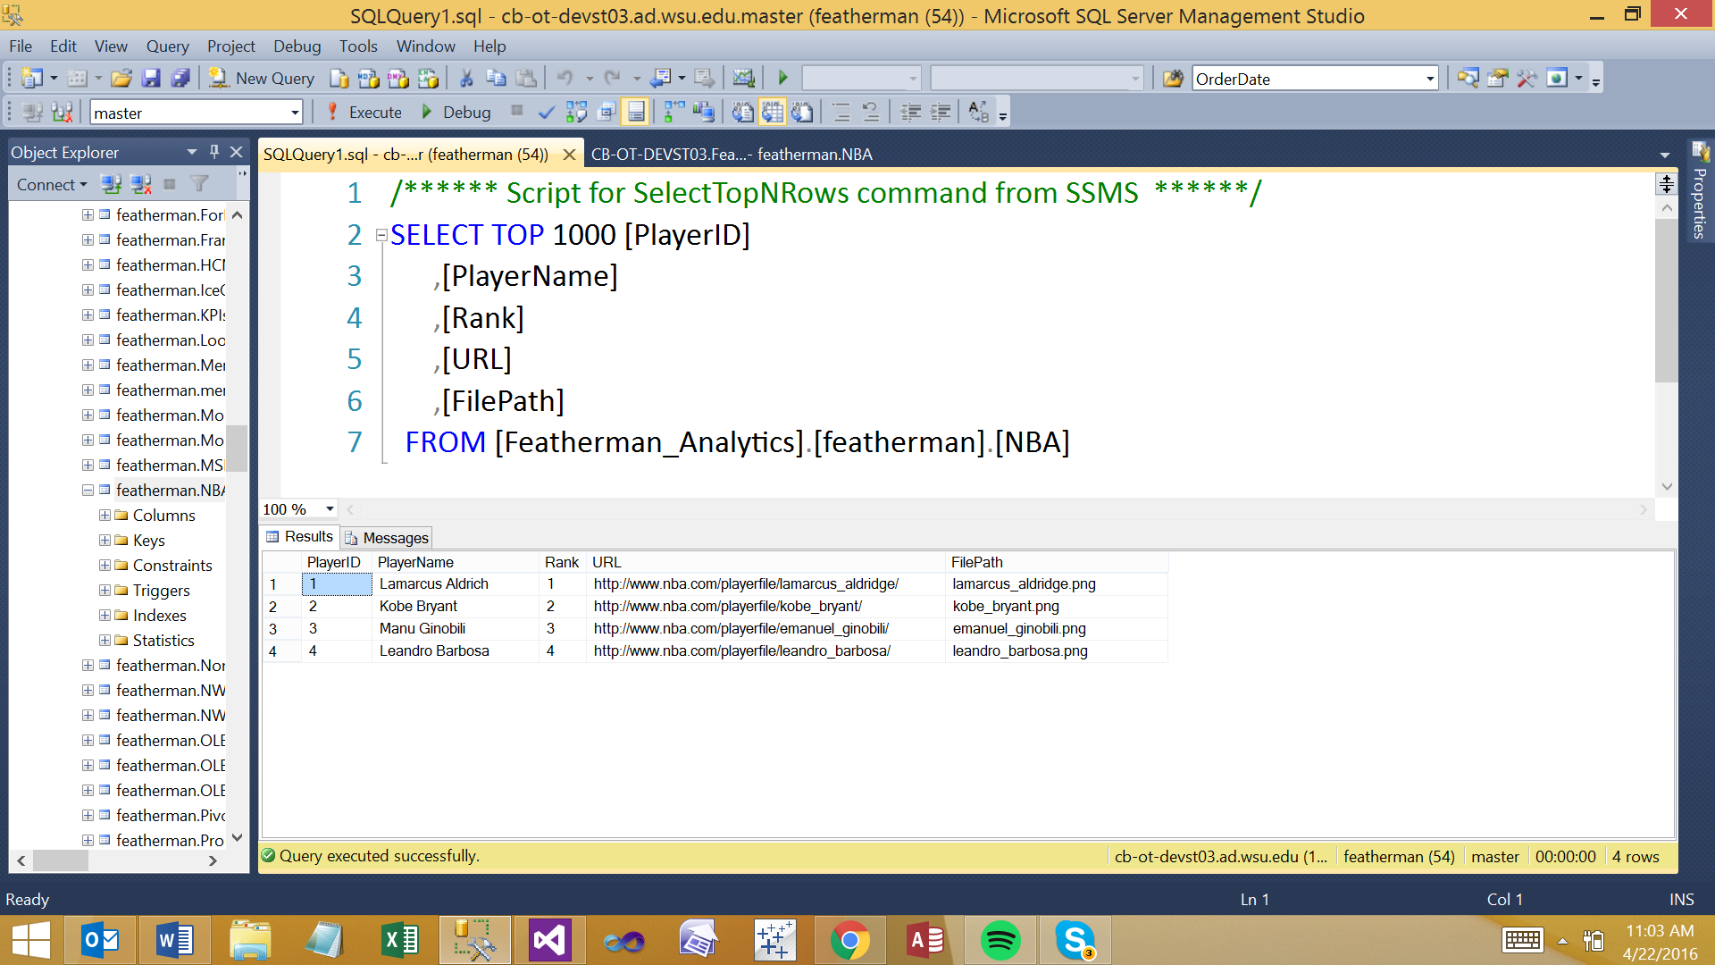

<http://cb-ot-devst13.wsu.edu/featherman/MIS325/Section3-ProgramEnhancements/picsinDB.aspx>

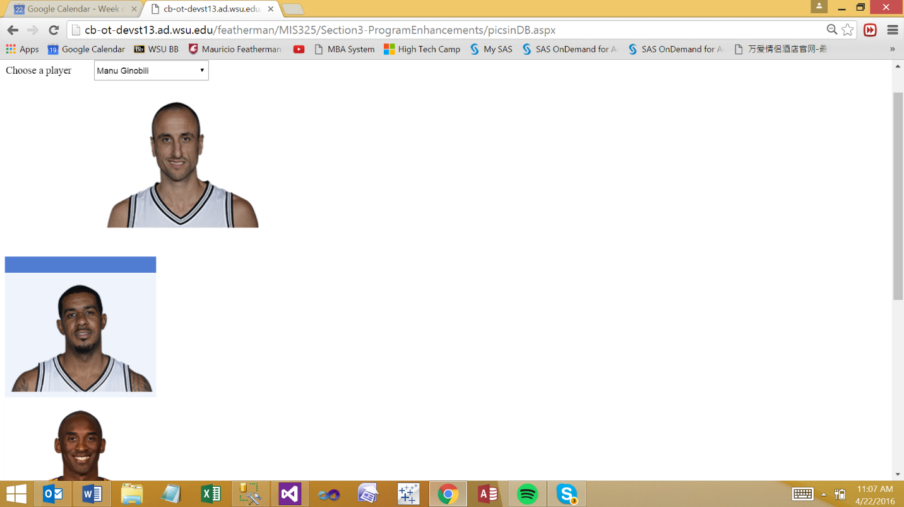

Imports System.Data

Imports System.Data.SqlClient

Partial Class

MIS325_Section3_ProgramEnhancements_picsinDB

Inherits System.Web.UI.Page

Public Shared gdtPlayers As New DataTable

Protected Sub Page_Init(sender As Object, e As EventArgs) Handles Me.Init

Dim getPLayers As New SqlDataAdapter("Select * FROM NBA", con)

With gdtPlayers.Rows

If .Count > 0 Then .Clear()

End With

Try

getPLayers.Fill(gdtPlayers)

With DropDownList1

.DataSource = gdtPlayers

.DataTextField = "PlayerName"

.DataValueField = "PlayerID"

.DataBind()

.Items.Insert(0, "Select a player")

End With

With GridView1

.DataSource = gdtPlayers

.DataBind()

End With

Catch ex As Exception

Response.Write(ex.Message)

End Try

End Sub

Protected Sub DropDownList1_SelectedIndexChanged(sender As Object, e As EventArgs) Handles DropDownList1.SelectedIndexChanged

Image1.ImageUrl = gdtPlayers.Rows(DropDownList1.SelectedIndex - 1).Item("FilePath")

End Sub

End Class

