**Screenshots**

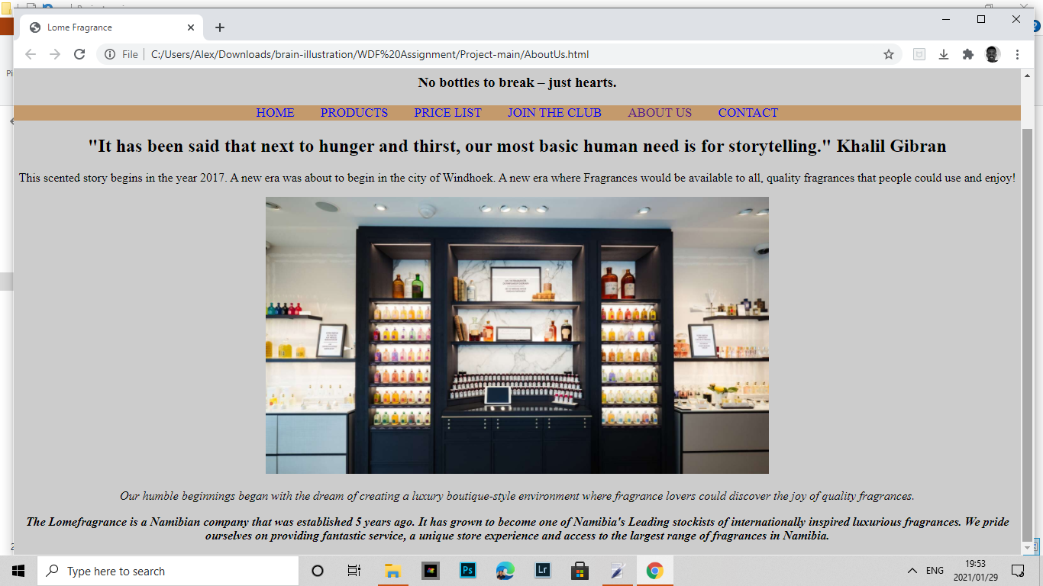

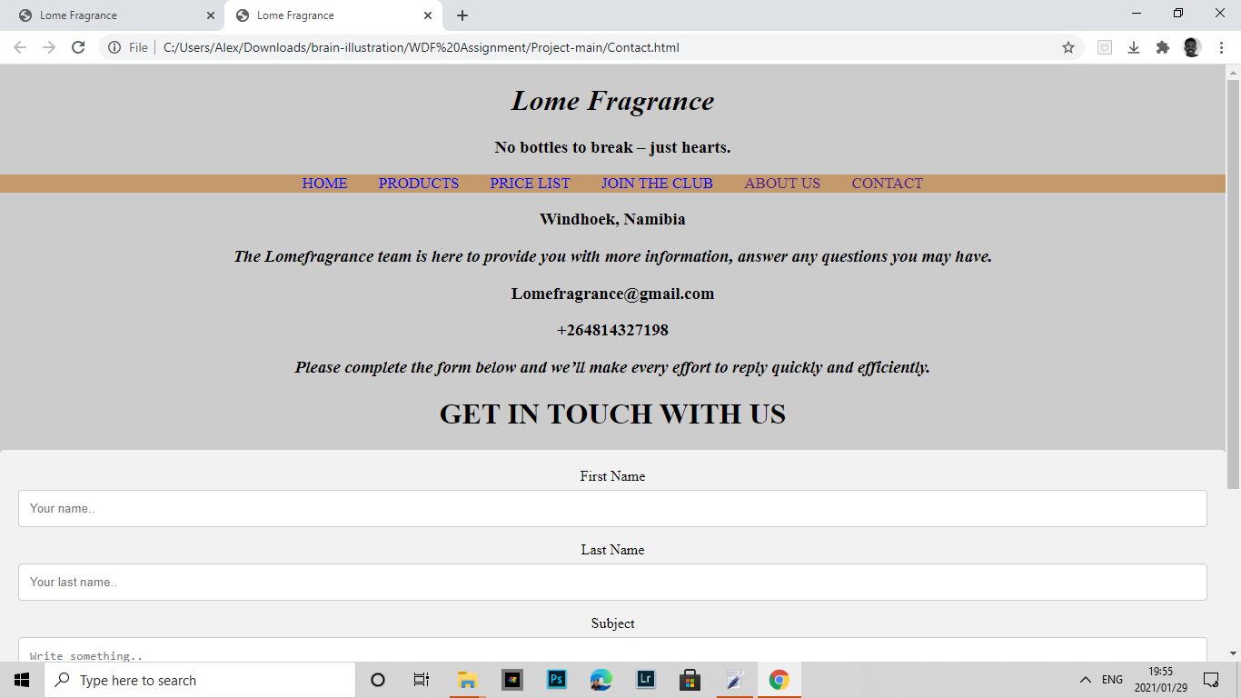

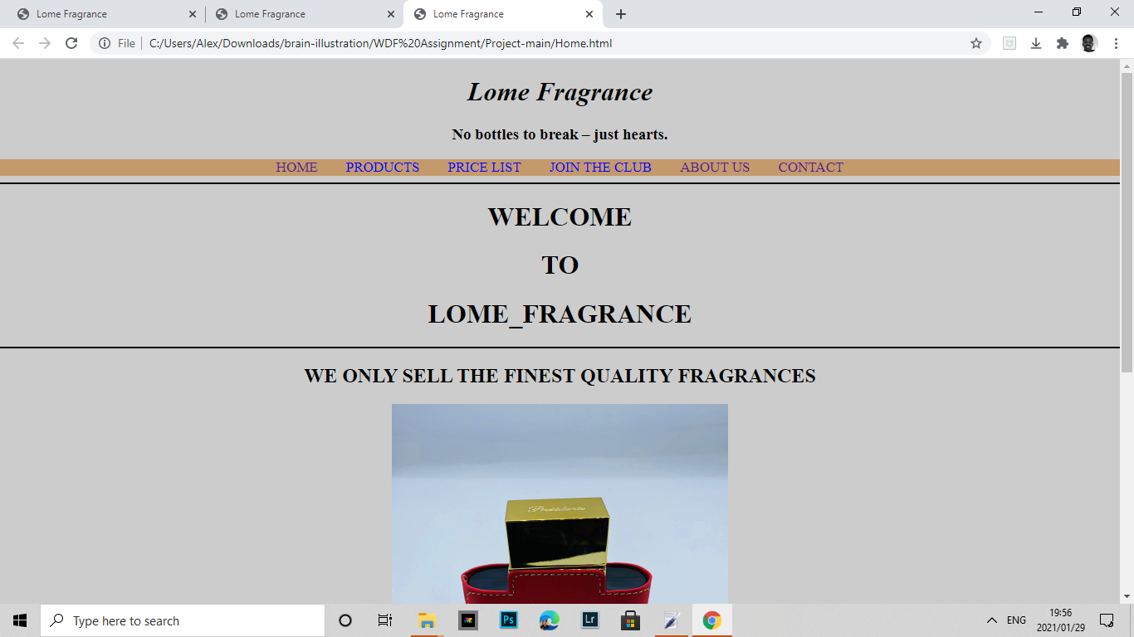

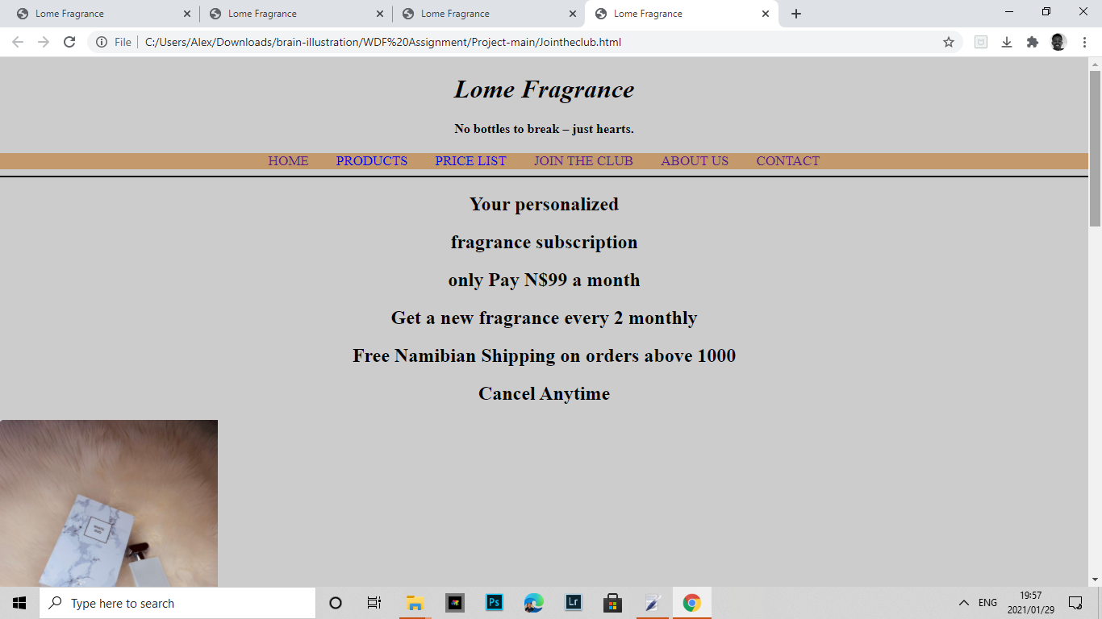

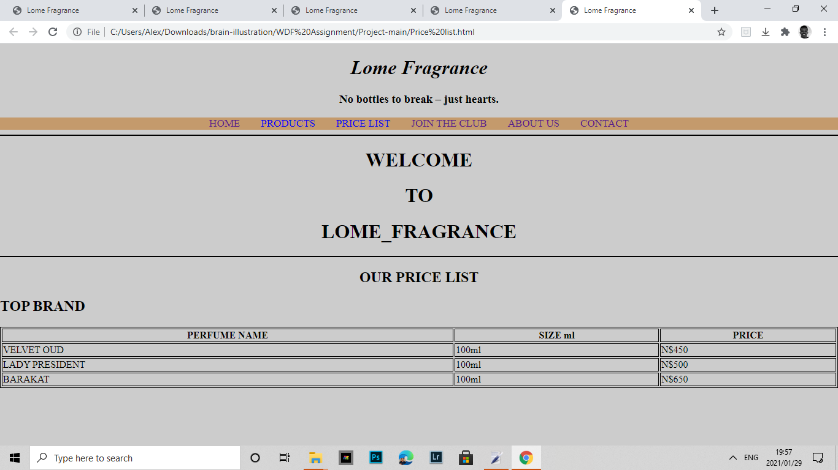

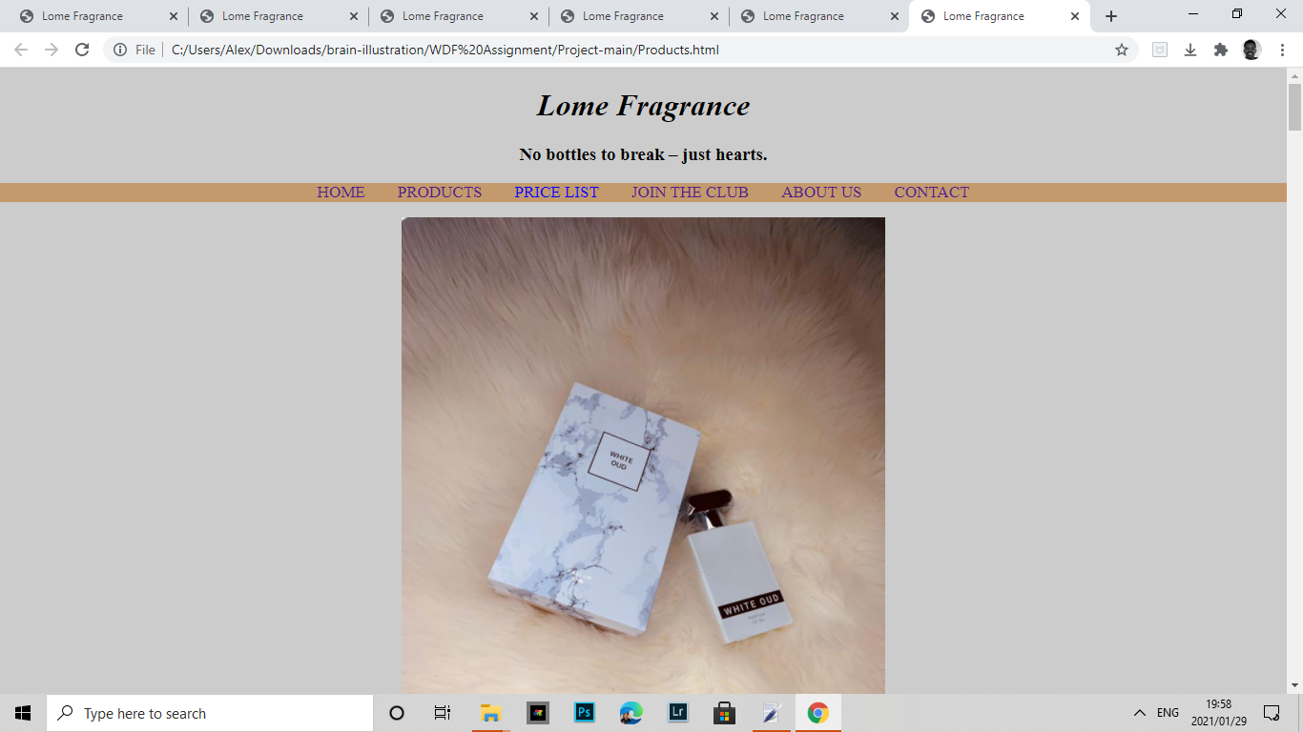

**Techniques**

HTML:is the most basic building block of the web.it defines the meaning and structures of web content

CSS:is a style sheet language used for describing the presentation of a document written in a markup language such as html.

JavaScript:often abbreviated as JS,is programming language that conforms to the ECMA Script specification

**Requirements**

All group members were required to create a GitHub account and make contribution to the  group project via GitHub and after all group members must present the project to your group lecturer in class.

**Project link**

Https://github.com/Wdfgroup234/Project