
NextTech Limited
SRS for Cartnexus
CartNexus - Men’s FashionE-Commerce Platform

Internship Title: E-Commerce Website
Batch: 26/220

Students Details
Name | ID
Md. Robiul Isalam | 222002068
Ahrafun Nahar Arifa | 222002066
Hasebul Hasan | 221002104
Labib Tahmid | 221002269
Zinedin Hassan Choudhury | 222002148

Submission Date: Mar 08, 2026
Supervisor’s Name: Mobasser Ahmed

Contents
1. Introduction 3
1.1 Purpose 3
1.2 Scope 3
1.3 Definitions & Abbreviations 3
1.4 References 4
2. Overall Description 4
2.1 Product Perspective 4
2.2 User Classes 4
2.3 Operating Constraints 4
3. Functional Requirements 4
3.1 Storefront (FR-SF) 4
3.2 Customer Account (FR-CU) 5
3.3 Administration (FR-AD) 5
3.4 Data & Integration (FR-DT) 5
4. Non-Functional Requirements 6
5. Data Flow Diagrams (DFD) 6
5.1 Level 0 (Context Diagram) 6
5.2 Level 1 DFD 7
5.3 Level 2 DFD (decomposition) 7
5.3.1 Process 2.0 — Cart & Checkout (expanded) 7
5.3.2 Process 4.0 — Admin Back Office (expanded) 8
6. Entity Relationship Diagram (ERD) 8
7. Class Diagram (Logical / Layered) 9
8. Budget (Indicative) 10
9. Revision History 10

Document | Details
Version | 1.0
Date | 2026-04-09
Project | CartNexus
Stack | React (Vite), Node.js (Express), MySQL

1. Introduction

1.1 Purpose
This SRS defines functional and non-functional requirements, system context, data structures, and high-level design views (DFD levels 0–2, ERD, class diagram) for CartNexus, a bilingual (English / Bangla) online storefront with customer shopping flows, checkout, customer accounts, and an administrative back office.

1.2 Scope
In scope
- Product catalog discovery (categories, brands, search, filters).
- Product detail pages with optional color variants.
- Shopping cart (client-side state) and guest / registered checkout with COD-style payment recording.
- Customer registration, login, profile, saved addresses, and order history.
- Admin: dashboard analytics, catalog (categories, brands, products), orders, inventory, users, home hero, blog, CMS pages (terms/privacy/faqs), store settings (contact, social, WhatsApp/Messenger).
- Public APIs and JSON responses; file uploads for avatars, catalog covers, hero images.
- Real-time admin dashboard refresh via WebSocket after new orders.
Out of scope (current codebase)
- Integrated payment gateways (card/mobile wallet) — checkout records payment_method; external PSP integration is future work.
- Native mobile apps (responsive web only).
- Multi-tenant / multiple stores in one deployment.

1.3 Definitions & Abbreviations
Term | Meaning
SRS | Software Requirements Specification
DFD | Data Flow Diagram
ERD | Entity Relationship Diagram
CMS | Content Management (editable legal/info pages)
COD | Cash on delivery
JWT | JSON Web Token (auth)

1.4 References
- Canonical DB: backend/db/schema.sql
- Change log: backend/db/db-changelog.txt

2. Overall Description

2.1 Product Perspective
CartNexus is a three-tier application:
- Presentation: React SPA (frontend/), i18n (EN/BN).
- Application: REST API + WebSocket (backend/src/server.js, routes under /api).
- Data: MySQL (cartnexus database).
External actors: Visitors/Customers, Administrators. Optional: email/SMS providers (not hard-required in core).

2.2 User Classes
User class | Description
Guest | Browse, add to cart, checkout without account (or with optional account).
Customer | Registered user: profile, addresses, orders.
Admin | Full back-office access via JWT-protected /api/admin/*.

2.3 Operating Constraints
- Node.js LTS, modern evergreen browsers.
- MySQL 8+ recommended; UTF-8 (utf8mb4).
- Environment variables for DB credentials, JWT secret, optional VITE_API_URL.

3. Functional Requirements

3.1 Storefront (FR-SF)
ID | Requirement
FR-SF-01 | Display home hero from home_hero (API).
FR-SF-02 | List/filter products by category, brand, price, stock; product detail with variants when configured.
FR-SF-03 | Shopping cart persisted in browser (context); quantities and variant selection.
FR-SF-04 | Checkout collects delivery data; creates order via POST /api/orders; supports guest or Bearer token.
FR-SF-05 | Static/marketing pages: About, Contact (store settings), Blog, Terms/Privacy/FAQs (CMS API when available).
FR-SF-06 | Footer/store settings: social links, WhatsApp/Messenger FAB when configured.

3.2 Customer Account (FR-CU)
ID | Requirement
FR-CU-01 | Register, login, JWT session (storage).
FR-CU-02 | Profile (name, phone, avatar upload).
FR-CU-03 | CRUD addresses (user_addresses).
FR-CU-04 | List own orders (GET /api/orders with customer token).

3.3 Administration (FR-AD)
ID | Requirement
FR-AD-01 | JWT login; role admin required for /api/admin/*.
FR-AD-02 | Dashboard: revenue, orders, charts, tasks, suggestions (API-driven).
FR-AD-03 | Manage categories, brands, products (including descriptions, variants, covers).
FR-AD-04 | Manage orders (status updates); inventory adjustments and movement history.
FR-AD-05 | Manage users (list, role); blog posts; CMS HTML pages; home hero; store settings.
FR-AD-06 | WebSocket subscription for dashboard refresh on relevant events.

3.4 Data & Integration (FR-DT)
ID | Requirement
FR-DT-01 | Public read APIs for catalog, blog, CMS pages, store settings, home hero.
FR-DT-02 | Uploaded files served under /uploads/*.
FR-DT-03 | Orders immutable line items snapshot in order_items.

4. Non-Functional Requirements
ID | Category | Requirement
NFR-01 | Performance | Catalog and product APIs are paginated/filtered; avoid unbounded scans in admin lists.
NFR-02 | Security | Password hashing (bcrypt); admin/customer JWT separation; HTTPS in production.
NFR-03 | Availability | Graceful degradation if optional tables/features are missing (503 with coded errors where implemented).
NFR-04 | i18n | UI strings EN/BN; product/content bilingual fields were modeled.
NFR-05 | Maintainability | Migrations + changelog for schema drift.

5. Data Flow Diagrams (DFD)

5.1 Level 0 (Context Diagram)
Shows the system boundary and external interactions.
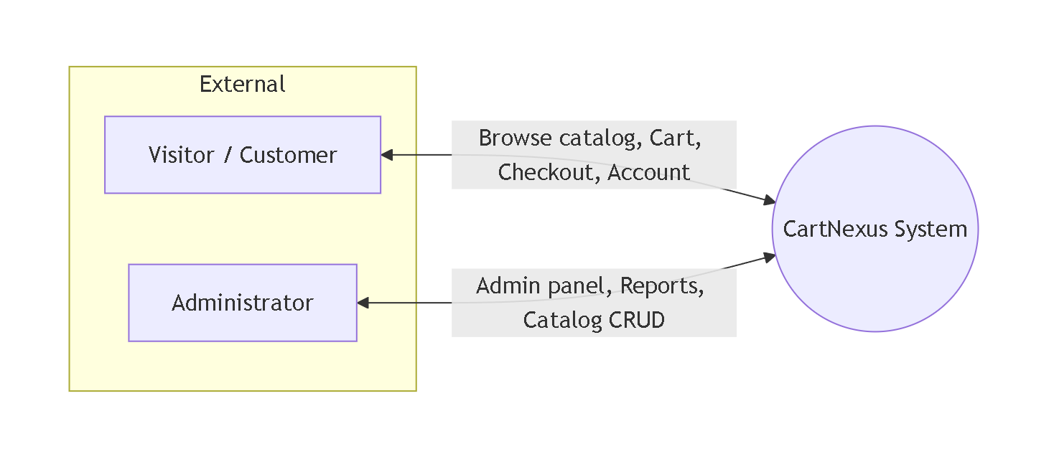
Data flows (summary)
- Customer → System: search/browse requests, cart actions, checkout payload, login credentials, profile updates.
- System → Customer: product/catalog data, order confirmation, auth tokens.
- Admin → System: CRUD operations, file uploads, configuration.
- System → Admin: analytics, lists, confirmations

5.2 Level 1 DFD
Major processes inside CartNexus and shared data stores.
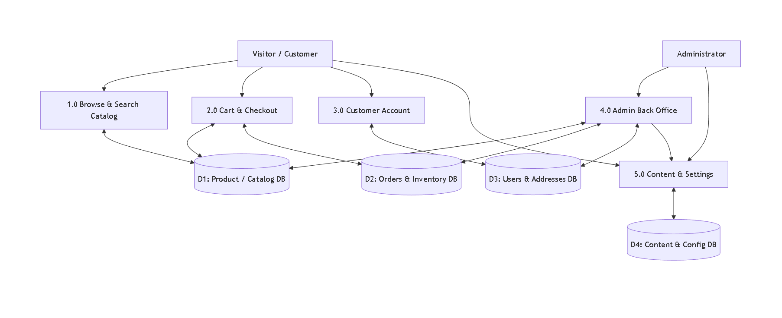
Store grouping (logical)
Store | Typical tables
D1 | categories, brands, products, product_color_variants
D2 | orders, order_items, inventory_stock_movements
D3 | users, user_addresses, admin_task_completions
D4 | home_hero, blog_posts, cms_pages, store_settings

5.3 Level 2 DFD (decomposition)

5.3.1 Process 2.0 — Cart & Checkout (expanded)

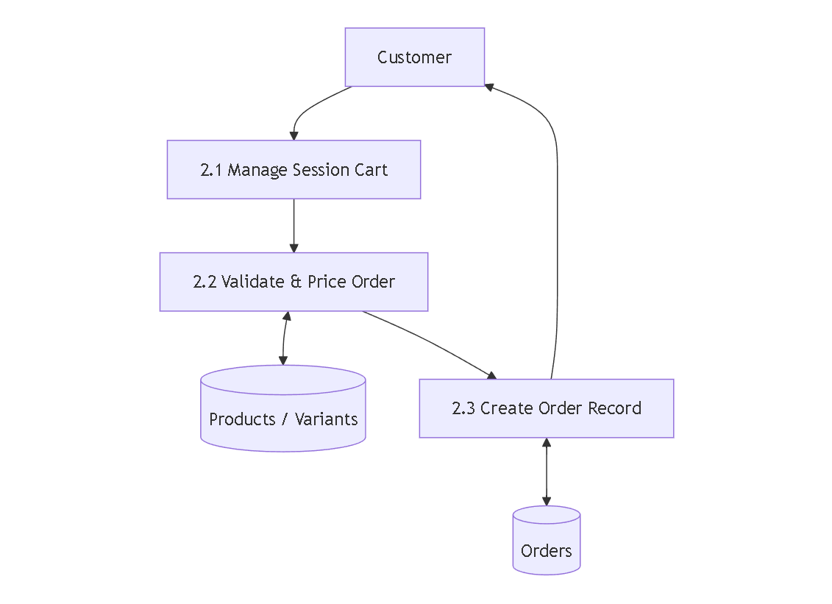

5.3.2 Process 4.0 — Admin Back Office (expanded)

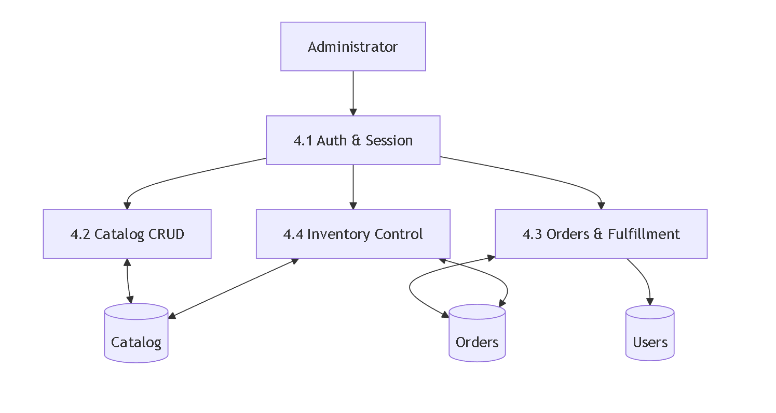

6. Entity Relationship Diagram (ERD)
Core relationships are aligned with backend/db/schema.sql. Cardinality in notes.
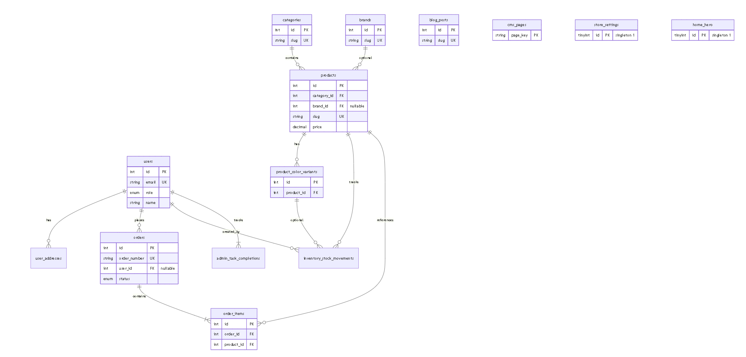

7. Class Diagram (Logical / Layered)
The codebase is primarily JavaScript modules (not Java-style classes everywhere). The diagram below captures logical responsibilities (UML-style) mapped to major folders.
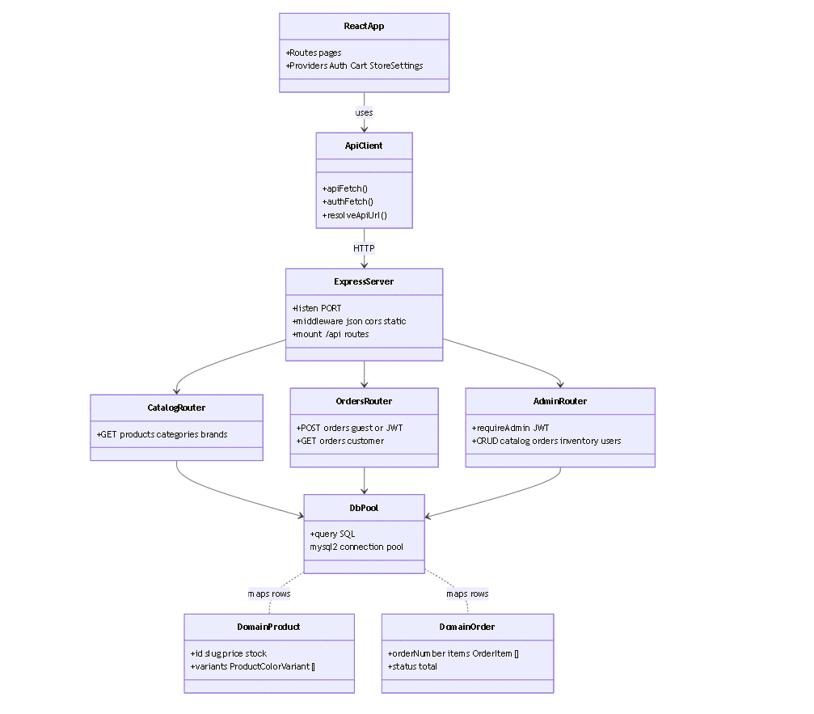

8. Budget (Indicative)
Figures are planning estimates in BDT (Bangladesh Taka). Adjust for team rates, timeline, and hosting choice.
Item | Description | Low (BDT) | High (BDT)
A. One-time development | Design + storefront + admin + DB + deploy (already largely implemented; use for future phases or maintenance) | 200,000 | 800,000+
B. Domain & SSL | .com / .bd domain + TLS (often included with hosting) | 1,500 | 5,000 / yr
C. Hosting | VPS (2–4 GB RAM) or cloud VM for Node + MySQL | 12,000 | 60,000 / yr
D. Database | Same VM or managed MySQL add-on | 0 | 30,000 / yr
E. Storage & CDN | Product images on server or object storage | 0 | 15,000 / yr
F. Email / SMS | Transactional email; optional OTP/SMS | 0 | 24,000 / yr
G. Backup & monitoring | Automated DB backup, uptime | 0 | 12,000 / yr
H. Maintenance | Small fixes, dependency updates, minor features (optional retainer) | 30,000 | 120,000 / yr
Rough first-year total (excluding large new features): ~55,000 – 250,000 BDT recurring + variable dev.

9. Revision History
Version | Date | Notes
1.0 | 2026-04-09 | Initial SRS with DFD 0–2, ERD, class diagram, budget

