Project Conceptual Discussion
Initial ideas and design planning

Project Name
Agile Software Projects Module
BsC Computer Science - University of London

Participants:
Davide Basile
Wiam Ghoussaini
Nelson Waissman

Scrum June 1st 2024

For the meeting (contributed by Wiam)
- The Game Design,
- Assets Required
  - Maybe use Photoshop and/or www.miro.com
  - Crystals and models using standard Unreal assets
- Coding Required
  - Unreal engine for development
  - Install / Setup
  - C++ development
- Design

2) Our Schedule for completing it.
- Free time we have to work on the project
  - Nelson - Weekend - Aug 5th to Aug 17th (vacations)
  - Davide - Flexible and ok with Saturday meetings (evenings)
  - Wiam - Flexible and ok Saturday meetings

- Task Division between us, who will write what code.
- Setting up catchup meetings to keep us updated on completion
- Risk management & if someone can't keep up.

3) Other topics
- If we should mention to the university that we have two team members who are not working with us.

List of Midterm Deliverables (contributed by Davide)

List of deliverable components
Work required
Formal specification of the system using modelling techniques / UML
Scope of the project (defining project in terms of what it’s going to achieve)
Requirements elicitation (what stakeholders expect from the system)
Market research / analysis
Description of our approach (agile methods, identifying right way of working, formative process)
Early, low fidelity prototypes (even on paper)

From the week 9 video 5.101 (contributed by Nelson)
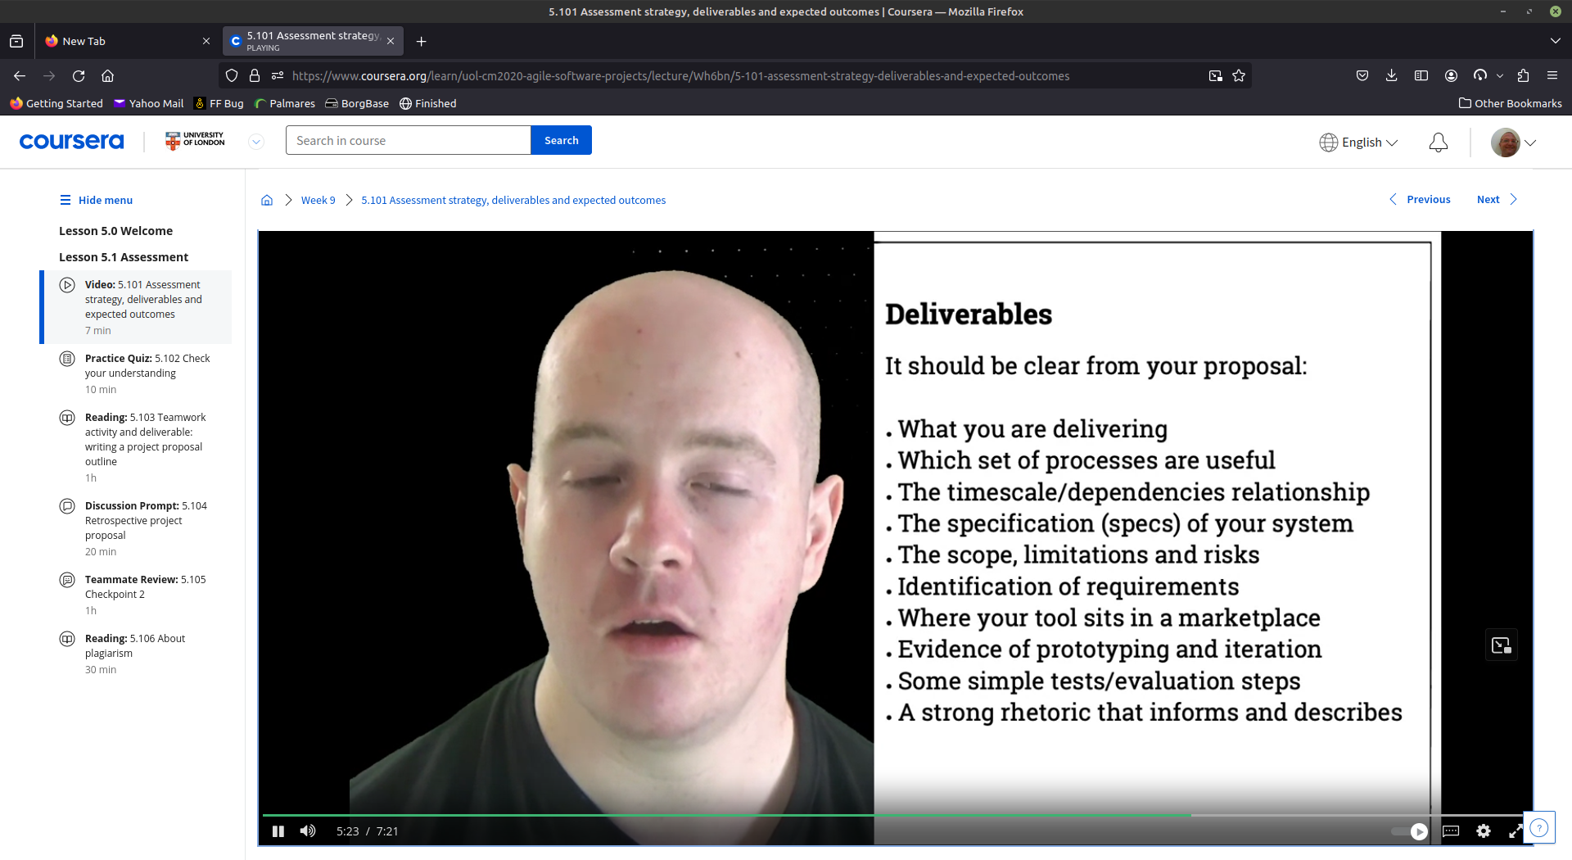

Initial Design Discussion (contributed by Wiam)

For the Game:
we need to prepare all the assets for it. then we need to write down a main game loop, with its initial setup. test that loop three times to optimize it.
The Setup:
Create Grid to customization requirement.
Position Crystals in each square in the Grid.
Make each Crystal at Level 3. so it has two levels up and two levels down to go.
Initiate Random Damage Generator.

The Game Loop:

Start.
Random Positions are chosen for Damage, if 10x10 grid then choose 30-50 crystals for damage.
Damage Crystals in this position. Reposition Crystals.
If Position Chosen Twice Execute double damage. (no damage should exceed 2 hits).
Player turn: Heal up to 1/2 or 3/4 number of damage Crystals one time or two times, three times in case of blackheart to bring them to level 2 or 3 again. (no three time healing for normal crystals).
Press Next Turn Button.
Repeat Loop.

Classes probably needed, based on Single Responsibility Principle
CrystalHearts Class (
Object Properties:
Color string or property from asset creation
LevelPosition int
SoundEffect file
BlackHeartStatus bool
AreaHealingEffect bool
Functions:
ColorSetter,
LevelSetter
SoundEffectSetter
ConditionUpdater [If level 1 --> Color Red --> change properties accordingly light = red soundeffect = death hymn; if level 2--> color orange; if level 3 --> color yellow; if level 4 -->color green; if level 5 --> color blue && AreaHealing; if level 0 --> color black; BlackHeartEffect on)
Grid Class
ObjectsProperties
RowNumber
ColumnNumber
Grid Array
Functions:
RowSetter
ColumnSetter
DrawGrid
LevelMechanic Class:
Properties:
Grid
CrystalHeart
RoundCounter
Healing Chances
Functions:
Grid & Crystal Creator
TurnUpdater (Updates Turn by Turn based on button press) [Updates each round; if RandomDamagePosition == crystal position then this crystalProperties +=1 or -=1; if blackHeartEffect == 1 then this.crystal ==black && Positions surrounding it -= 1 on next turn unless BlackHeartEffect == 0]
RandomEffectGenerator(rownumb, columnnumb) [chooses random positions for damage between rownum && columnnum, Pass arrayValue to TurnUpdater, && choose random positions for positive effect, pass values]
UI Class:
I have no idea please help me out here guys,
I WAS THINKING HERE TO CREATE THE GAME LIKE THE MINESWEEPER LAYOUT. GIVE ME OUR OPINIONS. there will be a side tab at the top left to fix options.
Finally, MainLoop:
Setup{
GridSettings =
DrawGrid
SetupCrystals
}
MainLoop{
TurnUpdater
If crystalClicked --> CrystalProperties +=1
} (edited)

Table of Contents for Report ( contributed by Wiam)

Table of contents:
- Introduction
- Concept
- Aims and Objectives
- Stakeholders
- Scope
- SWOT Analysis
  - Strength
  - Weaknesses
  - Opportunities
  - Threats
- PESTLE Analysis
  - Political Factors
  - Technological Factors
  - Social Factors
  - Economic Factors
  - Legal Factors
  - Environmental Factors
- Market research
  - SOURCE 1
  - Source 2
  - Source 3
- Design Modeling
  - Initial prototype
    - Asset Creation/Preparation
    - Main Game Loop Components:
      - Grid
      - Assets positioning
      - Game Mechanics
  - Main Game Loop Testing
    - First Iteration
    - Second Iteration
    - Third Iteration
  - Menu UI
    - Highest Score Display
    - Play Game Button
    - Options
      - Increase Healing
      - Increase Damage Frequency
      - Increase Grid Size
    - Exit Button
  - Level Design
    - Background Image
    - Background Soundtrack
    - Custom Size 3D Grid
    - Transparent 3D Diamonds
    - UI
      - Score Display
      - Healing Chances Display
  - Game Mechanics:
    - Diamond’s Movement
    - Click & Heal Mechanic
    - Click & Release Mechanic
    - Stop Option
  - Extra Features:
    - Diamonds’ Color
    - Diamonds’ Light
    - Different Backgrounds
    - Sound Effects
- User Testing:
  - First Iteration
  - Second Iteration
  - Conclusion for user testing
- Technical and Functional specification
  - Tools used
    - Unreal Engine
    - Github
  - Outsourced Tasks
    - Assets
  - Functional Requirements
  - Non-Functional Requirements
- Performance Analysis - Project log journal
  - Coming up with the concept
  - Developing the concept
  - Finalizing the concept and providing basis
  - Conducting SWOT & PESTLE Analysis
  - Prototyping
  - User Testing
  - General
- Planning
- Conclusion
- References:
  - Appendix
    - Initial Concept sketches
    - Initial Plan
    - Game Analysis and components
    - Division of Tasks

Initial Planning (Contributed by Nelson)

Weekly Scrum Meetings

Sprint 1
Week 1 ends on Saturday June 8th
Week 2 ends on Saturday June 15th

Introduction, Concept, Aims and Objectives - Nelson
Stakeholders, SWOT Analysis, PESTLE Analysis - Davide
Market Research Design - All team
UI discussion/Indie Games/Theme
Interest/Publicity
Game Design - Wiam

Sprint 2
Week 3 ends on Saturday June 22th
Finish Prototyping and pseudo code
Share assets and understand Unreal

Week 4 ends on Saturday June 29th
User Testing Design
Heuristic Evaluation
Technical and Functional Design
Finding assets and preparing
Planning
Can start coding

Final report review and changes
Week 5 ends on Saturday July 6th Report must be completed, submission before July 8th

Conclusion/References

Sprint 3
Week 6 ends on Saturday July 13th
Week 7 ends on Saturday July 20th

Sprint 4
Week 8 ends on Saturday July 27th
Week 9 ends on Saturday August 3rd

Sprint 5
Week 10 ends on Saturday August 10th Nelson is out
Week 11 ends on Saturday August 17th Nelson is out

Sprint 6
Week 12 ends on Saturday August 24th
Week 13 ends on Saturday August 31st

Final Reviews and changes
Week 14 ends on Saturday September 7th Project must be completed, submission by September 9th

Conclusions from Q and A videos on week 10:

Coursework Aims: Particular focus on centred design. Reinforce abilities in project management, planning, critical awareness and design to create better software

Challenge: devise, develop and produce a software application that demonstrates our technical skill, user centred design profeciency and project management capability. Software must be designed with the user in mind and must shows awareness of professional issues in software engineering. It must be non-trivial.

Report should include: Aims and Objectives, Planning, Specification, Scope, Requirements, Literature, Market Research, Approach and Motives, Prototyping, Assumption Testing.

Report should answer: What is the concept, who are the stakeholders, what is already on the market on the same concept, functional components and technical architecture, low fidelity prototype and what did you learn from it. High fidelity prototype and what did you learn from it. What's the next phase?

Title Page: Needs to include Group members (student IDs), Date, Title (make it descriptive).
Abstract: Optional. It is a synopsis of what appears on the report
Table of Contents: Assemble it after document is written. Include appendices
Style: Use passive voice (avoid I and we). Keep language formal. Avoid coloquialisms. Use do not instead of don't.
Introduction: Summarize background. Approach to coursework (what and why). Should include: terms of reference, history and background of the problem involved, scope of the report and any limitations.
User Requirements: Data gathering process. An overview of who the stakeholders are. Analysis of users. Identify requirements for the proposed design. What does it do and how does it meet users wants, needs and desires.
Project Management: Project planning, group structure if appropriate, Gant charts, milestones. How does the process looks like. Regular meetings (how often). Why was it important. Document tools used.
Model Design: Actions and tasks user will carry out in our system. Storyboards, activity diagrams. Use cases, sequence diagrams or flow charts.
Prototype: Prototypes should be evaluated and the report should show evidence of prototype evaluation. We want to see design iterations. Several low fidelity prototypes, some medium fidelity and at least one high fidelity. Include summary data.
Functional Specifications: Shoud not assume specific technologies.
Technical Architecture: Attribute specific technologies to functional specs. Justify your choice of technologies with reasoned arguments for rejecting or retaining alternative technologies.
Ethical Audit: Issues with data privacy, IP rights and how to manage them. Do not work with minors or vulnerable adults. Other risks at play?
Evaluation: How did you work towards your goals. Were they achieved? Key indicators for progress and success.

Conclusion: Summarise your findings. Note any surprising results. State what would you have done if more time were available.
Bibliography: Sources referenced and include bibliography. Always give author, title and date visited in addition to URLs.
Reference figures too: Always refer to figure number when writing about it. Cite source for reused images.
Appendices: Do not count towards word total. Tracking logs and raw data from surveys should go into the appendix. Anything that is discussed goes into the report, otherwise into the appendix.

