**OUTPUTSCREENSHOTS**

OUTPUT OF THE WEBSITE:--

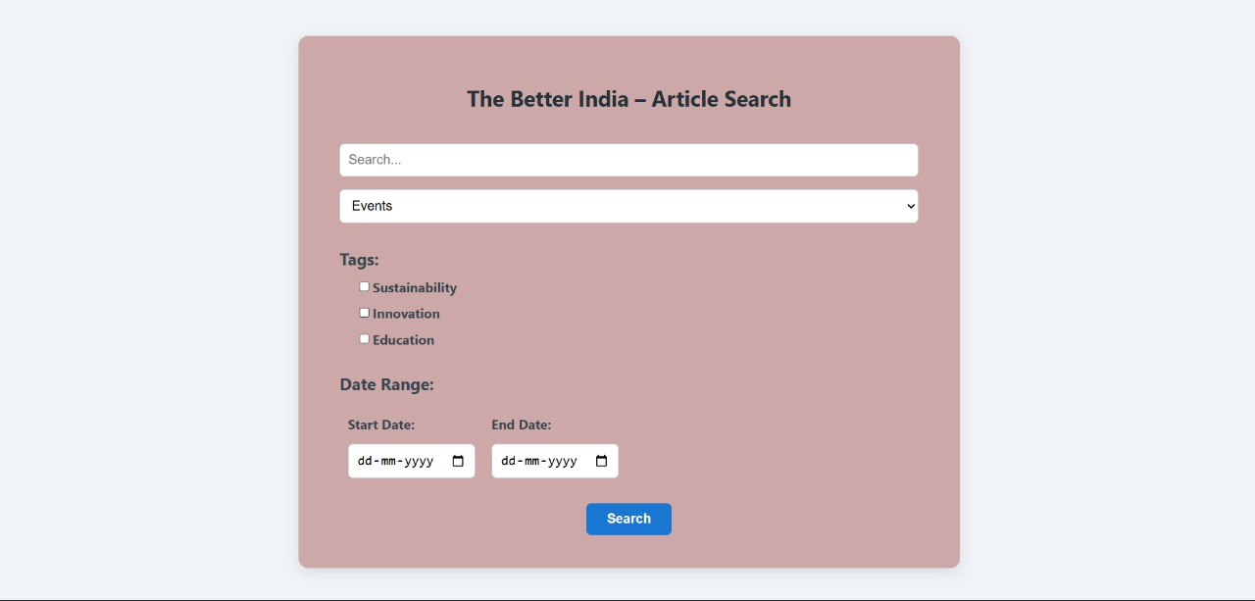

OUTPUT OF THE TESTING USING POSTMAN TOOL:--

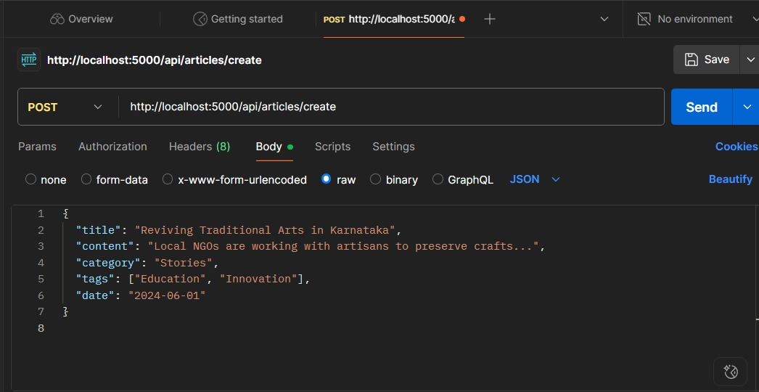

OUTPUT OF THE BACKEND USING MY SQL:--

