PRODUCTION REFERENCE | VERSION 0.1
WKE Educational Comic Series
Master Production Bible
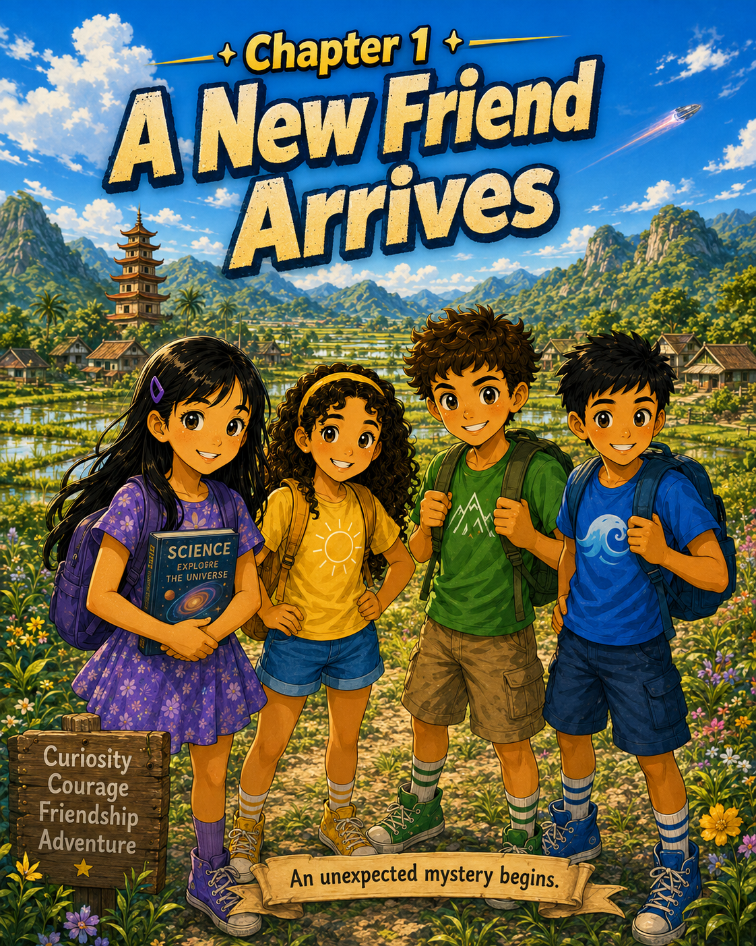
Chapter 1 visual anchor: A New Friend Arrives
Purpose: Protect story canon, educational quality, character identity, and visual continuity from script through lesson-player publication.
Learners | Ages 9-12 | CEFR A1-A2
Confirmed cast | Mia, Zara, Leo, Ethan, and Keelan
Current status | Chapter 1 published | Chapter 2 in production
Updated | August 2, 2026

1. How to use this bible
Production rule: Read the relevant canon, character, language, and scene rules before producing a page. Resolve conflicts before generating later artwork.
- Confirm outcomes. Define the story movement, character movement, and learner-language goal.
- Script the page. Record exact panel action, dialogue, positions, props, and transition from the prior page.
- Check canon. Compare names, identity colors, models, ship, crash-site map, and object locations.
- Create and letter. Generate or illustrate from approved references, then add only approved text.
- Review and publish. Complete learning and continuity QA, preserve alternates, and upload the single canonical page.

Canon hierarchy
- Owner decisions Newest explicit decisions confirmed by the project owner.
- Approved artwork Published dialogue and final canonical pages.
- Approved scripts The newest chapter and page records.
- Working standards Recommendations in this bible that have not yet been explicitly locked.
- Drafts Unapproved generations and alternates never overrule canon.

Series promise
Four friends discover Keelan, a stranded blue alien, and are drawn into a larger mystery. Their adventures combine curiosity, courage, friendship, science, discovery, and age-appropriate wonder.
- The story must be engaging even when no lesson activity is attached.
- Images should let learners infer meaning without translating every word.
- Characters model cooperation, empathy, reasoning, and safe decision-making.
- Every chapter gives teachers opportunities for prediction, retelling, speaking, and comprehension.

2. Cast canon
Character | Identity | Model and story anchors
Mia | Purple | Long straight black hair; purple clip and dress; science-oriented, cautious, and analytical.
Zara | Yellow | Long dark curly hair; yellow headband and sun shirt; warm, encouraging, and empathetic.
Leo | Blue | Short black hair; blue wave shirt; energetic, playful, curious, and action-oriented.
Ethan | Green | Curly brown hair; green mountain shirt; imaginative, hopeful, adventurous, and persistent.
Keelan | Blue alien | Blue fur, pointed ears, golden-dark eyes, orange stars, fangs, tail; gentle, magical, and weak after the crash.

Character voice
Mia: Evidence-focused and thoughtful. She may use slightly more precise language but must remain A1-A2 accessible.
Zara: Supportive, expressive, and attentive to feelings.
Leo: Direct, enthusiastic, and ready to act.
Ethan: Optimistic, imaginative, and persistent.
Keelan: Gentle and initially cautious; short statements reflect limited language and weakness.

Keelan model lock
Before additional final pages are approved, create a reference sheet that fixes Keelan’s height, ear proportions, star pattern, finger count, tail, fang placement, and magic effect.
- Use the same golden-dark eye design and orange star motif in every panel.
- Keep a stable child-to-Keelan scale in group shots.
- Define one approved paw anatomy and use it from every angle.
- All human characters must clearly appear 9-12, with practical clothing and age-appropriate poses.

3. Learner and language framework
Confirmed learner: Ages 9-12 at CEFR A1-A2, reading independently or with teacher support.

Language controls
- Prefer high-frequency concrete words that are supported by the picture.
- Keep most balloons between 3 and 10 words and focused on one idea.
- Keep narration concise, normally 8-18 words, and use it only for necessary transitions.
- Introduce approximately 6-10 useful target words or phrases per chapter.
- Repeat important sentence frames naturally in later panels and chapters.
- Avoid unexplained idioms, sarcasm, dense exposition, and abstract vocabulary.
- Use names when a pronoun or speaker could be unclear.
- Make every balloon tail unambiguous for emerging readers.

Language already established
Function | Published example
Reassuring | I’m not going to hurt you.
Ability | I can use a little magic.
Suggesting | Maybe we should help him.
Imperatives | Wait! / Run! / Stay together.
Possibility | Maybe it powers the ship.
Past cause and present result | My ship crashed. I’m weak.

Educational quality gate
- An A1 learner can follow the central action from images and familiar words.
- An A2 learner can read most dialogue independently and explain key choices.
- New language is inferable from action, expression, object, or repetition.
- The page supports a simple retell, prediction, or speaking prompt.

4. Visual and continuity standard
Working canvas: 1122 x 1402 pixels, portrait, approximately 4:5. Chapter 1 pages 3-6 currently differ and must be standardized before unified print or reader export.

Art direction
- Warm, detailed, painterly comic rendering with manga/anime influence.
- Saturated natural color, golden forest light, expressive faces, and readable body language.
- Three to six panels with consistent black borders and gutters.
- Parchment-style panel numbers, white balloons, black outlines, and clear tails.
- Yellow, black-outlined display lettering reserved for major sound effects.
- Stable identity system: Mia/purple, Zara/yellow-sun, Leo/blue-wave, Ethan/green-mountain, Keelan/blue-orange-stars.

Crash-site map
Spatial canon: Chapter 1 places the broad saucer on the left and the root/tree hollow on the right. The four backpacks remain beside the ship entrance unless a later page shows them being moved.
Current conflict: Chapter 2 page 1 changes or blurs the ship/hollow relationship and omits the backpacks. Resolve the scene map before creating the next final page.

Spacecraft model
- Broad, flattened circular saucer with a raised central dome.
- Dark segmented metal shell, blue illuminated details, and a round entrance.
- Interior contains a glowing blue crystal or power object.
- Damage and smoke may develop, but the silhouette and doorway remain recognizable.

Preferred lettering workflow
Generate clean artwork without final dialogue where practical, then add balloons, tails, panel numbers, and approved text in a controlled lettering pass. This prevents spelling drift and unclear speakers.

5. Chapter architecture
- Hook or continuation. Reconnect readers to the unresolved question.
- Immediate goal. Give the characters a clear problem, need, or decision.
- Discovery. Reveal useful information about Keelan, the ship, the world, or a friend.
- Choice or complication. Require cooperation, courage, empathy, or reasoning.
- Small payoff. Resolve one question or complete one meaningful action.
- Forward pull. End with a new question, discovery, risk, or promise.

Backward-design fields
- Story goal and emotional/character goal.
- One communicative language goal.
- Six to ten target words or phrases.
- Grammar learners will encounter, without forcing explicit explanation into the comic.
- Visual supports for unfamiliar meaning.
- Three to five post-reading comprehension or speaking prompts.

Production workflow
- Define outcomes. Decide what changes in the story and what learners will understand or use.
- Write the beat sheet. Confirm hook, goal, discovery, complication, payoff, and forward pull.
- Write page scripts. Record every panel’s composition, dialogue, emotion, props, and continuity anchors.
- Review language. Check A1-A2 readability, dialogue length, visual support, and speaker clarity.
- Review canon. Check models, identity colors, ship, location, props, and previous-page match.
- Create art. Use approved prompt blocks, models, and scene maps.
- Letter the page. Use only approved script text and verify reading order and tails.
- Run QA. Complete the continuity and learning checklist at full resolution.
- Archive and upload. Preserve alternates, mark one canonical file, update records, and publish in order.

6. Current story canon

Chapter 1 - A New Friend Arrives
Status: Published. Cover plus six story pages.
The friends debate whether aliens exist, witness a crash, investigate the ship and glowing crystal, follow movement to a tree hollow, and meet Keelan. The chapter ends when Keelan says, “Wait!”
- Meadow play and science reading establish the four friends.
- Mia doubts aliens exist; Ethan refuses to give up hope.
- A spacecraft crashes near the woods.
- The children enter the saucer and find a glowing blue crystal.
- Movement and golden eyes appear in a nearby tree hollow.
- Keelan emerges and stops the children from running.

Chapter 2 - title TBD
Status: In production. One canonical page confirmed.
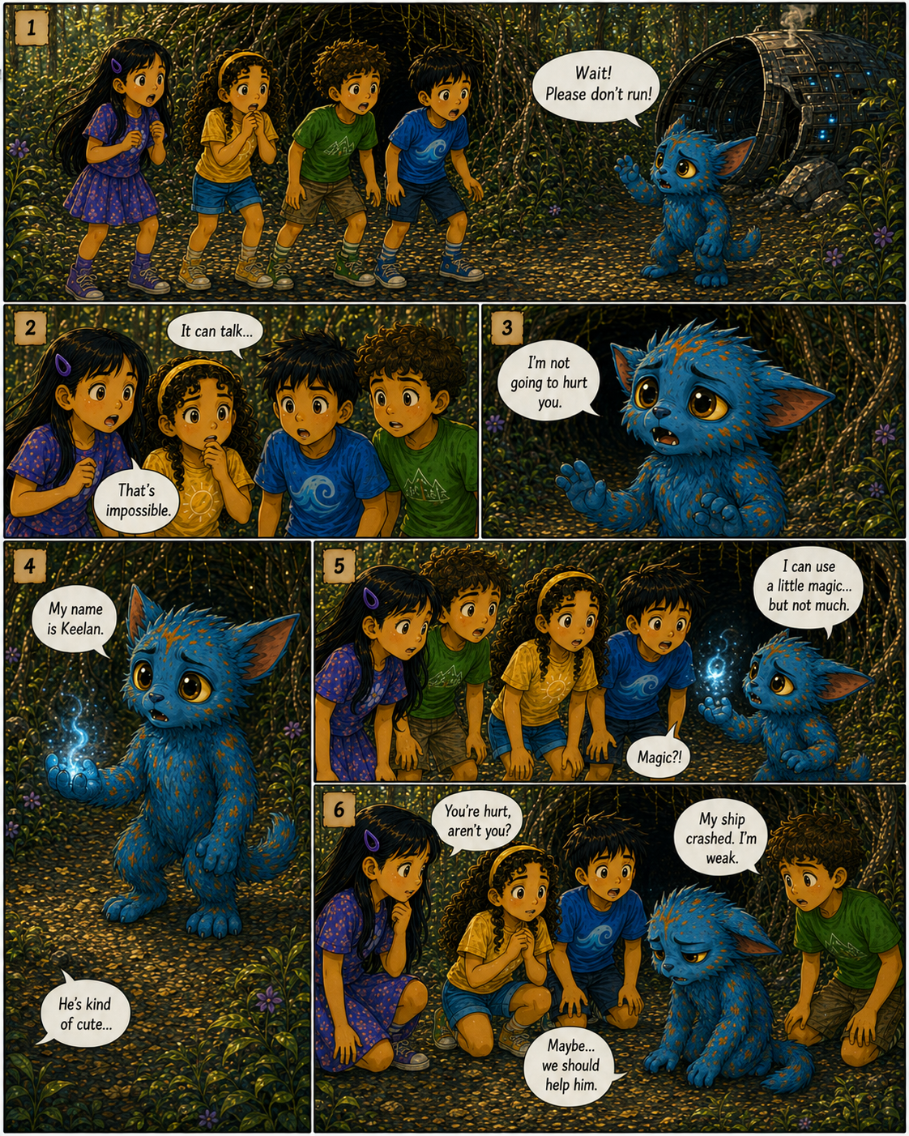

Chapter 2, Page 1 record
Panel 1: Keelan calls, “Wait! Please don’t run!”
Panel 2: The children react: “It can talk…” and “That’s impossible.”
Panel 3: Keelan reassures them: “I’m not going to hurt you.”
Panel 4: Keelan introduces himself. A child observes that he is cute.
Panel 5: Keelan reveals limited magic. A child responds, “Magic?!”
Panel 6: The children notice he is hurt; Keelan says the crash left him weak; they consider helping.

Canon established
- The alien’s name is Keelan and the approved dialogue uses he/him pronouns.
- Keelan is peaceful, speaks the children’s language, and can use limited magic.
- The crash left Keelan weak.
- The children begin moving from fear toward empathy and cooperation.

Next-page requirements
- State the specific help Keelan needs.
- Preserve all five models and the approved crash-site map.
- Continue one clear A1-A2 communicative goal.
- Move toward a concrete Chapter 2 payoff and ending hook.

7. Approval checklist

Story connection
- [ ] First panel matches prior positions, emotion, props, and lighting.
- [ ] The page has one clear story job and understandable transitions.
- [ ] The last panel creates a reason to continue.

Character and environment
- [ ] All models, identity colors, clothing symbols, age, and anatomy match.
- [ ] Ship, hollow, landmarks, backpacks, books, and crystal remain consistent.
- [ ] Screen direction and character order do not jump without explanation.

Language and learning
- [ ] A1 learners can follow the main action from the visual context.
- [ ] A2 learners can read most dialogue independently.
- [ ] Every balloon has one clear idea, an obvious speaker, and approved text.

Technical
- [ ] Canvas, gutters, panel numbers, lettering size, reading order, and safe area pass.
- [ ] No unintended extra fingers, duplicate characters, cropped limbs, or floating objects.
- [ ] Canonical filename, page order, alternate archive, and chapter record are correct.

Known issues requiring resolution
Priority | Issue | Required decision
High | Mixed page aspect ratios | Approve one canvas and standardize all pages.
High | Ship design and crash-site geography drift | Approve a spacecraft model and scene map.
Medium | Backpacks disappear | Show recovery or preserve their location.
Medium | Keelan model drifts | Approve the full model sheet before more final pages.
Medium | Magic appears before its dialogue reveal | Move the effect or revise the script beat.
Low | Mia hair-clip count varies | Lock one model.
Low | Chapter 1 page 5 lacks panel numbers | Add numbers or revise the series convention.
Low | Some balloon tails are unclear | Clarify attribution during lettering.

Open story decisions
- Chapter 2 title.
- The specific repair, object, or action Keelan needs.
- The Chapter 2 payoff and final hook.
- Whether the children help alone, retrieve the crystal, or seek an adult.

Change log
Version 0.1 - August 2, 2026: Confirmed the cast names and color identities, Keelan’s name, the ages 9-12 learner band, CEFR A1-A2 target, Chapter 1 record, Chapter 2 page 1, and the first production standards.

