
Vikhram Ravi
Chennai, India

+91 7904763387


vikhramravi2002@gmail.com
 LinkedIn Portfolio

SUMMARY

interdisciplinary researcher pursuing a dual M.Tech in Nanobiotechnology (ASNSMM) and MS in Immunobiology (University of Arizona). Bridging the gap between nanotechnology and immunology, my expertise spans bioinformatics and smart nano-formulations. My long-term goal is to leverage these insights to advance personalized medicine, cancer therapeutics, and gene-based therapies. I enjoy troubleshooting multidisciplinary challenges.
EDUCATION

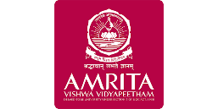
Amrita Vishwa Vidyapeetham, Coimbatore August 2024 – July 2026
Amrita School of Nano Sciences and Molecular Medicine, Kochi
Master of Technology, Nanobiotechnology 9.48/10


University of Arizona, USA December 2024 – May 2026
Department of Immunobiology, College of Medicine, Tucson
Master of Science, Immunobiology 4/4


Saveetha Institute of Medical and Technical Sciences, Chennai July 2020 - June 2024
Saveetha School of Engineering, Chennai
Bachelor of Technology, Biotechnology 9/10


National Institute of Open Schooling, India June 2018 - May 2020
Open Schooled, Chennai
Senior Secondary, Physics, Chemistry, Biology, Computer Science 78.6 %


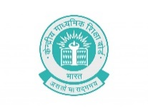
Central Board of Secondary Education, India June 2017 - May 2018
Vikhe Patil Memorial School, Pune
Secondary, Class X 6.72/10

EXPERIENCE

NextGen Biology Newsletter, Visakhapatnam February 2026 - Present
Volunteer Remote
- Dynamic Support, Content Editing and Proofreading.

Sri Projects, Chennai February 2024 - July 2024
Intern On-Site
- Biogas yields of various substrates, VBA Macros involving various conditions / real time scenarios from field data, Biogas Output Mass Balance Calculations for Biogas Plants.
- Basics of AFT Fathom for fluid dynamics analysis in Biogas Plants, Stress Analysis for Bio-related plants using CEASAR II.
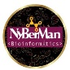
NyBerMan Bioinformatics, France February 2024 - July 2024
Intern Remote
- Analyzing the data from COSMIC database for Breast cancer mutations.
- Molecular Docking to identify a suitable drug which is effective against specific mutations.

TECHNICAL SKILLS
Characterization SEM, DLS/ZETA, XRD, H-NMR, FTIR
Bioinformatics Molecular Docking, PyMOL, DSV, Binding Site Prediction, BLAST, MD Simulation, Linux
Polymer Chemistry Linear Polymer Synthesis, Carothers Equation
Gene Delivery Polyplex systems, Core-Shell systems
Molecular Biology DNA/RNA Extraction, Plasmid Isolation, TLC, SDS PAGE, ELISA, ROS/Toxicity Assays
Cell Culture L929, RAW 264.7, HEK 293, PBMC Isolation, Transfection Experiments, in vitro Assays
Statistical / Data Analysis Origin Lab, SPSS, GraphPad PRISM, Tableau
Industrial Biotechnology Biogas Mass Balance, PFD, AFT Arrow, CAESAR II Stress Analysis
Documentation MS Office Suite, LaTeX, Markdown, VBA Macros

SOFT SKILLS

Conflict Resolution
Time Management
Process Optimization & Automation
Flexible & Adaptive
Listening

PROJECTS

Master’s Thesis June 2025 - Ongoing
A Novel Non-Viral Gene Vector: PBAE based Core-Shell Nanoparticle System for Gene Delivery
- Synthesis of PBAE, Troubleshooting approaches and Optimization
- Core-shell system design, Cell Culture, GFP-Transfection studies (in progress)
Bachelor’s Thesis May 2024
Examining the Therapeutic effects of Camphene Conjugated with Zinc Oxide Nanoparticles on Zebrafish Larvae
- Developmental Toxicity Studies in Zebrafish in-vivo model.
- Neurotoxicity analysis by using locomotory parameter.
- Effects on ROS Enhancement Levels using GPx and GST parameters.
- Lipid Peroxidation level analysis using DCFH-DA staining fluorescent Assay
Obsidian- Personal Knowledge Database May 2024
- I've created a personal knowledge management system for my coursework using Obsidian. The topics have storyboard layout to help connect related notes with a mind map approach.
- The list of topics is categorized and available in my personal portfolio under projects section. (Note: The HTML canvas export has some bugs; raw files are available upon request.)
GenAI Project (Hobby/Personal) May 2024
Caraoke, Offline Karaoke app for syncing Lyrics with song
- Source code was developed using AI with prompts.
- APK was built using Android Studio.
Mini Projects
Ammo Mist, Ammonia sensor for Aquariums October 2023 - March 2024
- Developed a module with IoT support for detecting dissolved ammonia in Aquariums
- The setup is different from the conventional electrode-based ammonia detection.
- Received Institutional Patent for the invention.
Clin Mist, Natural Surface Disinfectant July 2022 - December 2022
- A novel surface disinfectant utilizing the antimicrobial properties of terpinen-4-ol extracted from Green tea extract.
- The product received institutional patent

COURSES & CERTIFICATIONS


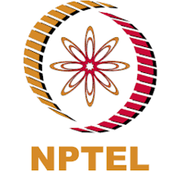
Fundamentals in Biotechnology and Genetics June 2024

Issuer: Alison (NPTEL)

- DNA tools, Basics of Heredity and Genetic terms, Mendelian Genetics
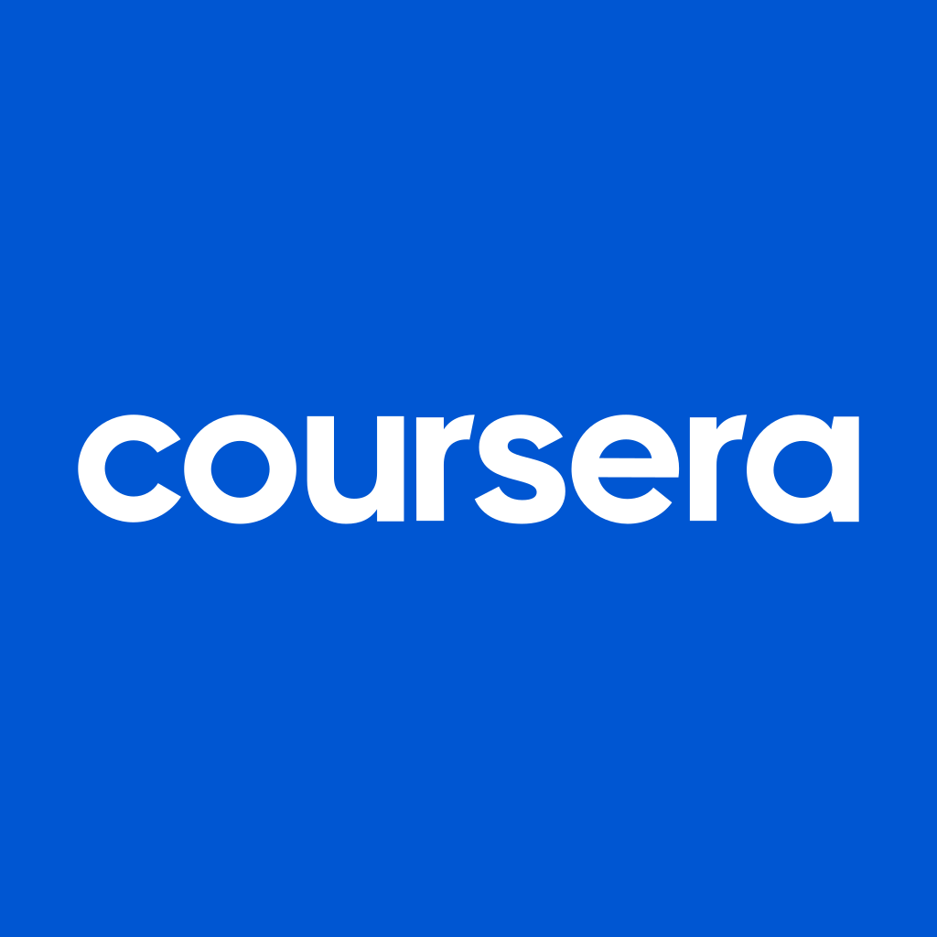
Google Business Intelligence April 2024

Issuer: Google (Coursera)
- Obtained the Professional Certificate by completing the three courses, Foundations of Business Intelligence, The Path to Insights: Data Models and Pipelines, Decisions, Decisions: Dashboards and Reports


Drug Discovery March 2024

Issuer: UC San Diego (Coursera)
- The phases in the development of drug, parameters involved in bringing a drug from the laboratory to the market.


Introduction to the Biology of Cancer March 2024

Issuer: Johns Hopkins University (Coursera)

- Obtained the certificate with Honors by completing the optional course on Introduction to Liver Cancer

Drug Delivery: Principles and Engineering October 2022

Issuer: IISc Bangalore (NPTEL)
- Obtained the certificate with Honors by completing the optional course on Introduction to Liver Cancer

CONFERENCES & WORKSHOPS

Virtual Winter School on Computational Chemistry, GROMACS Jan 2026
- Engaged with training modules led by the GROMACS Team and the Virtual Winter School for molecular docking simulations
8th Indian Myeloma Congress, Annual Conference of IMAGe, Amrita Institute of Medical Sciences, Kochi Jan 2026
- Attended the workshop on Flow Cytometry for MRD, Demonstration of Gating strategies and viewpoint on MRD clinical decisions based on NGF. Expert viewpoint on Flow Cytometry vs NGS.
Workshop on “Electrospinning for Nanofibre production”, Sathyabama, Chennai May 2024
14th International Conference on Science & Innovative Engineering, Chennai April 2024
- Paper Presentation titled, "Evaluating the Pharmacological Profile of Novel Drug Camphene conjugated with Zinc Oxide Nanoparticles using Zebrafish Larvae model".
Workshop on “Biomass Fermentation and Distillation for Bioethanol Production”, Sathyabama, Chennai May 2024
Workshop on “Biomimetic Scaffolds Fabrication for Tissue Engineering using Novel Electrospinning Strategies”, Binghamton University June 2021
PUBLICATIONS

Springer – BioNanoScience September 2024
Investigating the Protective Effect of Camphene-Conjugated Zinc Oxide Nanoparticles Against Pseudomonas aeruginosa Infection in Danio rerio
DOI : 10.1007/s12668-024-01561-3
AWARDS

GATE Biotechnology 2026 - Qualified, IIT Guwahati March 2026
Institute Scholarship, ASNSMM, Amrita Vishwa Vidyapeetham July 2024 – Present
- 2nd Rank Holder of the Nanobiotechnology Department.
Best Outgoing Student, SSE, SIMATS University November 2024
- Best Outgoing Student of 2024 Batch
- First mark in Plant Biotechnology and Molecular Biology
CHESS:
VALOR represented team Zelos, ASNSMM, 1st Place March 2025
SIMAM represented team Samudra, SIMATS, 1st Place May 2022
CBSE Nationals represented Jawahar Vidyalaya, 2nd Runner Up November 2014
CBSE Zonals represented Jawahar Vidyalaya, 1st Runner Up October 2014

REFEREE

Dr. Dhanya Narayanan (Assistant Professor, ASNSMM, Kochi) dhanyan@aims.amrita.edu
Dr. Nafees Ahmad (Professor, Immunobiology, UoA, Tucson) nafees@arizona.edu
Dr. I. Praveen Kumar (Assistant Professor, SIMATS, Chennai) praveenkumarissac@gmail.com

