|  |
| --- |
| We R Vr |
| Game Design Document |
| **Robot Cowboy Game** |
| Version #02  All work Copyright © 2018 by We R VR Games.  All rights reserved. |
| **MacDonald Maunder** |
|  |

|  |
| --- |
| March 9, 2018 |

**Table of Contents**

1. **Version History**
   1. First Version
2. **Body**
   1. Game Overview
   2. Game Play Mechanics
   3. Camera
   4. Controls
   5. Interface Sketch
   6. Menu and Screen Description
   7. Game World
   8. Levels
   9. Characters
   10. Enemies
   11. Weapons
   12. Sound Index
   13. Art/Multimedia Index
   14. Future Features
       1. **Game Play Mechanics**
       2. **Menu and Screen Description**
       3. **Levels**
       4. **Enemies**
       5. **Items**
       6. **Script**
       7. **Scoring**
       8. **Sound Index**
       9. **Story Index**

**Version History**

**Version 1:**

* Table of Contents Added
* Future Features Updated

**Version 2:**

* Game Overview
  + Has been finalized.
* Game Play Mechanics
  + Player Movement, firing, and reload
* Camera
  + FPS camera added
* Controls
  + WASD and mouse controls added
* Interface Sketch
  + UI added
* Menu and Screen Description
  + Main Menu added
* Game World
  + Robot cowboy theme finalized
* Levels
  + Level 1 added
* Characters
  + Player weapon showing
* Enemies
  + AI added
* Weapons
  + pistol
* Sound Index
  + Music & walking
* Art/Multimedia Index
  + Main menu art and textures added

1. **Game Overview**

*The Game is a first-person shooter VR game set in a cowboy world with robots. The player progresses through 3 levels fighting enemies and in the third fights a boss and finishing the game.*

1. **Game Play Mechanics**

*The player walks around and takes out enemies by shooting them with their gun.*

1. **Camera**

*The game is shot in a first-person perspective.*

1. **Controls**

*The player uses WASD to move and the mouse to fire. E interacts with objects and R reloads.*

1. **Interface Sketch**

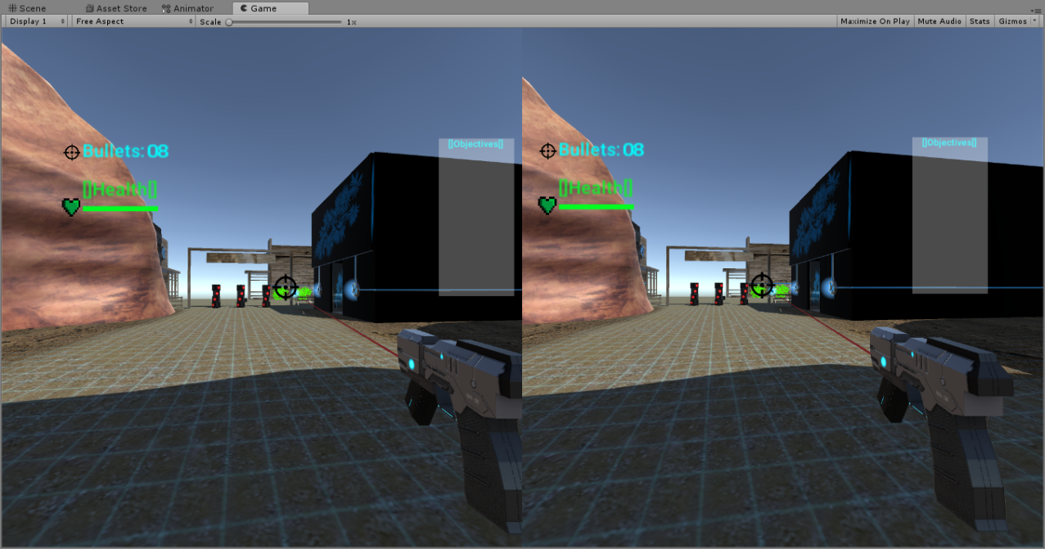

1. **Menu and Screen Descriptions**

*Main Menu: Play opens level one of the game as seen in the image for the Interface Sketch. Quit exits the game.*

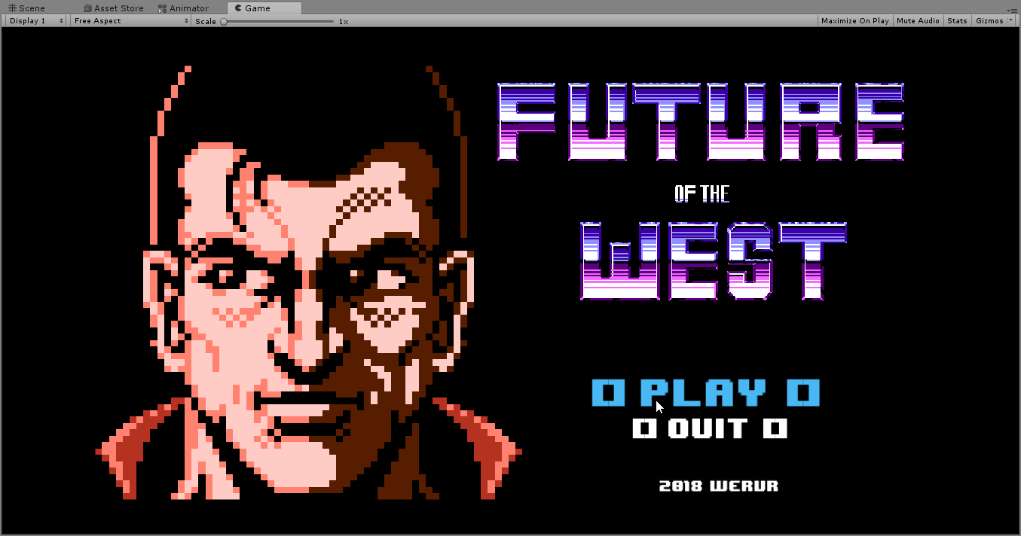

1. **Game World**

*The game takes place in a small desert town much like in a western movie. There are buildings the main one is a Saloon. The inhabitants of the town are robots.*

1. **Levels**

*The first level is in the town and the player must travel through towards the Saloon.*

1. **Game Progression**

*The Player fights their way through the town and must defeat the enemies to survive. The player can only advance to the next level by reaching the exit.*

1. **Characters**

*A gun is visible and is the only part of the player we see.*

1. **Enemies**

*Cowboy bots: robots that stand and shoot at the player once they are within a certain range. Currently only the functionality is present (no mesh).*

1. **Weapons**

*A revolver that fires 10 shots before reloading. A burst shot can be fired doing increased damage but using more bullets.*

1. **Abilities**

*The player can sprint.*

1. **Sound Index**

*Walking sounds, Level one background music, main menu music*

1. **Art / Multimedia Index**

* *Image for title screen*
* *Team logo*
* *Ground and wall textures*

1. **Future Features**
   1. **Game Play Mechanics**

*They can destroy enemy bullets by shooting them in mid air.*

* 1. **Menu and Screen Descriptions**

*The Main menu needs SETTINGS. The pause menu has a CONTINUE button and a RETURN TO MENU button.*

* 1. **Levels**

*The second level is in the saloon which has much closer areas that the player must go through. The third level is in a destroyed version of the town fighting a giant robot.*

* 1. **Enemies**

*Cowboy bots: robots that stand and shoot at the player once they are within a certain range. (model and texture needed).*

*RoboBoss: Massive Robot tank that fires bullets from multiple angles.*

* 1. **Items**

*Ammo packs: Increase ammunition carried by the player.*

*Letters: Pieces of paper that tell the story of the game.*

* 1. **Script**

*The Player must fight his way through the town to defeat the bad guy. He is fighting for revenge of a loved one.*

* 1. **Scoring**

*The player earns points when they hit an enemy and lose points when they are hit or when they miss.*

* 1. **Sound Index**

*Shooting, getting hit, hitting enemies, enemies shooting, the boss sound, background noise.*

* 1. **Story Index**

*The Player has to fight his way through the town to defeat the bad guy. He is fighting for revenge of a loved one*