- Run nslookup to obtain the IP address of a Web server in Asia. What is the IP address of that server?
202.115.47.176
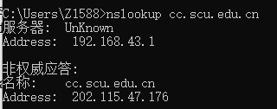
- Run nslookup to determine the authoritative DNS servers for a university in Europe.
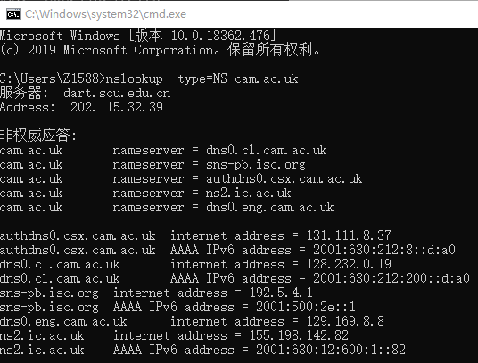
- Run nslookup so that one of the DNS servers obtained in Question 2 is queried for the mail servers for Yahoo! mail. What is its IP address?
IP地址是192.168.1.1和192.168.1.5
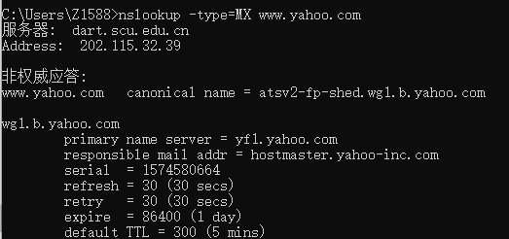
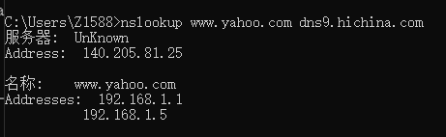
- Locate the DNS query and response messages. Are then sent over UDP or TCP?
udp 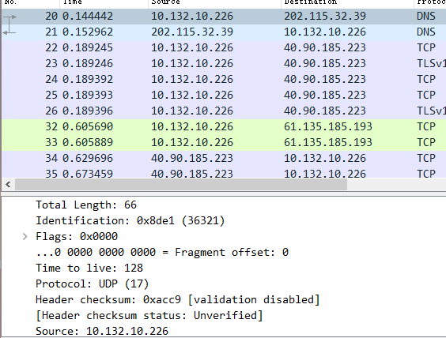

- What is the destination port for the DNS query message? What is the source port of DNS response message?
53；53
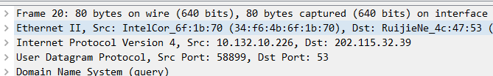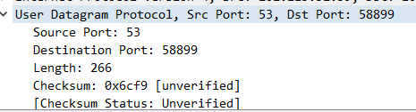
- To what IP address is the DNS query message sent? Use ipconfig to determine the IP address of your local DNS server. Are these two IP addresses the same?
202.115.32.39；一样的
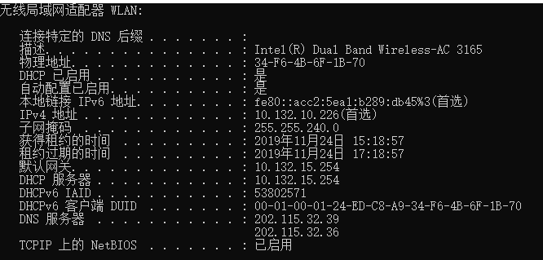
- Examine the DNS query message. What “Type” of DNS query is it? Does the query message contain any “answers”?
类型为A，没有应答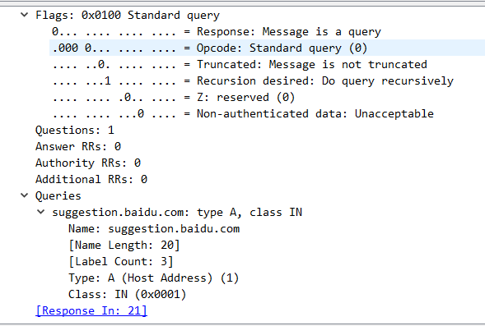
- Examine the DNS response message. How many “answers” are provided? What do each of these answers contain?
2个RRs被提供，每个应答的RRS都包含下面的这些信息，name、type、class、time to live、data length。第一个RR包含CNAME信息，第二个包含Address信息。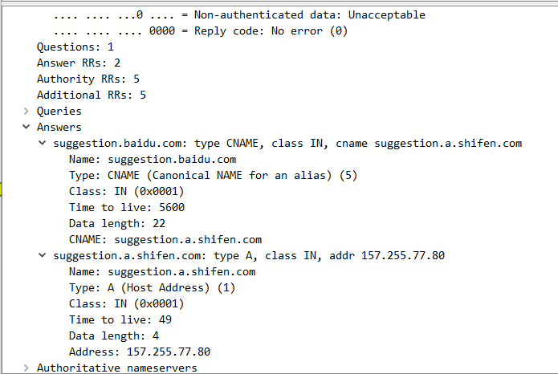
- Consider the subsequent TCP SYN packet sent by your host. Does the destination IP address of the SYN packet correspond to any of the IP addresses provided in the DNS response message?
不一致
- This web page contains images. Before retrieving each image, does your host issue new DNS queries?
没有。
- What is the destination port for the DNS query message? What is the source port of DNS response message?
53；53
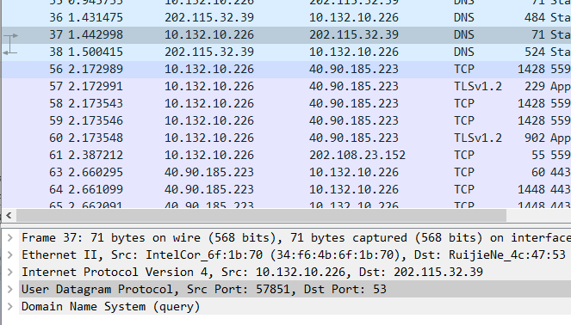
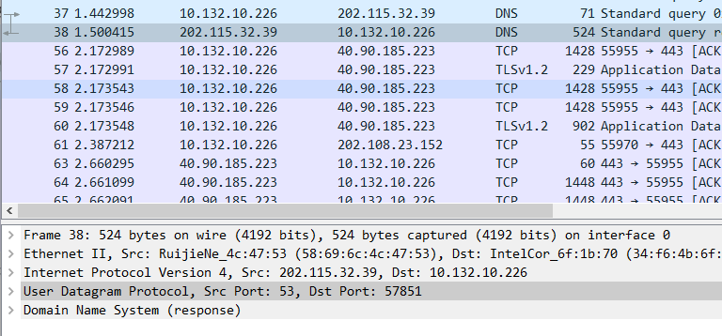
- To what IP address is the DNS query message sent? Is this the IP address of your default local DNS server?
202.115.32,39；一样
- Examine the DNS query message. What “Type” of DNS query is it? Does the query message contain any “answers”?
AAAA；没有应答
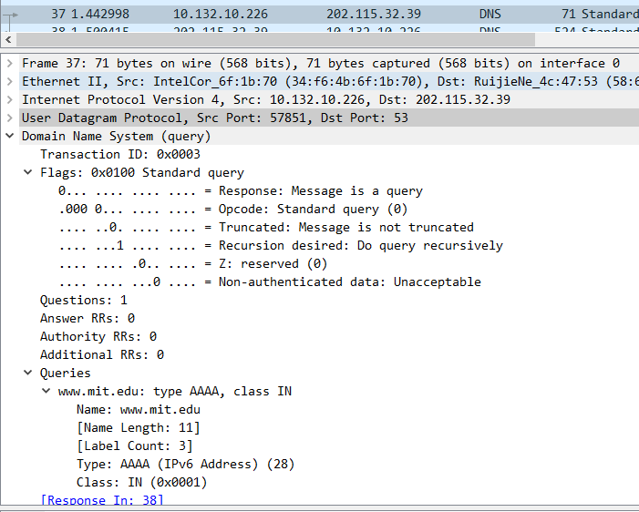
- Examine the DNS response message. How many “answers” are provided? What do each of these answers contain?
四个回答；
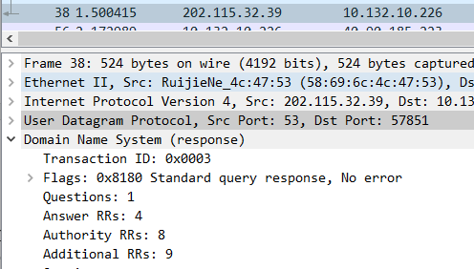
第一个回答包括： name、type、class、time to alive、data length、CNAME
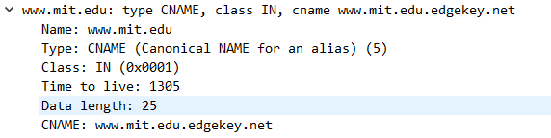
第二个回答包括：name、type、class、time to alive、data length、CNAME
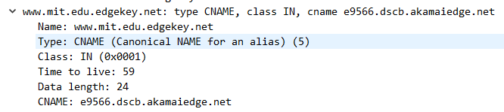
第三个回答包括：name、type、class、time to alive、data length、AAAA address
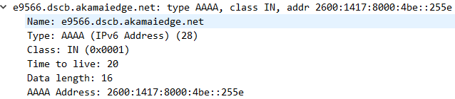
第四个回答包括name、type、class、time to alive、data length、AAAA address
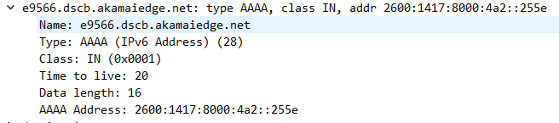
- Provide a screenshot.
实验截图已附在每题的下面
- To what IP address is the DNS query message sent? Is this the IP address of your default local DNS server?
202.115.32.39；一样。
- Examine the DNS query message. What “Type” of DNS query is it? Does the query message contain any “answers”?
NS；没有应答
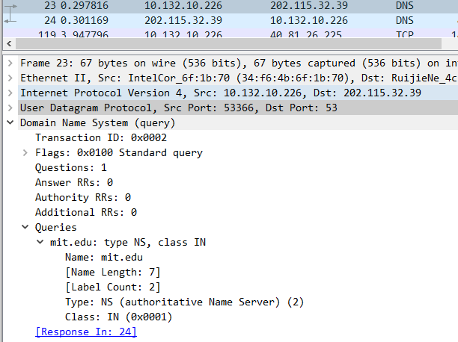
- Examine the DNS response message. What MIT nameservers does the response message provide? Does this response message also provide the IP addresses of the MIT namesers?
提供了8个，并在额外的RRS记录中提供了域名服务器的IP地址。
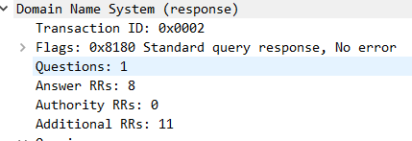
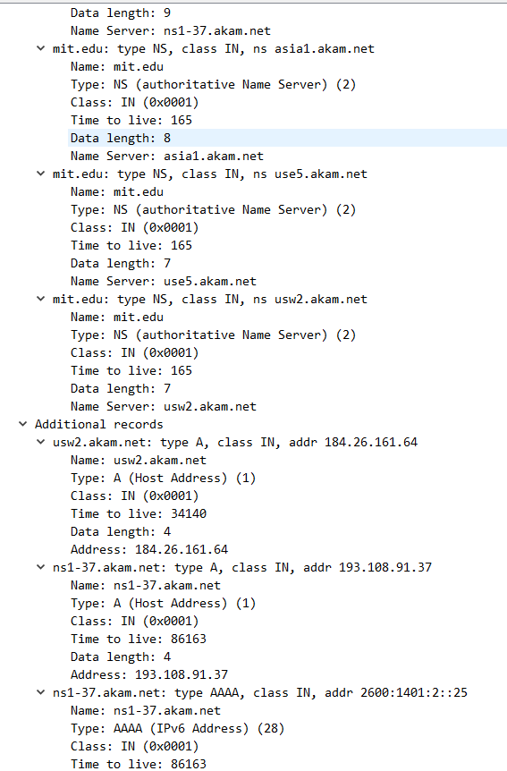
- Provide a screenshot.
截图已附在每个题后面。
- To what IP address is the DNS query message sent? Is this the IP address of your default local DNS server? If not, what does the IP address correspond to?
- Examine the DNS query message. What “Type” of DNS query is it? Does the query message contain any “answers”?
- Examine the DNS response message. How many “answers” are provided? What does each of these answers contain?
- Provide a screenshot.
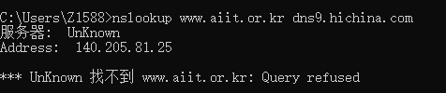
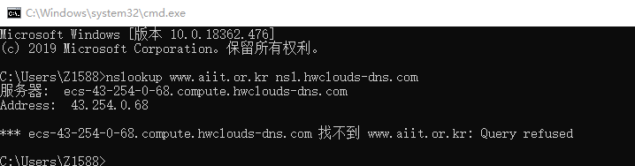
换用国内域名服务器找不到该记录。

