# 计网HTTP抓包实验

1. Is your browser running HTTP version 1.0 or 1.1? What version of HTTP is the server running?

1.1；1.1

1. What languages (if any) does your browser indicate that it can accept to the server?

zh-Hans-CN;zh-Hans

1. What is the IP address of your computer? Of the gaia.cs.umass.edu server?

10.132.1.247;128.119.245.12

1. What is the status code returned from the server to your browser?

200

1. When was the HTML file that you are retrieving last modified at the server?

Wed, 06 Nov 2019 06:59:02 GMT

1. How many bytes of content are being returned to your browser?

128

1. By inspecting the raw data in the packet content window, do you see any headers within the data that are not displayed in the packet-listing window? If so, name one.

HTTP请求报文中还有Host字段、connection字段、Accept字段、User-agent字段、Accept-Encoding字段等

HTTP响应报文还有server、connection、ETag、Date等字段

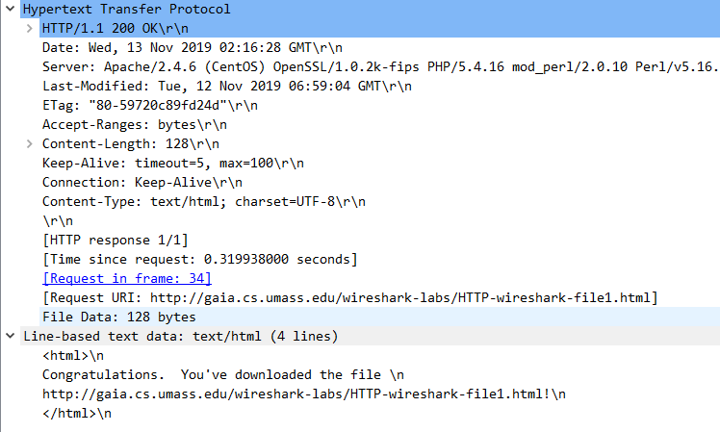

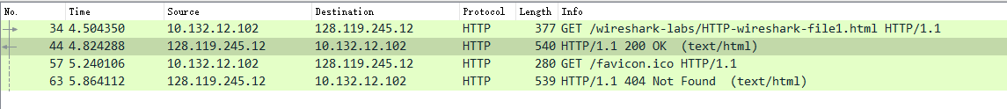

1. Inspect the contents of the first HTTP GET request from your browser to the server. Do you see an “IF-MODIFIED-SINCE” line in the HTTP GET?

没有这个字段，因为浏览器首次获取该页面。

1. Inspect the contents of the server response. Did the server explicitly return the contents of the file? How can you tell?

明确返回了，从Line-based text data可看出

1. Now inspect the contents of the second HTTP GET request from your browser to the server. Do you see an “IF-MODIFIED-SINCE:” line in the HTTP GET? If so, what information follows the “IF-MODIFIED-SINCE:” header?

有那个字段了。信息是：Wed, 06 Nov 2019 06:59:02 GMT，是上次访问网站的最新修改时间。

1. What is the HTTP status code and phrase returned from the server in response to this second HTTP GET? Did the server explicitly return the contents of the file? Explain.

304，表示未修改，没有返回页面的内容，因为没有修改，浏览器已缓存。

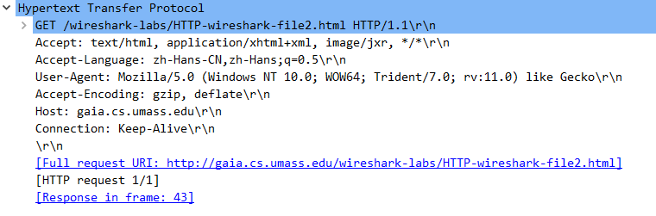

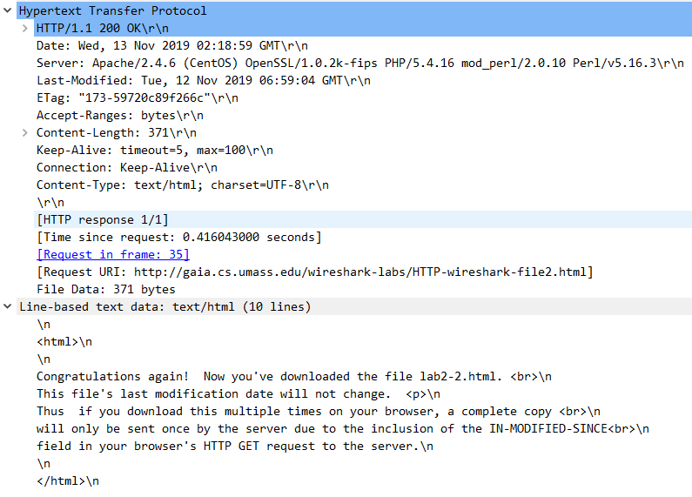

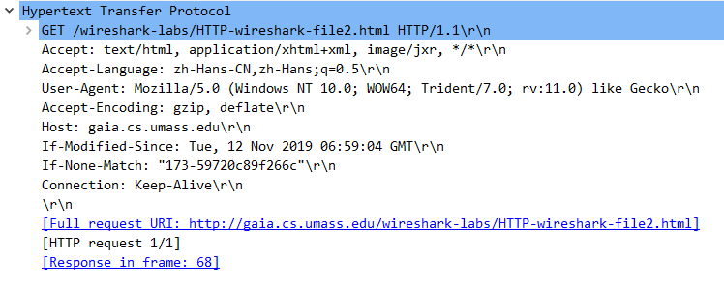

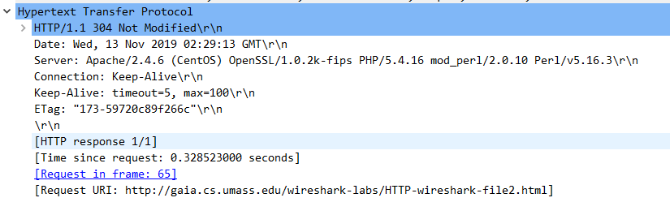

1. How many HTTP GET request messages did your browser send? Which packet number in the trace contains the GET message for the Bill or Rights?

1；#52(1394)

1. Which packet number in the trace contains the status code and phrase associated with the response to the HTTP GET request?

#52(1394)

1. What is the status code and phrase in the response?

200；ok

1. How many data-containing TCP segments were needed to carry the single HTTP response and the text of the Bill of Rights?

4个数据段

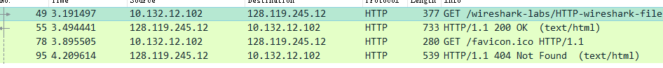

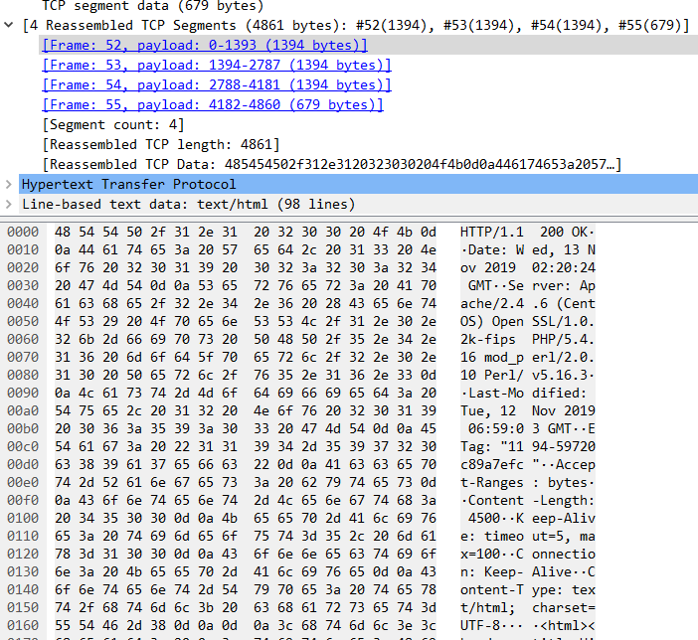

1. How many HTTP GET request messages did your browser send? To which Internet addresses were these GET requests sent?

3(出现4个有一个是获取.ico文件)；128.119.245.12

1. Can you tell whether your browser downloaded the two images serially, or whether they were downloaded from the two web sites in parallel? Explain.

不是并发下载的，因为请求是先后到达的，所获取的对象也是先后到达的

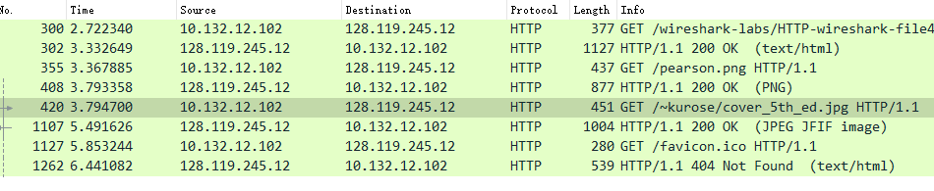

1. What is the server’s response (status code and phrase) in response to the initial HTTP GET message from your browser?

401，未授权，授权访问

1. When your browser’s sends the HTTP GET message for the second time, what new field is included in the HTTP GET message?

新出现了一个字段，Authorization

