1.根据下列工序的逻辑关系绘制出一个双代号网络图并进行节点编号。

|  |  |  |  |  |  |  |  |  |
| --- | --- | --- | --- | --- | --- | --- | --- | --- |
| 工序 | A | B | C | D | E | F | G | H |
| 紧后工序 | B、C | D、E、F | E、F | E | G | H | I、J | J |

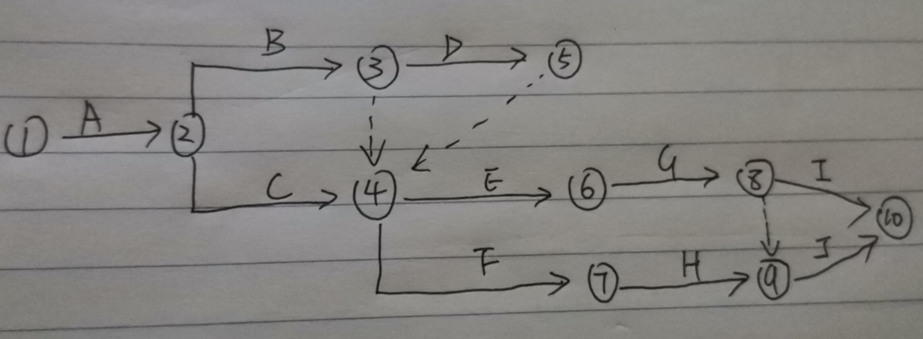

2.计算图示双代号网络图时间参数，并标出关键线路。

