# timestap

1. Using the timestamp program, what is the estimated clock rate of your processor in cycles per second? (2 points)

1556491000Hz

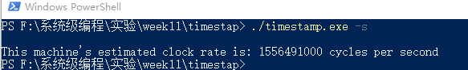

1. What is the approximate timer interval of your operating system? Report your answer in both cycles and in seconds. (14 points)

3,207,428Hz，3207428/1556491000 = 2.06 ms

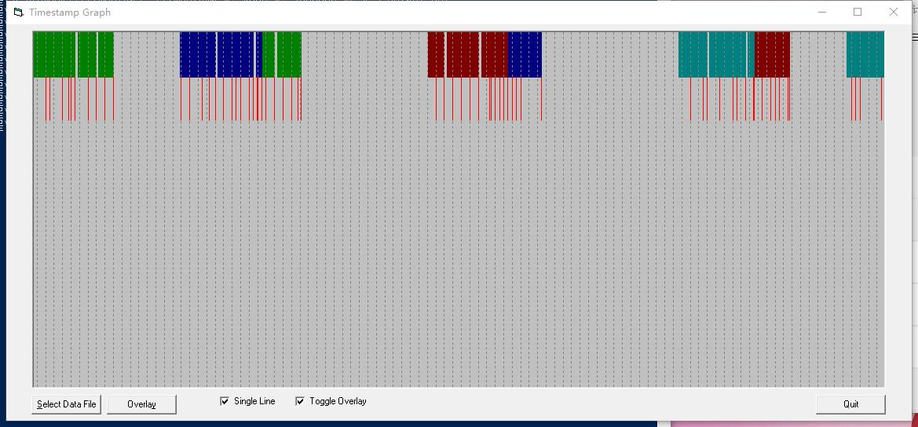

1. What are the minimum and maximum lengths of the timer interrupts that you observed? Do not count timer interrupts that switched to a different thread or different process. (2 points)

最大： 4,811,136

最小：199,658

1. How many total interrupts did you record? (2 points)

65次

1. How many of these were timer interrupts? (2 points)

34次

1. How many timer interrupts resulted in context switches to another thread that belongs to the timestamp program? (3 points)

3次

1. Did a timer interrupt resulted in a context switch to a different process? If so, how many times did this occur, and how many timer intervals did these other processes run? (3 points)

无

1. Did a thread finish executing before the end of a timer interval? If so, how many times did this happen and what did the operating system schedule for the rest of that timer interval? Was it one of the other timestamp threads, or another process? (3 points)

有，调度别的程序

2. How many timer intervals elapse from the time your program started to the time your program ended? (1 point)

100

1. How many of those intervals did your program not run? (1 point)

42

1. Expressed as a hyphen delimited string of the label numbers, what was the execution order of the threads? (For example, from the data in the screen shots above, the execution order was 0-1-2-3-0-1-2-3-0-1-2-3-0-1-3) (2 points)

0-1-0-2-1-3-2-3