四川大学期末考试试题（闭卷）

# （2017~2018 学年第 2 学期） B 卷

课程号： **311143040** 课程名称：系统级编程任课教师：

适用专业年级：软件工程 **2015** 级学号： 姓名：

|  |  |  |  |  |  |  |  |
| --- | --- | --- | --- | --- | --- | --- | --- |
| 考生承诺  我已认真阅读并知晓《四川大学考场规则》和《四川大学本科学生考试违纪作弊处分规定（修订）》，郑重承诺：   1. 已按要求将考试禁止携带的文具用品或与考试有关的物品放置在指定地点； 2. 不带手机进入考场； 3. 考试期间遵守以上两项规定，若有违规行为，同意按照有关条款接受处理。   考生签名： | | | | | | | |
| 题号 | 一**(40%)** | 二**(10%)** | 三**(13%)** | 四**(6%)** | 五**(9%)** | 六**(12%)** | 七**(10%)** |
| 得分 |  |  |  |  |  |  |  |
| 卷面总分 |  | 教师签名 |  | | 阅卷时间 |  | |

注意事项：1. 请务必将本人所在学院、姓名、学号、任课教师姓名等信息准确填写在试题纸和添卷纸上；

1. 请将答案全部填写在本试题纸上；
2. 考试结束，请将试题纸、添卷纸和草稿纸一并交给监考老师。



|  |  |
| --- | --- |
| 评阅教师 | 得分 |
|  |  |

一、单项选择题（本大题共 **20** 小题，每小题 **2** 分，共 **40** 分）

提示：在每小题列出的四个备选项中只有一个是符合题目要求的，请将其代码填写在下表中。错选、多选或未选均无分。

|  |  |  |  |  |  |  |  |  |  |
| --- | --- | --- | --- | --- | --- | --- | --- | --- | --- |
| **1** | **2** | **3** | **4** | **5** | **6** | **7** | **8** | **9** | **10** |
|  |  |  | | |  | | |  | |
| **11** | **12** | **13** | **14** | **15** | **16** | **17** | **18** | **19** | **20** |
|  |  |  |  |  |  |  |  |  |  |

1. Which statement about preprocessor is TRUE?

1. The preprocessor provides the ability for the inclusion of header files, macro definition, conditional compilation.
2. It is invoked by the compiler as the last part of translation.
3. It translates a c source file into an objective file.
4. It translates c source code into assembly code.

答案：A，A选项是预处理的定义。

2. In assembly language, the return value of a function is saved in register ( ).

1. AX
2. BX
3. CX
4. DX

答案：A，汇编中函数返回值放在累加器中传出。

3. Given the following code segments, which statement is NOT correct?

int ary[10] ;

int * pary =ary ;

A. *(ary+3)=10; B. pary[4]=10; C. pary++; D. ary++;

答案：A，没有类型转换，编译会报错。

4. Which tool does not belong to debugging tools of Visual Studio 2017 ?

A. register window B. memory window C. disassembly D. project investigator

答案：D，寄存器、内存、反汇编窗口都是调试时候才能出现的窗口，而D不是。

5. Given the following code segments, which statement is true?

int a[8]={1,2,3,4,5,6,7,8};

int *p = &a[1];

A. p[-1] is equivalent to a[0] B. p[-1] is illegal

C. *(p)-1 is equivalent to a[0] D. *(p)-1 is illegal

答案：AC，可能A更正确，p[-1]便指向了a[0]，而C选项只是减1过后刚好与a[0]值相同。

6. The following definition statement will require the compiler to allocate ( ) bytes on stack in a 32 bits system.

int *p = “world”;

A. 5 B. 6

C.4 D. 9

答案：B，五个字符、六个字节，因为还有一个’\0’

7. Which statement is NOT true ?

1. AH and AL can NOT be used simultaneously in assembly program.
2. AH and AX can NOT be used simultaneously in assembly program.
3. BX and AX can be used simultaneously in assembly program.
4. BH and AL can be used simultaneously in assembly program.

答案：D，AH就是高位AX寄存器，BH就是高位BX（基址）寄存器，AL就是地位的AX寄存器，BL就是低位的BX寄存器，高位、低位需要统一，所以D错误。

8.When executing a function callee(), which of the following are true regarding the value of the frame pointer?

i.it marks the top of the stack frame of the function that invoked callee().

ii.it marks the bottom of the stack frame of callee()

iii.it is the top of the stack.

A.iii only

B.ii only

C.i only

D.i and ii only

答案：D，执行函数时，位于该栈帧的栈底和栈顶。

9.consider the malloc() function. which one of the following sentences is correct?

A.the malloc() returns the amount of memory allocated

B.the malloc() allocates the desired amount of memory on the stack C.the malloc() allocates the desired amount of memory on the heap

D.the allocated memory is only local to the function

答案：C，malloc函数分配成功返回void *，其是在堆上分配空间。

1. the c expression a->b is equivalent to

A.*(a + b)

B.(&a) + b

C.(*a).b

D.(&a).b

答案：C

1. Which of the following addresses is 8-byte aligned?
2. 1110110101110111
3. 1110110101110100
4. 1110110101110000
5. 1110110101110110

答案：C，上述数字全部与8相除，若余数为0或与7做&为0，就是八字节对齐的。

12. Which of the following is an example of external fragmentation?

A. A malloc’ed block need to be padded for alignment purpose.

1. A user writes data to a part of the heap that isn’t the payload of a malloc’ed block.
2. There are many disjoint free blocks in the heap.
3. A user malloc’s some heap space and never frees it.

答案：C，外部碎片就是堆上有很多零散的块，而这些快太小，不足以使用，这就是外部碎片。

13. Which of the following reason(s) explain(s) why an explicit linked list implementation has better performance?

i. Immediate coalescing when freeing a block is significantly faster for an explicit list.

ii.The implicit list has to include every block in the heap, whereas the explicit list could just include the free blocks, making it faster to find a suitable free block.

iii. Inserting a free block into an explicit linked list is significantly faster since the free block can just be inserted at the front of the list, which takes constant time.

1. i and iii only
2. ii only
3. All
4. i and ii only

答案：C，显示链表只含空闲块，而隐式链表含有每个块。

1. which of the following is normal skill of making program run faster

i.reducing procedure calls ii.enhancing parallelism

iii.eliminating unneeded memory references

A.i and ii only

B.iii

C.all

D.ii and iii only

答案：C，全部都是，减少过程调用，提高并发，消除不必要的内存引用。

1. Which of the following is the correct ordering (left to right) of a file’s compilation cycle (a filename with no extension is an executable):
2. foo.c -> foo.o -> foo.s -> foo
3. foo -> foo.s -> foo.o -> foo.c
4. foo.c -> foo.s -> foo -> foo.o
5. foo.c -> foo.s -> foo.o -> foo

答案：D，源文件变为汇编再变为目标文件最后加载入内存运行。

16. Among all replacement policies of dynamic memory management, ( ) favors lower addresses of the heap memory if available and ( ) aims at minimizing fragmentation.

i.Best fit ii.Worst fit iii.First fit iv. Next fit

A. iii and i B. iii and iv

C. ii and i D. ii and iv

答案：A，首次分配每次都从低开始，所以倾向于分配低地址的块，而最适合分配每次找最合适的那一块，这样碎片的程度就会最小，但实现和所耗的时间也最多。

17. what can loader do?

i. translate the c code into machine code

ii.resolution

iii.load or map the executable object file from the disk to memory

A.i and ii only. B.i and iii only. C.i, ii and iii. D.iii only.

答案：D，加载器就是将可执行文件加入进内存。

1. a reentrant function can be entered

A.multiple times but only by one thread at a time

B.concurrently by more than one thread

C.at several points, not only the top

D.only once before variables are reinitialized

答案：B，可重入函数，就是多线程都能访问，互相不影响的函数。

1. what is right about trap?

i. it is a kind of exception

ii.it can be used to implement system call

iii.it can be used to implement hard disk interrupt

A.ii only.

B.i and iii only.

C.i, ii and iii.

D.i and ii only.

答案：D，陷阱是一种异常类型，系统调用时使用。

1. your computer has 32-bit integers and a direct cache containing 128 32-byte cache lines. in the following code fragment, the compiler allocates a at address 0x800000 and b at address 0x801000. before the execution of the code fragment, the arrays a and b have never been used, so they are not in the cache. what is the minimum number of bytes from each of the arrays a and b that could be fetched into the cache from main memory, during the execution of the code?

int b[1024]; int a[1024]; for (i = 0; i < 17; sum += a[i] + b[i], i++);

A.68

B.17

C.96

D.1088

答案：D，每行能放8个整数，能放128行，刚好1024个整数，采用直接映射，所以a[i]和b[i]映射到同一个位置的，所以循环了17次，没有一次命中，而每次循环都要加载16个数，总共加载了16*17=272，每个整数4个字节，总共272*4=1088.

|  |  |
| --- | --- |
| 评阅教师 | 得分 |
|  |  |

二、bit operation（本大题共10 分）。

Now complete the following functions according to the following rules.

Each "Expr" is an expression using ONLY the following:

1. Integer constants 0 through 0xFFFFFFFF inclusive.
2. Function arguments and local variables (no global variables).
3. Some of the problems restrict the set of allowed operators. You are expressly forbidden to:
4. Use any control constructs such as if, do, while, for, switch, etc.
5. Define or use any macros.
6. Define any additional functions in this file.
7. Call any functions.
8. Use any other operations, such as &&, ||, -, ?, or [] :
9. Use any form of casting.

You may assume that your machine:

1. Uses 2s complement, 32-bit representations of integers.
2. Performs right shifts arithmetically.
3. Has unpredictable behavior when shifting an integer by more than the word size.

/* PositiveNum using only ~ and | , ignore 0

* Example: NegativeNum(-5) retrun -5 , NegativeNum(5) retrun -5, Negative(0) can return any value * Legal ops: ~ | * Max ops: 8 */ int PositiveNum (int x)

{

}

/*

ResetByte -Reset byte n from word x to 0x0

* Bytes numbered from 0 (LSB) to 3 (MSB)
* Examples: ResetByte (0x12345678,1) = 0x12340078
* Legal ops: ! ~ & | << >> * Max ops: 6*/

int ResetByte (int x,int n)

{

}

|  |  |
| --- | --- |
| 评阅教师 | 得分 |
|  |  |

* 1. stack discipline（本大题共13 分）。

Consider the following C code and assembly code for a recursive function:

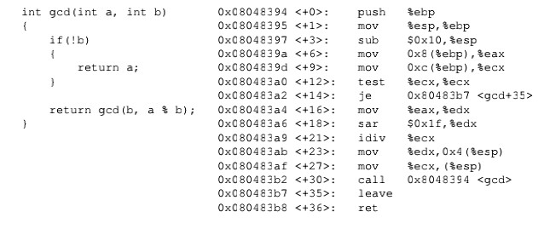

Imagine that a program makes the procedure call

gcd(213,18). Also imagine that prior to the invocation,

the value of ESP is 0

xffff1000

-

that is, 0xffff1000 is

the value of ESP immediately before the execution

of call instruction.

1.

Note that the call gcd(213,18) will result in the

following invocation: gcd(213,18), gcd(18,15),

gcd(15,3), gcd(3,0). Fill in the stack diagram with

the

values that would be present immediately before the

execution of the ret instruction for gcd(3,0).

. What are the values of ESP and EBP

2

immediately before the execution of the ret

instruction for gcd(15,3)?

ESP= _____________________________

EBP=_

_____________________________

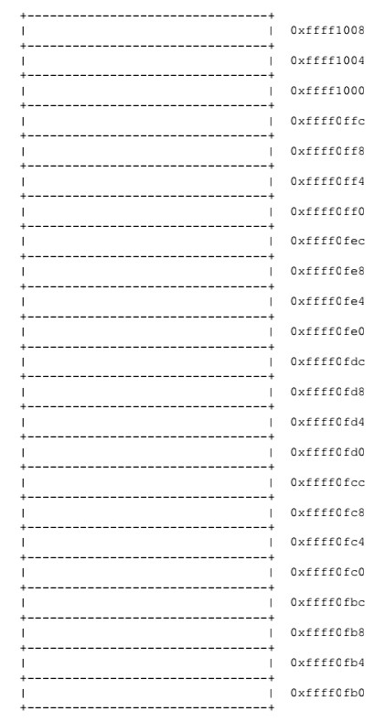

* 1. Performance Measurement（本大题共6 分）。

The marketing department at your company has promised your customers that the next software release will show a 2X performance improvement. You have been assigned the task of delivering on that promise. You have determined that only 80% of the system can be improved. How much (i.e., what value of S) would you need to improve this part to meet the overall performance target? Your answer should include the rule and equation your calculation is based on.

|  |  |
| --- | --- |
| 评阅教师 | 得分 |
|  |  |

* 1. Dynamic Memory Allocation（本大题共9 分）。

We have learned several garbage collection algorithms, including Mark and Sweep, reference counting and copying collection. Please fill in the following form by comparing their advantages and disadvantages.

|  |  |  |  |
| --- | --- | --- | --- |
|  | Can full heap space be used? | Does periodical interruptions occur? | Is it able to solve circular structures? |
| Mark and Sweep |  |  |  |
| Reference counting |  |  |  |
| Copying  collection |  |  |  |

* 1. Cache（本大题共12 分）。

1. Analyse the locality the following code with nested loop. Note：This is th[e pseudo](https://cn.bing.com/dict/search?q=pseudo&FORM=BDVSP6&mkt=zh-cn)[-code.](https://cn.bing.com/dict/search?q=code&FORM=BDVSP6&mkt=zh-cn)

integer data(M, N); （5分 ） for (i = 0; i < M; i=i+1) { for (j = 0 ; j < N; j=j+1) { sum += data( i , j );

}

}

1. You are evaluating a system’s cache performance on a machine with a 1024-byte direct-mapped data cache with 16-byte blocks (B =16). You are given the following definitions: （7分 ） struct position { int x; int y; int z1; int z2;

};

struct position grid[16][16]; int total_x = 0, total_y = 0, total_z = 0; int i, j, k;

You should also assume: (1) sizeof(int) == 4. (2) grid begins at memory address 0. (3)The cache is initially empty. (4)The only memory accesses are to the entries of the array grid. Variables i, j , total_x, total_y and total_z are stored in registers. Determine the cache performance of the following code:

for (i = 0; i < 16; i++){ for (j = 0; j < 16; j++) { total_x += grid[i][j].x; total_y += grid[i][j].y;

total_z += grid[i][j].z1+ grid[i][j].z2; }

}

1. What is the total number of reads? _______.
2. What is the total number of reads that miss in the cache? _______ .
3. What is the miss rate? _______.
4. What would the miss rate be if the cache were twice as big?

And explain every answer briefly.

七、Answering Question（本大题共10 分）。

1. What is the mean of our textbook of CSAPP？Please give your understanding about it, such as what you have learned from this course or this textbook.（5分）

1. What is exception? Please draw a figure to show how the exception is handled in IA32, and in this figure you should show the CPU and memory (such as exception handler, exception handler table,

etc ).（5分）