SMART validation against manual (WGLS) classification
Summary for the team — tier-1 dataset (1,054 variants)
We use the geneticist's manual classification as the reference standard and test two automated approaches against it: (1) OncoKB-only and (2) SMART multi-evidence. The aim is not a perfect benchmark (the manual calls are tumour-type specific while our approaches are tumour-agnostic) but to check whether our automated calls give useful information — especially for genes outside the tumour-specific panel that are never reviewed manually.

1. What we are measuring
The geneticist (WGLS) classified each variant manually — this is the truth we compare against. We then ask how well each of our two approaches reproduces those calls. One important caveat is coverage:
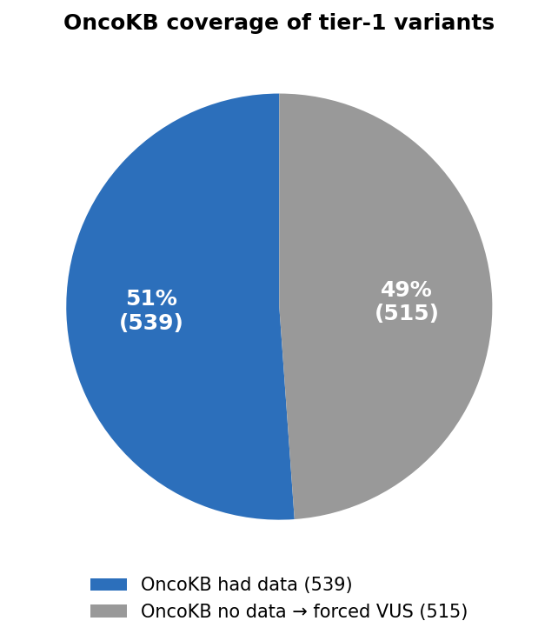
Almost half the variants had no OncoKB record, so they default to VUS. These are abstentions, not genuine 'not oncogenic' calls — counting them as correct negatives would make accuracy look better than it is. We therefore also report a chance-corrected, ordinal measure (weighted kappa).

2. How each approach decides if a mutation is pathogenic
Both approaches end in the same three-way call — Oncogenic, VUS, or Benign — but they reach it very differently. For the 'pathogenic vs not' question, 'pathogenic' means a final call of Oncogenic or Likely Oncogenic; everything else (VUS, Likely Benign, Benign) counts as not pathogenic.
OncoKB-only
The verdict is taken directly from the single OncoKB oncogenicity annotation, with no other evidence used:
- OncoKB = Oncogenic / Likely Oncogenic / Resistance → Pathogenic
- OncoKB = Unknown / Inconclusive → VUS
- OncoKB = Likely Neutral / Neutral → Benign
- No OncoKB record → VUS (this is what happens to ~49% of variants)
SMART multi-evidence (SVIG-UK points)
We follow the SVIG-UK / ACGS 2025 point system: each piece of evidence adds or subtracts points, and the running total decides the tier. This lets us classify variants even when OncoKB is silent. Points used in this v1:
- OncoKB call: Oncogenic +10, Likely Oncogenic / Resistance +6, Likely Neutral −4, Neutral −7
- ClinVar: Pathogenic +5, Likely pathogenic +3, oncogenic flag +4, Benign −5, Likely benign −3
- Loss-of-function (frameshift / stop-gain / splice, HIGH impact): +4
- Mutational hotspot (OncoKB or CancerHotspots): +2
- Population frequency (gnomAD): absent +2, ultra-rare +1, ≥0.1% −4, ≥1% −8
- In-silico predictors: REVEL ≥0.7 or SpliceAI ≥0.2 → +1; clearly benign in-silico → −1
- Gene constraint (LOEUF < 0.6): +1
- Synonymous change: −4
The total score maps to a tier: ≥10 = Oncogenic, 6–9 = Likely Oncogenic, 0–5 = VUS, −1 to −6 = Likely Benign, ≤ −7 = Benign.

3. How well each approach matches the geneticist
Approach (vs geneticist) | Acc | Sens | Spec | PPV | F1 | Weighted κ
OncoKB-only (current verdict) | 0.934 | 0.953 | 0.915 | 0.914 | 0.933 | 0.633
SMART multi-evidence (SVIG-UK v1) | 0.933 | 0.937 | 0.928 | 0.925 | 0.931 | 0.744
Both approaches agree substantially with the geneticist. The multi-evidence approach raises specificity, precision and the ordinal agreement (weighted kappa 0.63 → 0.74, from 'substantial' towards 'strong'), at a small cost in sensitivity.
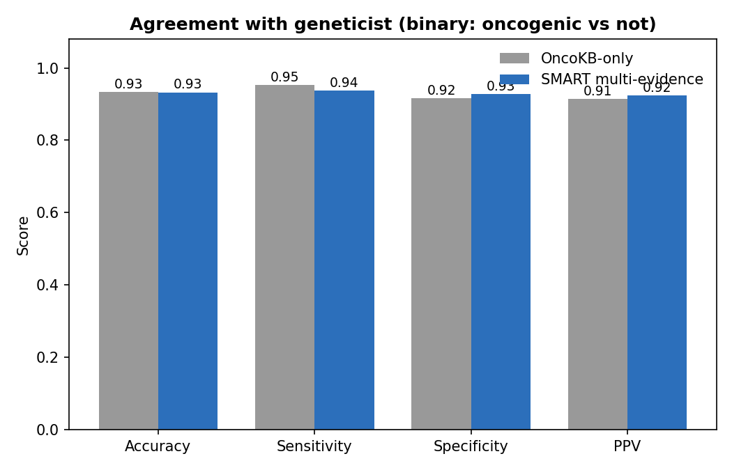
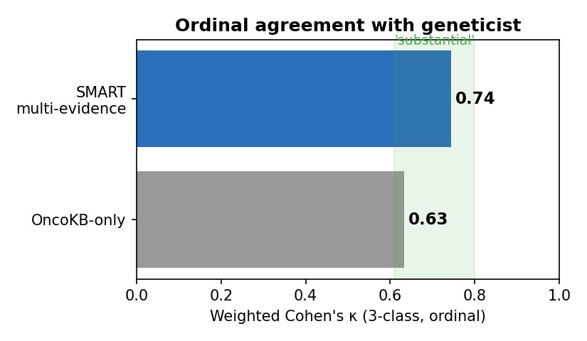

4. Where the added value comes from (and what's missing)
The key test is what multi-evidence does with the 515 variants OncoKB could not judge. The direction is the important part:
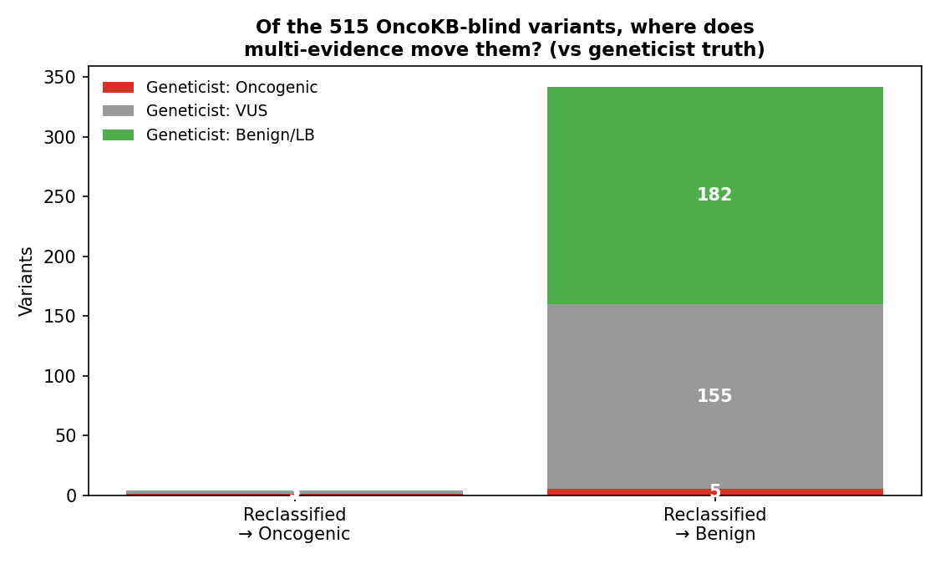
- Benign side (value): multi-evidence correctly de-prioritises ~182 non-actionable variants OncoKB couldn't judge. This is the real gain — less manual review noise.
- Oncogenic side (gap): it recovers almost none of the missed actionable variants. This is faithful to the guidelines — a high REVEL score alone is only weak evidence. The strong discriminator (O4: somatic frequency from GENIE/COSMIC) is not yet in the pipeline.
- Cost to watch: 5 variants the geneticist called oncogenic were moved to benign — these need manual review.

5. Take-home for the team
- SMART agrees substantially with manual classification (weighted kappa 0.63–0.74).
- Its current strength is filtering out non-actionable variants, reducing review burden.
- To recover missed actionable variants, the top priority is adding somatic-frequency data (GENIE/COSMIC, the SVIG-UK 'O4' code).
- All numbers are reproducible and every per-variant call is auditable (scripts + tables in the validation_report folder).
Caveat: manual (WGLS) calls are tumour-type specific while SMART/OncoKB is tumour-agnostic, so some SMART 'over-calls' are defensible. The multi-evidence classifier here is a v1 approximation, not the certified WGLS pipeline.

