**To remove blue underlines right click on bulb and select Ignore prefer_const_constructors for the whole file**

1. Create a new app using this command run in terminal
   1. Flutter create app_name (name should be in lcase)
   2. Install flutter extension
2. To run your app on chrome browser

* Open terminal
* Write flutter channel beta and enter
* Write flutter upgrade
* flutter config –enable-web
* **Make sure to uninstall code runner before**

1. Run in terminal by using command flutter run
2. Go to main.dart class in lib folder
   1. Remove the class code MyApp
   2. Type st press tab and add stateless widget
   3. Rename the class and placeholder widget will show plan black screen
   4. Replace that placeholder widget to MaterialApp widget
   5. Create another widget Scaffold (This contains the whole screen of the page)
   6. Add background color using backgroundcolor property
      1. There are two ways to put color
         1. Color(0xff and then hexacode)
         2. Colors.yellow
   7. Add body widget and take container in it
      1. Container widget just like div in html and it takes width height to make specific space
      2. It uses Color instead of backgroundcolor property
   8. Add another child widget within container widget and add text
      1. To give styling use style and TextStyle
3. To wrap a widget into another widget right click on bulb and click wrap in widget
4. To keep whole thing in center wrap with center widget (it is just like center tag in html)

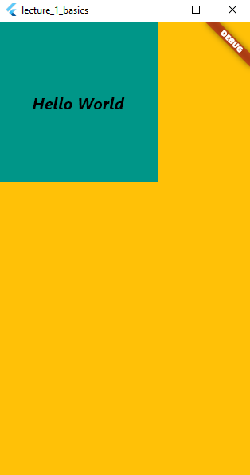

1. Wrap container widget with safearea widget
   1. Safearea widget will give some margin from top on mobile
   2. In container for margin and padding there are some already defined property (but use when not using center tag specially for padding)
      1. Margin: EdgeInsets.all(10) for all sides
      2. margin: EdgeInsets.symmetric(vertical: 10), for vertical
      3. margin: EdgeInsets.fromLTRB(10,22,30,12) for all sides differently
      4. margin: EdgeInsets.only(left: 20 , right : 30) for specific sides differently
      5. padding: EdgeInsets.all (10) for all sides
      6. padding: EdgeInsets.symmetric(vertical : 10) for vertical
      7. padding: EdgeInsets.fromLTRB(10,22,30,12) for all sides differently
      8. padding: EdgeInsets.only(left: 20 , right : 30) for specific sides
2. Wrap container with Column widget. It will automatically make Children tag bcoz column or rows have multiple child.
   1. Copy and paste the whole container with text to make multiple child of column
   2. Column enables property MainAxisAlignment with different values like flex
      1. mainAxisAlignment: MainAxisAlignment.center
      2. mainAxisAlignment: MainAxisAlignment.end
      3. mainAxisAlignment: MainAxisAlignment.start
      4. mainAxisAlignment: MainAxisAlignment.SpaceBetween
      5. mainAxisAlignment: MainAxisAlignment.SpaceAround
      6. mainAxisAlignment: MainAxisAlignment.SpaceEvenly
   3. Add a container widget at last and add width: double.infinity property so that It will keep all extra space in x-axis (width: double infinity is width value )
   4. Row enables property CrossAxisAlignment with different values like flex
      1. crossAxisAlignment: CrossAxisAlignment.start
      2. crossAxisAlignment: CrossAxisAlignment.end
      3. crossAxisAlignment: CrossAxisAlignment.baseline
      4. crossAxisAlignment: CrossAxisAlignment.center
3. SizedBox : a container creates a more decorated box for its child widget to sit in. On the other hand, SizedBox acts like a box widget that has a constant height and width for its child widget.
   1. Create a sizedbox widget between two containers and give it height if the container are in column.
   2. If the containers are in row then give with to sizedbox

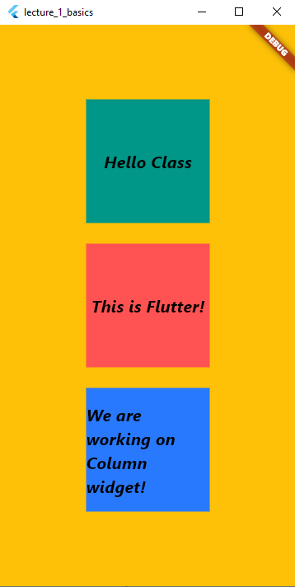output