Lab Journal: 3

Date: 03/03/2024

Department of Software Engineering

Bahria University, Islamabad

Object Oriented Programming Lab (Spring 2024)

Teacher: Engr. M Waleed Khan

Student: Hashir Bin Asad BSE 2B

Enrollment: 01-131232-030

|  |  |  |  |  |  |
| --- | --- | --- | --- | --- | --- |
| **Task No:** | **Task Wise Marks** | | **Documentation Marks** | | **Total Marks**  **(20)** |
| **Assigned** | **Obtained** | **Assigned** | **Obtained** |
| 1 | 3 |  |  |  |  |
| 2 | 3 |  |
| 3 | 3 |  |
| 4 | 3 |  |
| 5 | 3 |  |

**Comments:**

**Signature**

# Lab No: 3- Pointers, File Handling, STL, and Advanced Data Structures in C++

## Introduction:

Use of pointers, understand file handling in C++, delve into the Standard Template Library (STL), and explore advanced data structures such as vectors, maps.

## Tools Used:

VS Code

## Task(s):

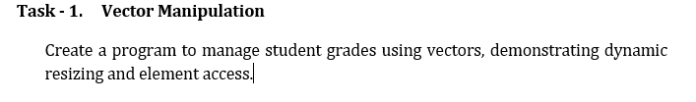

Code:

#include <iostream>

#include <vector>

#include <string>

#include<limits>

using namespace std;

class GradeManager {

private:

    vector<string> gradeList;

public:

    void addGrade(string grade) {

        gradeList.push_back(grade);

    }

    void displayGrades() {

        if (gradeList.empty()) {

            cout << "No grade entered, Please enter a numeric or alphabetical grade!";

        } else {

            cout << "\nGrades: ";

            for (string grade : gradeList) {

                cout << grade << " ";

            }

            cout << endl;

        }

    }

};

int main() {

    GradeManager gradeManager;

    char userChoice;

    string Grade;

    do {

        cout<<endl;

        cout << "1. Add grades (Both numeric and alphabetical accepted)\n";

        cout << "2. Display all grades\n";

        cout << "3. Exit\n";

        cout << "Please enter your choice: ";

        cin >> userChoice;

        cin.ignore(numeric_limits<streamsize>::max(), '\n');

        switch (userChoice) {

            case '1':

                do {

                    cout << "Please enter the grade (or 'x' to stop): ";

                    getline(cin, Grade);

                    if (Grade != "x") {

                        gradeManager.addGrade(Grade);

                    }

                } while (Grade != "x");

                break;

            case '2':

                gradeManager.displayGrades();

                break;

            case '3':

                cout << "Exiting the program...\n";

                break;

            default:

                cout << "Invalid choice! Please try again.\n";

        }

    } while (userChoice != 3);

    return 0;

}

### Screenshot(s):

### 

Code:

#include <iostream>

#include <map>

#include <string>

using namespace std;

class ContactManager {

private:

    map<string, string> contacts;

public:

    void addContact(const string &name, const string &phoneNumber) {

        contacts[name] = phoneNumber;

        cout << "Contact added successfully!\n";

    }

void searchContact(const string &name) {

    if (contacts.count(name) > 0) {

        cout << "\nContact found:\nName: " << name << "\nPhone Number: " << contacts[name] << endl;

    } else {

        cout << "Contact not found!\n";

    }

}

};

int main() {

    ContactManager contactManager;

    char choice;

    do {

        cout << "\n1. Add a contact\n";

        cout << "2. Search for a contact\n";

        cout << "3. Exit\n";

        cout << "Enter your choice: ";

        cin >> choice;

cin.ignore();

        switch (choice) {

            case '1': {

                string name, phoneNumber;

                cout << "Enter name: ";

                getline(cin , name);

                cout << "Enter phone number: ";

                getline (cin, phoneNumber);

                contactManager.addContact(name, phoneNumber);

                break;

            }

            case '2': {

                string name;

                cout << "Enter a contact name to search: ";

                getline (cin, name);

                contactManager.searchContact(name);

                break;

            }

            case '3':

                cout << "Exiting program...\n";

                break;

            default:

                cout << "Invalid choice! Please try again.\n";

        }

    } while (choice != '3');

    return 0;

}

Screenshot(s):

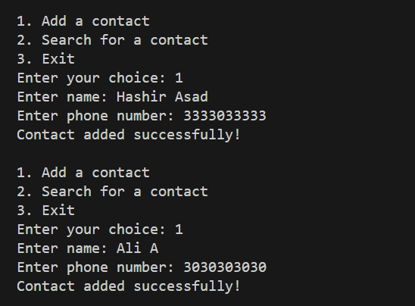

## Extra Tasks:

### Code:

### Screenshot:

## Conclusion: