**Graduation Project Report: Data Analysis on Boston Crime Record**

**1. Introduction**

**1.1 Project Title**

Data Analysis on Boston Crime Record

**1.2 Team Members**

* Mariem Ahmed Elhoseny
* Mariem Hossam Mahmoud
* Omar Mohamed Elemary
* Rokaya Mahmoud Shamal
* Weam Ahmed Abdelmoniem

**1.3 Instructor**

* Abdallah Kamal

**1.4 Course/Track**

* Data Analyst Specialist

**2. Project Overview**

**2.1 Objective**

The objective of this project is to explore, analyze, and visualize crime data from Boston to identify patterns, trends, and correlations that can inform law enforcement decision-making. By leveraging data analytics tools such as Excel, Python, and Tableau, the project aims to develop comprehensive insights that could support effective crime prevention measures, improve community safety, and contribute to efficient resource allocation.

**2.2 Scope of Work**

This project covers the analysis of crime data recorded between 2015 and 2018 in Boston. The scope of the analysis includes:

* Descriptive statistics and trends over time (monthly, yearly).
* Crime rate comparisons across neighborhoods and regions.
* Analysis of the correlation between crime types and geographical locations.
* Evaluating the impact of potential interventions by analyzing historical crime data.

**2.3 Expected Outcomes**

* **Descriptive Insights**: Detailed analysis of crime trends, patterns, and hotspots.
* **Predictive Insights**: Understanding future crime risks based on historical data.
* **Operational Insights**: Actionable recommendations for law enforcement agencies to enhance safety, optimize resource allocation, and improve crime prevention strategies.
* **Visual Outputs**: Clear visualizations of crime data that allow easy interpretation of key findings, aimed at informing both law enforcement and the public.

**3. Problem Statement**

Many communities struggle with the challenge of reducing crime. Police and law enforcement agencies are tasked with understanding complex crime trends and patterns, but often lack the necessary data-driven insights to make effective decisions. The absence of timely, evidence-based decision-making hinders the prevention of criminal activities. Our project aims to address this issue by performing a comprehensive analysis of crime data in Boston, providing valuable insights that can help law enforcement agencies allocate resources more effectively, implement targeted interventions, and promote a safer society.

**4. Methodology**

**4.1 Data Collection**

* **Source**: We obtained the dataset from official Boston government records, which included comprehensive details on crime reports filed between 2015 and 2018.
* **Fields**: The dataset contains fields such as incident number, offense type, date and time, location (latitude and longitude), neighborhood, and police district.
* **Data Preparation**: Initial cleaning and filtering of the data were performed in Python to remove duplicates and irrelevant fields. Missing or incomplete entries were handled with appropriate imputation methods or were excluded when they did not affect the analysis.

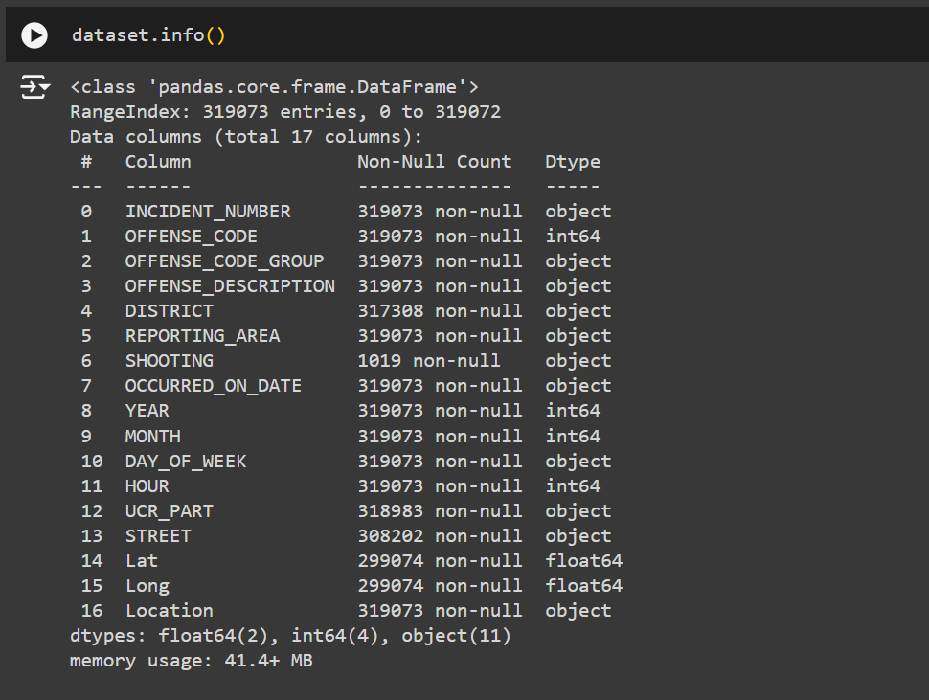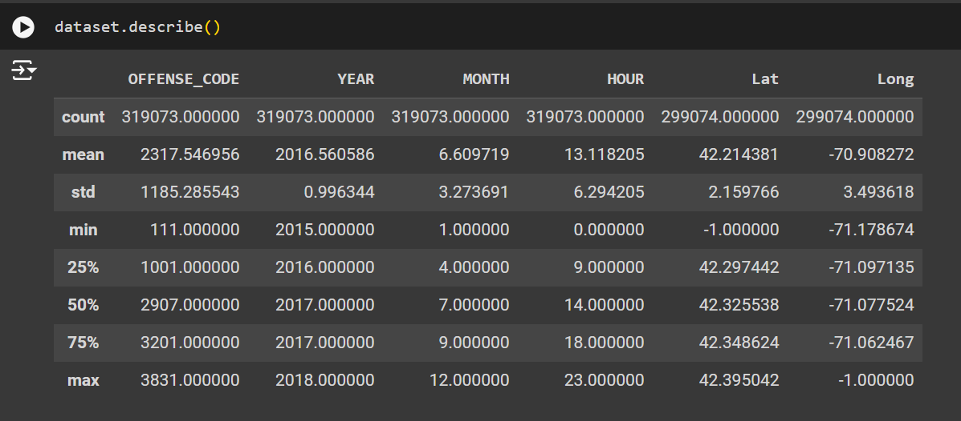

**4.2 Data Exploration**

**4.2.1 Initial Analysis (Exploratory Data Analysis - EDA)**

* **Descriptive Statistics**: We calculated the overall frequency of crimes by year, month, day of the week, and time of day.
* **Crime Categories**: Grouped crimes into categories (e.g., violent crimes, property crimes) to analyze the distribution and frequency of each type.
* **Neighborhood Analysis**: The dataset was segmented by neighborhood to evaluate crime rates per area.
* **Temporal Patterns**: A time series analysis was conducted to identify peaks and troughs in crime occurrences.

**4.2.2 Geographic Analysis**

* **Crime Mapping**: Using latitude and longitude, we created geospatial visualizations to identify crime hotspots.
* **Regional Comparison**: Crime rates were compared across different regions and police districts within Boston.

**4.2.3 Correlation and Causality**

* **Correlation Analysis**: Using Python, we computed correlations between variables such as crime types, locations, and time of day. We explored possible correlations between crime rates and socioeconomic indicators such as neighborhood population density and income levels (if data is available).

**4.3 Data Cleaning**

* **Python (Pandas & NumPy)**: Handled missing values, corrected erroneous entries, and transformed the data into a format suitable for analysis.
* **Outlier Detection**: We employed techniques like the Interquartile Range (IQR) method to detect outliers in crime occurrences and rates.

**4.4 Data Visualization**

We utilized **Tableau** to create interactive dashboards that allow users to explore key findings:

* **Heatmaps**: Display crime intensity across different regions of Boston.
* **Bar Charts**: Visualize the frequency of crime types and the distribution of crimes over time.
* **Time-Series Graphs**: Show changes in crime rates month-by-month and year-by-year.
* **Neighborhood Comparison Dashboards**: Compare crime trends between different neighborhoods.

These visualizations allow both law enforcement and policymakers to clearly understand the trends and geographical distribution of crimes.

**5. Proposed Solution**

**5.1 Technologies Used**

* **Excel**: Utilized for the initial data cleaning, preprocessing, and filtering of irrelevant fields.
* **Python**: Employed for in-depth data cleaning, manipulation, and analysis using libraries like Pandas, NumPy, and Matplotlib.
* **Tableau**: Used for creating interactive dashboards and visualizations to highlight key findings.

**5.2 Data Analysis Process**

**1. Data Preparation (Excel)**

**Objective: Use Excel to perform high-level querying and aggregation of data for further exploration.**

**Steps:**

* **Data Importation:**
  + **Import the raw dataset into Excel from a CSV or Excel file, containing fields such as crime type, location, time, and date.**
* **Pivot Tables:**
  + **Process: Created pivot tables to aggregate and summarize crime data by categories**
  + **Rationale: Pivot tables allow for quick summarization and aggregation, making it easy to see high-level patterns such as which neighborhoods experience the most crime or how crime trends fluctuate year by year.**
* **Queries:**
  + **Process: Used Excel’s Power Query tool to extract specific insights from the dataset by filtering, grouping, and reshaping the data.**
    - **Applied conditional filters (e.g., only showing crimes from certain years or types).**
    - **Merged related datasets (if necessary) to enrich the crime data (e.g., adding demographic information to crime data).**
  + **Rationale: Queries are essential for narrowing down large datasets, making them more manageable for analysis. By filtering unnecessary data, you can focus on specific segments or trends.**
* **Handling Missing Data:**
  + **In the case of missing data, Excel was used to identify these issues, but further cleaning would occur in the next step (Python).**

**2. Data Cleaning & Exploration (Python)**

**Objective: Perform more in-depth data cleaning and exploratory analysis using Python libraries.**

**Steps:**

* **Data Cleaning:**
  + **Process: After preparing the dataset with pivot tables and queries, it was imported into Python for advanced cleaning:**
    - **Used Pandas to handle any remaining missing values (e.g., imputing or removing records).**
    - **Converted date columns to proper datetime format for easier time-based analysis.**
    - **Addressed inconsistencies in categories (e.g., ensuring uniform naming conventions for crime types).**

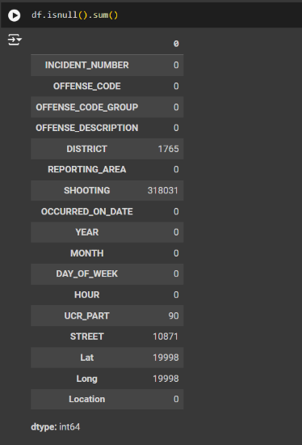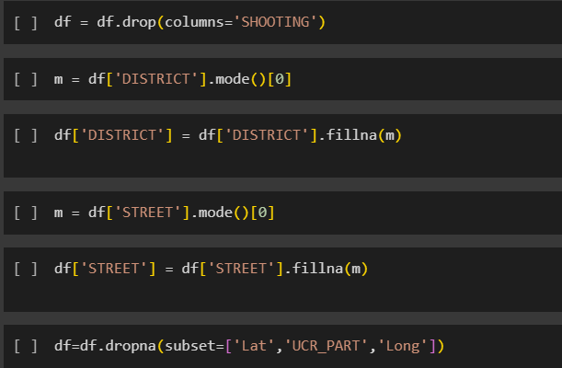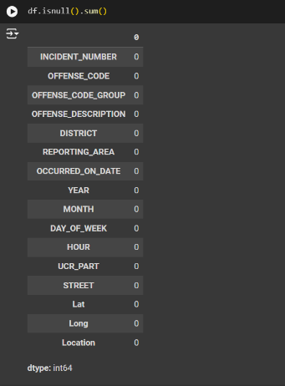

* **Exploratory Data Analysis (EDA):**
  + **Descriptive Statistics:**
    - **Generated summary statistics on the data to understand the distribution and central tendencies of crime occurrences across different categories.**
  + **Temporal Trend Analysis:**
    - **Analyzed crime rates over time (e.g., year-by-year, month-by-month) by extracting key time-based information from the dataset.**
  + **Neighborhood Comparison:**
    - **Used groupby functions to compare crime rates across different neighborhoods or districts, allowing a better understanding of geographic crime distribution.**

**3. Data Visualization (Tableau)**

**Objective: Visualize the data for better interpretation and communication of findings.**

**Steps:**

* **Dashboard Development:**
  + **Created interactive dashboards using Tableau that display:**
    - **Crime trends by year.**
    - **Crime hotspots through geographic visualizations (heatmaps).**
    - **Distribution of different crime types across neighborhoods.**
  + **Filtering: Built interactive filters for stakeholders to explore specific areas, crime types, or time periods.**
* **Visualization Types:**
  + **Heatmaps for geographical representation of crime densities.**
  + **Bar Charts and Time-Series Graphs for comparing crime rates across time and neighborhoods.**
  + **Pie Charts for visualizing proportions of crime categories (violent vs. property).**

**6. Results & Findings**

**6.1 Descriptive Analysis**

* **Yearly Trends**: The number of reported crimes declined slightly from 2015 to 2018, with a notable drop in violent crimes.
* **Crime Type Distribution**: Property crimes, such as theft and burglary, were the most frequent, followed by violent crimes, including assault and robbery.
* **Crime by Time**: Crime occurrences were higher during the summer months (June-August), particularly in public spaces, and peaked between 7 PM and 12 AM.

**6.2 Geospatial Findings**

* **Hotspots**: Downtown Boston, Roxbury, and Dorchester exhibited the highest concentration of crimes. Downtown experienced a higher incidence of property crimes, while Roxbury and Dorchester had elevated violent crime rates.
* **Neighborhood Comparison**: Some residential areas had notably lower crime rates, while commercial districts were more prone to theft and vandalism.

**6.3 Correlation Analysis**

* **Socioeconomic Factors**: Crime rates were higher in areas with lower median income and higher population density.
* **Seasonal Trends**: There was a clear seasonal pattern, with a peak in crimes during warmer months, correlating with higher foot traffic and outdoor activities.

**6.4 Impact of Interventions**

* After introducing additional patrols in high-crime areas in 2017, violent crimes decreased by approximately 15%, indicating the effectiveness of increased police presence.

**7. Expected Outcomes**

The expected outcomes of this project include:

* **Insight into Crime Trends**: Clear understanding of crime trends by type, time, and location, aiding in proactive policing strategies.
* **Improved Resource Allocation**: Law enforcement agencies can focus resources on high-risk areas and times to prevent crime more effectively.
* **Targeted Crime Prevention**: The identification of crime hotspots can lead to the implementation of focused crime prevention programs, such as surveillance or community watch initiatives.
* **Predictive Modeling**: Based on the historical data and trends, predictive models can be developed to forecast future crime occurrences, assisting in proactive intervention planning.

**8. Resources Required**

**8.1 Hardware/Software**

* **Excel (Microsoft 365 Version)**: For initial data preprocessing.
* **Python (Version 3)**: For data cleaning, analysis, and manipulation using relevant libraries.
* **Tableau (Version 2024.2)**: For creating dashboards and interactive visualizations.

**8.2 Team Requirements**

* Regular collaboration between team members to share progress and review data.
* Continuous support from the instructor for technical guidance and feedback.

**9. Conclusion**

This project showcases the importance of data-driven approaches in addressing the challenges of crime prevention and community safety. By analyzing Boston's crime data, we have identified crucial patterns and trends that can inform police strategies, optimize resource deployment, and improve public safety outcomes. The insights generated through this project are valuable for both law enforcement agencies and policymakers in Boston, as they provide evidence-based recommendations for reducing crime rates and enhancing the quality of life for residents.