Big Data Use Case Domains for Telecom Operators

Rabiul Islam Jony1, Ahsan Habib1, Nabeel Mohammed1, Rakibul Islam Rony2

1. University of Liberal Arts Bangladesh

{rabiul.islam, nabeel.mohammed, ahsan.habib}@ulab.edu.bd

1. Primeasia University iut.rony@gmail.com

***Abstract*—Telecommunications, Telco in short, companies have a unique advantage compared to other industries is that they control the communication infrastructure which is used frequently by their customers to avail different kind of services. This way they have more data than other industry which enables them to track where their customers are, how they interact, and how they transact business. But leveraging that customer information requires Telco to transform a 19th century business model into one that meets today's demand for real-time business and consumer insight. Telcos have been moving multiple terabytes of data around their networks for years. However, data with properties - volume, variety, and velocity which is collectively termed as Big Data, exposes new opportunities in different ways to get insight from that and at the same time posses challenges to be capable of handling and analyzing this data. This work focuses on finding possible use cases, according to the comments of Telco industry and academic experts, how this multi properties data, Big Data, is currently being utilized and also, could be utilized on Telco industries. Twelve Big Data use case domains for Telco operators including examples, typical required data types and challenges for each such domain are presented.**

***Key words*— Big Data, Big Data use cases, Big Data in telecom**

# INTRODUCTION

The telecommunications industry constantly transfers petabytes of data across their networks. Due to next generation mobile network rollouts, such as LTE (Long-term evolution), IoT (internet of things) and M2M (Machine-to-Machine communications) along with increased use of smart phones and rise of social media, mobile operators are experiencing a rise in volume, variety and velocity in the data they collect. According to [1], 54 percent of telecom operators claimed, that big data is a current strategic priority in their organization. According to ITU, 2013 will be the year, when the majority of Mobile operators will start treating big data as strategic priority for both internal and external use [2].



2015

IEEE International Conference on Smart City/SocialCom/SustainCom together with DataCom 2015 and SC

2 2015

Big data can be defined as large volume, high velocity and verities of data, which is complex to process with traditional applications, but able to bring new business opportunities to the industries by enhanced insight generation. Big data technology provides companies, such as telecom operators with an ideal platform for centralizing and storing and analyzing their structured, unstructured and semi-structured data. These yield major advantages in data analysis, knowledge discovery and new business opportunity identification.

This paper focuses on potentiality of Big data in different industries, specially telecom operators and tries to identify potential Big Data use cases such as reduce churn, increase Average Revenue Per User (ARPU) and geo marketing for telecom operator companies. As a part of this research, 20 experts form Aalto University, vendors and operators of Finland were interviewed to shed understanding on big data and its use cases in telecom industry.

The rest of the paper is structured as follow: in section II we present Big Data business potentiality in different industries. Big data in telecom industries is discussed in section III. In section IV telecom operators’ potential big data use case domains are discussed. Finally, section V concludes the paper discussing assessment of this paper and future scopes.

# BIG DATA BUSINESS POTENTIALITY IN DIFFERENT INDUSTRIES

According to McKinsey Global Institute (MGI) research, big data is becoming the key basis of competition, underpinning new waves of productivity growth, innovation and customer surplus of the future market [3].

The cloud architecture, open source software and commodity hardware of recent market made the big data processing available to the companies which are not even highly resourced. Researchers argued that big data is not just a property of big web companies like Google or Facebook, organizations of different sizes and industry groups are now leveraging it in many ways [4].

Figure 1 below shows the potentiality of big data as a new business asset in different industries [5]. It shows that the top

|  |
| --- |
| Figure 1: Big data potentiality in different industries (data taken from [5]) |

industries or domains are customer relation management and healthcare, followed by retail, banking, education, advertising, fraud detection and so on. Telecom industry is in the latter half in the ranking.

Telecom industry, in practice includes other domains, such as customer relationship management, fraud detection and social media. This fact reflects the potentiality of big data in telecom industry as well.

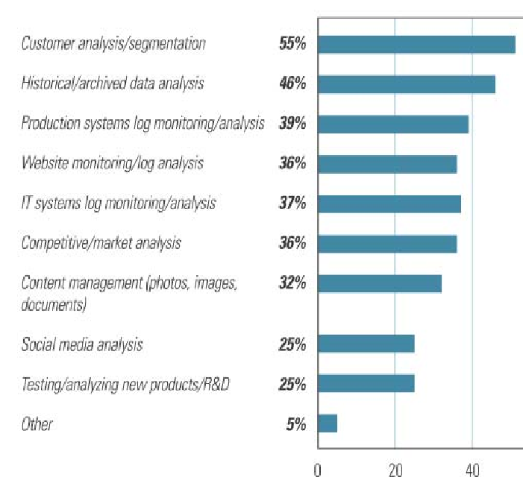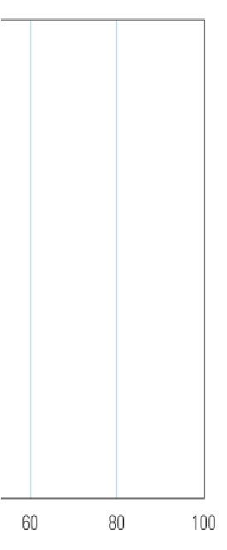

Figure 2: Types of big data initiatives within an organization

[4]

Figure 2 lists big data initiatives emerged from the survey explained in [4]. According to the survey, the two top most initiatives are customer analysis or segmentation and historical data analysis. Other initiatives includes production system log monitoring, IT system log monitoring, market analysis and so on.

Big data can bring business benefits to the organizations in several ways; few applicable possibilities are discussed below.

* **Create transparency**: Organizations can make their big data accessible for their stakeholders in a timely way and make their business progress and strategy transparent.
* **Supply chain management**: Big data analytics can improve organizations’ supply chain management by ensuring real-time delivery management, better vendor management, automated product sourcing and segmented supply chain.
* **Allow experimentation to discover needs**: Big data analytics will allow the organizations to do more experiments on their business strategy and products to find out new requirements.
* **Dynamic pricing**: Big data analytics allow the organizations to optimize their product pricing according to the customer needs, market research and business target.
* **Targeted marketing**: Big data can provide the organizations with information about customers’ needs and interests, which will allow them to do targeted marketing.
* **Innovate new business models, services and products**: Proper data analysis can provide the organizations with insights about the market, e.g. which types of products are being appreciated or neglected by the customers. New business models, new services or products can be invented by analyzing these types of data.
* **Predictive analysis**: Predictive analysis can identify events before occurring and predict the outcome before implementation.
* **Better understand the customers**: Organizations can utilize their customer data to understand their customers more efficiently and know how, when, and what they want.
* **Lessen Business OPEX and CAPEX**: Big data analytics will allow the organizations to lessen their operational cost and capital cost in different ways, e.g. by optimizing business strategy.
* **Improve performance**: Big data analysis can also offer improved performance by improving decision making accuracy and saving time.
* **Compete more effectively**: Big data analysis will allow the organizations to know about themselves and the rivals in the market. Proper Big data analysis will allow the companies to compete more effectively and survive in the market.
* **Data-Driven Decision-Making (DDDM)**: DDDM is the technology to use data analytics as insights for decision making. Survey on 179 large publicly traded firms showed, the firms that adopt DDDM had output and productivity as high as 6% than the others who did not [6]. More data analysis will offer more effective and accurate decision making.
* **Insight generation**: Analyzing big data will allow the organizations to generate more insights, which were not possible with small datasets.

Big data also has some limitations. Sometimes it can produce few patterns which are entirely caused by chance, not replicable or having no predictive power. It might also provide weaker patterns, where strong patterns get ignored.

# BIG DATA IN TELECOM INDUSTRY

Currently there are little more than 6.2 billion mobile subscriptions worldwide, and this number is predicted to reach 9 billion by 2017 [7]. With large subscriber base, telecom operators typically need to handle big amount of subscriber data. In addition, every call, internet connection and sending of SMS generates network data for operators. According to Gartner, 1.8 billion mobile phones were sold and among those 31 percent were smartphones in 2011 [8]. After introduction of smart phones, YouTube, Facebook and possibility of watching TV from the internet, data traffic in operators’ network has increases heavily. According to [9], monthly global mobile data traffic will surpass 10 exabytes in 2017.

In 2011, global mobile data traffic was eight times greater than the total global internet traffic in 2000. According to the Cisco VNI Mobile Traffic Forecast, the typical smartphone generated 35 times mobile data traffic which is around 150MB per month than the typical basic feature cell phone in 2011 [9]. In 2012, Global mobile data traffic grew 70 percent in 2012 reaching 885 petabytes per month at the end of 2012. Mobile video traffic has exceeded 50 percent for the first time in 2012 and the mobile network connection speeds also been doubled in 2012. Though smartphones were only 18 percent of total global handsets, still 92 percent of total global handset traffic was represented by smartphones [9]. Increasing number of smartphones is going to affect the global network traffic vastly. In [9], a forecast of mobile data traffic growth by the year 2017 has been presented and it is as big as 11.2 exabytes per month.

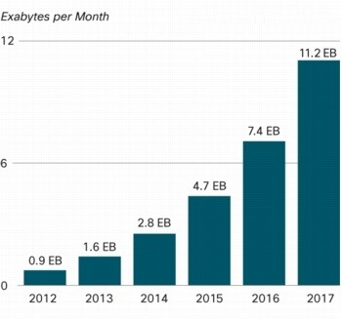

Figure 3: Cisco forecast on mobile data traffic growth by 2017

[9]

# BIG DATA USE CASE DOMAINS FOR TELECOM OPERATORS

This research covers two types of use cases for operators in different domains, namely, external use cases and internal use cases. Internal use cases e.g. increase ARPU, reduce churn and network improvement represent the use cases which typically require internal data. On the other hand, external use cases represent the use case which typically requires data from external sources along with internal data. The key big data use case domains for telecom operators are described below. These use case domains were identified through interviews and online research conducted by the author.

*A. Improvement of different characteristics of the Network*

Operators have always been concerned about network performance improvement. Now with big data analytics operators can identify problems, perform real-time troubleshooting and fix network performance issues. It might also offer use cases such as improved network quality, less power consumption, efficient resource management.

For example, Turkcell (leading mobile phone operators of Turkey) has rolled out a big data application, to help it recover from network failures by correlating data from different sources in real time to identify the root cause of failure [10].

All SON (Self-organizing network) automation such as provisioning, configuring and commissioning can be adapted to changes in the environment and traffic demand based on the insights gained from big data analytics [11]. It can also let the operators to prioritize the alarms, which would be very useful to save time and service failure [12].

The typical data types required are network element data, CDRs, location data, XDRs, traffic data and network events data.

Typical challenges to meet these use cases are needed for e.g. real-time network optimization and real-time network monitoring. It also includes high-velocity streams of CDRs to detect critical network events as they happen.

*B. Marketing and Sales*

Marketing and sales can be considered as the largest domain of big data usage in telecom industry. Proper big data analytics allow the operators to create more intelligent marketing campaigns, and to do sales analytics to increase the sales. It can also be utilized to improve the results of marketing promotions, increase revenue and implement geo marketing and real-time marketing.

For example, Globe Telecom (Telecommunications Company in the Philippines) uses big data analytics to improve effectiveness of promotions by 600% [13]. The typical required data for these use cases are subscriber location data, subscriber data, social media data and previous campaigns data.

Delivering these types of intelligent marketing campaigns requires rapidly processing of high volumes of location data, automatically combining it with other data, and making it deliverable in real time.

One big challenge to meet these use cases is unstructured data (e.g. text, images, and videos) analysis, which requires advanced tools and skilled personnel.

*C. Security*

Big data analytic allows telecommunication companies to detect and analyze high-velocity fraud activities in real time and take actions immediately. It can also be utilized for e.g. real time cyber security monitoring, information security management and preventing unauthorized physical or virtual access.

For example, Elisa Oyj (Finnish Telecommunications Company) offering service called Elisa Vahti, which provides real-time security monitoring of subscribers’ home/cottage/office [14].

By comparing subscribers’ current calling behavior with a profile of his past usage, and using deviation detection and anomaly detection techniques, operators can identify super imposition frauds [15]. Operators can also provide security services to other organizations utilizing their big data analytics capabilities.

These types of use cases typically require e.g. location data, XDRs and subscriber data.

*D. Improving customer care services*

Operators can use big data analytics to enhance the customer care services. Operators can get a good understanding on why the subscribers call, and then impose an automated procedure to resolve their calls faster [16]. Delivering a higher level of customer care can be a key strategy in differentiating an operator’s brand form its competitors. Big data analytics can allow the operators to reduce the numbers of customer care calls and earn customer satisfaction by solving the subscriber problem in real-time.

For example, one Tier 1 mobile service provider in United States transforms call centers with real-time access to customer and product data [17].

Improving the customer care service typically requires subscriber data, network performance data, network events data, customer care agents’ data and historical data.

These use cases require large volumes of data aggregation in real-time and the velocity of the data is also high, which make it challenging.

1. *Business development and innovating new business models*

Big data analytics can improve operators’ current business by suggesting optimization in the business strategy, such as setting new business targets, and new business models. This domain includes both external internal use cases. External use cases involve use cases, such as deliver remote cloud services to other companies and creation of profitable new business partnerships with other companies. There are more Big data use cases in the business domain for telecom operators, which can improve operators’ business e.g. generate own application services, reduce churn, increase ARPU, reduce CAPEX and OPEX.

Use cases in this domain require both internal and external data. Location data, subscriber sentiment data from social media, and external data from the other partner companies such as content providers are the typical required data types.

Typical challenges to meet the use cases of this domain are that, they involve accessing diverse data sources and correlating them in real-time.

1. *Products and Services development*

Operators can utilize big data analytics for their products and service development. They can monitor the performance analysis, margin analysis, pricing impact and stimulation, and impact of supply chain utilizing it. Historical sales data analysis of previous products and services can allow the operators to predict the possible outcome or revenue possibility of the new product or service. It also allows the operators to find out the next best product or services i.e. personalized services, according to the subscribers’ usage behavior, interest and sentiment. Operators can also predict and analyze the pricing impact of any specific service or product and stimulate it if required. It can also help the operators to improve supply chain management by e.g. monitoring the performance of each partner in the supply chain, and do what-if analysis for a new product launch.

These types of use cases typically require data from the product and service data bases, billing data and pricing data etc.

1. *Billing*

With proper big data analysis, operators can ensure accurate billing for the subscribers’ usage. Accurate billing assurance, bill shock prevention, billing information provisioning in real-time, are the typical use cases in this domain.

These use cases typically require billing data, subscriber profile data, XDRs, and CDRs.

1. *Intelligent**Transportation Service (ITS)*

Operators with their big data analytics can help the government or individual subscriber to improve their transportation service. Operators can visualize the traffic situation in a specific area and let the subscribers know about it, when they require. They can also provide some pop-up services which will send the subscribers traffic information e.g. if there is road blocking on their way. Operators can also offer services such as vehicle tracking with GPS services for security purposes, route mapping, suggesting the nearest gas station when gas is running low and tracking of driven kilometers for taxation purposes.

These types of use cases will typically require data types, such as location data from the handset, and mapping data from the data bases.

1. *Public sector*

Operators can utilize their big data analytics in different public sector use cases. These can also be categorized as external use cases. Operators can offer services, such as locating tracking for elderly people or a device, and cars. They can also offer services like power grid information, such as information about load shedding, or information about some individual’s connection bills. One important use cases would be the response to the calamities.

Typically they require location data, weather data, and required information from other sources, such as power grid.

1. *Healthcare*

Operators can utilize their big data analytics capability to improve the healthcare services. Operators with collaboration with healthcare centers can offer services such as remote healthcare monitoring, connected hospitals, case conferencing, chronic disease management, online medical library to the subscribers. Operators can also offer services like drug authentication to the subscribers and emergency alerting and monitor to the healthcare providers. One telecom operator from France, Orange S.A. along with some health care centers are already offering healthcare services such as connected hospitals, case conferencing, shared medical imaging, drug authentication [18].

These types of services can also gain customer satisfaction and grow number of customers, which can grow operators’ businesses.

1. *Media and Entertainment*

Telecom operators with their big data analytics capability can learn subscribers’ interest and sentiment about media and entertainment. Operators can utilize those learning to suggest programs and news to the subscribers accordingly. This might help the operator earning customer satisfaction and also invent some new business models, such as collaboration with media companies.

For example, TeliaSonera (mobile network operator) offers its phone and internet subscribers subsidized access to the popular music service Spotify [19].

Sentiment data from social media, usage data from devices, location data and external data from the media and entertainment organizations are the typical data types required for these use cases.

1. *Others*

There are some other big data use cases for telecom operators, such as quality control, partner analysis, and cost and contribution analysis. Others use cases might also include e.g. improving banking and insurance sectors, or providing the subscribers with services like mobile banking, mobile insurance, mobile retail shopping and mobile pricing analysis of products.

For example, Elisa Oyj (Finnish Telecommunications Company) launched an E-Wallet that supports virtual credit cards and master card pay passes [20].

Telecom operators can unearth several potential use cases by effectively monetizing the increased volume, variety, and velocity of network, subscriber, and other business data. Proper data preprocessing and analysis capabilities are required for it.

# CONCLUSION

This paper identifies potential Big data use case domains for telecom operators. It also presents the corresponding examples, required data types and typical challenges to implement the use cases. However, newer use cases are emerging as operators are more focusing on their big data strategy. For example, potential use cases based on location data are emerging currently. As a result, location based services can be introduced as a separate use case domain. As the field of big data is still in a great state of change and development, the possibilities for research in this area are extensive and the interest on the findings will certainly rise if the adoption of big data rises as expected.

VI. BIBLIOGRAPHY

1. CITO Research, "Big Data Insights in a Rush," Research Paper 2012.
2. International Telecommunication Union. (2013, May) Telco Big Data: 2013 will be a strategic year for Mobile Operators. [Online]. http://www.itu.int/ITU-

D/ict/newslog/Telco+Big+Data+2013+Will+Be+A+Strategic

+Year+For+Mobile+Operators.aspx

1. James Manyika et al., "Big data: The next frontier for innovation, competition, and productivity," McKinsey Global Institute, 2011.

1. J. McKendrick, "2013 Big Data Opportunities Survey," Unisphere Research, 2013.
2. KDnuggets. (2012) Data Mining application in 2012. [Online]. http://www.kdnuggets.com/polls/2012/whereapplied-analytics-data-mining.html
3. Erik Brynjolfsson, Lorin Hitt, and Heekyung Kim, "Strength in Numbers: How Does Data-Driven Decisionmaking Affect Firm Performance?," in *International Conference on Information Systems*, 2011.
4. Ericsson, "Traffic and Market Report," 2012.
5. Rob van der Meulen and Janessa Rivera, "Gartner Says Worldwide Mobile Phone Sales Declined 1.7 Percent in 2012," Gartner, Egham, UK, Press Release 2013.
6. Cisco, "Cisco Visual Networking Index: Global Mobile Data Traffic Forecast Update, 2012–2017," 2013.
7. J. Middleton. (2013) Turkcell using Big Data to track faults. [Online]. http://telecoms.com/173682/turkcell-using-big-datato-track-faults/
8. Ericsson, "Big Data Analytics," 2013.
9. S. Wallin and L. Landen, "Telecom Alarm Prioritization," in *Advanced Information Networking and Applications - Workshops, 2008. AINAW 2008. 22nd International Conference on*, Okinawa, 2008, pp. 1468 - 1473.
10. IBM, "Globe Telecom: Gaining marketing agility with smart promotions," 2010.
11. Elisa. (2013) Elisa Vahti. [Online]. http://www.elisa.fi/vahti/
12. G. M. Weiss, "Data Mining in Telecommunications," in *Data Mining and Knowledge Discovery Handbook*., 2005, pp. 1189-1201.
13. Justin van der Lande, "How CSPs can can generate profits from thier data," Analysys Mason, 2013.
14. IBM, "Tier 1 Mobile Service Provider transforms call centers with real timeaccess to customer and product data," 2012.
15. Orange Healthcare, "Joining up healthcare," 2013.
16. TeliaSonera. (2013) Spotify music on the computer, mobile, TV and almost anywhere! [Online].

## http://www.teliasonera.com/en/innovation/entertainment/2011

/4/draft/

[20] Elisa, "Elisa Annual Report 2012," 2012.