 Computing Department

Umm Al-Qura University

Course Title :Software documentation and technical writing

Course Number:CS3123-1-1-3-461

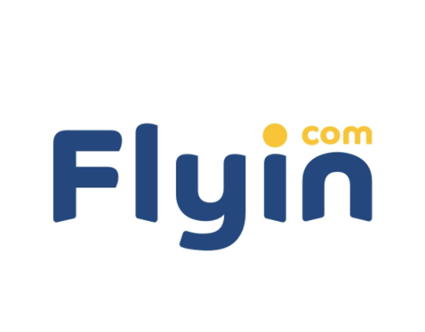

|  |  |
| --- | --- |
| 444010478 | MaJd awd Al-harbi |
| 444010975 | Weam Ahmad Al-shardi |

Supervising Professor: Mona Al-Aoufi

Introduction

“Flyin” is one of the leading online travel and tourism platforms, offering an integrated experience that includes booking flight tickets, hotel accommodations, and car rentals. The program features an easy-to-use interface, allowing users to explore various options based on their budget and needs. Additionally, “Flyin” provides regular offers and discounts for travelers, making it a popular choice for many. Users can also track their flights and easily modify bookings via the app or website. With 24/7 customer service, “Flyin” aims to meet customer needs and provide a comfortable and safe travel experience.

Functional requirements:

1- The user will be able to book flights, search for flights and book them.

2-The user can manage tickets and passengers can modify or cancel reservations.

3-The user must issue electronic boarding passes.

4-The user has to pay online and supports different payment options like digital wallets, credit cards etc.

5- The user will be able to view notifications to passengers about delays, approaching flight time or time changes in flight schedules.

6-The user can adapt it to work on smartphones, computers, iOS, Android and other operating systems.

Non-functional requirements:

1-The system should load pages in less than 3 seconds.

2-The system should protect and secure customer and payment data.

3-The system should be easy to use, and the interface should be user-friendly for all age groups.

4-The system must be able to scale to handle thousands of users at the same time without failure or downtime..

Purpose of the application:

The goal of the application was the idea of ​​the first researcher of Flyin website in 2012 and the quest to develop the concept of comfortable travel, by providing exceptional and distinctive travel and tourism services via the Internet that enjoy great ease and high luxury for travelers from all over the world, especially travelers from the Middle East region. The founders of Flyin.com are proud to be the first Saudi website in its field, providing integrated and high-level travel and tourism services using the latest technologies.

The reason for his existence:

It provides a comprehensive and convenient solution for travelers, organizes their trips, solves the problem of long searches, saves time with the best quality and price, and all the available and diverse options.

The problems you solve and the needs you address:

Save money, time and effort by choosing, accessing and modifying reservations with ease without wasting time.

:Main tasks

Flight Information Gathering

The system gathers and provides up-to-date information on flight schedules, ticket prices, and availability. It also monitors potential delays, cancellations, and gate changes, ensuring users have the latest updates on their booked or searched flights.

Sending Notifications

The app sends timely reminders for check-in, boarding times, and flight status updates. It also provides notifications about delays, gate changes, and approaching travel dates to ensure a smooth travel experience.

Educational Information

The system offers helpful tips and information on travel-related matters, such as baggage policies, check-in procedures, visa requirements, and customs regulations for different destinations, ensuring travelers are well-prepared for their journey.

Monitoring Travel Conditions

The app tracks weather conditions at departure and arrival locations, offering advice or alerts on potential weather disruptions. It also monitors airport traffic, suggesting the best times to arrive at the airport for a hassle-free check-in experience.

Opinion poll:

<https://forms.gle/jWiNit9Zp9qw6Yya9>

Survey results:

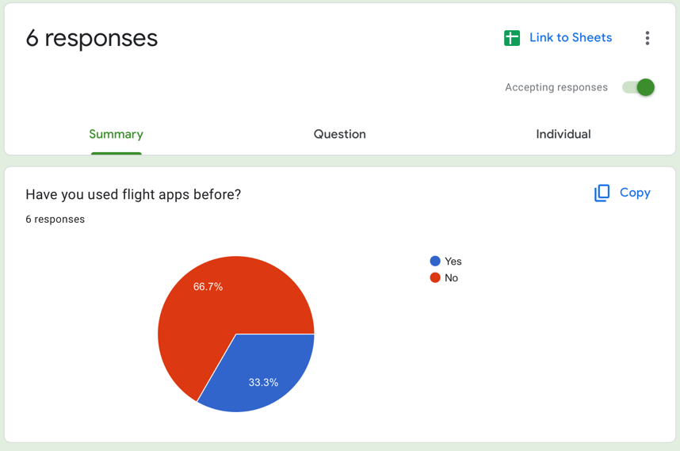

There is a large percentage of people who have never used flight apps before, which means there is a great opportunity to motivate them to try these apps.

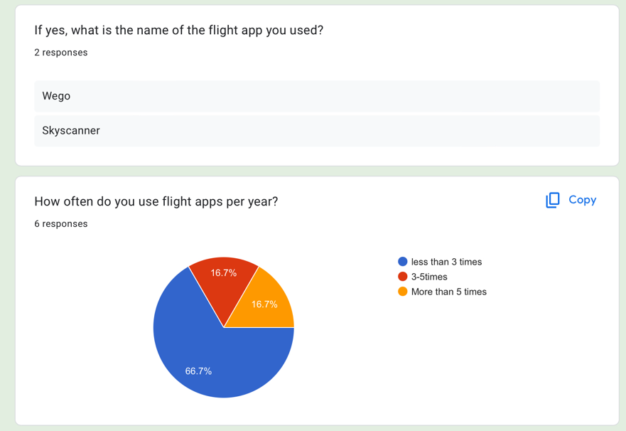

1. Flight name apps used: Wego and Skyscanner appear to be the most commonly used apps among respondents who have ever used flight apps. 2. Contribution to flight app usage: About 66.7% of respondents used flight apps less than 3 times, while 33.4% used them more than that.

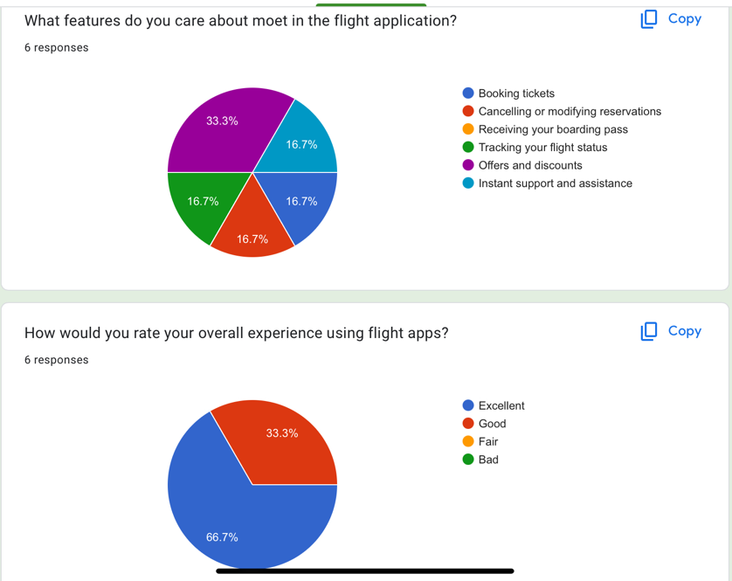

1. Top features of flight apps: Users are equally interested in multiple tools such as requesting a subscription, modifying servers, receiving a memory card, and tracking learning, with a significant interest in offers and immediate support.

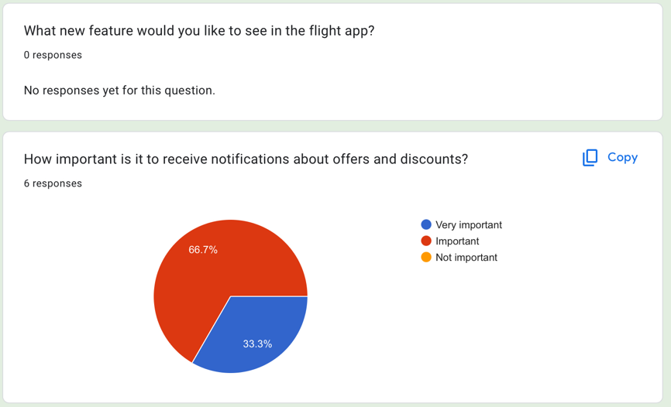2. Evaluating the experience of using flight apps: About 66.7% of participants rated it as “excellent”, while 33.3% considered it “good”.

It seems that offers and discounts attract the attention of many and are important to the majority (66.7%). They are one of the advantages of the application for the traveler to get the most benefit.

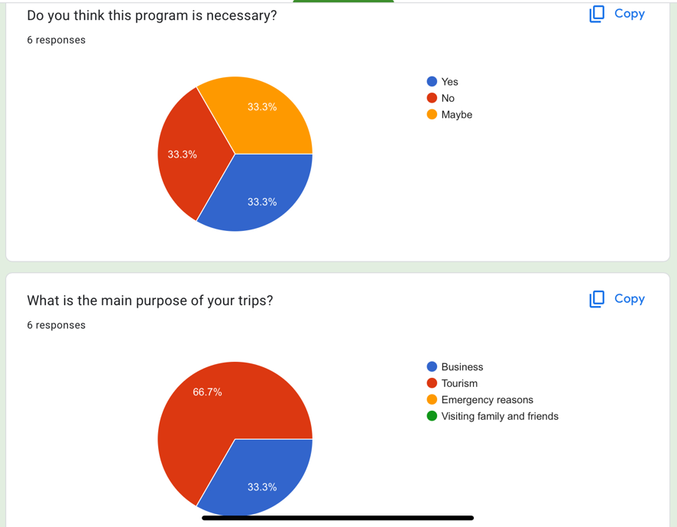

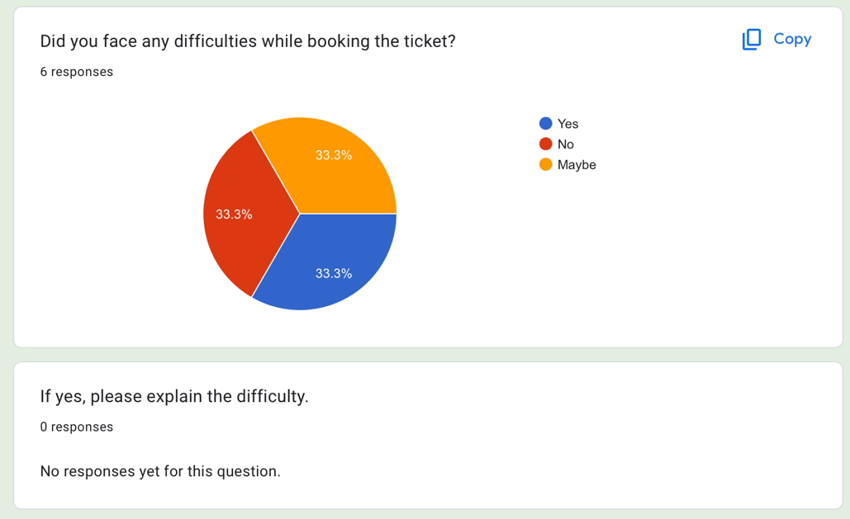The application is important for those looking to save time and effort, and is secondary for those who have time and constitute a large percentage of travelers for tourism and business, unlike the rest.

The application, like other applications, has its difficulties, and the application is keen to avoid all difficulties.

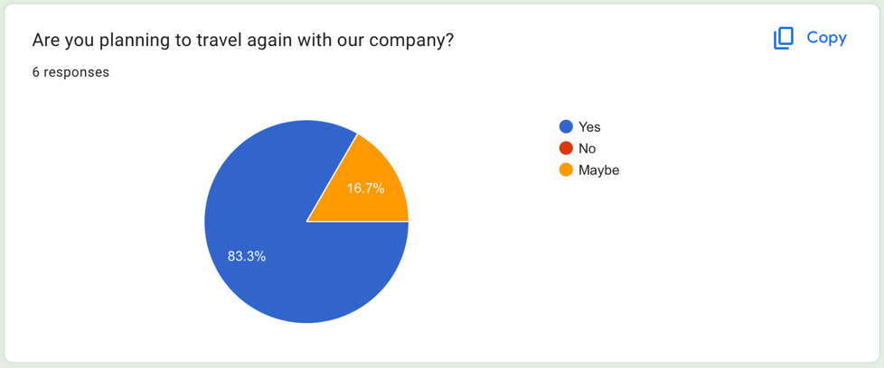

Our application is keen on the ease of traveler, complete satisfaction and progress towards achievements

Poll solution:

We always care and are keen on our meticulous attention to receiving our customers’ comments to avoid errors and reach the first ranks with our customers to provide services that are worthy of their aspirations and develop all aspects as shown through the questionnaire and we are keen to solve all current and future customer problems.

Comparison:

|  |  |  |
| --- | --- | --- |
|  | FIyin | ALmosafer |
| Disadvantages | Additional fees are  Applied  The delay in booking confirmation  Issues with refunds in case of booking changes | Provides hotel bookings but does not offer a way to contact the hotel directly  Considered one of the worst programs in terms of customer service  Uses a 12-hour format for flight times |
| Advantages | Easy booking the ability to book easily via phone or app  Loyalty rewards loyalty programs and rewards for frequent users  Multiple payment options supports a variety of payment methods to meet users' needs | Allows customers to book a hotel  Offers users discounts and special deals  Flexible payment options with multiple methods available |

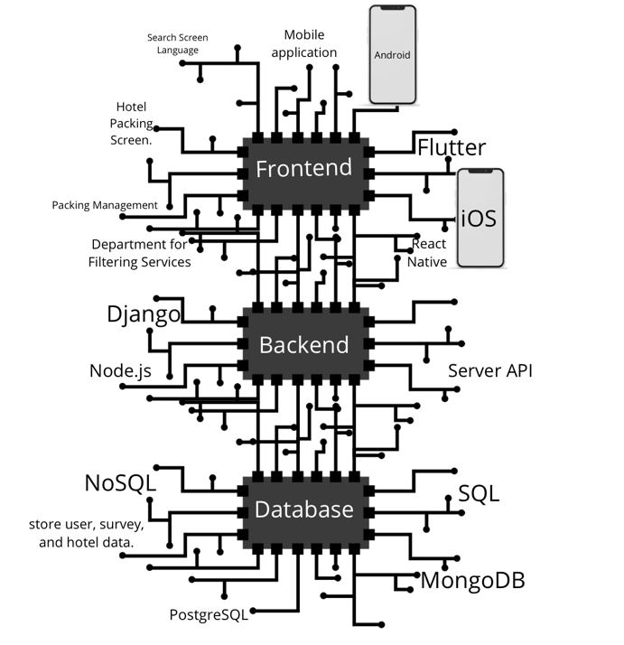system architectures:

Representation of the main components such as the interface, backend, database and part of their branches.

data models:

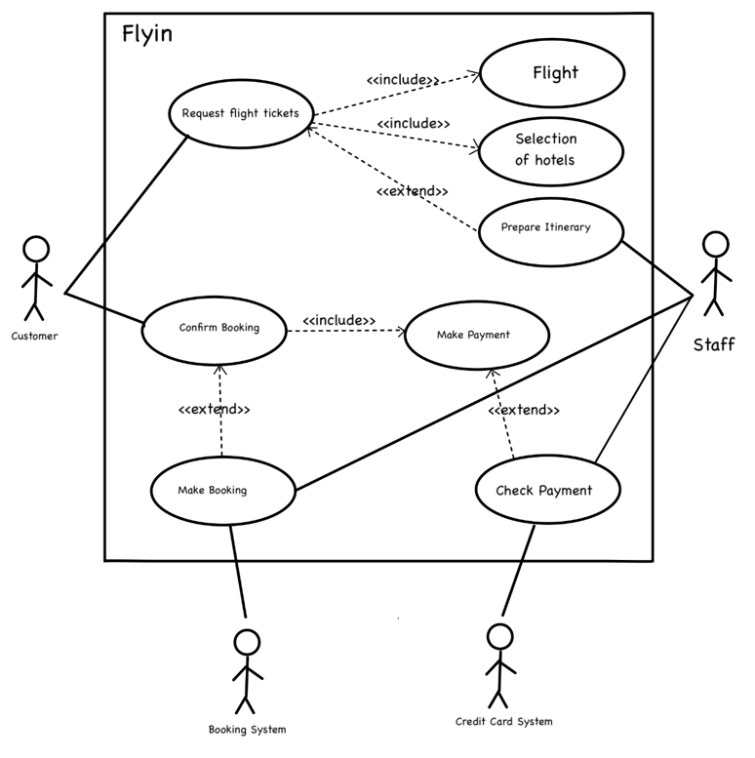

technical specifications:

Client: Mobile application (iOS and Android).

Server: RESTful API server to interact with the database.

Payment services (such as PayPal, Visa, MasterCard).

Its basic programming languages ​​and tools based on its various components:

1. (Frontend)

- JavaScript: It enables the user interface.

- React Native or Flutter: Works on iOS and Android devices.

2. (Backend)

- Node.js.

- Python.

- Java.

3. (Database)

- MySQL.

Summary:

An electronic platform for flight and hotel reservations, the first of its kind in the Middle East, that achieves the concept of luxury tourism for our customers without burdens or fatigue. We are the first electronic platform for travelers in the Gulf in particular and the Middle East in general. With exceptional advantages, in order for us at Flyin to achieve leadership among specialized sites, we provide high-level competitive services represented in ease of use, our prices, and modifying reservations.

Appendices:

Technical Writing Style Guide

Google writing style

Conclusion

We always strive for our values ​​and to develop all the services we provide by using new and advanced technology methods and improving the services provided to our customers and our main values, and most importantly, we start from basic values ​​that we believe in and are keen on in our dealings since the launch of Flyin and providing our services We always strive to achieve mutual trust through the advanced services we provide, characterized by continuous follow-up of procedures, by constantly developing our employees to provide services at a high professional level to satisfy the customer.

Reviewer

Author: Not specified. "Flyin". Flyin, creation date(2012). Website.

<https://www.flyin.com/aboutUs.ar.html>

Author: Not specified. "Flyin". Flyin, creation date Not specified. Website.

https://blog.flyin.com/