1. Introduction

Since the development of computer, computer scientist were looking for the development of machine that behave, interact, think like hu-man . A truly artificial intelligence dream is about development of m-achine that have ablity to perceives its environment and takes actions that maximize its chancesof successfully achieving its goal . Also soci-alization of machine is one of the greatly researched topic in the present day world. Among soci-alization of machine one of the prominent aspect is fair talk or humanly interaction with human. Humans interact with each other mainly through speech, but also through body gestures, to emphasize certain parts of their speech and to display emotions. Emotions often mediate and facili-tates interaction among human.Though nothing is said verbally, there is much understood about the message we send and receives through the use of non verbal comunication. Thus understanding emotion often brings context to seemingly bizarre and complex social communication .

Emotion can be identified through a variety of mean such as voice intonation , body language , facial expression , and more complex methods such as electroencephalography(EEG) . However, the easier, more practical method is to examine facial expressions . As it is key communitcation, computer scientist have extensively studied and researched this topic in order to integrate this feature in machine. A number reserches put forward by computer scientist for the recognition of emtions using facial expressions .

Automatic recognition of facial expressions can be an important component of natural human-machine interfaces; it may also be used in
behavioral science and in clinical practice. Although humans recognize facial expressions virtually without effort or delay, reliable expression recognition by machine is still a challenge .

1.1 ABOUT THE PROJECT

In this project we try to implement automatic emotion recognition system using facial features based on the CNN model . Basically we develop a graphical user interface(GUI) that take input in the form of static picture or real streaming video and try to predict the emotions of the all the involving characters . This is basically divided into two parts (i) development of the backend (ii) development of the front end .

1.2 About the Emotion Classification

In recent years researchers have made considerable progress in developing automatic expression classifier [7, 8, 9].. Some expression recognition sys-
tems classify the face into a set of prototypical emotions such as happiness, sadness and anger.[10]. Others attempt to recognize the individual muscle movements that the face can produce [11] in order to provide an objective description of the face. The best known psychological framework for describing nearly the entirety of facial movements is the Facial Action Coding System (FACS) [12]. FACS is a system to classify human facial movements by their appearance on the face using Action Units (AU). An AU is one of 46 atomic elements of visible facial movement or its associated deformation; an expression typically results from the accumulation of several AUs [7, 8]. Moreover, there have been several developments inthe techniques used for facial expression recognition:
Bayesian Networks, Neural Networks and the multilevel Hidden Markov Model (HMM) [13, 14]. Some of them contain drawbacks of recognition rate or timing. Usually, to achieve accurate recognition two or more techniques can be combined; then, features are extracted as needed. The success of each technique is dependent on pre-processing of the images because of illumination and feature extraction.

1.3 Need for the Emtoion Recognition

Our behavior is what we do and how do we act . It comprises various activity like running and jumping , verbal behavior, like saying thing we regret later or complicated behaviour .Since emotions have great impact on the behavior of human ,statistical study of the emotion of human help in analysing personal issues, tensions ,trauma and others of human. Following are the some of the usage of emotion recognition:

1. There is a lot of evidence, that human emotions influence interactions with software products. There is also a record of investigation on how products can influence human feelings [Hill 2009] and those feelings make people buy or not. Therefore investigating emotions induced by products is an object of interest of designers, investors, producers and customers, as well.

2. Employers require high work efficiency and high quality coding in software engineering firms . Unfortunately, these two requirements are often in conflict, as a computer program developed under time pressure is usually of low quality .So, automatic emotion recognition and statistic give idea about the behaviour of employee in pressurized environment .

3. Some emotional states support learning processes and other suppress them . However the two states are highly confusing with respect to learning as for example positive mood as hilarity is not good for learning processes, while slightly negative emotional states foster critical thinking and are appropriate for analytical tasks. So

4.Emotion based food or music recommender system is one of the best application of emotion recognition .

5. Emotion recognition is very important topic in Humanization of robot and improving human-machine interface . It is among extensively studied topic of humanoid development .
6. E-Acting Evaluation System . Emotion is critical for actor to display at each moment in some screen play . So automatic emotion recognition system can be integrated in software to analyse emotion of actor and its performance evaluation .Also AI system capable of creating animation found its abundant application .

1.4 Challenges

Although humans recognize facial expressions virtually without any effort or delay, reliable facial expression recognition by machine is still a huge challenge. Automatic facial expression analysis and recognition is a complex task because faces vary from one individual to another quite considerably due to different age & ethnicity. Even if recognition is done in a constraint of faces specific to some culture, several factors like presence of facial hair, glasses etc. make this task complex. Another challenge to this recognition task is the variation in size and orientation of the face in input images. This disables a search for fixed pattern in the images. Pose of the faces may differ due to angle of the camera. There may be faces which are frontal or non frontal. Faces may be at different angle which may obscure some of the facial features. However, in many practical applications, such as robotics, the performance of facial point extraction algorithm usually depends on the environmental factors such as lighting conditions heavily. So if the illumination is non-uniform, facial point can be detected inaccurately and hence high recognition rate of facial expression hardly expected

1.5 Tools Used

Basically in our project we worked at developing both front end and backend and accordingly we require follwing set of tools :
1. Front End (GUI) development tool
2. Deep Learning tool
3. Image processing tool
4. Some Plotting and Visulaization based tools
5.Others

1.5.1 Front End (GUI) Development Tool

For the front end development we used a QT based python wrapper module PyQt 5 . PyQt is one of the most popular Python bindings for the Qt cross-platform C++ framework. PyQt developed by Riverbank Computing Limited. Qt itself is developed as part of the Qt Project. It support a whole bunch of gui development class like QtGui,QtCore ,QtWidgets . Besides that it also have drag and drop gui development tool ‘ Qt Designer‘ that support substantialy fast development .

1.5.2 Deep Learning Tool

Python based extremely popular deep learnign tool ‘Tensor Flow’ and ‘Keras’ is used .
Tensorflow is extremely fast mathematical computing library developed by google and made public in 2015 .It is originally written in C++ . We have used its python API . It support both CPU and GPU system . The entire computation is accomplished by creating a computational graph, which takes multidimensional matrices called “Tensors” and does computations on them. Each node in the graph denotes an operation. The Graph is run in a Session, where you specify what operations to execute in the run-function. Data from outside may also be supplied to ‘ placeholders’ in the graph, so you can run it multiple times with different input. Furthermore, intermediate result (such as model weights) can be incrementally updated in ‘variables’, which will retain their values between runs.



Keras: Keras is acting as front end for the tensor flow . Actually writing the code in using tensorflow API is quite lengthy also the error are quite difficult to trace and analyse as it give error of its C++ code . Keras simplify all the crap . It give Sklearn type format for training and testing .
Also with just a few lines of code is enough to create pretty sound model .

1.5.3 Image Processing Tool

While preprocessing and testing, it require grabbing facial features , smoothing image for removing some noise and contrast equalization, for using camera . For all the above requirement we use Python API of C++ based image processing and computer vision library that OPEN CV .
It supports a number of class and functions like Haar Cascade for grabbing facial feature , histogram equalization for maintain contrast , cv2.VideoCapture class for accessing the camera etc .

1.5.4 Plotting and visualization tool

Matplotlib : For getting the insight of the distribution of images count and plotting the loss and accuracy we haved used python based plotting library matplotlib . Alse it used for displaying the confusion matrices and images and other plotting .Matplotlib is a Python 2D plotting library which produces publication quality figures in a variety of hardcopy formats and interactive environments across platforms. Matplotlib can be used in Python scripts, the Python and IPython shells, the Jupyter notebook, web application servers, and four graphical user interface toolkits.



1.5.5 Others

We require other python library like numpy and pandas for little bit normalization and reading csv file respectively .Also we have used pynput to add some sort of keyboard binding to capture image on provokation of some key.

1.6 NEURAL NETWORK

Neural Networks is one of the most successful machine learning algorithms. The development of neural networks have been key to teaching computers to think and understand the world in the way that humans do. Essentially, a neural network emulates/mimics the human brain. Brains cells, or neurons, are connected via synapses. This is similar as a graph of nodes (neurons) connected by weighted edges (synapses).
The human brain consists of 100 billion cells called neurons, connected together by synapses. If sufficient synaptic inputs fire to a neuron, that neuron will also fire. We call this process “thinking”. We can model this process by creating a neural network on a computer. A neural network has input and output neurons, which are connected by weighted synapses. The weights affect how much of the forward propagation goes through the neural network. The weights can then be changed during the back propagation — this is the part where the neural network is now learning. This process of forward propagation and backward propagation is conducted iteratively on every piece of data in a training data set. The greater the size of the data set and the greater the variety of data set that there is, the more that the neural network will learn, and the better that the neural network will get at predicting outputs.
Basically neural network consist of following parts:
1) Neurons. A neural network is a graph of neurons. A neuron has inputs and outputs. Similarly, a neural network has inputs and outputs. The inputs and outputs of a neural network are represented by input neurons and output neurons. Input neurons takes input and output neurons yeild result . It is represented as node in the graph and input and output as edges .
2) Connections and Weights. A neural network consists of connections, each connection transferring the output of a neuron to the input of another neuron. Each connection is assigned a weight.
3) Propagation Function. The propagation function computes the input of a neuron from the outputs of predecessor neurons. The propagation function is leveraged during the forward propagation stage of training.
4) Learning Rule. The learning rule is a function that modifies the weights of the connections. This serves to produce a favored output for a given input for the neural network. The learning rule is leveraged during the backward propagation stage of training.

1.6.1 Deep Neural Network
A network of neuron layers if number of layers is more than 3 layers then we cal such a neural network architecture as deep neural network (DNN) .
It might contain from 20 to 100 neurons layer.

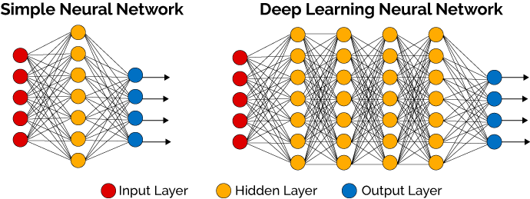

1.6.2 Forward Propagation
In the forward propagation step, first input values are multiplied with the weight of the first layers and then accumulated over any of the different activation function and this is the input to next layer . Similary this layer multiply the input it get with weights and accumulated over activation funcion and so on till we reach output layer . Now the loss is calculated and backward propagation begins . This is clearly depicted in the figure attached .
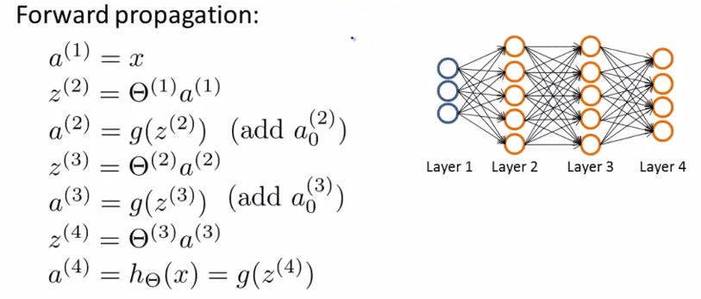

1.6.3 Backward Propagation

After calculating the loss , the weight of the different layers are updated so as to to minimize the loss in the next ieration this is all accompolished by chain rule of differentiation . The equation involved is best summarized in the picture below .

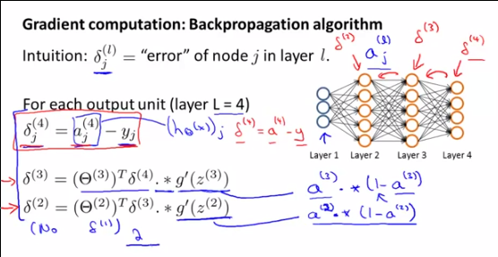

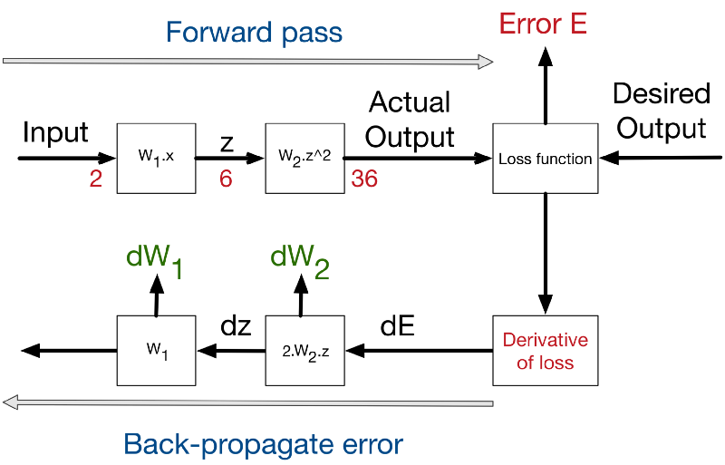

1.6.4 Convolutional Neural Network

Convolutional neural network is one of the neural network architecture that is extensively used in th computer vision . What I saw in covolutional neural network s that it comprises of two part ,first is for feature extraction and image compression and second is classification . For the first part it has three layers convolutional, ReLU,Max-Pooling . For the second part there is dense layer . So in total following four layers are there:
1. ConVolutional Layer
2. Relu Layer
3. Max-pooling Layer
4. Dense Layer
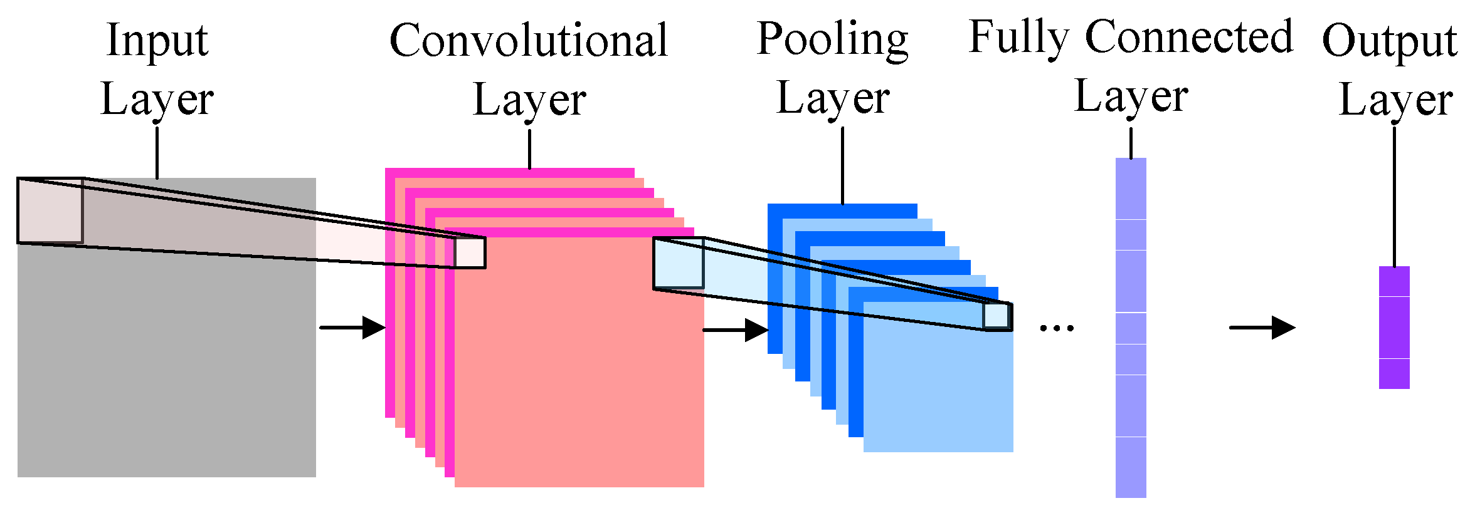

1.6.4.1 Convolutional Layer

Basically in the convolutional layer the image is convolved with a filter . Filter is basically a weighted 2D matrix that run through the image do cross multiplication and and averaging finally creating new image with the average value . The size of filter can be any thing but odd is prefered . The value of the weight are randomly initialized which is subsequently updated and modified in the back propagation . Convolutional layer output a new iamge for each of the filter or number of images is equal to number of the filters .
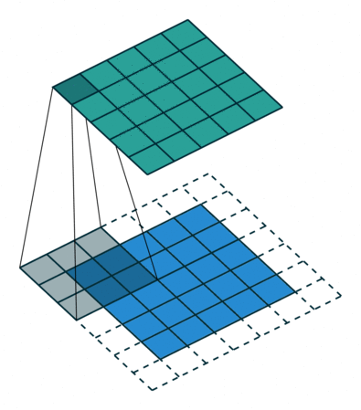

1.6.4.2 Relu Layer

Relu transform function only activaes a node if the input is above a certain
quantity. While the input is below threshold the output is zero. But when theinput rise above certain threshold it has linear relationship . It is used to get rid of the negative value . Basically for the image intensity is considered that’s why negative vintensity has no meaning .

1.6.4.3 Max-Pooling Layer

Pooling is a vector to scalar transformation that operates on each local region of an image, just like convolutions do, however, unlike convolutions, they do not have filters and do not compute dot products with the local region, instead they compute the average of the pixels in the region (Average Pooling) or simply picks the pixel with the highest intensity and discards the rest(Max Pooling) .Max Pooling has worked best in recent years, it is based on the idea that the maximum pixel in a region represents the most important feature in that region. It also reduces the computational cost of the convnet .

1.6.4.5 Dense Layer

In the dense layer the images we get from the previous layer is raveled and a vector is formed now this vecttor is acting as the represenation of the image . It is also called fully connected layer . The fully connected layer comsprise of neurons that are connected in the manner as shown in the neural network .This portion of the network actually make classification .

1.6.4.6 Dropout Layer

This is the another layer in addition to the above layer that basically used to protect the model from over-fitting . It also reduce the computational cost of training . It works by randomly setting some activations to 0, essentially killing them. By doing this, the network is forced to explore more ways of classifying the images instead of over-depending on some features. This was one of the key elements in the AlexNet.

3. Implementation

3.1 Introduction

Basically our implementation consist of two part first is for the creation and training of the CNN model and in the second part for the develop-ment of the GUI front end . We use a litle bit shallow network with 3 convolutional layer only because of technological constraint (cpu powered machine) and singl fully connected layer with 3072 neurons .
We experimented with 30 epochs at last.

3.2 Dataset
A few words about our dataset .We have used Kaggle FER 2013 competetion dataset that is a 48*48 grayscale image of mainly facial data . In total there are about 37000 image . It is actually csv format data with image is in the form of a string of pixel values separated by space . Each tuple labelled with a number between 0-6 such that 0 corresponds to Angry, 1 mean Disgust, 2 mean Sad, 3 mean Happy, 4 fear, 5 surprise ,6 contempt .
The data distribution of different feature is depicted in follwing graph

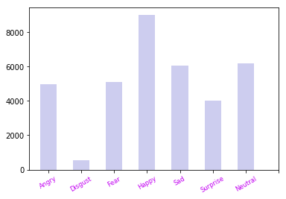

A few examples of the images are as under:
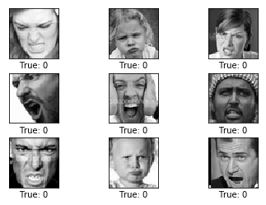
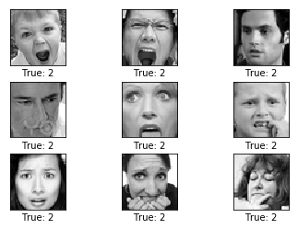

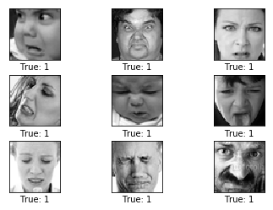
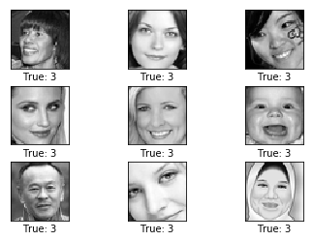

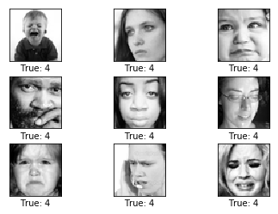
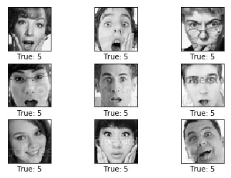

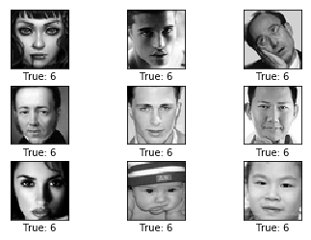

3.3 WORK FLOW
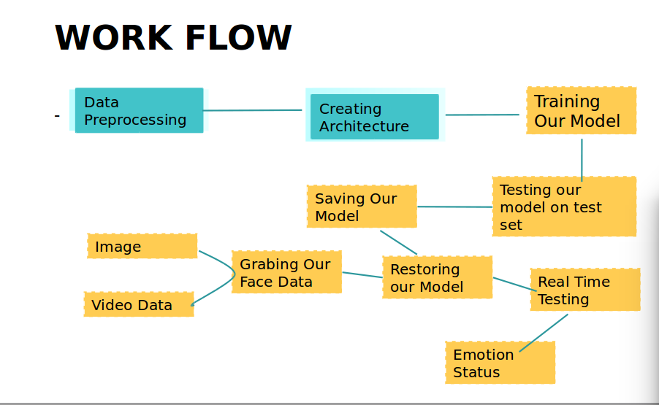
3.3.1 Preprocessing

In the preprocessing we basically first brought the data using pandas and then convert it into a numpy array and save it in ‘.npz’ format . It help in converting the data only one time however it consumed about 650 mb memory which is used furthur steps.This conversion was quite lengthy infact .Therefater we do one hot encoding of the emotions . We randomize the data to put some kind of variance in the data .Thereafter
We do some kind of mean normalization. Finally we split the data in train and validataion set such that 25000 data object in train set and remaining for the validation set .

3.3.2 Architecture Construction and Training

Basically we created a CNN architecture that comprises of 3 convolutional layer such that first two convolutional layer is followed by a maxpooling layer . And last convolutional layer is followed by dropout layer . There after two dense layer . First convolutional layer is having 64 filters such that each of size = 5 followed by a relu layer. Maxpooling layer too have same kernel size . Second convolution layer has 64 filters of 5*5 and a relu layer . Third convolutional layer having 128 filter of 5*5 each and relu actiavtion of layer. Third convolutional layer is folloed by a dropout layer .
The dropout layer is followed by fully connected layer having 3072 neuron and having relu activation layer . And then output layer that is having softmax activation function . Each of the maxpooling layer have pool_size of 3*3 . After traing the model we save the model and its weight in json and hdf5 format .
The architecture is created using python Python keras module. It is quite popular and provide easy way to construct our model .
Intially
It is best depicted using the given photo -
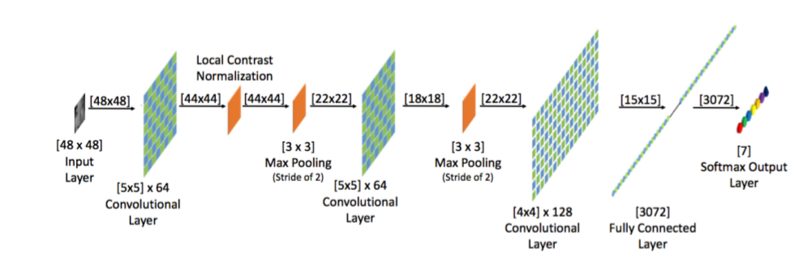

We trained our model with 30 epochs using stochastic gradient decent with batch size of 64. It takes almost 3 hrs to complete execution.
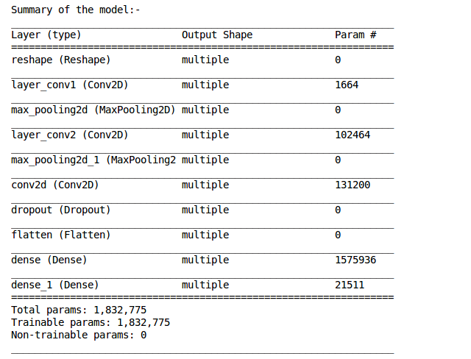

Optimizer | Adam
Learning-rate | .001
Regularization | Dropout

3.3.3 Haar Cascade

In addition to above neural network model we use another machine learning based tool Haar Cascade which is provided by open cv . It is used for grabbing facial portion from the image. It is basically based on the machine learning that make use of weak a number of weak filters that in sychronization produce very impressive result .
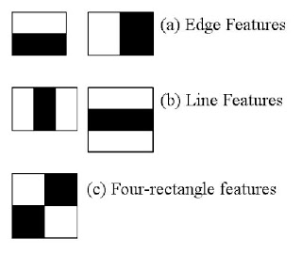
The algorithm has four stages:
1. Haar Feature Selection
2. Creating Integral Image
3. Training Adaboost Training
4. Cascading Classifiers

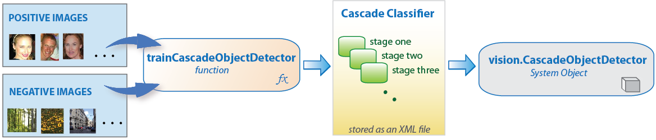

3.3.4 Front End Development

For the front end development we have used PyQt module which is wrapper over or python API of C++ based Qt module .It give facilty of drag and drop of various element like button, layout etc using Qt Designer Tool .Our application have button for selecting a photo from the disk using file dialog . Also one click button for capturing image and video streaming . There is processing button that used for processing the image . Finally the output is displayed in text area in the left corner .

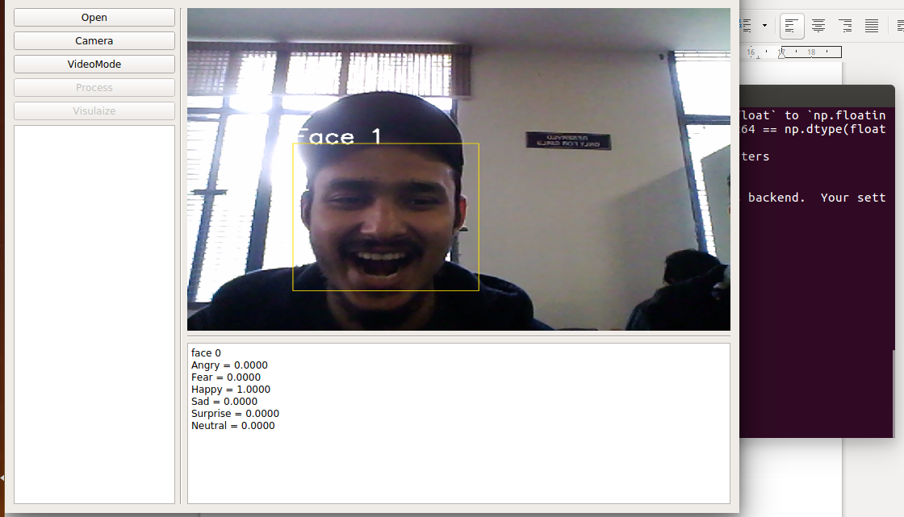

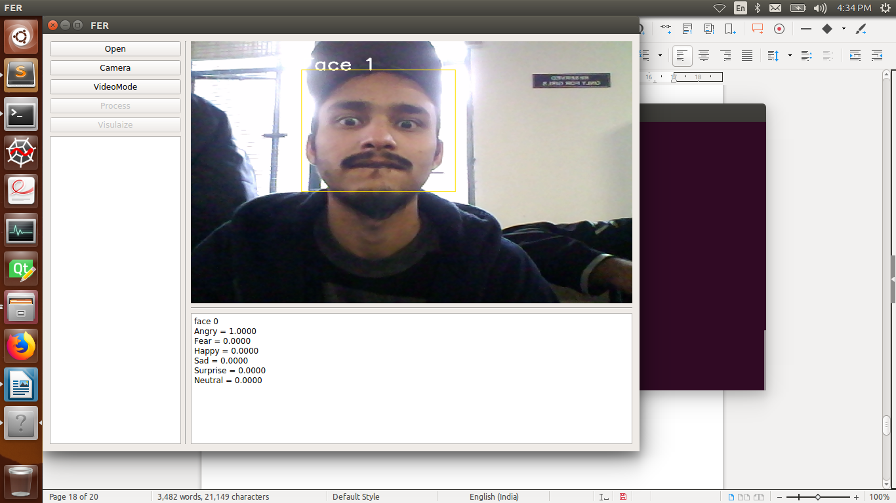

4. Experimental Result

In this experiment we trained our model initially with 18 epochs ,24 epochs and 40 epochs . We were able to attain training accuracy upto 65 % in just 10 epochs. But after that it slowed down and accuracy touched 90% in 24 epochs and 97% with 40 epochs . But the cross validation scored about 52% . While training, loss is negligible(zero)~0.09, but the cross validation take opposite direction indicating overfitting . We tried with different regularization and randomization but cross validation has not improved as desired . In fact many of the paper that have used FER 2013 datsets, their accuracy lies between 55-65% only . That pretty much indicates that dataset do not have optimum variance that lets a good result . Also, the winner of FER 2013 kaggle competition scored an accuracy of ~71%.

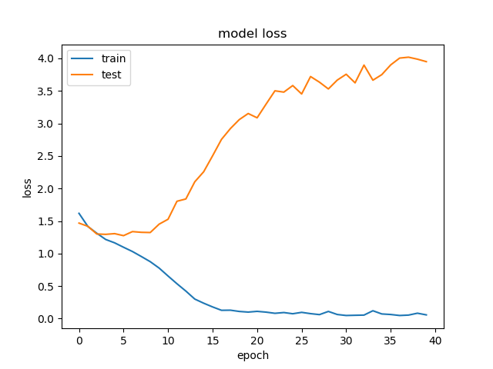
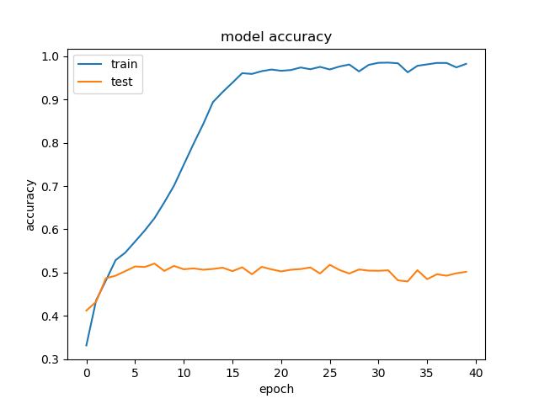

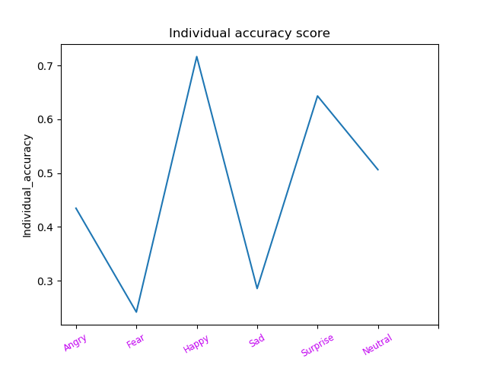
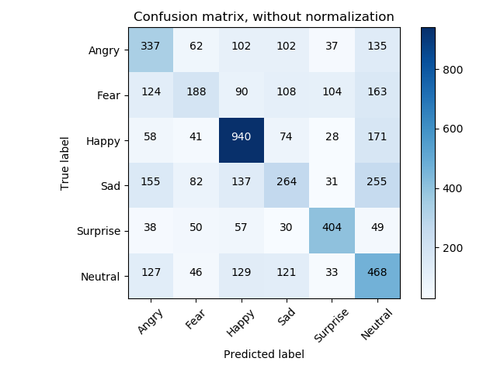

Conclusion

In this report we have made a model detecting emotion recognition using facial expression using convulutional neural networks.We have used FER dataset dated 2013 that consists of greyscale images.We have implemented the model using CNN with the help of various tools such as TensorFlow for deep learning,PyQt 5 for GUI development etc. We also have developed a GUI based application that is capable of grabing facial data as well as predicting the most prominent emotions.Since the data isnt optimum variance due to which it underoes overfitting with very shallow network infact ,where it isnt reasonable to think about overfitting.
Basically, in this project we have learned about neural networks,CNN and its implentation using TensorFlow.

Future work

Limitation of the facial expressions recognition is that they are sensitive to face orientation. Therefore, applying orientation invariant model would give better results .
Another limitation is that it is ethnic variant i.e. people located across globe have different expressions for the same emotion. Also it is accompanied with varying voices innotation as well as behaviour. So a model that takes in account all these parameters would perform well.
So future work will be integration of all these parameter in model training.

Also we have used grayscale and low resolution image due to technolo-gical limitations, so using a colored and high resolution would be in future work for better result.

refrences

[6] Nicu Sebe, Michael S. Lew, Ira Cohen, Yafei Sun,
Theo Gevers, Thomas S. Huang (2007) Authen-
tic Facial Expression Analysis. Image and Vision
Computing 25.12: 1856-1863

[7] Y. Tian, T. Kanade, and J. Cohn. Recognizing
action units for facial expression analysis. IEEE
Transactions on Pattern Analysis and Machine In-
telligence, 23(2), 2001.

[8] M.S. Bartlett, G. Littlewort, M. Frank, C. Lain-
scsek, I. Fasel, and J. Movellan. Fully automatic
facial action recognition in spontaneous behavior.
In Proceedings of the IEEE Conference on Auto-
matic Facial and Gesture Recognition, 2006

