Weather ETL Pipeline
for Egypt Governorates

Project: Weather ETL Pipeline
Version: 1.0
Author: Somaia Mahmoud Shapan
Date: May 2026
Status: Operational
Classification: Internal
Technology: Apache Airflow 3.2.0 / Python / SQL Server

Team Members
Mahmoud Wahied Muhammad Muhammad (Team Leader)
Mahmoud Mohamed Mahmoud Mostafa
Dahlia Sherif ElAshmawy
Somaia Mahmoud Shappan
Moamen Samir Afifi
Ahmed Gamal Elsaid

Document Control

Version History
Version | Date | Author | Description
0.1 | April 2026 | Somaia | Initial project setup with Airflow 2.8.1
0.5 | April 2026 | Somaia | Migrated to Airflow 3.2.0, added scikit-learn
0.9 | May 7, 2026 | Somaia | DAG finalized, hourly schedule active
1.0 | May 10, 2026 | Somaia | Production-ready, full documentation

Reviewers
Role | Name | Date
Developer | Mahmoud | May 2026

Table of Contents
Document Control 2
Version History 2
Reviewers 2
Table of Contents 3
1. Executive Summary 5
Project Overview 5
Business Objective 5
Expected Outcome 5
High-Level Scope 5
2. Introduction 6
2.1 Purpose 6
2.2 Intended Audience 6
2.3 Project Background 6
2.4 Scope 6
In-Scope 6
Out-of-Scope 6
3. Project Overview 8
3.1 Problem Statement 8
3.2 Solution Description 8
3.3 Goals and Objectives 8
3.4 Stakeholders 8
4. System Requirements 9
Requirements 9
Functional Requirements 9
Non-Functional Requirements 10
Performance 10
Availability 10
Reliability 10
Security 10
Maintainability 11
Technical Requirements 11
Infrastructure Requirements 11
Business Requirements 12
Assumptions and Constraints 12
Assumptions 12
Constraints 13
5. Architecture and Design 14
System Architecture 14
Overview 14
Component Map 14
Orchestration Layer (Airflow) 15
Service Responsibilities 15
Metadata Storage 15
Message Broker 15
Processing Layer (Python) 15
Storage Layer (SQL Server) 16
Network Topology 16
Data Flow Sequence 17
Volume Mounts 17
Failure and Retry Behavior 18
6. Technology Stack 19
Technology Stack 19
Overview 19
Orchestration 19
Apache Airflow 3.2.0 19
Celery 5.6.3 19
Message Broker 20
Redis 7.2 (bookworm) 20
Metadata Database 20
PostgreSQL 16 20
Target Database 20
Microsoft SQL Server 17 (MSSQLSERVER) 20
Data Processing 21
Python 3.13 21
pandas 2.3.3 21
requests 2.33.0 21
SQLAlchemy 2.0.48 21
pyodbc 5.3.0 22
scikit-learn 1.8.0 22
numpy 2.4.3 22
Containerization 22
Docker Desktop for Windows 22
Docker Compose 22
Custom Dockerfile 23
External Services 23
Open-Meteo Forecast API 23
Development Tools 23
7. ETL Pipeline 24
ETL Pipeline 24
DAG Configuration 24
Task 1: create_weather_table 24
Task 2: load_weather_data 24
Extract Phase 24
Transform Phase 25
Load Phase 26
Deduplication Mechanism 27
Standalone Script 27
8. Database Documentation 28
Database Documentation 28
WeatherForecast Table 28
Schema 28
Constraints 28
Indexes 29
Growth Estimate 29
weather_day View 29
Connection Details 30
Common Queries 30
9. Data Source: Open-Meteo API 31
Data Source: Open-Meteo API 31
Overview 31
Rate Limits 31
Request Format 31
Response Format 32
Error Handling in the Pipeline 32
Data Freshness 33
Governorate Coordinates 33
10. Deployment Documentation 35
Deployment and Operations 35
Deployment Architecture 35
Container-to-Host Communication 35
Volume Mapping 36
Environment Details 36
Host Requirements 36
Software Versions (Current Deployment) 36
Environment Variables 37
Network Ports 37
Fresh Installation 38
Step 1: Install Docker Desktop 38
Step 2: Prepare SQL Server 38
Step 3: Deploy Airflow 38
Step 4: Configure and Unpause 38
Configuration Changes 39
Changing SQL Server Credentials 39
Changing the Schedule 39
Adding or Removing Governorates 39
Rebuilding After Code Changes 39
Resetting Airflow to Clean State 39
Backup and Recovery 40
Backup 40
Recovery 40
Health Checks 40
Stopping the Pipeline 41
Troubleshooting 41
DAG not appearing in the UI 41
Task fails with "Login timeout expired" 41
Some cities return API errors 41
Container keeps restarting 41
11. Development Standards 42
Development Standards 42
Coding Standards 42
Python Style 42
Section Headers 42
Variable Naming 42
Function Structure 42
SQL in Python 43
Error Handling 43
DAG File Structure 43
Import Conventions 44
Git Workflow 44
Branching 44
Commit Messages 45
Files to Ignore 45
Adding a New Python Dependency 45
Adding a New DAG 46
Configuration Management 46
Secrets 46
Environment-Specific Values 46
12. Operational Runbook 47
Operational Runbook 47
RBO-01: Force a Manual DAG Run 47
RBO-02: Restart the Entire Pipeline 47
RBO-03: Restart a Single Container 47
RBO-04: Check Recent DAG Run Results 48
RBO-05: Add a New Governorate 48
RBO-06: Change SQL Server Password 48
RBO-07: Rebuild the Docker Image 48
RBO-08: Reset Airflow to Clean State 49
RBO-09: Clean Old Data from SQL Server 49
RBO-10: View Container Resource Usage 50
RBO-11: Diagnose a Failed DAG Run 50
RBO-12: Fix SQL Server Connectivity Issues 50
RBO-13: Create a Backup 51
Airflow Metadata + Logs 51
SQL Server Data 51
RBO-14: Stop Everything 51
13. Glossary 52
Sign-Off 54

1. Executive Summary

Project Overview
This project is an end-to-end Data Engineering pipeline designed to collect, process, and analyze weather data for 27 Egyptian Governorates. The system utilizes Apache Airflow to orchestrate a workflow that fetches real-time data, applies a Machine Learning model for temperature prediction, and stores the results in Microsoft SQL Server. It also includes a reporting layer (SQL View) for end-user analysis.

Business Objective
To establish a reliable, automated weather data collection system that enables historical trend analysis, temperature alert monitoring, and predictive temperature modeling for Egyptian governorates, supporting data-driven decision making.

Expected Outcome
- Hourly weather observations for 27 Egyptian cities stored in a structured database
- Automated alert classification for extreme temperatures (High >36C, Low <15C)
- ML-predicted temperature values based on humidity and wind speed correlations
- Deduplicated historical dataset growing at approximately 648 records per day

High-Level Scope
Single-machine deployment on a Windows workstation. Docker-based Airflow orchestration with CeleryExecutor. SQL Server target database. No cloud infrastructure, no external authentication, no user-facing application.

2. Introduction

2.1 Purpose
This document serves as the comprehensive technical reference for the Weather ETL Pipeline project. It covers system architecture, data pipeline design, database schema, deployment procedures, technology decisions, development standards, and operational runbooks. It is intended to be the single source of truth for understanding, deploying, and maintaining the system.

2.2 Intended Audience
Audience | Use Case
Data Engineers | Understand pipeline logic, extend functionality
DevOps / Infrastructure | Deploy, configure, troubleshoot
Project Stakeholders | Review system capabilities and requirements
New Team Members | Onboarding and knowledge transfer

2.3 Project Background
The project was initiated in April 2026 as a data engineering exercise to build an automated ETL pipeline for Egyptian weather data. It evolved through several iterations: starting with Airflow 2.8.1 and a basic DAG, then migrating to Airflow 3.2.0, adding scikit-learn for ML predictions, and stabilizing on the current architecture with CeleryExecutor, custom Docker images, and SQL Server integration.

2.4 Scope

In-Scope
- Weather data extraction from Open-Meteo API for 27 Egyptian governorates
- Hourly automated scheduling via Apache Airflow
- Temperature alert classification (High / Normal / Low)
- Linear regression temperature prediction model
- Data storage in SQL Server with deduplication
- Docker-based deployment with CeleryExecutor
- Operational runbook and troubleshooting guides

3. Project Overview

3.1 Problem Statement
There was no automated system to collect and store weather observations for Egyptian governorates in a structured, queryable format. Weather data was not available for historical analysis, trend detection, or alert monitoring.

3.2 Solution Description
An hourly batch ETL pipeline built on Apache Airflow that fetches current weather conditions (temperature, humidity, wind speed) from the free Open-Meteo API, classifies temperature alerts, predicts temperature using a linear regression model trained on each batch, and stores the results in SQL Server with deduplication by city and timestamp.

3.3 Goals and Objectives
Goal | Objective | Status
Automated data collection | Hourly weather fetch for 27 cities | Achieved
Data quality | Deduplication and constraint enforcement | Achieved
Alert system | Temperature classification per observation | Achieved
ML prediction | LinearRegression per batch | Achieved
Operational reliability | Auto-restart, retry logic, health checks | Achieved

3.4 Stakeholders
Role | Name | Responsibility
Developer / Owner | Mahmoud | Design, implementation, documentation, operations

4. System Requirements
Full requirements are documented in docs/requirements.md. Summary below.

Requirements

Functional Requirements
ID | Requirement | Priority
FR-02 | The system shall fetch temperature, humidity, and wind speed | Must
FR-03 | The system shall run the pipeline on an hourly schedule | Must
FR-04 | The system shall store results in SQL Server | Must
FR-05 | The system shall prevent duplicate records per (city, timestamp) | Must
FR-06 | The system shall classify temperatures into alert categories | Must
FR-07 | The system shall predict temperature using a linear regression model | Should
FR-08 | The system shall continue processing if individual city API calls fail | Must
FR-09 | The system shall log success, skip, and error for each city | Must
FR-10 | The system shall print a summary of inserted and skipped records | Must
FR-11 | The system shall create the target table automatically if absent | Must
FR-12 | The system shall provide a standalone test script outside Docker | Should

Non-Functional Requirements

Performance
ID | Requirement | Target
NFR-02 | A single API request shall timeout after 10 seconds | 10s timeout
NFR-03 | The system shall not exceed 4 GB RAM for Docker | 4 GB Docker allocation
NFR-04 | The system shall not exceed 3.5 GB Docker image size | ~3.1 GB actual

Availability
ID | Requirement | Target
NFR-06 | Airflow containers shall auto-restart on failure | restart: always in compose
NFR-07 | The system shall tolerate a SQL Server restart without data loss | Unique constraint guard

Reliability
ID | Requirement | Target
NFR-09 | Failed tasks shall retry once with a 5-minute delay | 1 retry, 5 min backoff
NFR-10 | DAG code changes shall take effect without container restart | dag-processor auto-parses

Security
ID | Requirement | Current State
NFR-12 | Container-to-SQL traffic shall be encrypted | TrustServerCertificate=yes
NFR-13 | Airflow UI shall require authentication | Username/password
NFR-14 | The Fernet key shall not be committed to version control | In .env (gitignored)

Maintainability
ID | Requirement | Target
NFR-16 | Changing the schedule shall require editing only the schedule param | Single line in DAG
NFR-17 | Adding a new Python dependency shall require Dockerfile change only | pip install line

Technical Requirements
ID | Requirement
TR-02 | Docker Compose v2
TR-03 | SQL Server 2019+ with TCP/IP enabled on port 1433
TR-04 | ODBC Driver 17 for SQL Server (host for standalone, container for DAG)
TR-05 | Python 3.13+ (container runtime)
TR-06 | Apache Airflow 3.2.0
TR-07 | CeleryExecutor with Redis broker and PostgreSQL backend
TR-08 | Network connectivity to api.open-meteo.com (port 443) from Docker containers
TR-09 | Host disk space: minimum 20 GB free
TR-10 | Host RAM: minimum 8 GB (4 GB allocated to Docker)

Infrastructure Requirements
ID | Requirement | Notes
IR-02 | Docker Desktop running with WSL2 kernel | Not Hyper-V backend
IR-03 | SQL Server running as native Windows service | Not inside Docker
IR-04 | Persistent Docker volume for PostgreSQL metadata | postgres-db-volume
IR-05 | Bind-mounted directories for DAGs, logs, config, plugins | Shared with host filesystem
IR-06 | Host firewall allowing port 1433 inbound from WSL2 subnet | Usually auto-configured
IR-07 | DNS resolution for api.open-meteo.com from inside containers | Docker uses host DNS

Business Requirements
ID | Requirement | Priority
BR-02 | Identify cities with extreme temperatures for alert purposes | Must
BR-03 | Store historical weather data for trend analysis | Must
BR-04 | Use a free external weather data source to avoid licensing costs | Must
BR-05 | Predict temperature from other weather variables using ML | Should
BR-06 | Provide a human-readable view with day-of-week information | Should

Assumptions and Constraints

Assumptions
- Open-Meteo API remains free and available with no authentication required
- SQL Server Express edition storage limits (10 GB) are sufficient for
projected data growth (~75 MB per year)
- A single worker container can process 27 sequential API calls within the
5-minute target
- The host machine remains powered on and connected to the internet for
scheduled runs to execute

Constraints
- No horizontal scaling (single worker container)
- No persistent ML model (retrained per batch, discarded)
- No alerting or notification system (alerts stored in DB only)
- No data archival mechanism (table grows indefinitely)

5. Architecture and Design
Full architecture documentation is in docs/architecture.md.

System Architecture

Overview
The system is a batch ETL pipeline that runs on an hourly schedule. It is composed
of three layers: orchestration (Airflow), processing (Python), and storage
(SQL Server). All infrastructure runs locally on a single Windows machine.

Component Map
+---------------------------+
| Windows Host Machine |
| |
+----------+ | +---------------------+ |
| Open-Mete| | | Docker Desktop | |
| API | | | (WSL2 backend) | |
| (cloud) | | | | |
+----+-----+ | | +----------------+ | |
| | | | airflow-project| | |
| HTTPS GET | | | (docker-compose| | |
| (27 requests) | | | network) | | |
| | | | | | |
+----------------+-->+ | postgres:16 | | |
| | | redis:7.2 | | |
| | | apiserver | | |
| | | scheduler | | |
| | | dag-processor | | |
| | | worker | | |
| | | triggerer | | |
| | +-------+--------+ | |
| | | | |
| +----------|-----------+ |
| | |
| host.docker.internal |
| (port 1433) |
| | |
| +----------v-----------+ |
| | SQL Server (MSSQL17) | |
| | | |
| | Weather_DataBase | |
| | -> WeatherForecast | |
| | -> weather_day (vw) | |
| +-----------------------+ |
+---------------------------+

Orchestration Layer (Airflow)

Airflow 3.2.0 runs inside Docker Compose using the CeleryExecutor pattern.
This means task execution is distributed across multiple containers.

Service Responsibilities
- apiserver: Exposes the web UI on port 8080 and the REST API. All DAG
management, manual triggers, and monitoring happen here.
- scheduler: Evaluates DAG schedules and decides when to create DagRuns.
It places task instances into the executor queue every 5 seconds.
- dag-processor: Parses Python files in the dags/ directory, serializes
DAG definitions, and writes them to the metadata database. Re-parses on file
change.
- worker: A Celery worker that picks up task instances from the Redis queue
and executes them. This is where the actual Python code (API calls, SQL
inserts) runs.
- triggerer: Manages async triggers (deferrable operators). Not used by
the current pipeline but required by Airflow 3.x.
- init: Runs once at startup. Initializes the metadata database, runs
migrations, creates the admin user, and sets file permissions. Exits after
completion.

Metadata Storage
PostgreSQL 16 stores all Airflow state: DAG definitions, run history, task
instance states, connection configs, variables, and audit logs. The data
persists in the Docker volume `postgres-db-volume`.

Message Broker
Redis 7.2 acts as the Celery message broker. The scheduler pushes task
execution requests to a Redis queue. Workers pull from this queue. Results
are written back to PostgreSQL.

Processing Layer (Python)
All data processing logic lives in `airflow-project/dags/weather_etl_pipeline.py`.
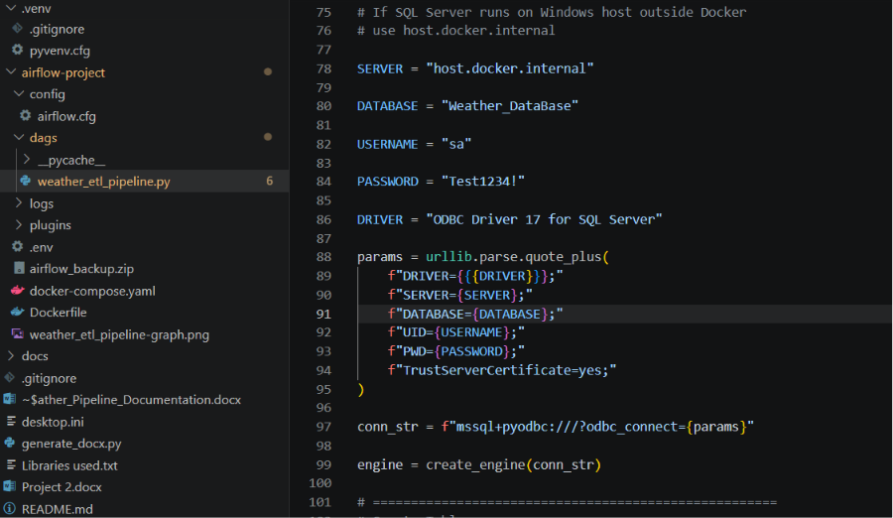
It runs inside the worker container.
Libraries installed in the custom Docker image are documented in detail in
[tech-stack.md](tech-stack.md#data-processing).
Package | Installed Version | Purpose
requests | 2.33.0 | HTTP calls to Open-Meteo API
SQLAlchemy | 2.0.48 | Database connection and query engine
pyodbc | 5.3.0 | ODBC driver for SQL Server
scikit-learn | 1.8.0 | LinearRegression model

The worker container also has Microsoft ODBC Driver 17 installed at the OS
level (via apt in the Dockerfile) to enable pyodbc connectivity to SQL Server.

Storage Layer (SQL Server)
Microsoft SQL Server (MSSQL17) runs natively on the Windows host, outside Docker.
The pipeline connects from inside the Docker network using the hostname
`host.docker.internal` on port 1433.
The target database is `Weather_DataBase`. The pipeline creates and manages
a single table (`WeatherForecast`) and an optional view (`weather_day`).
Connection string pattern:
mssql+pyodbc:///?odbc_connect=
DRIVER={ODBC Driver 17 for SQL Server};
SERVER=host.docker.internal;
DATABASE=Weather_DataBase;
UID=sa;
PWD=***;
TrustServerCertificate=yes;

Network Topology
Docker Compose creates a default bridge network named `airflow-project_default`.
All Airflow containers share this network and resolve each other by service
name (e.g., `postgres`, `redis`, `airflow-apiserver`).
To reach the host machine from inside a container, Docker provides the special
DNS name `host.docker.internal`. This resolves to the host's internal IP
(192.168.65.254 on Docker Desktop for Windows).
SQL Server must have TCP/IP enabled and listening on 0.0.0.0:1433 for
containers to connect. Shared memory or named pipes alone are insufficient
because containers are network-isolated from the host.

Data Flow Sequence
The following sequence occurs on every hourly DAG run:
1. scheduler creates DagRun for the current hour
2. dag-processor has already parsed and registered the DAG
3. scheduler queues create_weather_table task
4. worker picks up task, connects to SQL Server via host.docker.internal
5. worker executes CREATE TABLE IF NOT EXISTS
6. scheduler queues load_weather_data task (depends on step 5 success)
7. worker picks up task
8. worker loops through 27 governorates:
- sends HTTPS GET to api.open-meteo.com
- parses JSON response
- appends to in-memory list
9. worker constructs pandas DataFrame from collected data
10. worker transforms:
- converts timestamp strings to datetime
- classifies alert (High/Normal/Low)
- trains LinearRegression on batch
- predicts temperature column
11. worker loads row by row:
- checks SELECT COUNT WHERE city=X AND timestamp=Y
- if count=0: INSERT via pandas to_sql
- if count>0: skip
12. worker prints summary (inserted/skipped counts)

Volume Mounts
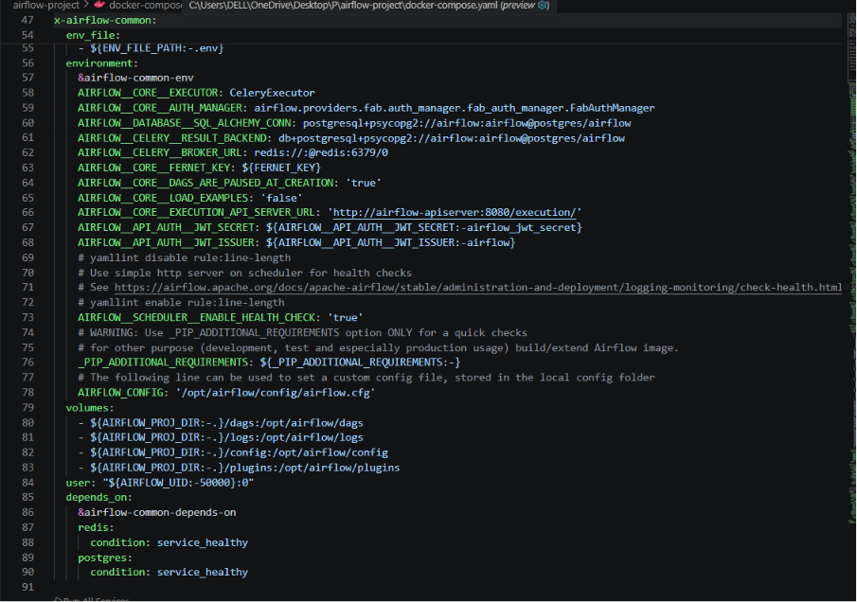
The docker-compose.yaml mounts the following host directories into every
Airflow container:
Host Path | Container Path | Purpose
airflow-project/dags | /opt/airflow/dags | DAG Python files
airflow-project/logs | /opt/airflow/logs | Task execution logs
airflow-project/config | /opt/airflow/config | airflow.cfg overrides
airflow-project/plugins | /opt/airflow/plugins | Custom plugins

Changes to files in `dags/` are picked up by the dag-processor within one
parse cycle (approximately 30 seconds). No container restart is needed
to pick up DAG code changes.

Failure and Retry Behavior
- Each task has 1 retry with a 5-minute delay between attempts.
- Individual city API failures (timeout, network error) are caught inside
the extract loop and do not fail the task. The city is skipped and the
loop continues.
- If zero cities return data, the task raises `ValueError` and the task fails.
- The `UNIQUE(city, timestamp)` constraint prevents duplicate inserts at the
database level even if a DAG run overlaps with a retry or manual trigger.

6. Technology Stack
Full technology breakdown is in docs/tech-stack.md.

Technology Stack

Overview
The project uses a local-only architecture. Orchestration runs in Docker
containers on the development workstation, and data lands in a native SQL
Server instance on the same machine.

Orchestration

Apache Airflow 3.2.0
Attribute | Detail
Executor | CeleryExecutor (distributed task queue)
Image | apache/airflow:3.2.0 (Debian Bookworm base)
UI Port | 8080
Python version | 3.13 (bundled in Airflow image)

Why Airflow: Declarative DAG definition, built-in retry/scheduling, web UI
for monitoring, and Python-native task development.
Why CeleryExecutor over LocalExecutor: CeleryExecutor distributes task
execution to separate worker containers, isolating the scheduler from task
failures. LocalExecutor runs tasks in the scheduler process, which is simpler
but less resilient.

Celery 5.6.3
Attribute | Detail
Broker | Redis 7.2
Result Backend | PostgreSQL 16 (via SQLAlchemy)
Concurrency | 16 prefork workers per worker container

Bundled with Airflow, not installed separately.

Message Broker

Redis 7.2 (bookworm)
Attribute | Detail
Image | redis:7.2-bookworm
Port | 6379 (container-internal only)
Persistence | None (in-memory, data lost on restart)
Authentication | None

Why Redis: Required by CeleryExecutor. Lightweight, fast, no configuration
needed for a single-node setup. Version pinned to 7.2 due to Redis licensing
change (RSALv2/SSPLv1) starting with 7.4.
Note: If Redis restarts, in-flight task messages are lost. The scheduler will
re-queue them on the next heartbeat cycle.

Metadata Database

PostgreSQL 16
Attribute | Detail
Image | postgres:16
Port | 5432 (container-internal only)
Database | airflow
Credentials | airflow / airflow
Persistence | Named Docker volume (postgres-db-volume)

Why PostgreSQL: Default and recommended metadata backend for Airflow. Required
by CeleryExecutor for result backend storage.
Why version 16: Latest stable at time of project creation. Strong performance
and compatibility with Airflow 3.x.

Target Database

Microsoft SQL Server 17 (MSSQLSERVER)
Attribute | Detail
Edition | Developer or Express
Installation | Native Windows service (not Dockerized)
Port | 1433 (TCP/IP, must be enabled manually)
Database | Weather_DataBase
Auth | SQL Server Authentication (sa user)
ODBC Driver | 17 (installed in container and on host)

Why SQL Server: Project requirement. Chosen for familiarity and existing
infrastructure on the development machine.
Why not Dockerized: SQL Server on Docker Desktop for Windows has known
performance limitations with volume mounts on WSL2. Running natively avoids
these issues and simplifies connectivity.

Data Processing

Python 3.13
Runs inside Airflow containers. Not installed on the host for DAG execution
(host Python 3.14 is used only for standalone testing).

pandas 2.3.3
Attribute | Detail
Used for | Building tabular data from API responses

requests 2.33.0
Attribute | Detail
Used for | GET requests with timeout and error handling

SQLAlchemy 2.0.48
Attribute | Detail
Used for | Connection pooling, raw SQL via text(), to_sql

pyodbc 5.3.0
Attribute | Detail
Used for | Low-level database connectivity
Dependency | Requires ODBC Driver 17 at OS level

scikit-learn 1.8.0
Attribute | Detail
Used for | LinearRegression model (temperature prediction)
Features | humidity, wind_speed
Target | temperature

Why LinearRegression: Simple, interpretable, no hyperparameter tuning needed.
Training on 27 observations per batch is fast. A more complex model would
overfit on such a small dataset.

numpy 2.4.3
Attribute | Detail
Direct usage | None (transitive dependency only)

Containerization

Docker Desktop for Windows
Attribute | Detail
Compose version | v2 (bundled)

Docker Compose
Attribute | Detail
Services | 9 (7 running + cli profile + flower profile)
Network | airflow-project_default (bridge)
Volumes | 1 named (postgres-db-volume) + 4 bind mounts

Custom Dockerfile
Attribute | Detail
OS packages | gnupg2, curl, ca-certificates, msodbcsql17, unixodbc-dev
Python packages | pandas, requests, sqlalchemy, pyodbc, scikit-learn
Image size | ~3.12 GB

Why custom image: The stock Airflow image does not include SQL Server ODBC
drivers or the Python packages needed by the DAG. Installing at runtime via
`_PIP_ADDITIONAL_REQUIREMENTS` is slow and non-deterministic. A custom image
ensures reproducible builds.

External Services

Open-Meteo Forecast API
Attribute | Detail
Auth | None (free, no API key)
Rate limit | ~10,000 requests/day (soft guideline)
Data freshness | 15-minute intervals
Used for | Current temperature, humidity, wind speed

See `docs/data-source.md` for full API documentation.

Development Tools
Tool | Version | Purpose
sqlcmd | 18 | SQL Server CLI queries
SSMS | 20+ | SQL Server GUI management
Docker CLI | 24+ | Container management
Docker Compose | v2 | Multi-container orchestration
text editor / IDE | any | DAG and config editing

No CI/CD pipeline is configured. All deployment is manual via docker-compose.

7. ETL Pipeline
Full pipeline documentation is in docs/pipeline.md.

ETL Pipeline
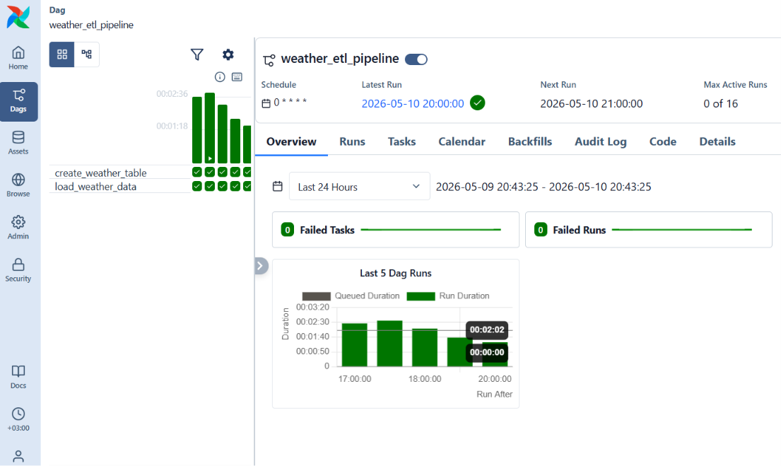
This document describes the extract-transform-load logic in detail.

DAG Configuration
File: `airflow-project/dags/weather_etl_pipeline.py`
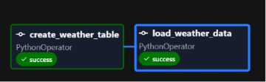
dag_id = "weather_etl_pipeline"
schedule = "@hourly" # triggers at the top of every hour (UTC)
catchup = False # no backfill for missed intervals
start_date = 2026-05-07 # earliest possible run date
retries = 1
retry_delay = 5 minutes
owner = Mahmoud
The DAG defines two tasks with a sequential dependency:
create_weather_table >> load_weather_data

Task 1: create_weather_table
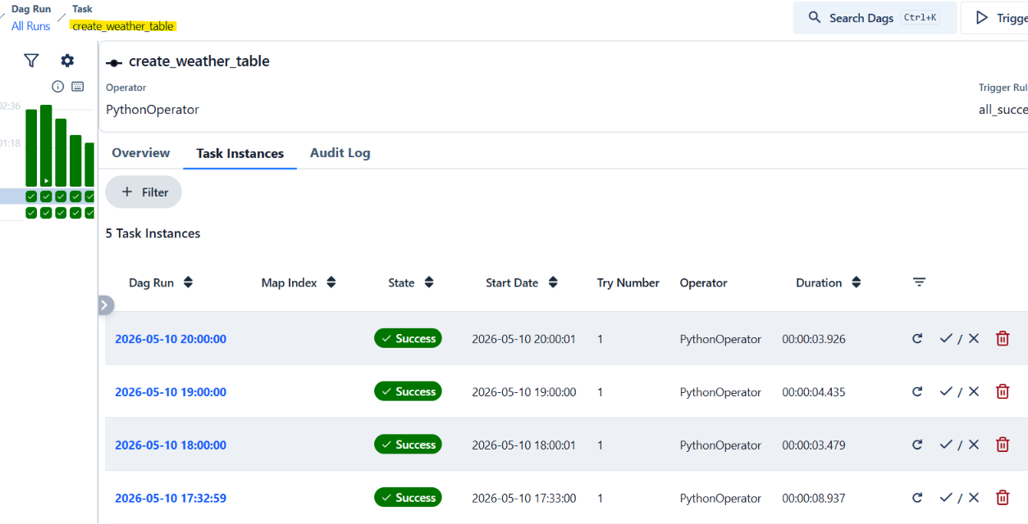
Callable: `create_table()` (line 105)
This task is idempotent. It checks for the table's existence before creating
it using the SQL Server `sysobjects` catalog view:
IF NOT EXISTS (
SELECT * FROM sysobjects WHERE name='WeatherForecast' AND xtype='U'
)
CREATE TABLE WeatherForecast ( ... )
If the table already exists, the statement does nothing. This allows the task
to succeed safely on every run.
The connection is opened with `engine.begin()` which auto-commits the DDL
statement and auto-rolls back on error.

Task 2: load_weather_data
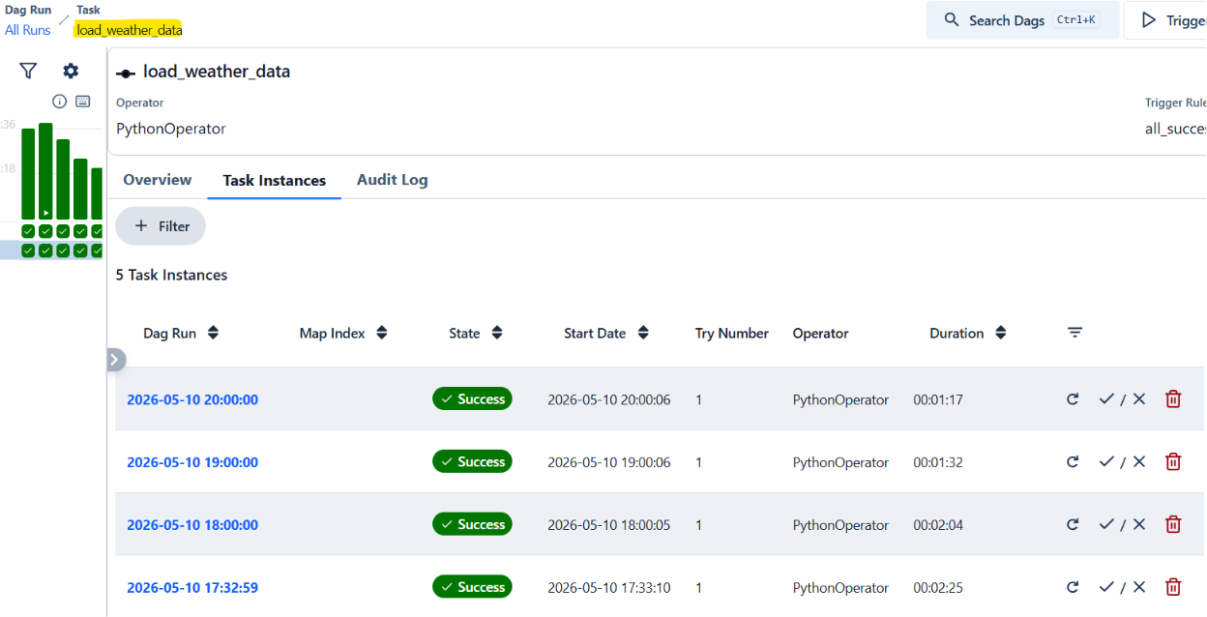
Callable: `load_data()` (line 253)
This task contains the full ETL logic. It calls `extract_transform()` to build
a DataFrame, then iterates over each row to conditionally insert.

Extract Phase
The extract loop iterates over the `governorates` list (27 entries). For each
governorate, it sends an HTTP GET request to:
https://api.open-meteo.com/v1/forecast
Query parameters per request:
Parameter | Value
latitude | gov["lat"] (float)
longitude | gov["lon"] (float)
current | temperature_2m,relative_humidity_2m,wind_speed_10m
timezone | Africa/Cairo

The `timeout` is set to 10 seconds. If a request fails (network error,
timeout, non-200 status), the exception is caught and the city is skipped.
The loop continues to the next governorate.
Each successful response returns JSON with a `current` object. The pipeline
extracts four fields:
JSON Key | DataFrame Column
current.time | timestamp
current.temperature_2m | temperature
current.relative_humidity_2m | humidity
current.wind_speed_10m | wind_speed

Also appended from the governorates list: `city` and `country`.
After the loop, the collected list is converted to a pandas DataFrame. If the
DataFrame is empty (all 27 requests failed), a `ValueError` is raised and the
task fails.

Transform Phase
Three transformations are applied in sequence:
1. Datetime Conversion
df["timestamp"] = pd.to_datetime(df["timestamp"])
Converts the ISO 8601 string from the API (e.g., "2026-05-10T14:00") to a
pandas Timestamp object. SQLAlchemy will handle conversion to SQL Server
DATETIME on insert.
2. Alert Classification
df["alert"] = df["temperature"].apply(
lambda x: "High Temperature" if x > 36
else ("Low Temperature" if x < 15 else "Normal")
)
Applied per row. The thresholds are in degrees Celsius:
Temperature Range | Alert
> 36 C | High Temperature
< 15 C | Low Temperature
15 C - 36 C | Normal

3. ML Prediction
X = df[["humidity", "wind_speed"]]
y = df["temperature"]
model = LinearRegression()
model.fit(X, y)
df["predicted_temperature"] = model.predict(X).round(1)
A new LinearRegression model is trained from scratch on each batch. The model
uses humidity and wind speed as features (X) and actual temperature as the
target (y). The prediction is rounded to one decimal place.
Note: Because the model is trained and discarded per run, there is no model
persistence. Each run produces independent predictions based solely on the
current batch of 27 observations.

Load Phase
The load phase iterates over the DataFrame row by row:
for _, row in df.iterrows():
For each row:
- Call `record_exists(city, timestamp)` which executes:
```sql
SELECT COUNT(*) FROM WeatherForecast
WHERE city = :city AND timestamp = :timestamp
```
- If count > 0, print `[SKIPPED]` and move to the next row.
- If count = 0, wrap the row in a single-row DataFrame and call:
```python
single_row.to_sql("WeatherForecast", con=engine, if_exists="append", index=False)
```
This generates an INSERT statement for one row.
- If the insert fails (e.g., constraint violation from a concurrent run),
the exception is caught and logged, and the loop continues.
After all rows are processed, a summary is printed:
=========== SUMMARY ===========
Inserted : 13
Skipped : 14
================================

Deduplication Mechanism
Deduplication operates at two levels:
Application level: The record_exists() function checks for an existing
row before attempting an insert. This avoids unnecessary INSERT attempts.
Database level: The UNIQUE(city, timestamp) constraint on the
`WeatherForecast` table acts as a hard guard. Even if two concurrent DAG runs
pass the application-level check simultaneously, only one will succeed. The
other will receive a constraint violation error, which is caught and logged.

8. Database Documentation
Full database documentation is in docs/database.md.

Database Documentation
Target: Microsoft SQL Server 17 (MSSQLSERVER instance)
Database: `Weather_DataBase`
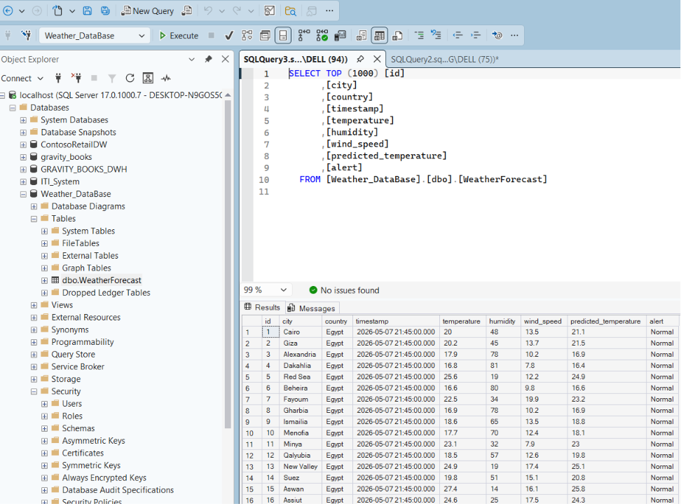

WeatherForecast Table
This is the single fact table in the pipeline. It is created by the DAG on
first run and grows over time as new weather observations are appended.
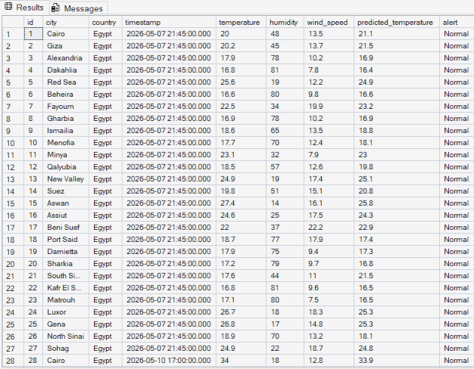

Schema
Column Type Nullable Description
--------------------- ------------- -------- -------------------------------
id INT NO Identity primary key (auto-increment)
city NVARCHAR(100) YES English name of the governorate
country NVARCHAR(100) YES Always "Egypt"
timestamp DATETIME YES Observation time from API (UTC, Africa/Cairo)
temperature FLOAT YES Current temperature in Celsius
humidity FLOAT YES Relative humidity percentage (0-100)
wind_speed FLOAT YES Wind speed at 10m altitude in km/h
predicted_temperature FLOAT YES ML-predicted temperature (LinearRegression)
alert NVARCHAR(100) YES Classification: High Temperature,
Low Temperature, or Normal

Constraints
PRIMARY KEY (id) -- clustered, identity(1,1)
UNIQUE (city, timestamp) -- prevents duplicate observations
The unique constraint on `(city, timestamp)` ensures that each governorate can
have at most one record per distinct timestamp. This is the deduplication
anchor for the entire pipeline.

Indexes
The unique constraint `uq_city_timestamp` automatically creates a non-clustered
unique index on `(city, timestamp)`. No additional indexes are defined.
For query patterns that filter by city and date range, this index provides
efficient lookups.

Growth Estimate
At full capacity (27 cities, hourly inserts):
Period | Rows (approx) | Disk (approx)
1 week | 4,536 | ~1.5 MB
1 month | ~19,440 | ~6 MB
1 year | ~236,520 | ~75 MB

These are conservative estimates. Actual size depends on how many API calls
succeed per run and whether manual triggers add additional rows.

weather_day View
File: `SQLQuery7-5-2026.sql`
A read-only view over `WeatherForecast` that renames columns to human-friendly
aliases and adds a computed `Day` column.
CREATE VIEW weather_day AS
SELECT
id AS ID,
city AS City,
country AS Country,
[timestamp] AS [Timestamp],
temperature AS Temperature,
humidity AS Humidity,
wind_speed AS [Wind Speed],
predicted_temperature AS [Predicted Temperature],
alert AS Alert,
DATENAME(WEEKDAY, [timestamp]) AS Day
FROM WeatherForecast;
The `Day` column returns the full weekday name in English (e.g., "Monday",
"Tuesday") based on the timestamp value. This is computed at query time and
not stored on disk.
Usage:
SELECT * FROM [dbo].[weather_day];
Note: As of the current deployment, this view is defined in the SQL file but
may need to be created manually in SQL Server Management Studio or via sqlcmd
if it does not already exist in the database.

Connection Details
The DAG connects using the following configuration:
Driver: ODBC Driver 17 for SQL Server
Server: host.docker.internal (from Docker containers)
localhost (from standalone script)
Database: Weather_DataBase
User: sa
Password: stored in DAG source (plaintext)
Options: TrustServerCertificate=yes
The SQLAlchemy connection URL format:
mssql+pyodbc:///?odbc_connect=<URL-encoded connection string>

Common Queries
Recent observations for a specific city:
SELECT TOP 10 * FROM WeatherForecast
WHERE city = 'Cairo'
ORDER BY timestamp DESC;
Cities with high temperature alerts in the last 24 hours:
SELECT city, temperature, timestamp
FROM WeatherForecast
WHERE alert = 'High Temperature'
AND timestamp >= DATEADD(HOUR, -24, GETUTCDATE())
ORDER BY temperature DESC;
Average temperature by city today:
SELECT city, AVG(temperature) AS avg_temp
FROM WeatherForecast
WHERE CAST(timestamp AS DATE) = CAST(GETDATE() AS DATE)
GROUP BY city
ORDER BY avg_temp DESC;
Prediction accuracy (mean absolute error) for the latest run:
SELECT TOP 1
AVG(ABS(temperature - predicted_temperature)) AS mae,
MAX(timestamp) AS run_time
FROM WeatherForecast
WHERE predicted_temperature IS NOT NULL
GROUP BY CAST(timestamp AS DATE)
ORDER BY run_time DESC;

9. Data Source: Open-Meteo API
Full API documentation is in docs/data-source.md.

Data Source: Open-Meteo API

Overview
The pipeline uses the Open-Meteo Forecast API to retrieve current weather
conditions for each Egyptian governorate. Open-Meteo is a free, open-source
weather API that does not require registration or API keys.
Base URL: `https://api.open-meteo.com/v1/forecast`

Rate Limits
Open-Meteo does not enforce strict rate limits for non-commercial use. The
documentation mentions a soft guideline of approximately 10,000 requests per
day. This pipeline makes 27 requests per hourly run, totaling approximately
648 requests per day, well within the acceptable range.
No rate-limit headers (`X-RateLimit-Remaining`, `Retry-After`) are returned
in responses.

Request Format
Method: `GET`
Parameters used by this pipeline:
Parameter | Type | Required | Description
longitude | float | yes | Geographic longitude of the city
current | string | yes | Comma-separated list of current weather variables
timezone | string | no | IANA timezone identifier for time formatting

The `current` parameter in this pipeline requests:
- `temperature_2m`: air temperature at 2 meters above ground in Celsius
- `relative_humidity_2m`: relative humidity at 2 meters in percent (0-100)
- `wind_speed_10m`: wind speed at 10 meters above ground in km/h
The `timezone` parameter is set to `Africa/Cairo` (UTC+2 or UTC+3 with DST).

Response Format
The API returns JSON. The structure relevant to this pipeline:
{
"latitude": 30.0444,
"longitude": 31.2357,
"timezone": "Africa/Cairo",
"timezone_abbreviation": "EET",
"utc_offset_seconds": 7200,
"current": {
"time": "2026-05-10T14:00",
"interval": 900,
"temperature_2m": 32.5,
"relative_humidity_2m": 45,
"wind_speed_10m": 18.3
}
}
Fields extracted by the pipeline:
JSON Path | Mapped To | Type
current.temperature_2m | temperature | float
current.relative_humidity_2m | humidity | float
current.wind_speed_10m | wind_speed | float

The `time` field is returned in the requested timezone (Africa/Cairo) as an
ISO 8601 string. The `interval` field indicates the measurement window in
seconds (900 = 15 minutes).

Error Handling in the Pipeline
Each API request is wrapped in a try/except block with a 10-second timeout:
response = requests.get(url, params=params, timeout=10)
response.raise_for_status()
Failure scenarios:
Scenario | Behavior
HTTP 4xx/5xx | raise_for_status() triggers except, city skipped
JSON parse error | Caught by generic except, city skipped
Missing JSON key | Caught by generic except, city skipped

If all 27 cities fail, the DataFrame will be empty and the task raises
`ValueError("No weather data extracted")`, causing the task to fail and
trigger a retry after 5 minutes.

Data Freshness
The `current` weather values are updated by Open-Meteo every 15 minutes
(the `interval` field in the response). Running the pipeline hourly means
each run captures the most recently available observation. Consecutive runs
within the same 15-minute window may return identical `time` values, in
which case the deduplication logic will skip the duplicate insert.

Governorate Coordinates
The 27 coordinates are hardcoded in the DAG file. They represent the
administrative capitals of each Egyptian governorate:
# | City | Latitude | Longitude
1 | Cairo | 30.0444 | 31.2357
2 | Giza | 30.0131 | 31.2089
3 | Alexandria | 31.2001 | 29.9187
4 | Dakahlia | 31.0409 | 31.3785
5 | Red Sea | 24.6826 | 34.1532
6 | Beheira | 30.8481 | 30.3436
7 | Fayoum | 29.3084 | 30.8428
8 | Gharbia | 30.8754 | 31.0335
9 | Ismailia | 30.5965 | 32.2715
10 | Menofia | 30.5972 | 30.9876
11 | Minya | 28.1099 | 30.7503
12 | Qalyubia | 30.3292 | 31.2165
13 | New Valley | 25.4514 | 30.5466
14 | Suez | 29.9668 | 32.5498
15 | Aswan | 24.0889 | 32.8998
16 | Assiut | 27.1783 | 31.1859
17 | Beni Suef | 29.0661 | 31.0994
18 | Port Said | 31.2653 | 32.3019
19 | Damietta | 31.4165 | 31.8133
20 | Sharkia | 30.7326 | 31.7195
21 | South Sinai | 28.7670 | 33.6405
22 | Kafr El Sheikh | 31.1107 | 30.9388
23 | Matrouh | 31.3543 | 27.2373
24 | Luxor | 25.6872 | 32.6396
25 | Qena | 26.1551 | 32.7160
26 | North Sinai | 31.1313 | 33.7984
27 | Sohag | 26.5591 | 31.6957

10. Deployment Documentation
Full deployment documentation is in docs/deployment.md.

Deployment and Operations

Deployment Architecture
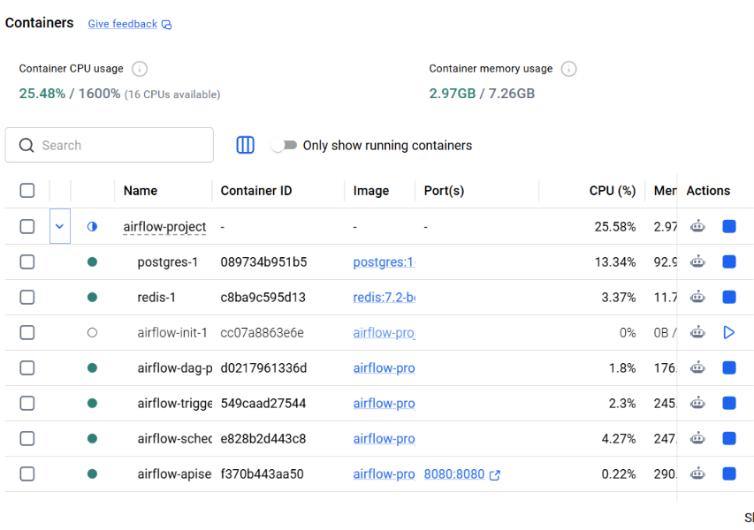
Windows Host (192.168.1.x)
|
+-- SQL Server (MSSQL17) Native Windows service
| |-- Listening on 0.0.0.0:1433
| |-- Database: Weather_DataBase
| |-- Auth: SQL Server (sa)
|
+-- Docker Desktop (WSL2 backend)
|
+-- Docker Network: airflow-project_default (bridge)
|
+-- postgres:16 Container
| |-- Port: 5432 (internal only)
| |-- Volume: postgres-db-volume
| |-- Credentials: airflow / airflow
|
+-- redis:7.2-bookworm Container
| |-- Port: 6379 (internal only)
| |-- No authentication
|
+-- airflow-apiserver Container
| |-- Port: 8080 -> 8080 (exposed to host)
| |-- Login: airflow / airflow
|
+-- airflow-scheduler Container
| |-- Port: 8974 (health, internal)
|
+-- airflow-dag-processor Container
|
+-- airflow-worker Container
| |-- Connects to host SQL Server via
| host.docker.internal:1433
|
+-- airflow-triggerer Container
|
+-- airflow-init Container (exits after setup)

Container-to-Host Communication
Containers reach SQL Server through Docker's DNS resolver. The hostname
`host.docker.internal` resolves to `192.168.65.254` (Docker Desktop gateway).
Traffic is routed from the WSL2 virtual machine to the Windows host network
stack and arrives at SQL Server on port 1433.
Firewall note: Windows Defender Firewall must allow inbound connections on
port 1433 from the WSL2 subnet. Docker Desktop typically configures this
automatically.

Volume Mapping
Host Path Container Path Type
------------------------------------- ------------------------- ------
airflow-project/dags /opt/airflow/dags bind
airflow-project/logs /opt/airflow/logs bind
airflow-project/config /opt/airflow/config bind
airflow-project/plugins /opt/airflow/plugins bind
postgres-db-volume /var/lib/postgresql/data named
Bind mounts allow live editing of DAG files on the host. The named volume
persists PostgreSQL data across container recreations and docker-compose down
(unless `docker-compose down -v` is used).

Environment Details

Host Requirements
Resource | Minimum | Recommended
CPU | 2 cores | 4 cores
RAM | 8 GB (4 GB for Docker) | 16 GB
Disk | 20 GB free | 50 GB free
Docker version | 24.0+ | Latest stable
SQL Server | 2019 Express | 2022 Developer

Software Versions (Current Deployment)
Component | Version | Source
Docker Desktop | Latest | docker.com
WSL2 Kernel | Latest | Docker Desktop bundled
Docker Compose | v2 (bundled) | Docker Desktop
SQL Server | MSSQL17 | Native Windows install
ODBC Driver | 17 | Microsoft (host + container)
Airflow | 3.2.0 | apache/airflow:3.2.0 image
PostgreSQL | 16 | postgres:16 image
Redis | 7.2-bookworm | redis:7.2-bookworm image
Python (in container) | 3.13 | Airflow base image

Environment Variables
File: `airflow-project/.env`
Variable | Value | Purpose
AIRFLOW_UID | 50000 | Container user ID
AIRFLOW__CORE__FERNET_KEY | RYITNM0V5hwAyF0_U6K8G32d4oAoSat... | Encryption key for secrets

File: `airflow-project/docker-compose.yaml` (environment section)
Variable | Value
AIRFLOW__CORE__AUTH_MANAGER | airflow.providers.fab.auth_manager...
AIRFLOW__DATABASE__SQL_ALCHEMY_CONN | postgresql+psycopg2://airflow:airflow...
AIRFLOW__CELERY__RESULT_BACKEND | db+postgresql+psycopg2://airflow:airflow
AIRFLOW__CELERY__BROKER_URL | redis://:@redis:6379/0
AIRFLOW__CORE__DAGS_ARE_PAUSED_AT_CREATION | true
AIRFLOW__CORE__LOAD_EXAMPLES | false
_AIRFLOW_WWW_USER_USERNAME | airflow
_AIRFLOW_WWW_USER_PASSWORD | airflow

Network Ports
Port | Service | Bound To | Accessible From
5432 | postgres | Container only | Other containers
6379 | redis | Container only | Other containers
8974 | scheduler health | Container only | Internal healthcheck
1433 | SQL Server | 0.0.0.0:1433 | Docker containers

Fresh Installation

Step 1: Install Docker Desktop
Download and install Docker Desktop for Windows with the WSL2 backend.
Allocate at least 4 GB RAM and 2 CPUs to Docker.
Verify:
docker --version
docker-compose --version

Step 2: Prepare SQL Server
Install SQL Server 2019 or later (Express edition is sufficient).
Enable mixed-mode authentication during setup.
After installation, open SQL Server Configuration Manager:
- Navigate to SQL Server Network Configuration > Protocols for MSSQLSERVER
- Enable TCP/IP
- Right-click TCP/IP > Properties > IP Addresses > IPAll > set TcpPort to 1433
- Restart the SQL Server service
Create the target database:
CREATE DATABASE Weather_DataBase;
Verify TCP connectivity:
sqlcmd -S localhost,1433 -U sa -P "YourPassword" -C -Q "SELECT 1"

Step 3: Deploy Airflow
cd airflow-project
docker-compose build
docker-compose up -d
Monitor container startup:
docker-compose logs -f
Wait for all 7 containers to report healthy. This typically takes 2-3 minutes.

Step 4: Configure and Unpause
Open http://localhost:8080. Login with airflow / airflow.
Find the `weather_etl_pipeline` DAG and toggle it from paused to active.
The first run will trigger at the top of the next hour.

Configuration Changes

Changing SQL Server Credentials
Edit the connection parameters in `airflow-project/dags/weather_etl_pipeline.py`
at lines 78-86:
SERVER = "host.docker.internal"
DATABASE = "Weather_DataBase"
USERNAME = "sa"
PASSWORD = "YourNewPassword"
Then the dag-processor will pick up the change within 30 seconds. No restart
required.

Changing the Schedule
In the same file, modify line 32:
schedule="@hourly", # options: @daily, @weekly, "0 */2 * * *", etc.

Adding or Removing Governorates
Edit the `governorates` list at line 40. Each entry requires:
{"city": "Name", "country": "Egypt", "lat": 00.0000, "lon": 00.0000}
Coordinates can be looked up at https://open-meteo.com/en/docs.

Rebuilding After Code Changes
If the DAG Python code changes, the dag-processor detects the file change
automatically. No action needed.
If the Dockerfile changes (new system package or pip dependency):
cd airflow-project
docker-compose build
docker-compose up -d
This rebuilds the image and recreates all containers. The PostgreSQL metadata
and Redis state are preserved across rebuilds because they use Docker volumes.

Resetting Airflow to Clean State
This removes all DAG run history, task logs, and UI state. It does not touch
SQL Server data.
# Stop all Airflow services (keep postgres and redis running)
docker-compose stop airflow-scheduler airflow-worker airflow-apiserver \
airflow-dag-processor airflow-triggerer
# Drop and recreate the metadata database
docker exec airflow-project-postgres-1 psql -U airflow -d postgres \
-c "DROP DATABASE airflow;"
docker exec airflow-project-postgres-1 psql -U airflow -d postgres \
-c "CREATE DATABASE airflow;"
# Clean old logs
rm -rf airflow-project/logs/*
# Start everything fresh
docker-compose up -d
The init container will re-run migrations and create the admin user.

Backup and Recovery

Backup
The `airflow_backup.zip` file contains a PostgreSQL dump and logs archive.
To create one manually:
# Dump metadata
docker exec airflow-project-postgres-1 pg_dump -U airflow airflow \
> airflow_metadata_backup.sql
# Package
Compress-Archive -Path logs, airflow_metadata_backup.sql \
-DestinationPath airflow_backup.zip

Recovery
# Restore metadata
Get-Content airflow_metadata_backup.sql | docker exec -i \
airflow-project-postgres-1 psql -U airflow airflow
Note: SQL Server data (`Weather_DataBase`) must be backed up separately using
SQL Server native backup (`.bak` files via SSMS or sqlcmd).

Health Checks
Verify the entire stack:
# Container health
docker ps --format "table {{.Names}}\t{{.Status}}"
# Airflow internal health
docker exec airflow-project-airflow-apiserver-1 \
curl -s http://localhost:8080/api/v2/monitor/health
# SQL Server connectivity from Docker
docker exec airflow-project-airflow-worker-1 python -c \
"import pyodbc; \
conn = pyodbc.connect('DRIVER={ODBC Driver 17 for SQL Server}; \
SERVER=host.docker.internal;DATABASE=Weather_DataBase; \
UID=sa;PWD=Test1234!;TrustServerCertificate=yes'); \
print('OK'); conn.close()"
All three should return positive results for the pipeline to function.

Stopping the Pipeline
cd airflow-project
docker-compose down # stop and remove containers
docker-compose down -v # also remove volumes (deletes metadata DB)
Using `down` without `-v` preserves the PostgreSQL data volume, so the next
`docker-compose up -d` will resume with all history intact.

Troubleshooting

DAG not appearing in the UI
Check the dag-processor logs for import errors:
docker-compose logs airflow-dag-processor
Common causes: Python syntax error, missing import, wrong import path.

Task fails with "Login timeout expired"
SQL Server TCP/IP is not listening. Verify:
netstat -an | findstr ":1433"
If no listener is found, open SQL Server Configuration Manager, enable TCP/IP,
and restart the SQL Server service.

Some cities return API errors
This is expected behavior. The Open-Meteo API may timeout for individual
requests. The 10-second timeout is conservative. Affected cities are logged
and skipped; they will be retried on the next hourly run.

Container keeps restarting
Check the container logs:
docker-compose logs <service-name>
Common causes: insufficient memory (requires 4 GB for Docker), port 8080
already in use by another process.

11. Development Standards
Full development standards are in docs/development-standards.md.

Development Standards

Coding Standards

Python Style
All DAG code follows these conventions, consistent with the existing codebase:
- Indentation: 4 spaces, no tabs
- Line length: no strict limit, but keep readable (existing code averages ~70 chars)
- String quotes: double quotes for strings, single quotes only inside f-strings
if needed to avoid escaping
- Blank lines: one blank line between functions, two blank lines between
sections (separated by comment headers)
- Trailing whitespace: none

Section Headers
The DAG file uses comment blocks to separate logical sections:
# =====================================================
# Section Name
# =====================================================
New sections should follow this pattern for consistency.

Variable Naming
Context | Convention | Example
Functions | snake_case | create_table, load_data
Variables | snake_case | all_data, inserted, skipped
DataFrame columns | snake_case | temperature, wind_speed
DAG IDs | snake_case | weather_etl_pipeline
Task IDs | snake_case | create_weather_table

Function Structure
Functions should:
- Be defined with `def` on its own line
- Have a blank line after the definition
- Use a single blank line between logical steps inside the function
- Print status messages using the `[SUCCESS]`, `[ERROR]`, `[SKIPPED]`,
`[INSERTED]` prefix pattern
- Return values explicitly (no implicit None returns for void functions)

SQL in Python
- Use triple-quoted multi-line strings for SQL queries
- Use SQLAlchemy `text()` with named parameters (`:city`, `:timestamp`)
for parameterized queries
- Never use string formatting or f-strings to build SQL queries
- Use `engine.begin()` for DDL and write operations (auto-commit)
- Use `engine.connect()` for read operations

Error Handling
- Use specific exception types where possible
- The existing pattern uses a generic `except Exception as e` in the extract
loop to catch all API failures per city -- this is acceptable for network
calls but avoid it for database or logic errors
- Always log the error context (city name, query, etc.)

DAG File Structure
A DAG file should follow this order:
# 1. Imports
from airflow import DAG
from airflow.providers.standard.operators.python import PythonOperator
from datetime import datetime, timedelta
import requests
# ... other imports
# 2. Default arguments
default_args = { ... }
# 3. DAG definition
dag = DAG( ... )
# 4. Configuration constants
SERVER = "..."
DATABASE = "..."
# ... connection setup
# 5. Data definitions (lists, dicts)
governorates = [ ... ]
# 6. Helper functions
def create_table(): ...
def extract_transform(): ...
def record_exists(): ...
def load_data(): ...
# 7. Task definitions
create_table_task = PythonOperator( ... )
load_weather_task = PythonOperator( ... )
# 8. Pipeline dependencies
create_table_task >> load_weather_task
No executable code at module level beyond definitions and the DAG object.
Airflow imports the file top-to-bottom on every parse cycle.

Import Conventions
Order of imports (separated by blank lines):
# 1. Airflow imports
from airflow import DAG
from airflow.providers.standard.operators.python import PythonOperator
# 2. Python standard library
from datetime import datetime, timedelta
# 3. Third-party packages
import requests
import pandas as pd
from sqlalchemy import create_engine, text
from sklearn.linear_model import LinearRegression
Import path for PythonOperator in Airflow 3.x:
# Correct (Airflow 3.x)
from airflow.providers.standard.operators.python import PythonOperator
# Deprecated (Airflow 2.x, generates warning in 3.x)
from airflow.operators.python import PythonOperator

Git Workflow

Branching
Branch | Purpose
dev | Active development
feature/* | New features (e.g., feature/add-alerting)
fix/* | Bug fixes (e.g., fix/api-timeout)

Commit Messages
Format:
<type>: <short description>
<optional longer description>
Types:
Type | Usage
feat | New feature
fix | Bug fix
docs | Documentation changes only
refactor | Code restructuring without behavior change
config | Configuration or infrastructure change
chore | Maintenance (cleanup, dependencies)

Examples:
feat: add air_pressure to weather metrics collection
fix: increase API timeout from 10s to 30s for Red Sea governorate
docs: add deployment architecture diagram to docs
config: upgrade Airflow from 2.8.1 to 3.2.0
refactor: extract connection config into Airflow variables

Files to Ignore
The `.gitignore` excludes:
- `__pycache__/` and `*.pyc` (Python bytecode)
- `.venv/` (local virtual environment)
- `airflow-project/logs/` (runtime logs, regenerated)
- `airflow-project/.env` (secrets and Fernet key)
- `.vscode/`, `.idea/` (IDE configs)
- `desktop.ini`, `Thumbs.db` (OS files)
- `*.docx` (binary documents)

Adding a New Python Dependency
- Add the package to the `RUN pip install` line in `airflow-project/Dockerfile`
- Add the pinned version to `requirements.txt`
- Rebuild: `docker-compose build && docker-compose up -d`
Do not use `_PIP_ADDITIONAL_REQUIREMENTS` in docker-compose.yaml for permanent
dependencies. It reinstalls on every container start, adding 30+ seconds to
startup time.

Adding a New DAG
- Create a new `.py` file in `airflow-project/dags/`
- Follow the DAG file structure above
- The dag-processor will detect the new file within 30 seconds
- No container restart needed
Each DAG should be in its own file. Do not define multiple DAGs in one file.

Configuration Management

Secrets
Currently, the SQL Server password is hardcoded in the DAG file. This is a
known security gap. The recommended migration path is:
- Store credentials in Airflow Connections (UI > Admin > Connections)
- Reference them in the DAG via environment variables or the Airflow secrets
backend
- Never commit `.env` files or passwords to version control

Environment-Specific Values
The only environment-specific value is `SERVER`:
- `host.docker.internal` inside Docker
- `localhost` for standalone testing
If deploying to multiple environments, use Airflow Variables or environment
variables to avoid hardcoding.

12. Operational Runbook
Full runbook is in docs/runbook.md.

Operational Runbook

RBO-01: Force a Manual DAG Run
When you need to trigger the pipeline outside the hourly schedule.
# Option A: Via Airflow UI
# 1. Open http://localhost:8080
# 2. Find weather_etl_pipeline
# 3. Click the play button (Trigger DAG)
# Option B: Via CLI
docker exec airflow-project-airflow-apiserver-1 \
airflow dags trigger weather_etl_pipeline
Verify the run:
docker exec airflow-project-airflow-apiserver-1 \
airflow dags list-runs -d weather_etl_pipeline

RBO-02: Restart the Entire Pipeline
When containers are unhealthy or behaving unexpectedly.
cd airflow-project
docker-compose restart
If restart does not resolve the issue:
docker-compose down
docker-compose up -d
Verify all 7 containers are healthy:
docker ps --format "table {{.Names}}\t{{.Status}}"
Wait 2-3 minutes for all health checks to pass.

RBO-03: Restart a Single Container
When one service is failing but others are fine.
# Example: restart only the worker
docker-compose restart airflow-worker
# Example: restart only the scheduler
docker-compose restart airflow-scheduler
The DAG run history and task state are preserved in PostgreSQL. In-flight
tasks will be re-queued by the scheduler after restart.

RBO-04: Check Recent DAG Run Results
# View the latest task logs
$files = Get-ChildItem -LiteralPath "airflow-project\logs\dag_id=weather_etl_pipeline" `
-Recurse -Filter "*.log" | Sort-Object LastWriteTime -Descending | Select-Object -First 3
foreach ($f in $files) { Get-Content $f.FullName -Tail 15 }
# Check row count in SQL Server
sqlcmd -S localhost -U sa -P "Test1234!" -C -Q `
"USE Weather_DataBase; SELECT COUNT(*) FROM WeatherForecast"

RBO-05: Add a New Governorate
- Open `airflow-project/dags/weather_etl_pipeline.py`
- Find the `governorates` list (line 40)
- Add a new entry:
{"city": "New City", "country": "Egypt", "lat": 00.0000, "lon": 00.0000}
- Save the file
- The dag-processor will detect the change within 30 seconds
- No container restart needed
- The new city will be included in the next hourly run (or trigger manually
with RBO-01)

RBO-06: Change SQL Server Password
- Change the `sa` password in SQL Server:
ALTER LOGIN sa WITH PASSWORD = 'NewPassword123!';
- Update the DAG file `airflow-project/dags/weather_etl_pipeline.py` line 84:
PASSWORD = "NewPassword123!"
- Update the standalone script `test_7-5-2026.py` line 48:
PASSWORD = "NewPassword123!"
- The dag-processor picks up the change within 30 seconds
- Verify connectivity:
docker exec airflow-project-airflow-worker-1 python -c \
"import pyodbc; \
conn = pyodbc.connect('DRIVER={ODBC Driver 17 for SQL Server}; \
SERVER=host.docker.internal;DATABASE=Weather_DataBase; \
UID=sa;PWD=NewPassword123!;TrustServerCertificate=yes'); \
print('OK'); conn.close()"

RBO-07: Rebuild the Docker Image
When the Dockerfile is modified (new OS package or Python dependency).
cd airflow-project
docker-compose build
docker-compose up -d
This recreates all containers with the new image. The PostgreSQL data volume
is preserved.
If you want a completely clean build (no cache):
docker-compose build --no-cache
docker-compose up -d

RBO-08: Reset Airflow to Clean State
When you want to clear all run history and start fresh.
Warning: This deletes all DAG run history and task logs. SQL Server data is
not affected.
# 1. Stop all Airflow services
cd airflow-project
docker-compose stop airflow-scheduler airflow-worker airflow-apiserver `
airflow-dag-processor airflow-triggerer
# 2. Drop and recreate the metadata database
docker exec airflow-project-postgres-1 psql -U airflow -d postgres `
-c "DROP DATABASE airflow;"
docker exec airflow-project-postgres-1 psql -U airflow -d postgres `
-c "CREATE DATABASE airflow;"
# 3. Clean logs
Remove-Item -LiteralPath "logs\*" -Recurse -Force
# 4. Start fresh
docker-compose up -d
The init container will run migrations and recreate the admin user.

RBO-09: Clean Old Data from SQL Server
When the WeatherForecast table grows large and you want to remove old records.
-- Delete records older than 30 days
DELETE FROM WeatherForecast
WHERE timestamp < DATEADD(DAY, -30, GETUTCDATE());
-- Or delete records older than 90 days
DELETE FROM WeatherForecast
WHERE timestamp < DATEADD(DAY, -90, GETUTCDATE());
-- Check current row count
SELECT COUNT(*) FROM WeatherForecast;
-- Check size on disk
EXEC sp_spaceused 'WeatherForecast';

RBO-10: View Container Resource Usage
# Live resource monitor (CPU, memory, network, disk I/O)
docker stats
# Disk usage summary
docker system df
# Per-container resource usage (snapshot)
docker ps --format "table {{.Names}}\t{{.Size}}" -s

RBO-11: Diagnose a Failed DAG Run
Step-by-step diagnostic flow:
# Step 1: Check which task failed
$files = Get-ChildItem -LiteralPath "airflow-project\logs\dag_id=weather_etl_pipeline" `
-Recurse -Filter "*.log" | Sort-Object LastWriteTime -Descending | Select-Object -First 3
foreach ($f in $files) { Write-Output "=== $($f.Name) ==="; Get-Content $f.FullName -Tail 10 }
# Step 2: If error contains "Login timeout expired"
# -> SQL Server TCP/IP is not listening
# -> See RBO-12
# Step 3: If error contains "ImportError" or "ModuleNotFoundError"
# -> Missing Python dependency in Docker image
# -> See RBO-07 to rebuild with the missing package
# Step 4: If error contains "Connection refused" or "ConnectTimeout"
# -> API network issue from Docker to Open-Meteo
# -> Usually transient, retry with RBO-01
# Step 5: If error contains "UNIQUE constraint"
# -> Duplicate insert attempt (expected, not an error)
# -> The row already exists, no action needed

RBO-12: Fix SQL Server Connectivity Issues
When tasks fail with "Login timeout expired" or "Connection refused".
# Step 1: Check if SQL Server service is running
Get-Service -Name 'MSSQLSERVER'
# Step 2: Check if port 1433 is listening
netstat -an | findstr ":1433"
# Step 3: If not listening, enable TCP/IP
# Open SQL Server Configuration Manager
# SQL Server Network Configuration > Protocols for MSSQLSERVER > Enable TCP/IP
# Properties > IP Addresses > IPAll > TcpPort = 1433
# Restart SQL Server service:
Restart-Service -Name 'MSSQLSERVER'
# Step 4: Verify from host
sqlcmd -S localhost,1433 -U sa -P "Test1234!" -C -Q "SELECT 1"
# Step 5: Verify from Docker
docker exec airflow-project-airflow-worker-1 python -c \
"import pyodbc; \
conn = pyodbc.connect('DRIVER={ODBC Driver 17 for SQL Server}; \
SERVER=host.docker.internal;DATABASE=Weather_DataBase; \
UID=sa;PWD=Test1234!;TrustServerCertificate=yes'); \
print('OK'); conn.close()"

RBO-13: Create a Backup

Airflow Metadata + Logs
# Dump PostgreSQL
docker exec airflow-project-postgres-1 pg_dump -U airflow airflow `
> airflow_metadata_backup.sql
# Package everything
Compress-Archive -Path "logs", "airflow_metadata_backup.sql" `
-DestinationPath "airflow_backup.zip" -Force

SQL Server Data
BACKUP DATABASE Weather_DataBase
TO DISK = 'C:\Backups\Weather_DataBase.bak'
WITH FORMAT, INIT, NAME = 'Weather_DataBase-Full Backup';
Or via SSMS: Right-click database > Tasks > Back Up.

RBO-14: Stop Everything
# Stop containers but keep data
cd airflow-project
docker-compose down
# Resume later
docker-compose up -d
To also remove the PostgreSQL data volume (full cleanup):
docker-compose down -v
Warning: `down -v` deletes all Airflow run history permanently.

13. Glossary
Term | Definition
ETL | Extract, Transform, Load -- the process of moving data from source to target with transformations
DAG | Directed Acyclic Graph -- Airflow's representation of a workflow with task dependencies
CeleryExecutor | Airflow executor that distributes tasks to Celery workers via a message broker
WSL2 | Windows Subsystem for Linux version 2 -- used by Docker Desktop as the virtualization backend
ODBC | Open Database Connectivity -- a standard API for accessing database management systems
pyodbc | Python module that provides ODBC database connectivity
SQLAlchemy | Python SQL toolkit and Object-Relational Mapping library
Fernet Key | Symmetric encryption key used by Airflow to encrypt connection passwords and variables
Celery | Distributed task queue library used by Airflow's CeleryExecutor
Redis | In-memory data store used as the Celery message broker
Celery Worker | Process that executes tasks from the Celery queue
Airflow Scheduler | Process that evaluates DAG schedules and queues task instances for execution
Dag Processor | Process that parses DAG files and registers them in the metadata database
Triggerer | Airflow process that manages asynchronous triggers for deferrable operators
Bind Mount | Docker volume type that maps a host directory into a container
Named Volume | Docker volume managed by Docker, stored in Docker's internal storage
host.docker.internal | Special DNS name in Docker Desktop that resolves to the host machine's IP
Open-Meteo | Free, open-source weather API that provides forecast and historical weather data
Linear Regression | Statistical method that models the relationship between a dependent variable and one or more independent variables
scikit-learn | Python machine learning library providing classification, regression, and clustering algorithms
pandas | Python data manipulation library providing DataFrame data structures
Idempotent | An operation that produces the same result whether executed once or multiple times
Catchup | Airflow behavior that backfills missed DAG runs between the start date and the current date
Fernet | Symmetric encryption implementation in the cryptography library, used by Airflow for secrets
Health Check | Docker mechanism to verify that a container is functioning correctly

Sign-Off

Role | Name | Signature | Date
Developer | Mahmoud |  | May 2026

