You need Eclipse 3.5 or later to install the EGit plug-in. In the newest version of Eclipse, you can click 'help' -> 'eclipse marketplace' and search for "egit".
Switch to “Git Repository Exploring” perspective.
Clone the repository (from repository view)
On GitHub, if you have write permissions to a repository, you can get the URL by logging in to your GitHub Account and pressing the ‘HTTP’ button on the repository page. For example, on http://www.github.com/ivpr/weave/, I get the following URL when I click ‘HTTP’: https://adufilie@github.com/IVPR/Weave.git
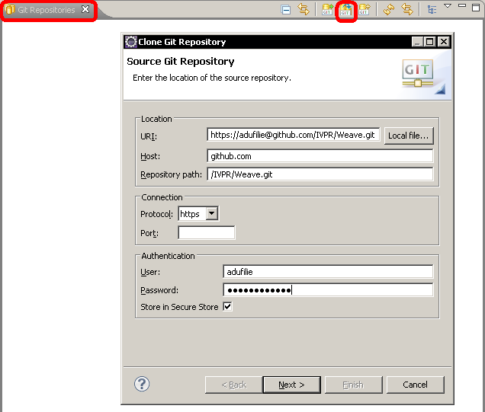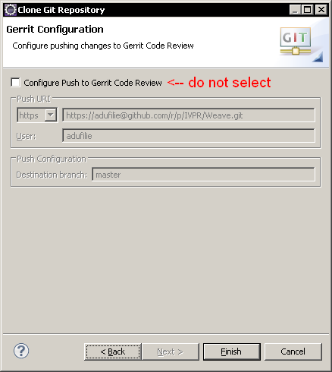
Import the projects (from repository view)
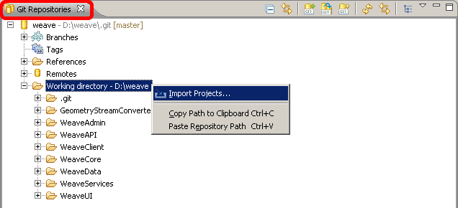
You can now start modifying the code. The projects & files you have modified locally have ">" in front of their names in eclipse (but not for files that have been added/removed).
Commit your changes to your local repository (from navigator view)
This does not affect the remote repository.
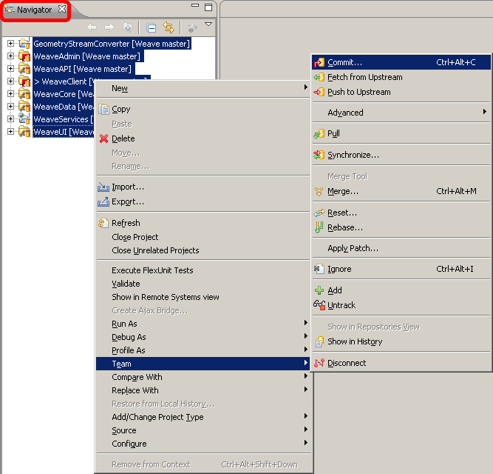
When you are satisfied with your local copy…
Push the changes from your local repository to the remote repository (from repository view)
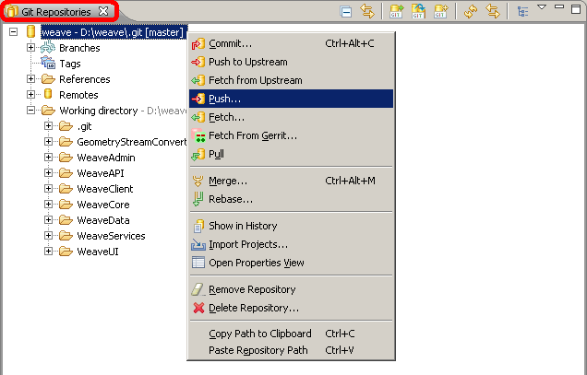
Do not use the automatically configured remote repository location – it doesn’t work. Instead, use the same repository location you entered earlier.
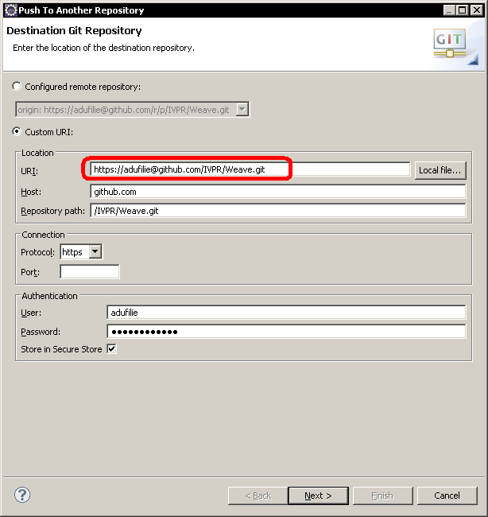
Specify the branches to push.
