Maciej Tkacz
Simulation Engineer - Physics-Based Robot Simulation, CAD-to-Sim, Python
PROFILE  Simulation engineer with two years of commercial experience building physics-based robot simulations and digital twins of production systems, scripting simulation logic in Python, and turning CAD models into working simulation assets. Mechanical Engineering student at Cracow University of Technology, so the physical parameters, kinematics and constraints I tune in a simulator are quantities I understand from first principles rather than numbers I adjust until the scene looks right. Currently a Robotics Engineer at ASTOR, programming Kawasaki and Epson industrial robots and their vision systems, building digital twins of production lines and commissioning the physical stations those twins describe - so I routinely see where a simulation and the real machine disagree. I also designed, built and programmed a SCARA robotic arm from scratch, including its forward and inverse kinematics, and validated the control software against the physical arm. I am now moving this work onto the OpenUSD and Isaac Sim pipeline, which is the toolchain rather than the discipline that is new to me.  WHAT I BRING  - Physics-based simulation, commercially: two years building robot workcell simulations and digital twins for automotive production, covering robot motion, process logic, collision checking, reach validation and cycle behaviour before anything was built physically.  - Python inside the simulator, including my own plugins: scripted simulation behaviour, automated scene and process setup, and optimized simulation performance through Visual Components' Python API. When a cell needed behaviour the built-in options could not express, I wrote plugins and functions for it rather than simplifying the process to fit the tool.  - CAD to simulation asset: SolidWorks, Autodesk Inventor, Fusion 360 and AutoCAD. I prepare, simplify and optimize 3D geometry specifically for simulation use - reducing mesh complexity, fixing collision geometry, and keeping assets usable rather than merely accurate.  - Validating and tuning physical parameters: kinematics, joint constraints, gear ratios, masses and inertias derived from CAD rather than guessed. My mechanical engineering coursework covers dynamic systems modelling, control and analytical mechanics.  - Where simulation meets the real machine: I program Kawasaki and Epson robots and commission the physical stations, so I see the gap between a model and the hardware regularly - which is the part of this discipline that cannot be learned from a simulator alone.  - Robot vision, on the station and in the simulator: the Epson vision system in RC+ and the Kawasaki vision system. Camera and robot calibration, object models and search setup tuned so detection holds up, part queues, and several different objects on a feeder at the same time. I have also run the Epson vision loop inside the RC+ simulator.  - Client trials, simulation first and then the real robot: for a specific project I test the chosen robot configuration in simulation, build a quick physical station around that robot, repeat the trial, and write the report with the measurements and the full procedure. The cell side of that work is Astraada PLCs in CODESYS, HMI screens, and Ethernet/IP, PROFINET, Modbus and EtherCAT.  - NVIDIA Isaac Sim and OpenUSD: currently in progress on my own hardware - porting the SCARA arm I built into USD and driving it from Python. I would rather state this accurately than claim commercial hours I do not have.  - Working practice: Git-based version control of simulation assets and code, technical documentation of simulation workflows, and direct communication of assumptions and constraints to client engineers.  SELECTED PROJECT  SCARA Robotic Arm - designed, built, programmed and measured | Personal R&D project  - Designed the complete machine: mechanical concept, CAD, kinematic layout and gear ratios, selection of NEMA stepper actuators and TMC/DRV drivers, microcontroller electronics and wiring.  - Implemented forward and inverse kinematics in Python and C++ and validated the control software against the physical arm rather than only against the model.  - Designed every printed part for stiffness and assembly in PET-G and carbon-fibre reinforced material, iterating through repeated print, assemble and test cycles.  - The reason this matters for a simulation role: I own both halves of the comparison. I have the CAD, the real masses and inertias, the kinematic model and the physical machine, which makes a measured sim-to-real study possible rather than hypothetical.  EXPERIENCE  Robotics Engineer | ASTOR, Krakow, Poland | Jul 2026 - present  - Build digital twins of production lines and robot simulations, validating reach, motion sequences and process behaviour before physical implementation.  - Program Kawasaki and Epson robots, including vision-guided applications: calibration, object models and search setup, part queues, and several different objects on a feeder at the same time.  - Run the Epson vision loop inside the RC+ simulator as well as on the station, and do the same class of vision work on the Kawasaki vision system.  - Design, build and commission demonstration stations presenting these robots in different applications - mechanical assembly, hardware-software integration, programming and bring-up.  - Program Astraada controllers in CODESYS: PLC logic, HMI screens, and the cell network on Ethernet/IP, PROFINET, Modbus and EtherCAT.  - For client projects, test a robot configuration in simulation first, then build a physical test station around the real robot and repeat the trial, to see how that configuration behaves in the actual application. Write the report with the measurements and the full procedure.  Application Engineer | AIAutomation, Poland | Jan 2025 - May 2026  - Built robotics simulations and digital twins of production workcells in Visual Components for automotive clients.  - Wrote Python scripts, plugins and functions inside Visual Components: automation and process logic where the built-in options were enough, and custom behaviour where they were not.  - Developed robot paths, motion sequences, process logic, collision checking and cycle flows; validated processes virtually before implementation.  - Prepared and optimized workcell layouts and 3D geometry for simulation use, working from CAD in SolidWorks and Autodesk Inventor.  - Worked from customer documentation and engineering standards, and presented simulation assumptions, constraints and improvement proposals directly to client engineers.  3D Printing and CAD Design Specialist | Cubic Inch Additive Manufacturing, Piaseczno, Poland | Dec 2022 and Jun 2023 - Aug 2023  - Started with an internship in December 2022. The company brought me back for the summer of 2023.  - Designed and optimized CAD models in Fusion 360 and Autodesk Inventor for additive manufacturing.  - Ran FDM, MJF and SLA printers in production: process parameters, post-processing and quality control.  - Coordinated production tasks in a 10-person team, balancing quality, manufacturability and deadlines.  Robotics and 3D Printing Intern | ASTOR Robotics Center, Krakow, Poland | May 2022  - Assembled mechanical hardware and 3D-printed components for Kawasaki robots and Astorino robot platforms.  - Programmed Kawasaki robots via teach pendant and wrote basic motion programs.  EDUCATION  - Cracow University of Technology - Mechanical Engineering, Engineer's degree in progress (Oct 2024 - present). Coursework: dynamic systems modelling, automation and control, analytical mechanics, mechatronics.  - PKMechPower Student Research Group, Mechanical Section - CAD and 3D-printed parts for a student vehicle, optimized for mass and strength.  - Zespol Szkol Informatycznych, Kielce - Software Technician diploma (Sep 2019 - Apr 2024).  CERTIFICATES  - Kawasaki robot operation and programming - integrator course with certificate, ASTOR Robotics Center.  - Epson industrial robot programming - certified course.  - Python programming courses, plus self-directed Python and C++ development in robotics and simulation projects. | 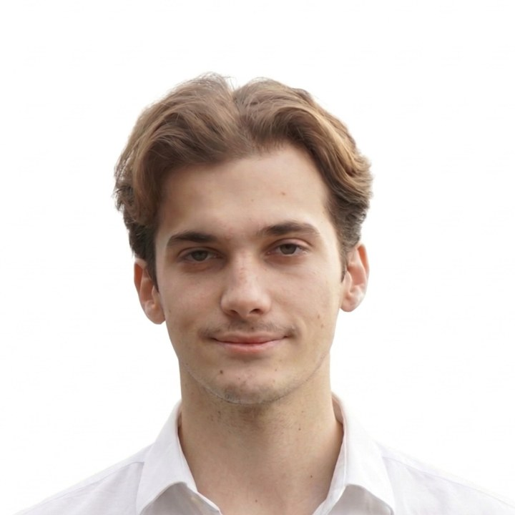  CONTACT  - maciek01110@gmail.com  - +48 881 912 125  - Krakow, Poland  ELIGIBILITY  - Polish citizen (EU)  - No sponsorship needed  LANGUAGES  - Polish - native  - English - C1  SIMULATION  - Visual Components  - Python plugins in VC  - Digital twins  - Physics-based simulation  - Collision checking  - Cycle & process validation  - Kinematics & constraints  - Isaac Sim (in progress)  CODE  - Python  - C++ / Arduino C  - Git  - MATLAB basics  - ROS (personal projects)  CAD & 3D  - SolidWorks  - Autodesk Inventor  - Fusion 360  - AutoCAD  - Mesh & collision prep  - FDM / SLA / MJF printing  VISION  - Epson vision in RC+  - Kawasaki vision  - Calibration  - Object models & search  - Part queues  - Multi-part feeder  - Vision-in-the-loop, RC+  ROBOTS  - Kawasaki  - Epson  - Self-built SCARA  CONSENT  I consent to the processing of my personal data for the purpose of this recruitment process.

