**Table of Figures**

Figure 1 Architectural Diagram 20

Figure 2 ERD 21

Figure 3 Registration/Login 22

Figure 4 Consultant Login 23

Figure 5 Training requests to Mentor 24

Figure 6 SME Questions 25

Chapter 1

* Introduction

* Overall Description

LMS landing page will have search and filter

▪ By default, All courses, which are offered by Organization or outsource companies, will display

▪ The user can filter courser based on categories,topics , by the organization , by the consultant . paid or unpaid .

▪ System should also suggest similar or related courses

▪ When user click on a course for details then it will show following content:

• A panel to start a course

• Course tittle , course fee, certificate fee

• Course owner

• Number of quizzes

• Number of hours

• Course level

• Per requisites

• Course detail will be shown.

• A list of documents to download related to that course (User should sign in to download the materials)

• Certificate request. At the end of the course if the user wants to receive a certificate online payment of a certain amount needs to be submitted

• User will have to login to register to a course

• Upon registration, completion and certificate generation confirmation email will be sent to the user .

• User dashboard and profile will keep a track of all the courses done and in progress.

• User should be able to send a message to the course owner and receive a response .

• Courses will be added by the administrator or submitted by the consult anting firm to the administrator for approval and will make it available .

• Administrator will have the option to deactivate any course

• Keep a record of all the course transitions

• Generate course certificate

• Change email templates

• Set course price and certificate price

• Course owner will add : tittle , level , prereq courses, outline , description, quizzes , add course video and noted , course image .

* Product Overview

The project envisages provision of handholding support and business development services to SMEs to promote business start-up, improve efficiencies in existing SME value chains to make them globally competitive and provide a conducive business environment .

Scope

* Development of New Components / Feature enhancements and Security Protocols etc.
* Data Migration, Maintenance & Support
* Maintenance of web portal
* Product Features
* Online Courses (Videos and Course Notes)
* Online Advisory Services (e.g. “e-Ticketing System” customization will be required)
* Communication between users
* Management of Downloadable items
* Management of Trainings / Workshops
* User Registration & Management
* Latest News ticker / scroll
* Information and Advice for SMEs
* Training Services for SMEs
* Helpdesk Registration
* All downloadable content must require user registration
* E-Payment System
* Newsletter / Email Subscriptions
* On-site Comprehensive Search
* Discussion Forum
* Dynamic Dashboard with graphical visualization of the user activities
* A system for mass emails and SMS notifications.
* User data to be collected for reporting purposes.
* Survey / Assessment and User Feedback Management System
* Publications
* Complaint Login system - E-ticketing
* Project Timelines
* Social icons and menu in footer
* Live Trainings / Workshop Sessions (e.g. “Knowledge Center (Learning Management System)” customization will be required)
* Stakeholders

The stakeholders for the website include:

* Existing and potential SMEs
* Service providers
* Public Sector Stakeholders, Students or Knowledge seekers
* Consultants
* Mentor
* Users
* **Web Administrator**

Are responsible for maintaining and updating their company's website. They help ensure website is user friendly and offer an optimal user experience.

* The administrator will have to monitor the following through their Dashboards:
* Approve the requests
* Approval of courses is required if content is uploaded by Service Providers
* Management of Downloadable Items e.g. Word, Excel, PPT and PDF files along-with Customized Reporting exportable to excel & pdf formats.
* Send confirmation email to users.
* Manage all transactions, if SME pay for a course to the client, who is then responsible to pay that specific Service Provider who upload that course.
* Manage users
* Analytics details
* Should have an option to push recently answered questions by consultant to put in FAQs.
* **Mentor**

Mentors are related to the client firm, they help the SMEs to plan, launch, maintain or grow their business. They offered different courses for SMEs which help in their business.

Their tasks are:

* No public profile
* No uploading
* One to one communication with SMEs, can be a video call
* Webinar
* Trainings
* Answer the queries by SMEs.
* Publications
* **Consultant**

Consultants can be a company or individuals, they help the SMEs to plan, launch, maintain or grow their business. They offered different courses for SMEs which help in their business.

Consultants can do following tasks through their Dashboards:

* Can be individual or companies
* Should signup/login
* Account will verify by admin
* Verified tag will shown
* Public profile
* Uploaded documents will be approved by admin then it will go publicly.
* Will receive reminder email if not logged in after months or account can be inactive after one year.
* Answer the questions.
* Badges will show after 30 average answers.
* Can manage their profiles
* Sector wise identification
* Give trainings (On ground trainings)
* Webinar
* Can upload courses in LMS
* One to many webinar communication
* Their activities will be shown by admin
* Publications
* **Service Provider (Companies)**
* Outsource Companies
* Should be paid by the client firm for the uploaded courses.
* **SMEs**

Existing or potential SMEs who needs help to plan, launch, maintain or grow their business. They avail different courses which are offered by Consultants or Mentors to help in their business.

SMEs can do following tasks through their Dashboards:

* Should Signup/Login
* Attend Trainings, Workshops, Seminars
* Receive guidance for business
* Ask questions from consultants
* Can rating to consultants
* Give feedback
* Download the content
* Should pay for certificates – E-payment
* Join Discussion Forum
* SMS Notification and emails for all announcements
* Avail funding
* Receive notifications
* Have option to upgrade to Consultant.
* Can put their success stores
* Text (250-1000 words)
* Image
* Functional Requirements
* Web Portal/Websites need to be professional in terms of design, graphics, layout and display of information.
* Overall, the sites need to look and perform more professionally.
* Revised and smooth Portal navigation
* Data Reporting & Analytics (Google Analytics)
* An integrated URL shortening system (like bit.ly)
* Integration of Subscribed International Importers directory, Trade Data etc.
* User Registration & Management
* Multi domain / Site Management.
* Content Updates Slider / Scroll.
* Dynamic Corporate Templates (at least 5 Mockups for the selection of 1)
* Feature Rich Text Editor – RTE
* Image Gallery / Video Gallery
* FAQs / Knowledge base
* A Logical 3 tier page hierarchy will be used
* Responsive Mobile interface
* Responsive Template over variant layouts of different devices
* Minimal load time (not more than 3 seconds)
* SEO Optimized Architecture, dynamic meta generation for Search Engine Indexing and Ranking
* User Friendly Interface, Readability and Consistency across the website
* Cross browser consistency using at least IE6, IE7, IE8, Edge, Firefox 2.x, 3.x, 4.x, 5.x, Safari and Chrome.
* XHTML/CSS/HTML used in the portal must be W3C compliant.
* Dynamic design structure smarty’s based framework (separate UI/UX layer)
* The website will be created using bootstrap with HTML 5 to achieve the responsive interfacing.
* The backend database will be developed with the functionality to be used online or on a local network.
* Custom Form Builder
* Image Carousal for Dynamic Banners
* Social media platform integration with dynamic data extraction based on meta
* Multi-level access and security should be generated in the Web Portal/websites.
* Role base approach the super admin will be able to approve the Mentor, Consultants (uploading documents and content) and SMEs.
* Website should be available in two (2) languages Urdu and English, Bilingual Support.
* Website Functionality

To design and develop a dynamic, flexible, scalable and user friendly website portal integrating content management system. Furthermore, the website / Portal architecture will be fluid so that it can be customized seamlessly in case a customization need arises in future.

* Downloadable Information

A section dedicated for users who wish to download / have access to relevant information in documented form.

* This may include document type, software type, multimedia type, etc.
* All downloadable content must require user registration
* User data to be collected for reporting purposes for all downloads from website and stored in the database. This should include login access for all internal users.
* Information and Advice for SMEs
* Live advisory / consultancy sessions for SMEs by the experts, the web portal will have the functionality for program announcements, online registrations and allocation of time slots for one-on-one consultancy sessions, user feedback and program rating etc.
* A section dedicated for Individual experts / consulting Firms enabling them to submit forms, upload documents and maintain their own profile and e-Ticketing complaint / query management system that may be linked to consultant database or designated resources. Further this section may include provision for the users to search for the individual experts / consulting firms to avail their services.
* A general section for registration of SME’s so that all announcements, product and services information and other information may be shared on regular basis.
* A system for mass emails and SMS notifications.
* Training Services for SMEs
* Offering online training programs, having features such as online registration / login profile of participants, presentations, presentation notes, training exercises, assessment and marking / grading, issuance of certificates and user feedback etc.
* Announcement of classroom based trainings and option for online registration.
* Helpdesk Registration
* Registration of SMEs approaching either physically, or through email / phone calls etc. and recording their contact details, information requests, and service provided by the helpdesk staff.
* E-Payment System
* A system to receive payments against e-services provided through the Portal; training programs, OTC documents (if any), any others as identified.
* Data Reporting & Analytics
* Reporting system including but not limited to user registration details, statistics related to description of downloads and their frequency, etc.
* Reports to be generated for all user based downloads / activities against any selected time frame.
* Dynamic Dashboard with graphical visualization of the user activities.
* Interoperability
* It needs to be ensured that while developing the said portal, all its constituent components used for such purpose, should not create dependency structure where other components or modules could not be integrated.
* Important Considerations
* All items including but not limited to web Portal template, components, plug-ins, modules, images, graphics or any kind of subscriptions should be licensed / purchased / copyrighted.
* The developers will create the web Portal on their own development server. The developer may shift the web Portal when it is ready to The Employer’s server for QC and testing purposes.
* JavaScript framework for front end listing e.g. data-tables etc. for efficient, fast pagination & searching of records and also for form validation.
* As per this tender document, any agreement that lead to subscription, should be avoided.

Website databases should have the following functionalities:

* The database must be well-designed, tuned and have well-documented conceptual and relational modeling and data normalization to at least the third form
* Online and offline data entry (if applied online, the data is stored locally and uploaded when internet is on)
* Custom data entry checks to validate data
* User management and access control to provide or limit roles and users
* The database should provide different levels of access (admin, developer, administrator)
* User interface configurable metadata and components
* Features to log deleted records and retrieve for future access
* Automatic backup system on a daily/scheduled basis to an external site
* Design and Implementation Constraints
* **Technology stack**
* Laravel 7.x
* MySQL

Chapter 3

* Specific Requirements
* External Interface Requirements
* **User Interfaces**
* Front-end software: HTML5, Bootstrap, CSS3, JavaScript
* Back-end software: MySQL
* **Hardware Interfaces**
* Windows.
* A browser which supports HTML & Javascript.
* **Software Interfaces**

Following are the software used:

|  |  |
| --- | --- |
| **Software used** | **Description** |
| Operating system | We have chosen Windows operating system for its best support and user-friendliness. |
| Database | To save the users records, SMEs records we have chosen MySQL database. |
| CMS | To implement the project we have chosen the base language of Laravel 7.x which is an open-source PHP web framework for its more interactive support. JavaScript framework for front end listing e.g. data-tables etc. for efficient, fast pagination & searching of records and also for form validation. |
| Server | The developer should create the web Portal on its own development server. The developer may shift the web Portal when it is ready to The Employer’s server for QC and testing purposes. |

* **Communication Interfaces**

This project supports all types of web browsers. The website will work and be tested against popular browsers including the following:

* Internet Explorer
* Google Chrome
* Mozilla
* Safari
* Opera

Chapter 4

* Design
* Architectural Diagram

**Figure 1 Architectural Diagram**

* ERD

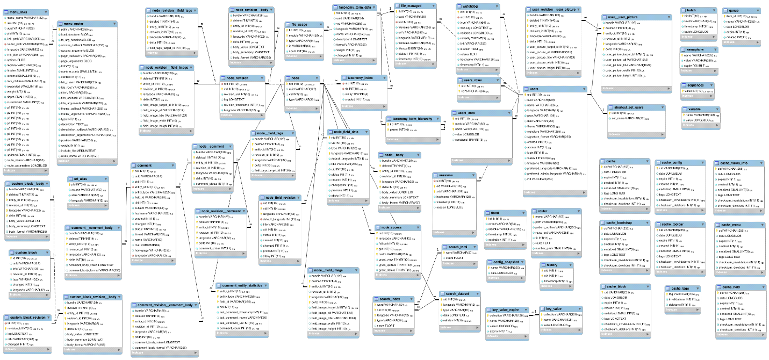

**Figure 2 ERD**

* Work flows
* **Registration / Login**

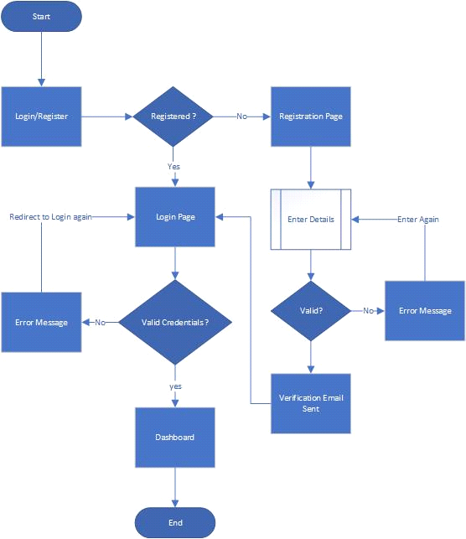

**Figure 3 Registration/Login**

* **Consultant login**

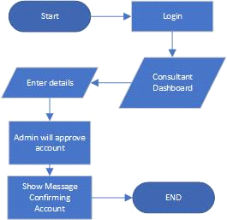

**Figure 4 Consultant Login**

* **Training requests to Mentor**

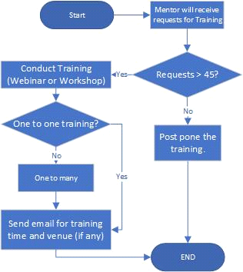

**Figure 5 Training requests to Mentor**

* **SME Questions**

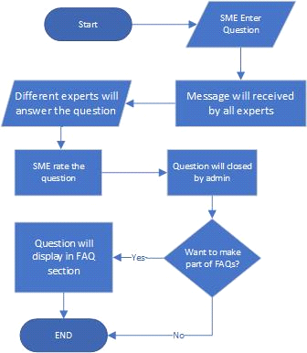

**Figure 6 SME Questions**

Chapter 5

* Non-Functional Requirements
* Security

The group or individual responsible for this platform’s development will demonstrate compliance with international security standards and best practices for integrity and confidentiality of website content/data (<http://www.w3.org/TR/wsc-ui/>). All administrative data transactions will use secure protocols providing confidentiality, integrity and non-repudiation. All inputs will be properly sanitized to prevent injection and cross-site scripting attacks.

Establishment of two (02) stage authentication security protocols for the access of web Portal. Company shall ensure portal security from internal and external unwarranted activity that may lead to compromise of data, service interruption or any such resultant which should have been part of system design vulnerabilities.

* Reliability

The development company/individual shall also ensure its reliability and efficiency in terms of performance, costs and other factors that may be hindrance.

* Maintainability

**Administrator**: The Administrator will manage the website through a simple dashboard interface. The user interface will allow modification/updating of content in all sections of the website. The Administrator will be able to introduce new administrators for specific sections who can modify/manage their respective sections. The section administrators/content managers will have privileges limited only to the modification of their respective sections.

**Identity Management**: This includes authentication services and authorization services which allow the administrator to manage usernames/passwords and map roles and privileges of other users.

**Website Analytics**: Google Analytics will be used to keep track of the website traffic. This will contain details about the top pages which were accessed, number of users who visited the site, mediums used to access website etc.

Chapter 6

* Web Pages
* Web Pages
* Home
* Business Guide
* Funding Programs
* About us
* Happenings
* Trainings
* Projects
* Knowledge center
* Resources
* Local Assistance
* **Home**

In the home section we will create a primary goal and responsibility to tell visitors where they are and what else they can do while they're visiting the site

* Banner
* A slider with different images.
* Startup Button (detailed description on next heading)
* Business startup

A Portion containing following cards (a mouse hover will show a drop down slide with all inner pages links related to that topic)

* Plan your business
* It gives your business direction, defines your objectives, maps out strategies to achieve your goals and helps you to manage possible bumps in the road. Preparing a business plan will help you work out the goals you want to achieve, and the strategies to achieve them.
* Launch your business
* Launching a business - which means to introduce your business to the marketplace. This is when your organization begins marketing and selling your solution.
* Manage your business
* Management consists of the interlocking functions of creating corporate policy and organizing, planning, controlling, and directing an organization's resources in order to achieve the objectives of that policy.
* Grow your business
* Growth strategy allows companies to expand their business. Growth can be achieved by adding new locations, investing in customer acquisition, expanding a product line, etc.
* Our Services

Different methods that can help with your business:

* Free Business counseling
* Find Advisor
* A page will display with following fields:
* Find (enter any keyword like course or advisor name)
* Near (Enter your Zip code)
* Search
* Trainings
* Webinars
* Webinars can be closed or open.
* Already planned webinars will show on page
* You can directly request to attend the webinar.
* A list of fields will be given to request for a new or existing webinar.
* Course name
* SME Name
* Email
* A button (Request for webinar)
* Workshops
* Workshops
* Already planned workshop will show on page and user can request for to join workshop till due date.
* A list of fields will be given to request for a new or existing webinar.
* Course name
* SME Name
* Email
* A button (Request for webinar)
* Funding programs
* Grants
* It will redirect us to a page with detailed information of Grants and how we can avail this service.
* Funding through partnership with banks
* It will redirect us to a page with detailed information of funding from banks and how we can avail this service.
* Testimonials
* A Slider will be shown in which all Success stories by SMEs, Partners and Clients.
* List of their partners
* A slider will be shown of all their partners logos
* When we click on a logo then it redirects to main website of that company.
* Footer
* Customer Service
* [About](https://www.sba.gov/about-sba) the firm
* Redirect to about page.
* [Contact](https://www.sba.gov/about-sba/what-we-do/contact-sba)
* Redirect to Local Assistance page
* [Media and Press Relations](https://www.sba.gov/about-sba/sba-newsroom)
* All publications will display here
* [Locations](https://www.sba.gov/about-sba/sba-locations)
* All offices with names and location on map.
* [Team](https://www.sba.gov/about-sba/sba-team)
* About team and their designations.
* [Tools and Features](javascript:void(0);)
* [Online Training](https://www.sba.gov/tools/sba-learning-center/search/training)
* [Find Events](https://www.sba.gov/events/find/)
* Gallery
* **Startup**
* A button on a banner which redirects you to primary guidelines to start a business.
* When u redirects to that page it will have the following content:
* Do your Research
* A learn more button will redirect the user to

Business Guide -> [Market research and competitive analysis](https://www.sba.gov/business-guide/plan-your-business/market-research-competitive-analysis)

* Make a plan
* A learn more button will redirect the user to

Business Guide -> Write your Business Plan

* Plan your finance
* A learn more button will redirect the user to

Business Guide -> Financial Services

* Choose business Structure
* A learn more button will redirect the user to

Launch your Business -> Choose a Business structure

* Choose business name
* A learn more button will redirect the user to

Launch your Business -> Choose a Business name

* Get registered
* A learn more button will redirect the user to

Launch your Business -> Register your Business

* Set up a location
* A learn more button will redirect the user to

Launch your Business -> Pick your Business Location

* Get your team ready
* A learn more button will redirect the user to

Manage your Business -> [Hire and manage employees](https://www.sba.gov/business-guide/manage-your-business/hire-manage-employees)

* Promote your Business
* A learn more button will redirect the user to

Manage your Business -> Marketing and sales

* **Business Guide**

You need a plan in order to make your business idea a reality. A business guide is a blueprint that will guide your business from the start-up phase through establishment and eventually business growth, and it is a must-have for all new businesses.

* Plan your business

A business plan is a written document that describes in detail how a business, usually a new one, is going to achieve its goals.

* [Market research and competitive analysis](https://www.sba.gov/business-guide/plan-your-business/market-research-competitive-analysis)
* Market research can also assist you to monitor market trends and keep an eye on what your competition is doing.
* All methods for doing a market research will define here.
* [Write your business plan](https://www.sba.gov/business-guide/plan-your-business/write-your-business-plan)
* A document that tells what you plan to do and how you plan to do it.
* A guidance for writing a business plan will be shown here.
* Financial Services

Financing is the process of providing funds for business activities, making purchases or investing.

* Financial Calculators
* The main function of a financial calculator is to calculate payments, determine interest rates and to solve for the present or future value of a loan or annuity.
* SME Financing Products
* SME Financing Products Database is a search engine of loans offered by Banks to entrepreneurs including small and medium sized businesses.
* In which u can select your preferred options from the menu and click 'search' for results.
* Credit Guarantee scheme for small and rural enterprises
* [Buy an existing business or franchise](https://www.sba.gov/business-guide/plan-your-business/buy-existing-business-or-franchise)
* A detailed guidelines for buy an existing or already active business.
* Launch your business

Business launch is the first impression people will remember.

* [Pick your business location](https://www.sba.gov/business-guide/launch-your-business/pick-your-business-location)
* A guideline for choose a location for business which is more suitable to SME.
* [Choose a business structure](https://www.sba.gov/business-guide/launch-your-business/choose-business-structure)
* How to choose an appropriate business structure will display here.
* [Choose your business name](https://www.sba.gov/business-guide/launch-your-business/choose-your-business-name)
* How to choose an appropriate name for business will be shown here.
* [Register your business](https://www.sba.gov/business-guide/launch-your-business/register-your-business)
* Method will be defined that how SME can register their business according to government rules and regulations.
* [Open a business bank account](https://www.sba.gov/business-guide/launch-your-business/open-business-bank-account)
* SME should open a separate account for business.
* Manage your business

Business management is the act of organizing people to accomplish the desired goals and objectives of a business. In each following links, it’s defined that how SME can manage their business.

* [Manage your finances](https://www.sba.gov/business-guide/manage-your-business/manage-your-finances)
* [Hire and manage employees](https://www.sba.gov/business-guide/manage-your-business/hire-manage-employees)
* [Pay taxes](https://www.sba.gov/business-guide/manage-your-business/pay-taxes)
* [Stay legally compliant](https://www.sba.gov/business-guide/manage-your-business/stay-legally-compliant)
* [Buy assets and equipment](https://www.sba.gov/business-guide/manage-your-business/buy-assets-equipment)
* [Marketing and sales](https://www.sba.gov/business-guide/manage-your-business/marketing-sales)
* [Close or sell your business](https://www.sba.gov/business-guide/manage-your-business/close-or-sell-your-business)
* Grow your business

It is a process of improving some measure of a business success. In following, detailed description in each link is defined.

* [Get more funding](https://www.sba.gov/business-guide/grow-your-business/get-more-funding)
* [Expand to new locations](https://www.sba.gov/business-guide/grow-your-business/expand-new-locations)
* [Merge and acquire businesses](https://www.sba.gov/business-guide/grow-your-business/merge-acquire-businesses)
* **Funding programs**
* Funding through partnership with banks
* SMEs conventionally turn to banks for a loan to fund their operations.
* The bank will also look to the credentials and experience of the SMEs in making its lending decision.
* Grants
* A Portal
* Grants are non-repayable funds or products disbursed or given, often a government department, corporation, foundation or trust, to a recipient, often a nonprofit entity, educational institution, business or an individual.
* **About Us**
* Our Story
* Write down the company’s story and History.
* CEO’s message
* A message from CEO including Video
* Vision & Mission
* A paragraph about the mission of the client firm
* Advisors
* List of Advisors will be shown
* View Profile
* Profile of a consultant with all their expertise will be shown.
* Meet the team
* List of all the key members with their information.
* **Happenings**
* News
* All news will be shown in a representable form
* Announcements
* Upcoming events with date and time
* Important news
* Events
* Workshops
* Topic
* Date and time
* Speakers
* Summary
* Seminars
* Topic
* Date and time
* Speakers
* Summary
* Gallery
* Video & images
* When click on them, a pop up image or video will be shown.
* Blogs
* All blogs by consultants will be displayed here.
* Success Stories
* SMEs will describe their success business with the client
* All the success stories including video will be shown here
* Stats
* Keep tracks and reports website traffic like
* Number of SMEs
* Number of consultants
* **Trainings**
* Offering online training programs, having features such as online registration / login profile of participants, presentations, presentation notes, training exercises, assessment and marking / grading, issuance of certificates and user feedback etc.
* Announcement of classroom based trainings and option for online registration.
* **Local Assistance**
* Get local assistance
* A button (Search nearby) will display here.
* A page will display in which a user can search the nearest office according to their location.
* Offices
* It will redirect to page in which list of all offices with map will be shown.
* Help Desk
* Registration of SMEs approaching helpdesks across the country, either physically, or through email / phone calls etc. and recording their contact details, information requests, and service provided by the helpdesk staff.
* FAQ’s
* List of different questions about business with their answers.
* The questions by SMEs will also be shown here with answers (if it will approved for FAQs).
* Complaint Login system - E-ticketing
* A form for complain
* Name
* Email
* Subject
* Complain
* After complaint submission an e-ticket will generate.
* **Projects**
* Upcoming projects
* All upcoming projects will display here with a small description.
* After redirect a detailed page of project will displayed.
* Ongoing Projects
* All ongoing projects will display here with a small description.
* After redirect a detailed page of project will displayed.
* Completed projects
* All completed and featured projects will display here with a small description.
* After redirect a detailed page of project will displayed.
* **Knowledge Center**
* A button (All courses)
* All courses, which are offered will display when user click on button.
* When user click on a course for details then it will show following content:
* A panel to start a course (some courses will be paid)
* Course detail will be shown.
* A list of documents to download related to that course (User should sign in to download the materials)
* Certificate request
* If SME request for a certificate then SME should pay for any course.
* The courses will display according to the following headings.
* Plan your business
* Sub topics of this heading will be display here and their related courses
* Launch your business
* Sub topics of this heading will be display here and their related courses
* Manage your business
* Sub topics of this heading will be display here and their related courses
* Grow your business
* Sub topics of this heading will be display here and their related courses
* **Resources**
* Publications
* A list of articles, books & other publications which are uploaded
* These documents will be downloadable.
* Research Publications
* A list of articles, books & other publications.
* These documents will be downloadable.
* Initiatives for SME promotion and Development

Chapter 7

* **Site** Map
* Site Map
* **Home**
* Language switch ( Urdu/English )
* Banner
* Business startup
* Plan your business
* Launch your business
* Manage your business
* Grow your business
* How we can help you?
* Free business counselling
* Grants
* Funding programs
* Testimonials
* List of their partners (can be a slider)
* Footer
* **Business Guide**
* Plan your business
* [Market research and competitive analysis](https://www.sba.gov/business-guide/plan-your-business/market-research-competitive-analysis)
* [Write your business plan](https://www.sba.gov/business-guide/plan-your-business/write-your-business-plan)
* Financial Services
* Financial Calculators
* SME Financing Products
* Credit Guarantee scheme for small and rural enterprises
* [Buy an existing business or franchise](https://www.sba.gov/business-guide/plan-your-business/buy-existing-business-or-franchise)
* Launch your business
* [Pick your business location](https://www.sba.gov/business-guide/launch-your-business/pick-your-business-location)
* [Choose a business structure](https://www.sba.gov/business-guide/launch-your-business/choose-business-structure)
* [Choose your business name](https://www.sba.gov/business-guide/launch-your-business/choose-your-business-name)
* [Register your business](https://www.sba.gov/business-guide/launch-your-business/register-your-business)
* [Open a business bank account](https://www.sba.gov/business-guide/launch-your-business/open-business-bank-account)
* Manage your business
* [Manage your finances](https://www.sba.gov/business-guide/manage-your-business/manage-your-finances)
* [Hire and manage employees](https://www.sba.gov/business-guide/manage-your-business/hire-manage-employees)
* [Pay taxes](https://www.sba.gov/business-guide/manage-your-business/pay-taxes)
* [Stay legally compliant](https://www.sba.gov/business-guide/manage-your-business/stay-legally-compliant)
* [Buy assets and equipment](https://www.sba.gov/business-guide/manage-your-business/buy-assets-equipment)
* [Marketing and sales](https://www.sba.gov/business-guide/manage-your-business/marketing-sales)
* [Close or sell your business](https://www.sba.gov/business-guide/manage-your-business/close-or-sell-your-business)
* Grow your business
* [Get more funding](https://www.sba.gov/business-guide/grow-your-business/get-more-funding)
* [Expand to new locations](https://www.sba.gov/business-guide/grow-your-business/expand-new-locations)
* [Merge and acquire businesses](https://www.sba.gov/business-guide/grow-your-business/merge-acquire-businesses)
* **Funding programs**
* Funding through partnership with banks
* Grants
* **About Us**
* Our Story
* CEO’s message
* Vision & Mission
* Advisors
* Meet the team
* **Happenings**
* News
* Announcements
* Events
* Workshops
* Seminars
* Gallery
* Video & images
* Success Stories
* **Trainings**
* Workshops
* Webinars
* **Local Assistance**
* Get local assistance
* Offices number
* Help Desk
* FAQ’s
* Complaint Login system - E-ticketing
* **Projects**
* Upcoming projects
* Ongoing Projects
* Completed projects
* **Knowledge Center**
* All Courses
* Courses related to planning a business
* Courses related to Launch a business
* Courses related to managing a business
* Courses related to growing a business
* **Resources**
* Publications
* Research Publications
* Initiatives for SME promotion and Development