Module Website

# Install Instructions for Module Website (Pierce Jordan)

## Student No: 10011177

## Manual Installation:

### Step 1:

Download this [*repository*](https://github.com/Web-Application-GMIT-Semester2/PierceJ_ModuleWebsite)from github. Click “Clone or download” and select “Download ZIP option”.

This will download a file called ***PierceJ_ModuleWebsite-master.zip*** to your Downloads folder or to a specified folder of your choice

### **Step 2:**

Right-Click on PierceJ_ModuleWebsite-master.zip and select Extract All option



**Step 3:**

Using the wizard extract files directly to %WEBSERVER%. This will place files into a subfolder called PierceJ_ModuleWebsite-master

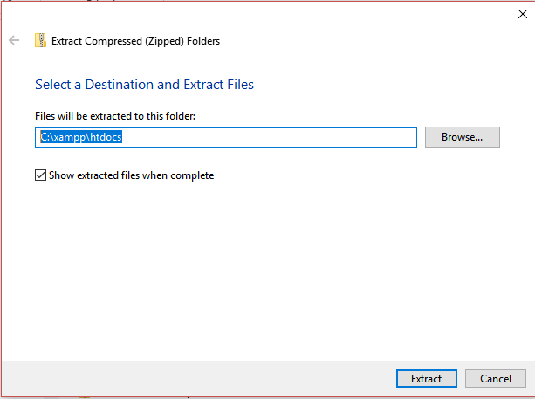%WEBSERVER% = path to your webserver installation. E.G. xampp = C:\xampp\htdocs

**Step 4:**

Launch browser of choice (Developed on Firefox, Tested on IE11, EDGE and Chrome).

**Step 5:**

Paste in following to browser address bar. This site contains a link to my final project.

<http://localhost/PierceJ_ModuleWebsite-master/>