**FYP Final Report**

**A Web Based Final Year Project Management System**

Final Year Project Report

by

**Tarique Hassan (023-17-0053)**

**Muhammad Ahsan (023-17-0045)**

**Suhail Ahmed (053-17-0013)**

In Partial Fulfillment

Of the Requirements for the degree

Bachelor of Science (CS/SE)

Sukkur IBA University,

Sukkur, Sindh Pakistan

(2021)

**A Web Based Final Year Project Management System**

by

**Tarique Hassan**

**Muhammad Ahsan**

**Suhail Ahmed**

SUBMITTED TO THE DEPARTMENT OF COMPUTER SCIENCE IN PARTIAL FULFILLMENT OF THE REQUIREMENTS FOR THE DEGREE OF

**BACHELOR OF SCIENCE IN COMPUTERR SCIENCE / SOFTWARE ENGINEERING**

at the

SUKKUR IBA University

**October, 2021**

**© 2021 Tarique Hassan, Muhammad Ahsan and Suhail Ahmed**. All rights reserved.

The author hereby grants permission to Sukkur IBA to reproduce and distribute publicly paper and electronic copies of this thesis and grant others the right to do so.

Signature of Author(s)

**Tarique Hassan, Muhammad Ahsan, Suhail Ahmed**

Certified by: Internal Examiner

**Khalid Hussain**

**Lecturer, Computer Science**

External Examiner

**<Name>,**

**<Designation>, <Department & Organization>**

Accepted by:

**<Name>,**

**<Designation>, <Department>**

**DECLARATION**

We hereby declare that this project report entitled “A WEB BASED FINAL YEAR PROJECT MANAGEMENT SYSTEM” submitted to the “DEPARTMENT OF COMPUTER SCIENCE**”**, is a record of an original work done by us under the guidance of Supervisor “KHALID HUSSAIN” and that no part has been plagiarized without citations. Also, this project work is submitted in the partial fulfillment of the requirements for the degree of Bachelor of Computer Science.

|  |  |
| --- | --- |
| **Team Members** | **Signature** |
| Tarique Hassan |
| Muhammad Ahsan |
| Suhail Ahmed |
|  |  |
|  |  |
| **Supervisor:** | **Signature** |
| Khalid Hussain |  |
| **Date:** ______________ |  |
| **Place:** ______________ |  |

**ACKNOWLEDGEMENTS**

We are truly happy and thankful to our supervisor “Khalid Hussain” who support us and shows the path for achieving our goal. He kept us motivated and gave us very healthy environment. We are also thankful to our committee head “Dr Abdul Rehman Soomrani” and FYP Coordinator “Dr Asif Rajput” for their valuable comments on our projects and also help us to gather information related to our project

Contents

INTRODUCTION 9

**1.1** **Project objectives** 9

**1.2** **Intended Audience** 10

**1.3** **Chapter Summary** 10

LITERATURE REVIEW 11

**2.1** **Overview** 11

**2.2** **Background** 11

Problem definition 14

**3.1** **Project Scope** 15

Methodology 16

**4.1** **Development Methodology** 16

**4.1.1** **Waterfall Development Model** 16

**4.1.2** **Application of Chosen Methodology** 17

**4.2** **Project Technical Approach** 19

**4.2.1** **Front-end framework** 20

**4.2.2** **Back-end framework** 20

**4.2.3** **Database Technology** 20

**4.3** **Work division** 20

Detailed design and architecture 22

**5.1** **System architecture** 22

**5.1.1** **System level block diagram** 23

**5.1.2** **Architecture Design Approach** 24

**5.1.3** **Architecture Design** 24

**5.1.4** **Subsystem Architecture** 26

**5.2** **Detailed system design** 26

**5.3** **Class diagram** 31

**5.4**  **Database diagram** 32

IMPLEMENTATION AND testing 33

**6.1** **Implementation** 33

**6.2** **Testing** 35

Results and discussion 44

Conclusion and future work 51

**8.1** **Conclusion** 51

**8.2** **Future Work** 51

**8.2.1** **Meetings** 51

**8.2.2** **Project Evaluation** 52

REferences 53

**List of Figures**

Figure 1: Waterfall Model 16

Figure 2: System level block diagram 23

Figure 3: System Architecture 24

Figure 4: System Architecture Design 25

Figure 5: Subsystem Architectural Design 26

Figure 6: Use case diagram 30

Figure 7 Class Diagram for FYP Management System 31

Figure 8: database diagram 32

Figure 9: Add User 44

Figure 10: Edit User 44

Figure 11: Add Supervisor 45

Figure 12: User List 45

Figure 13: Groups List 46

Figure 14: Approve Groups 46

Figure 15: Post New Report 47

Figure 16: Group Under Supervision 47

Figure 17: Submit Reports 48

Figure 18: Create Group 49

Figure 19: usability survey from students 50

Figure 20: usability survey from teachers 50

**List of Tables**

Table 1: Work division 20

Table 2: Login Unit Test 36

Table 3: Edit Profile Or User testing 37

Table 4: Document Submission Form testing 38

Table 5: Search User testing 39

Table 6: Login testing with different roles 40

Table 7: Manage User testing 41

Table 8: Make announcement testing 41

Table 9: Report submission testing 42

Table 10: Committee Evaluation testing 42

**ABSTRACT**

The entire final year project (FYP) is a year-long process including meetings of students with their supervisors to achieve FYP milestones. Most of the educational institutes manually manage FYPs of students which is a very hectic task for FYP committees, supervisors, and project group members. It is extremely important to implement recent technologies to reduce these complexities and provide a platform to communicate and manage more easily. The proposed system will provide an online platform that will help three kinds of users: final year project (FYP) committee, project supervisors, and project group members. Further, this web-based system will automate the whole FYP process that consists of assessing students, maintaining records of previous FYPs, and provide a user-friendly environment. This system can serve as a valuable source in educational institutes so that FYP committees, supervisors can monitor FYP related activities. In future, it can be extended to manage and achieve milestones for master’s and PhD thesis Programs.

***Chapter 1***

**INTRODUCTION**

In undergraduate program of computer science department, FYP (Final Year Project) is a project-based course which is an important part of degree for final year students. The objective of FYP is to examine student’s learning efforts, project management skill, teamwork, and performance throughout whole degree program.

In computer science department at Sukkur IBA University, the final year students are offered a project-based course for the last 2 semesters of the degree. In the first phase, students form a group of two, finalize their FYP idea and work together under a supervisor that comes in project allocation process. After that, students and supervisors arrange meetings to work further on the project. In these meetings students submit reports (i.e. abstracts, proposals, SRS’s) to their supervisors and get feedback to complete milestones of the project.

This whole manual process is time-consuming and difficult to manage. There should be an easier way to carefully monitor project activities, project records and project progress status. This will assist both supervisors and students to achieve the project milestones on given deadlines. Also, will be helpful for students in getting immediate feedback from their supervisors when they are not available in the campus. A web-based approach is best for monitoring project activities and progress.

* 1. **Project objectives**

The proposed system, as we will discuss in this section, will replace the manual system and solve these problems by providing a web-based platform to assist the users. Additionally, the system will combine whole FYP process in a single web-based platform which includes, managing user profiles, assessing students, keeping updated with project progress, and maintaining previous and current project records in a user-friendly way. This system can be used as a valuable source in computer science department at Sukkur IBA University so that FYP committees, supervisors, and students (groups) can monitor FYP related activities. The final output of the system will be a web-based final year project (FYP) management system.

* 1. **Intended Audience**

The intended audience are FYP Committee including FYP Coordinator, Project supervisor, and Project Groups. This system is for the Computer Science department, Sukkur IBA University to automate the whole manual process.

* 1. **Chapter Summary**

In this chapter, a brief introduction of the project and project objectives have been discussed including features of the project. In chapter 2, literature review is discussed which includes comparison of this project with other projects. In chapter 3 and 4, Problem definition which includes detailed background of project and methodology is discussed respectively. In chapter 5, the architecture and design of the project is discussed in detail. In chapter 6, implementation and testing of the project has been discussed. In chapter 7, results and discussion has been discussed. In chapter 8, conclusion and future wok has been discussed and finally, in chapter 9, the references are added.

***Chapter 2***

**LITERATURE REVIEW**

* 1. **Overview**

There are several FYP management systems but the details of most of the systems were hidden. In this literature review, we have compared two research papers. We performed studies on “The Development of a Final Year Project Management System for Information Technology Programs” and “Final Year Supervision Management System as a Tool for Monitoring Computer Science Projects”. Several differences are found in these papers. The first one had five modules including different design and functionality of modules. The detailed comparison of the two papers is explained below.

* 1. **Background**

**The Development of a Final Year Project Management System for Information Technology Programs** [1].

This project attempts to develop an online platform which facilitates the final year projects (FYP) process implemented by our information technology programs. Employment of the latest technologies is considered important in this system in order to allow different parties to communicate more professionally. Hence, they have programmed a comprehensive web-based system to help the users.

This system was based on five modules with functionalities.

1. Project allocation module:

In this module, the paper discussed the Group formation and project selection as the first two steps that will help students save efforts because these processes are done manually before by submitting paper forms to the coordinator.

1. communication module:

In this module, they have presented communication as an important issue, therefore, for the easiness of them. Currently, supervisors and groups members of the project communicate face-to-face on weekly meetings. Supervisor may not be able to spend much time with group members because he may be busy with other institution works. As a result, the progress of the project is affected.

1. project management module

to track the progress of the project, it is necessary to have a project management module. So, for this, they have implemented some features like TODO list which will track progress of the project.

1. file sharing & repository

File sharing and repository management is important. So, they have implemented this in which users can share files and repositories.

1. submission & grading module.

This module is for submission of documents, reports, etc. Grades of students are also assessed in this module.

**Final Year Supervision Management System as a Tool for Monitoring Computer Science Projects****[****2****]:**

This paper implements system which was specially designed for University of Kebangsaan Malaysia. According to the author of this paper, project management is necessary for the project planning, design, and development process. This also involves three kinds of users: students, supervisors, and head of department.

This paper introduces five modules for the implemented system:

1. Appointment module

* Setting Appointment.
* Weekly timeslot for meetings

2. Students and lecturers profile module

* Maintains the student’s information including contact and email address.
* Student has access to update the information.
* Student can enter academic work including score of subjects and which subjects he or she is currently studying.

3. Schedule monitoring module

* Administrative officer can make announcements for system implementation and documents writing activities.
* Supervisor has access to monitor student’s progress including project was submitted on deadline or not.
* Notification messages are sent through email to alarm students dates of lecturers are informed through these notifications.

4. Logbook module

* Records the meetings.
* Upload reference documents.
* Upload report documents for evaluation and reference.

5. Administrator module

* Department officer has access to this.
* Assign students to supervisors.
* Assigns the system development schedule and chapters writing.
* Logs the document submissions to the department office.

Each of these projects were developed according to the requirements of their organizations. The proposed system is similar to these projects and requirements for the system will be according to FYP process of Sukkur IBA University for computer science department.

***Chapter 3***

**Problem definition**

Currently, at Sukkur IBA University, Computer Science department is managing records related to FYP manually. FYP coordinator, supervisors, and students are facing difficulty in managing phases like, registration, assessing grades, allocation of projects and supervisors, and submission of reports.

Manual work for the FYP process has several disadvantages:

* Running the manual system reduces efficiency because it requires more human energy and consumes a lot of time.
* Supervisors and students (groups) face difficulties in discussing FYP related problems because there no system which maintains records of their meetings. That results in deadlines delays.
* No record of previously developed projects.
* Managing different phases of FYP process is difficult because there is no such system which provides a single platform to perform activities (i.e., submission, grading, announcements, deadlines).
* FYP work records are mishandled because manual record data is error prone.
* No status of project progress which makes it difficult for supervisor to monitor project deadlines.

The proposed system will provide a platform that maintains all FYP work records, meetings, project progress status, and easy to monitor for users. This way supervisors can review, give feedback and validate students’ work.

The proposed system, as we will discuss in this section, will replace the manual system and solve these problems by providing a web-based platform to assist the users. Additionally, the system will combine whole FYP process in a single web-based platform which includes, managing user profiles, assessing students, keeping updated with project progress, and maintaining previous and current project records in a user-friendly way. This system can be used as a valuable source in computer science department at Sukkur IBA University so that FYP committees, supervisors, and students (groups) can monitor FYP related activities. The final output of the system will be a web-based final year project (FYP) management system.

* 1. **Project Scope**

Our scope is to develop a web-based application. The fully working system will enable the department to manage whole FYP process including monitoring project progress, track meetings of students with supervisors by taking attendance, and reports submission (proposal, SRS, SDS, report, etc).

***Chapter 4***

**Methodology**

* 1. **Development Methodology**

After some suitable research in literature review, we decided to choose waterfall development model. The main reason for selecting this methodology is nature of system and time given for development. This project is small and have requirements

* + 1. **Waterfall Development Model**

Waterfall is the widely used development methodology when it comes to software development. Waterfall makes plenty of documentation and requirements fulfillment in the very start. It is based on self-contained stages or steps. In simple, we determine the project’s requirements and scope, analyze those requirements, design, implement, test, deploy and finally, maintain.

Figure 1: Waterfall Model

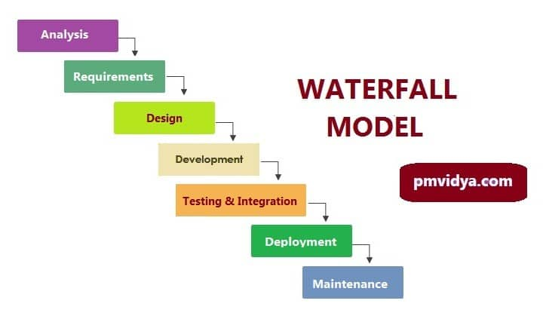

* + 1. **Application of Chosen Methodology**

**Stage 1: Analysis**

At Analysis stage, planning is completed. And after conversation with supervisor, Coordinator, group members, the project title “FYP Management System” is generated. After finalizing the name, literature review of existing systems has been done. The systems that found in literature are not the same with the idea we have. This FYP management System has some extra features that are discussed in literature review and requirement.

After deciding the scope of the project, we started reviewing literature of developed systems that are completed so for. Unluckily, the developed FYP management systems of the universities are either concealed or can’t be retrieved.

The problem statement is created After some study on the FYP Management Systems. The objective of proposed system is to improve effectiveness and efficiency of year long process of FYP.

Deliverables: Problem statement, objective and project scopes

**Stage 2: Requirement Gathering**

In this stage, Requirements have been gathered and analysis have been made. Meanwhile the existing system can’t be retrieved on the internet, an interview with the stakeholder of the FYP Management system has been performed. The requirement of purposed system is gathered After the interview. The requirements consist of the functional and non-functional requirements which are necessary for the development of the system.

Next, study is done for user interface, appropriate technologies and approaches were selected. This was to make sure the project should meet user’s expectation and requirements. We included studied features of systems and also added in proposed system.

The use case diagram is required to understand interaction between the user and the system. We can get the subject boundary which distinguishes the user and system from the use case. The operations performed by user are also shown. Deliverables: Requirement analysis, non-functional requirement and functional, use case diagram and methodology.

**Stage 3: Design**

The project development begins form the design stage. In design stage, decision is taken for the user interface. The system appearance should be proper and all functionalities of the system should be defined. Layout of the system is included in interface design, the number of links covered in a single page, the location of the navigation bar, the placement of the university name and the position where the information is being displayed.

Next is the design of database. ERD (Entity Relationship Diagram) is developed to extract entities. System’s all the data elements are included and properly assigned. All related tables to system are drafted. After getting tables normalization is performed.

Next, a test plan is designed. the test plan consists of functions that need performance testing. Test cases will detect the user who may be needed to test the system as separate user. In test plan, test data is also added. This plan can be executed after each component.

This is the most crucial stage where the complete project structure is developed.

Deliverables: database design (ERD), User interface design, system specification, test plan.

**Stage 4: Development**

At development stage, database is designed which is taken from the design stage. MySQL is used for creating database.

As soon as the database is created, development of system will begin. the system is developed on the basis of system requirement created in requirement gathering stage. The development of system should meet as described in methodology. All component required in are developed.

Deliverables: MYSQL database, working system

**Stage 5: Testing and Integration**

After the development of the system, planned testing should be performed. The user will enter data as discussed in test plan phase and test whether the expected result is generated. And keep record of each test.

Deliverables: system testing.

**Stage 6: Deployment**

In deployment stage, the system has matched with the requirement from the user and functions work as expected which help the user in executing tasks. Thus, the system is ready for the deployment and ready to be used by the user. The whole documentation of system must be done for future maintenance.

Deliverable: Final version of system

**Stage 7: Maintenance**

this stage is done after deployment, if any requirement is given by user, will be implemented. And any unwanted situation occurred will be handled.

* 1. **Project Technical Approach**

As this is a web-based project, we will use front-end and back-end frameworks for the development of this project.

* + 1. **Front-end framework**

We have finalized React.JS as front-end framework because it has better performance, higher scalability, and higher developers’ availability than other front-end frameworks including Angular.JS and Vue.JS [3], [4]. It is also better for our project.

* + 1. **Back-end framework**

We have finalized Node.JS as back-end framework because it is better for the project requirements. [5] [6]

Both these front-end and back-end frameworks use JavaScript language therefore, development of the project will be easier.

* + 1. **Database Technology**

We will use MySQL database [7].

* 1. **Work division**

Table 1: Work division

|  |  |  |
| --- | --- | --- |
| **Topics** | **Group Member** | |
| Background Basic knowledge about the system, React.JS and Node.JS | Studied by all Group Members | |
| **Study and Research of Requirements** | | |
| Requirements gathering | | Tarique Hassan (023-17-0053)  Suhail Ahmed (053-17-0013) |
| Requirements Analysis | | Suhail Ahmed (053-17-0013)  Muhammad Ahsan (023-17-0045) |
| **Site Visits** |  | |
| <https://www.codeinwp.com/blog/angular-vs-vue-vs-react/#license>  <https://www.letsnurture.com/blog/django-vs-laravel-vs-node-js.html> | Studied by all group members | |
| Research Papers | Studied by all group members | |
| **Design & Implementation** | **Design & Implementation** | |
| UI Design | UI Design | |
| Integrate with the UI | Integrate with the UI | |
| Front-end Development | Front-end Development | |
| Back-end Development | Back-end Development | |
| Database Design | Database Design | |
| Integrate with Database | Integrate with Database | |

***Chapter 5***

**Detailed design and architecture**

* 1. **System architecture**

We have divided project management system in modules.

1. **Manage Users Module**

This module contains management of three users; coordinator, supervisor, students. Coordinator will register students and supervisors by adding their personal information including name, email (or CMS ID), contact, and expertise (of supervisors).

1. **Users Info Module**

Coordinator will be able to view information of all supervisors and students. Supervisor will be able to view information of students (groups) that are under his/her supervision. Students will be able to view information of supervisors including their expertise and choose supervisor based on their project idea.

1. **Announcements Module**

In this module, coordinator will announce deadlines of project phases including reports submission and presentation dates. Supervisors and students will be able to receive those announcements and work accordingly.

1. **Project Allocation Module**

Students (groups) will share their FYP ideas with supervisors and get feedback and approval. If any supervisor is interested in the idea, then he/she will approve the project idea and can take that group under supervision.

1. **Project Reports Submission Module**

Students will submit project reports (i.e. abstract, proposal, SRS documents, etc.). Then supervisors can review those reports and give feedback of approval or changes (if any) and assign grades. Students will be able to view their grades as well.

1. **Project Progress Module**

This module contains progress of all current projects. All users can view list of current projects. List contains title of project idea, names of group members, and corresponding supervisor, etc. Additionally, coordinator can view progress of all projects. Supervisor can view progress of only those projects that are under his/her supervision. Students (groups) can view their own progress.

1. **Attendance Module**

Supervisor will mark weekly attendance of group members individually and our system will automatically alert students in case absents exceed.

1. **Developed Projects Module**

All users can view previously developed FYP projects and related work.

* + 1. **System level block diagram**

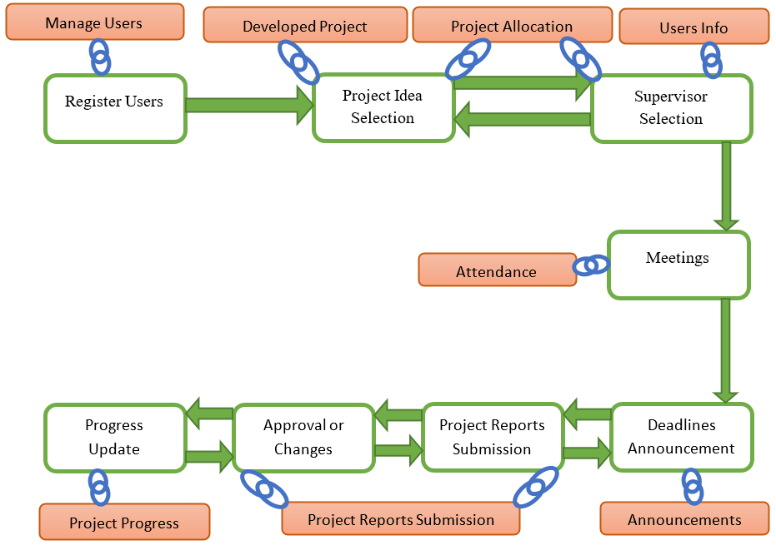

Figure 2: System level block diagram

* + 1. **Architecture Design Approach**

Our system is based on client server architecture. Client server architecture is mostly used for those applications that are distributed and managed on server. The client requests server for any data and in response the server sends back the requested data. The data may include web pages. In our case, the client is website application which is using both server for handling request and database for storing the data.

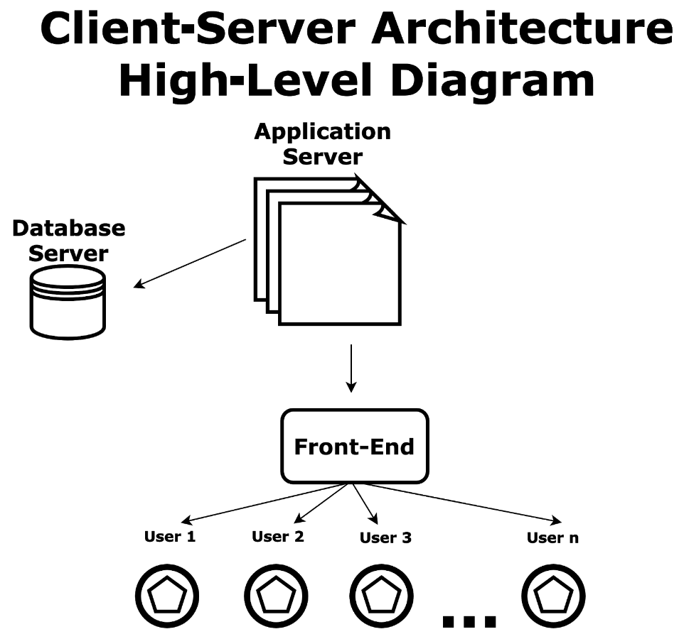

Figure 3: System Architecture

* + 1. **Architecture Design**

Architecture diagram shown in figure 1.0 is a graphical representation of complete system architecture at abstract level that shows set of concepts that are part of FYP Management System architecture.

It is divided into three layers that are:

1. Presentation Layer
2. Business Logic Layer
3. Data Layer

Presentation Layer shows the user interface (UI). Users (coordinators, supervisors, students) will interact with system through this layer. It will be developed using ReactJS, Bootstrap. The user input will be given through this interface. Then it will request the server for further processing and server will send it back to the user using web services.

Once the data is received at server (Business layer), the data will be verified for particular action. Then response will be sent accordingly. After server response if the request was to retrieve the data, it will fetch that data from database (Data Layer). If the request was to store the data, then it will request the database to store.

Data Layer contains the database tables for storing and retrieving the required data.

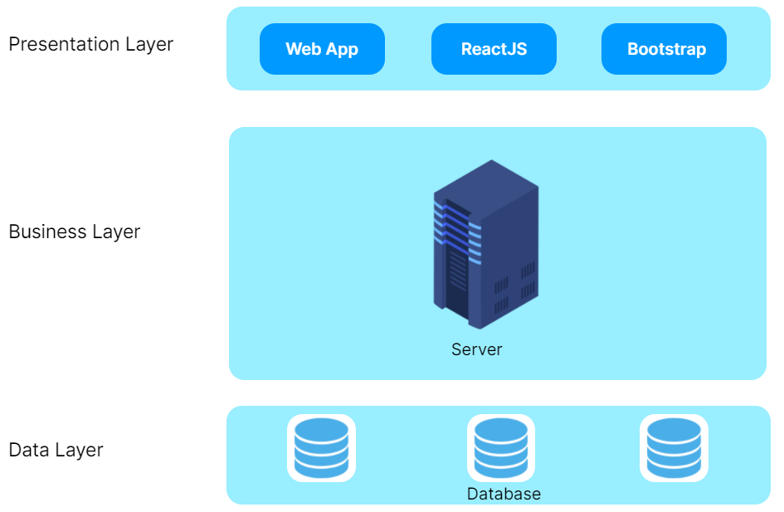

Figure 4: System Architecture Design

* + 1. **Subsystem Architecture**

Figure 5: Subsystem Architectural Design

* 1. **Detailed system design**

The modules as described in the System Architecture include: Users Module to manage coordinator, supervisor, and project group members; Users Info Module to view information of all kinds of users; Announcements Module for the coordinator; Project Reports Submission Module for students so that they can submit required documents and reports; Project Progress Module for tracking the project progress; Attendance Module for weekly meetings of the project members with their supervisor; Developed Projects Module as a record for all the developed projects.

* + 1. **Classification**
       1. **Web Application**

**For Interface**:

* ReactJS as front-end library
* VS Code as Development IDE
  + 1. **Definition**

This module is an interface of the website application through which user will interact.

**Register Users**

The system shall allow coordinator to register students and instructors. The system shall ask supervisors information including name, email, id, expertise of instructor.

**Login**

The system shall ask id and password from users (coordinator, supervisor, and student) to login into the system.

**View Information**

The system shall allow the coordinator to view information of students and instructors. The system shall allow the coordinator to view supervisors and their groups. The system shall allow the students to view information of instructors. The system shall allow instructors to view information of FYP group members under supervision. The system shall allow instructors to update their information.

**Announce Dates**

The system shall provide G-mail option to coordinator to announce deadlines of project reports, presentations, prototypes, source codes. The system shall allow students to view project deadlines notifications.

**Assign Project**

The system shall allow the coordinator to assign projects FYP groups.

**Allocate Supervisor**

System shall allow coordinator to assign supervisor to FYP groups.

**Submit Project Reports**

The system shall allow coordinator to create a slot for submission of abstract, proposal, SRS, SDS, final report, and source code. The system shall allow student to submit project work. The system shall allow supervisor of each group to view those reports and give feedback of approval or changes (if any) and assign grades. The system shall allow students to view their grades as well.

**Track Project Progress**

The system shall allow coordinator to view progress of all current projects. Progress includes title of project idea, names of group members, and corresponding supervisor, percentage of work done and work remaining. The system shall allow supervisor to view progress of only those projects that are under supervision. The system shall allow students (groups) to view their project progress.

**Meetings**

The system shall allow supervisor to start meeting. The system shall mark students present when the meeting starts. The system shall allow supervisor to assign topic and task to students. The system shall allow supervisor to view status of topics and tasks assigned in previous meeting. The attendance will be week-wise. The system shall automatically alert students in their profile in case absents exceed. The system shall allow students to view absents.

**Developed Projects Module**

The system shall allow coordinator, supervisors, and students to view previously developed FYP projects and related work.

**Project Evaluation**

The system shall allow FYP committee to evaluate FYP projects and provide feedback.

* + 1. **Responsibilities**

This module will be first responsible for user authentication by validating the user account with already stored users on database at the backend, secondly, it will be responsible for fetching user’s data by calling backend API’s. Also, t is responsible for connecting and syncing with server through NodeJS and MySQL database using xampp server. Finally, the user will be able to interact with the system modules (defined in **Definition** section above) and perform actions as per need.

* + 1. **Constraints**

This website application would run on computer, laptop and mobile with internet connection. Only English Language is be used. Each user has different specific access over the system. And user must have access Id and password.

* + 1. **Uses/Interactions**

**Use Case Diagram**

Figure 6: Use case diagram

* + 1. **Resources**

This website application requires a good internet connection. Minimum 50kb per second and web browser.

* + 1. **Processing**

The first task that the application is going to perform is authentication of user from the database and then the user will be able to perform his activities related to FYP. This system will use HTTP connection to connect with backend.

* 1. **Class diagram**

The class diagram shown in figure shows static structure for the proposed system by through [classes](https://en.wikipedia.org/wiki/Class_(computer_science)), their attributes, operations, and the relationships among objects.

Figure 7 Class Diagram for FYP Management System

* 1. Diagram, schematic

     Description automatically generated **Database diagram**

Figure 8: database diagram

***Chapter 6***

**IMPLEMENTATION AND testing**

* 1. **Implementation**

In Implementation the first thing that had been done was to download and install all development tools, and packages like React-Js, Minimal libraries, Bootstrap5, Node-Js, Es6 (ECMAScript 6), Sequelize, MySQL, XAMMP, Visual Studio.

After all tools and packages installation database entities are created by following ER-Diagram. And now the MYSQL has all the entities, now the coding can be started by first creating the login page.

To create an interface of the project, the Minimal templet is used. Some of designs are done through Material.com Library The interfaces can be easily designed with the help of these libraries. During the design of interfaces of the system, React-Js framework is used along with HTML, CSS, and JavaScript.

After Login page we have created Dashboard for each role. there are four roles initially, that use the system, that can be change or created dynamically. which are the FYP Supervisor and FYP group, Super Admin, FYP Coordinator all role have their own access to pages defined in Requirements.

* **Front-end**
* **React-Js:**

React is free, open-source, and component-based JavaScript library, created for building fast and interactive user interfaces for web and mobile applications. This library maintained by Facebook and a community of individual developers. React-Js can be used as a base in the development of single-page application or mobile applications. Although, React-Js is only concerned with state management and rendering that state to the Document object model (DOM), React-Js uses virtual DOM that makes more efficient.

Following are the features of React-Js:

* Improve performance because, uses Virtual DOM
* Easy creation of dynamic pages
* Reusable components
* Unidirectional data flow
* **Libraries and Packages:**
* **Minimal Libraries:**

Minimal libraries are the CSS libraries that provides beautiful designing, icons, and components for front-end.

* **Bootstrap:**

It is widely used toolkit. It is collection of tools like HTML, CSS and JavaScript. For creating interfaces of web pages. It is open-source and free project hosted on GitHub. It is also known as CSS framework.

* **Tools:**
* **Visual Studio Code**

This is an IDE (Integrated Development Environment) own by Microsoft for Linux, Windows, and MacOs. Visual code consists of following features:

* Debugging
* Syntax highlighting
* Intelligent code completion
* Snippets
* Code refactoring and embedded Git
* **Server**
* **Nodejs**

Node-Js is a cross-platform and open-source JavaScript runtime environment for developing server-side and networking projects. Node.js is a widely used tool for almost any type of project. Node.js runs the core of Google chrome, V8 JavaScript engine. Node.js create single process instead of creating new threads for each request. It comes with set of asynchronous I/O primitives in its standard library the permits requests without blocking.

it also offers a valuable library of different JavaScript modules which shortens the development of web applications using Node-Js.

The following are the features of Node-Js

* Asynchronous and Event Driven
* Very Fast
* Single Threaded but Highly Scalable
* No Buffering
* **ECMAScript 6**

ECMA Script also known as ES6 programming language. ES6 is the new standardized name of JavaScript and 6 shows its version. the last version ES5 was released in 2011. It was major improvement in JavaScript and included many more features to make large scale software development. ES6 was released in 2015. It was renamed to ECMAScript.

* **Packages and Libraries:**
* **Sequelize:**

It is based on promises of Node-Js ORM (object relational mapping) tool for MySQL, MongoDB and SQLite, etc. It provides features like solid transaction support, eager. Relations. lazy loading and read replication.

* **Database**
* **MySQL**

MySQL is developed by Oracle. It is a relational database management system (RDBMS) that bases on structured query language (SQL).

* 1. **Testing**

After the FYP management system is implemented, to make ensure that the system is working as expected, testing has to be performed. Also to ensure that the system matches the requirements. Moreover, system test will support to find exceptions that are concealed to the user. There are some testing types that consist of unit testing, functional testing, and integration testing. These testing should be done before system deployment.

* + 1. **Unit testing**

In unit testing, each system component is tested. The test of components contain, tables, forms, notifications in each module. This kind of test is done to ensure that errors do not occur during usage of system. If the error of bug occurs, they must be fixed immediately. It will minimize the number of failures in system. This test can be used to make sure the user have given input in correct format.

Test No 1: Login Unit Testing

Object: to make sure login form work correctly

Table 2: Login Unit Test

|  |  |  |  |  |
| --- | --- | --- | --- | --- |
| No: | Test case: | Attribute and value | Expected result | Result |
| 1 | Check user sign in when user clicks on the ‘Login’ button with correct input data | username: [suhailahmed.se17@iba-suk.edu.pk](mailto:suhailahmed.se17@iba-suk.edu.pk)  Password: 12345 | Successfully logged the dashboard page of the app | Pass |
| 2 | Check user sign in when user clicks on the ‘Login’ button without any input | username: null  Password: null | Sign in failed, error information display and request user to input username and password. | Pass |
|  | Check user sign in when user clicks on the ‘Login’ button with incorrect input data | username: [suhailahmed.se17@iba-suk.edu.pk](mailto:suhailahmed.se17@iba-suk.edu.pk)  Password: 12345 | Sign in failed, error information display and request user to input username and password. | pass |

Test No 2: Edit Profile Or User testing

Object: to ensure edit form work correctly

Table 3: Edit Profile Or User testing

|  |  |  |  |  |
| --- | --- | --- | --- | --- |
| No: | Test case: | Attribute and value | Expected result | Result |
| 1 | Check user Edit profile after user clicks on the ‘submit’ button on Edit page with correct information | Name: Suhail Ahmed  Batch: Fall-2017  Department: Computer Science  Email: [suhailahmed.se17@iba-suk.edu.pk](mailto:suhailahmed.se17@iba-suk.edu.pk)  Password: 12345 | Successfully | Pass |
| 2 | Check user Edit profile after clicking on the ‘submit’ button on Edit page with any missing information input data | Name: Suhail Ahmed  Batch: Fall-2017  Department: Computer Science  Email:  Password: 12345 | Update failed, error message display and request user to input complete data | Pass |
|  | Check user Edit profile after clicking on the ‘submit’ button on Edit page with Incorrect information of email | Email: [suhailahmed.se17](mailto:suhailahmed.se17@iba-suk.edu.pk)  Password: 12345 | update failed, error message display and request user to input correct email format. | pass |

Test No 3: Document Submission Form

Object: to make sure document submission work correctly

Table 4: Document Submission Form testing

|  |  |  |  |  |
| --- | --- | --- | --- | --- |
| No: | Test case: | Attribute and value | Expected result | Result |
| 1 | check submission form after user clicks on the ‘submit’ button with correct format file and with required size | File: .pdf, .docx, .doc, .pptx, .ppt  Size: as required | Successfully | Pass |
| 2 | Verify submission form after clicking on the ‘submit’ button with missing file | File: null | upload failed, error message display and request user to add file | Pass |
| 3 | Verify submission form after clicking on the ‘submit’ button with wrong extension file | File: any other than required  Size: as required | upload failed, error message display and request user to input file with correct extension. | pass |
| 4 | Verify submission form after clicking on the ‘submit’ button with large size of file | File: .pdf, .docx, .doc, .pptx, .ppt  Size: larger than require | upload failed, error message display and request user to input file with required size | pass |

Test No 4: Search User

Object: to make sure search option work correctly

Table 5: Search User testing

|  |  |  |  |  |
| --- | --- | --- | --- | --- |
| No: | Test case: | Attribute and value | Expected result | Result |
| 1 | Check user after user clicks on the ‘Search’ button with correct information | Name/Id: 053-17-0013 | Successfully  Show record | Pass |
| 2 | Check search user after clicking on the ‘Search’ button with no data | Name/Id: null | Error message displayed with value must be entered | Pass |
| 3 | Check search user after clicking on the ‘Search’ button with wrong id | Name/Id: 053-23-434 | Information displayed that there is no user with this Id | pass |

* + 1. **Functional Testing**

After unit testing, functional testing phase will start. In this the functionality of each individual component is tested. This is to make sure that system matches with given requirements. If all Error will be handled in phase of functional testing, then less exception will occur during system testing. This will improve overall quality of system.

Test No 1: Sign in testings with different roles

Objective to make sure that correct dashboard with correct role is loaded

Table 6: Login testing with different roles

|  |  |  |  |  |
| --- | --- | --- | --- | --- |
| No: | Test case: | Attribute and value | Expected result | Result |
| 1 | Login User | Email: [suhailahmed.se17@iba-suk.edu.pk](mailto:suhailahmed.se17@iba-suk.edu.pk)  Password: 12345 | Main page of Dashboard loaded according to role given | Pass |

Test No 2: Manage User

Objective to make sure correct user’s data is loaded and edited

Table 7: Manage User testing

|  |  |  |  |  |
| --- | --- | --- | --- | --- |
| No: | Test case: | Attribute and value | Expected result | Result |
| 1 | Click manage users | -- | Navigate to user manage page and load all users | Pass |
| 2 | Click on any user for edit | -- | All data is correctly loaded on given fields | Pass |
| 3 | Click on save changes with all fill data | Name: Suhail Ahmed  Batch: Fall-2017  Department: Computer Science  Email: [suhailahmed.se17@iba-suk.edu.pk](mailto:suhailahmed.se17@iba-suk.edu.pk)  Password: 12345 | All data successfully updated in database as well as on users page | Pass |

Test No 3: Make announcement

Objective to make sure Announcement correctly sent

Table 8: Make announcement testing

|  |  |  |  |  |
| --- | --- | --- | --- | --- |
| No: | Test case: | Attribute and value | Expected result | Result |
| 1 | Click on ‘Send’ after given complete information | Title: report submission deadline  Message: please submit your reports before 9/Nov/2022  Batch: 2018 | Message displayed successfully announced and send to specified batch | Pass |

Test No 4: Report submission

Objective to make sure reports are successfully submitted and showed in report management

Table 9: Report submission testing

|  |  |  |  |  |
| --- | --- | --- | --- | --- |
| No: | Test case: | Attribute and value | Expected result | Result |
| 1 | Click on ‘Submit’ when adding files | file | Report added in view report information and also added in data base | Pass |

Test No 5: Committee Evaluation

Objective to make sure Evaluation page is loaded correctly with all information

Table 10: Committee Evaluation testing

|  |  |  |  |  |
| --- | --- | --- | --- | --- |
| No: | Test case: | Attribute and value | Expected result | Result |
| 1 | Click on ‘Committee Evaluation nevigation’ | -- | All Groups in assigned Committee is loaded with all necessary information | Pass |
| 2 | Click on any Group from Drop-Down button | Group Id: 124 | All information of given group is loaded on page | Pass |
| 3 | Click Assign mark after give marks | Marks: 100 | Marks assigned to that group | Pass |

* + 1. **Integration Testing**

In integration testing all modules and components are deployed on user’s environment, and tested all components as combined like functional testing is done. The same cases are used for this testing but in combined.

***Chapter 7***

**Results and discussion**

Figure 9: Add User

Figure : Edit User

Figure : Add Supervisor

Figure : User List

Figure : Groups List

Figure : Approve Groups

Figure : Post New Report

Figure : Group Under Supervision

Figure : Submit Reports

Figure 16: Reports List

Figure : Create Group

**Usability survey from students:**

Figure 19: usability survey from students

**Usability survey from teachers:**

Figure 20: usability survey from teachers

***Chapter 8***

**Conclusion and future work**

* 1. **Conclusion**

The proposed system will be a better replacement of the manual system and will solve the problems discussed in Introduction section by providing a web-based platform to assist the users. The problem that users face is project and time management for the whole year FYP process. Project management of FYP activities include monitoring project activities, previous project records, and progress status of the developed and current projects. Time management problem arises when supervisors are not available for project meetings with their respective groups under supervision.

Hence, to reduce the mentioned problems, web-based application for FYP Management System is developed that can be accessed by the authorized users anytime and anywhere.

At the end, the FYP Management System is developed to assist the users by reduced workload, easier management of records where records are long-lasting. It also allows the user to see the project progress easily with just a click.

* 1. **Future Work**

The FYP management system is developed for the use of supervisors, coordinator, FYP committee of final year project for bachelors. In the coming future, this system can be extended for the use of master level and Ph. D students which will automate the process of final thesis and projects.

Future work includes following modules;

* + 1. **Meetings**

The system shall allow supervisor to start meeting. The system shall mark students present when the meeting starts. The system shall allow supervisor to assign topic and task to students. The system shall allow supervisor to view status of topics and tasks assigned in previous meeting. The attendance will be week-wise. The system shall automatically alert students in their profile in case absents exceed. The system shall allow students to view absents

* + 1. **Project Evaluation**

The system shall allow FYP committee to evaluate FYP projects and provide feedback.

Further there is one limitation, that is the upload student record module which does not accept the files with the format given. Coordinator will have to update students records manually by entering student information.

***Chapter 9***

**REferences**

A comprehensive list of references is cited using a standard format.

**REFERENCES**

1. Leung, C.-H., et al., *The Development of a Final Year Project Management System for Information Technology Programmes.* 2015. **494**: p. 86-97.

2. Bakar, M.A., et al., *Final Year Supervision Management System as a Tool for Monitoring Computer Science Projects.* Procedia - Social and Behavioral Sciences, 2011. **18**: p. 273-281.

3. IONUT NEAGU, F.C. *Angular vs React vs Vue: Which Framework to Choose in 2020*. 2020 [cited 2020 november 20]; Available from: https://[www.codeinwp.com/blog/angular-vs-vue-vs-react/#license](http://www.codeinwp.com/blog/angular-vs-vue-vs-react/#license).

4. Feoktistov, I. *Angular vs. React vs. Vue.js – choosing a JavaScript framework for your project*. 2020 [cited 2020 november 20]; Available from: https://relevant.software/blog/angular-vs-react-vs-vue-js-choosing-a-javascript-framework-for-your-project/#Angular,_React,_Vue_js_%E2%80%93_then_and_now.

5. Gr¨unwaldt, J.-M., *A Comparison of Modern Backend Frameworks*

*Protections against Common Web Vulnerabilities.* 2019.

6. Nurture, L. *Django vs Laravel vs Node js*. 2019 [cited 2020 november 20]; Available from: https://[www.letsnurture.com/blog/django-vs-laravel-vs-node-js.html](http://www.letsnurture.com/blog/django-vs-laravel-vs-node-js.html).

7. Kaur, M. *QL vs NoSQL : MySQL vs MongoDB — The Difference*. 2018 [cited 2020 november 20]; Available from: https://medium.com/@mandeepkaur1/sql-vs-nosql-mysql-vs-mongodb-the-difference-6145e437cd40.