SQL Murder Mystery - Detective notes

horizontal line

***CLUE 1: A crime has taken place and the detective needs your help. The detective gave you the crime scene report, but you somehow lost it. You vaguely remember that the crime was a ​murder​ that occurred sometime on ​Jan.15, 2018​ and that it took place in ​SQL City​.***

***Start by retrieving the corresponding crime scene report from the police department’s database.***

*All the clues to this mystery are buried in a huge database, and you need to use SQL to navigate through this vast network of information. Your first step to solving the mystery is to retrieve the corresponding crime scene report from the police department’s database. Below you can see how the database tables are connected.*

*Good luck!*

***\*\* note it might be easier if one member of the team keeps the next page diagram of how the tables are connected open, and another member can keep a record of the detective notes.***

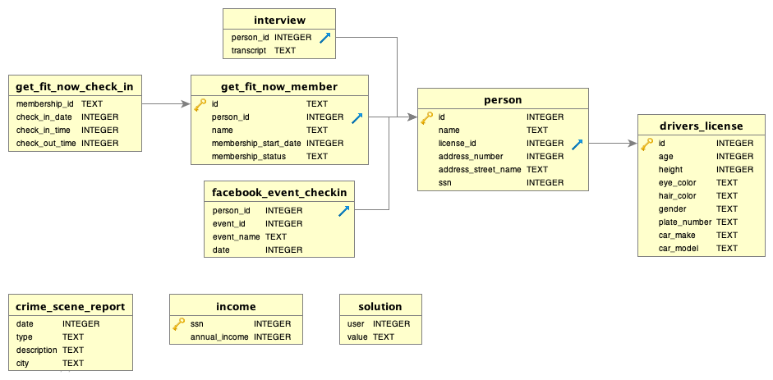

|  |  |  |
| --- | --- | --- |
| **Clue** | **SQL Command** | **Information** |
| 1 | We have started the first one for you:  select * from crime_scene_report where type = "murder" |  |
| 2 |  |  |
| 3 |  |  |
| 4 |  |  |
| 5 |  |  |
| 6 |  |  |
| 7 |  |  |
| 8 |  |  |
| 9 |  |  |
| 10 |  |  |
| 11 |  |  |
| 12 |  |  |
| 13 |  |  |
| 14 |  |  |
| 15 |  |  |
| 16 |  |  |
| 17 |  |  |
| 18 |  |  |
| 19 | Once you have identified the murder copy and paste the SQL code into your repl.it. All you have to do is change the name below and if you have got it right it will display congratulations.  INSERT INTO solution VALUES (1, '**Insert the fullname of the person you found here**');  SELECT value FROM solution; |  |
| **EXTENSION TASK** | | |
| **1** |  |  |
| **2** |  |  |
| **3** |  |  |
| **4** |  |  |