GitHub Classroom: Student Lab Guide
261-SWE-363
Purpose
This guide will help students through the complete first-time GitHub Classroom workflow: signing in, joining the course organization, accepting an assignment, working with the repository, and submitting the assignment using a Git tag.
Before You Start
- Use the GitHub account that you will use for the course.
- Make sure Git is installed on your computer.
- Keep your GitHub username and university email available.
Note: Screens may look slightly different depending on your browser, operating system, or GitHub updates. Follow the same buttons/options shown in the figures.
- Part A — Join GitHub Classroom and the Course Organization
Step 1 — Open the GitHub Classroom invitation
Open the GitHub Classroom link provided by your instructor. On the Classroom sign-in page, choose Sign in with GitHub.
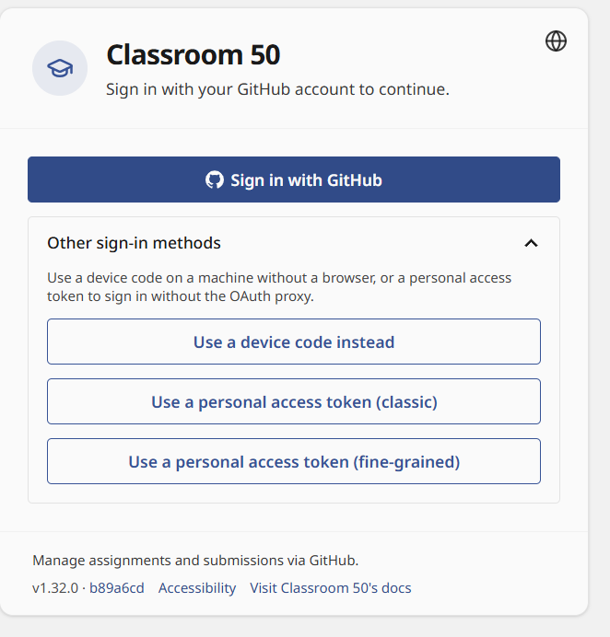
Step 2 — Sign in to GitHub
Enter your GitHub username/email and password, then select Sign in.
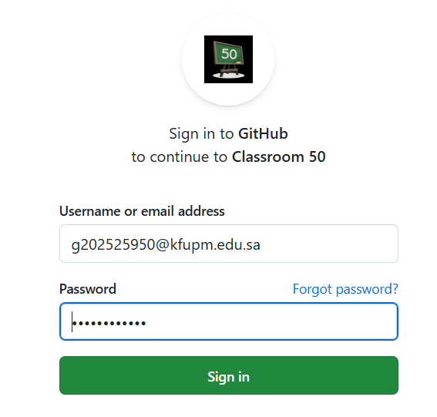

Step 3 — Complete device verification.
GitHub may send a verification code to your email. Enter the code and select Verify.
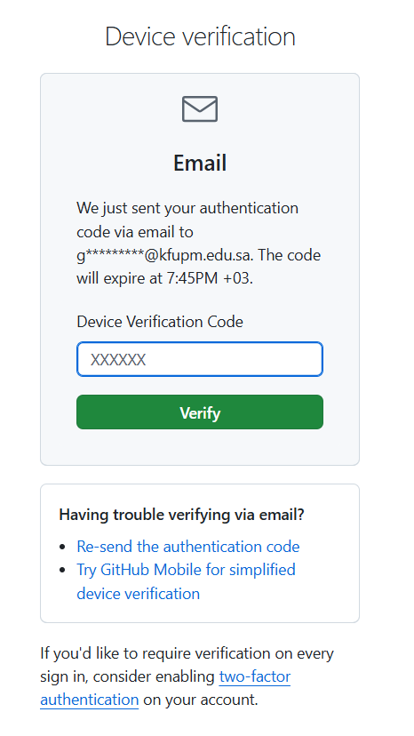
Step 4 — Authorize GitHub Classroom
Review the requested permissions and select Authorize Classroom 50. This allows GitHub Classroom to create and manage course repositories for you.
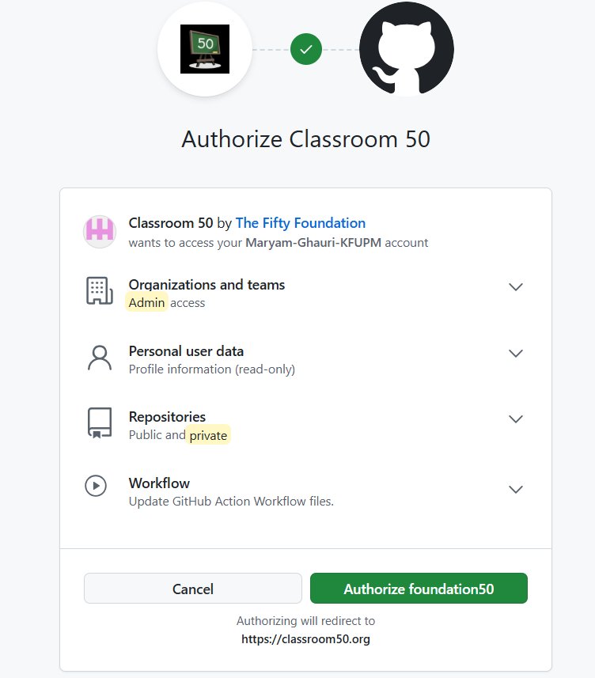
Step 5 — Check the organization page
After authorization, GitHub Classroom may show the course organization. If the organization is not yet connected, follow the invitation provided by the instructor.
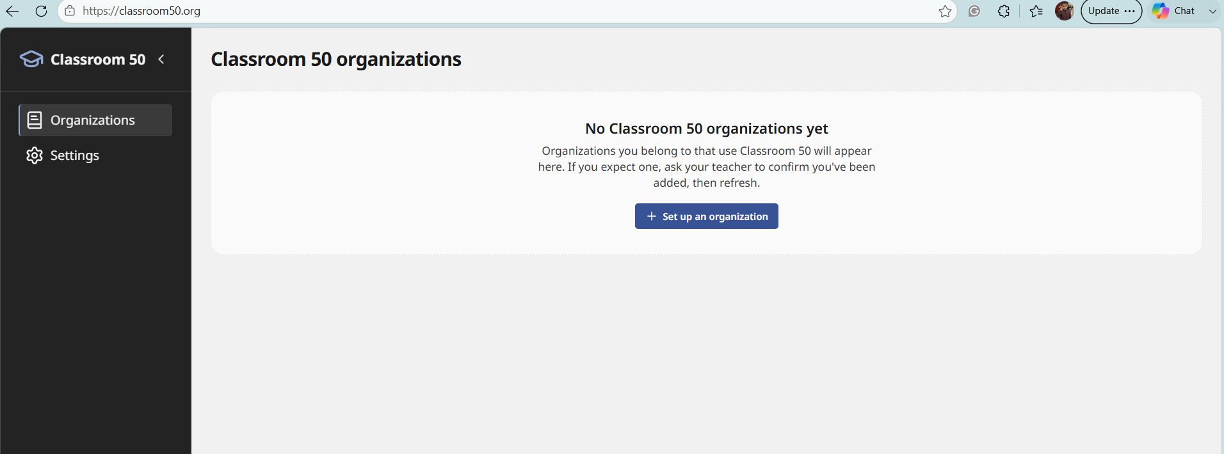

Step 6 — Accept the organization invitation
Open the invitation email for the Web-Engineering-KFUPM organization and select Join / Accept invitation.
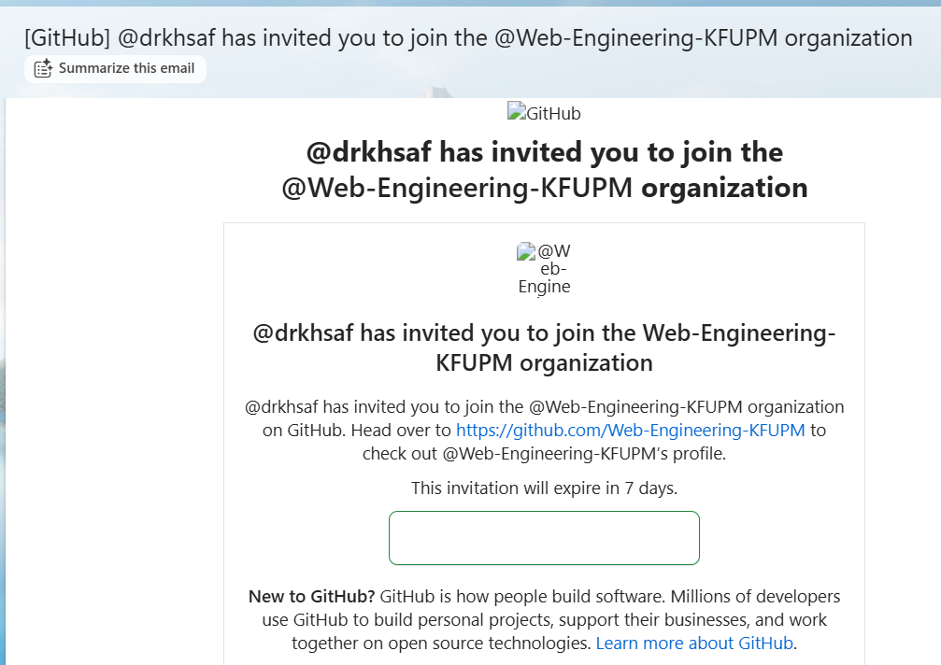
Step 7 — Confirm Web Engineering KFUPM page.
After accepting, GitHub should show the Web Engineering KFUPM organization in your account.
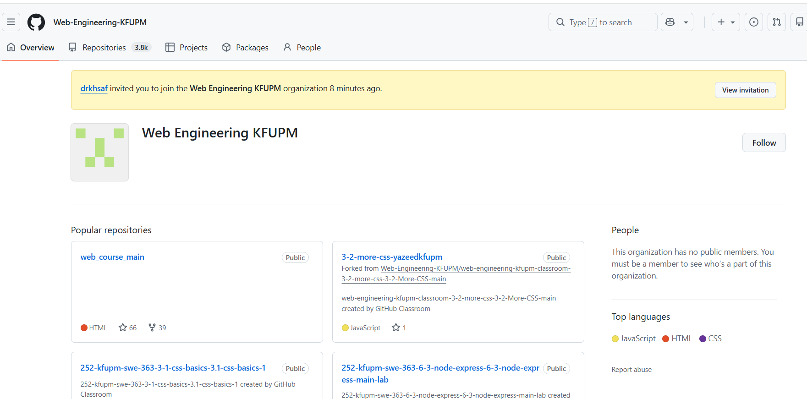
Step 8 — Optional membership notification
You may receive a GitHub notification confirming that you were added to the Web Engineering KFUPM team/classroom.
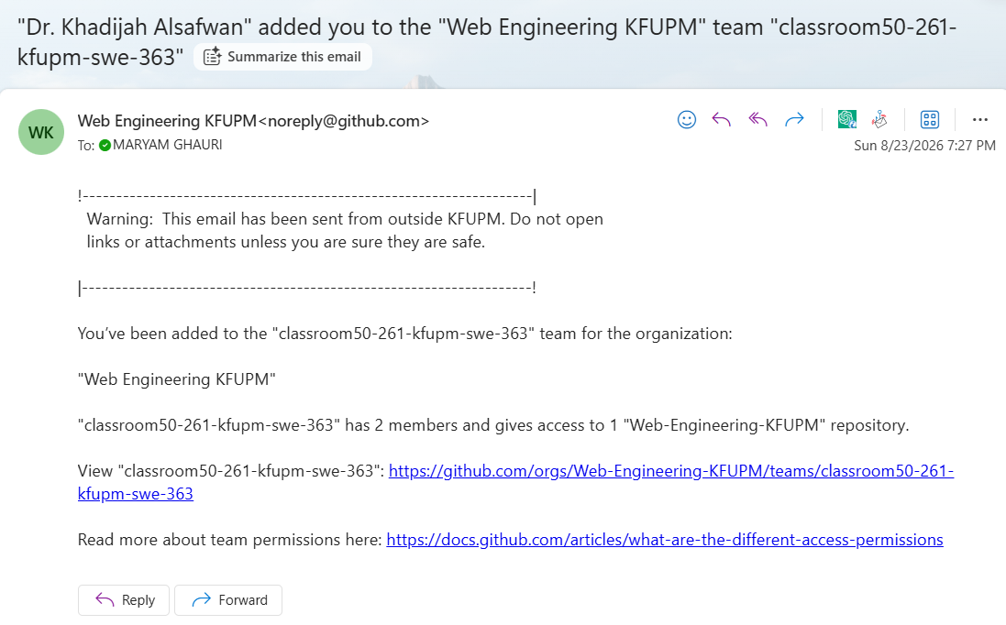
Step 9 — Recheck GitHub Classroom organizations
Return to GitHub Classroom → Organizations. The course organization should now appear.
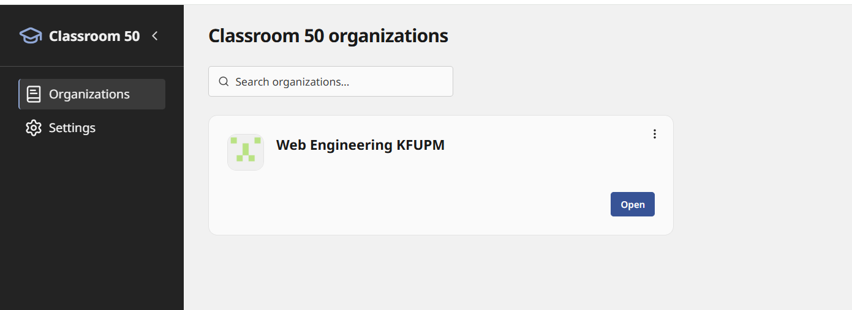
Step 10 — Open the course organization
Select Open beside Web Engineering KFUPM to continue to the classroom.

- Part B — Accept and Start Your First Assignment
Step 11 — Open Assignments
In GitHub Classroom, open the Assignments area and select the assignment provided by your instructor.
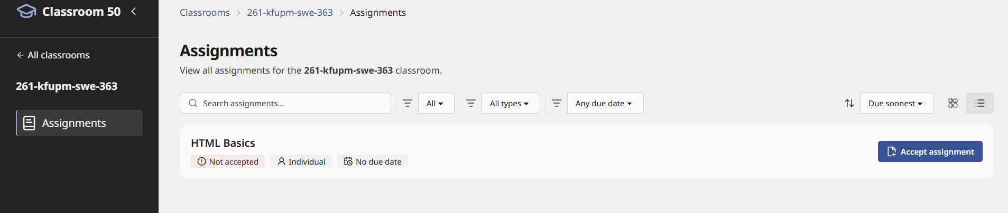
Step 12 — Accept the assignment
Read the assignment information and select Accept assignment. GitHub Classroom will create a personal repository for your work.
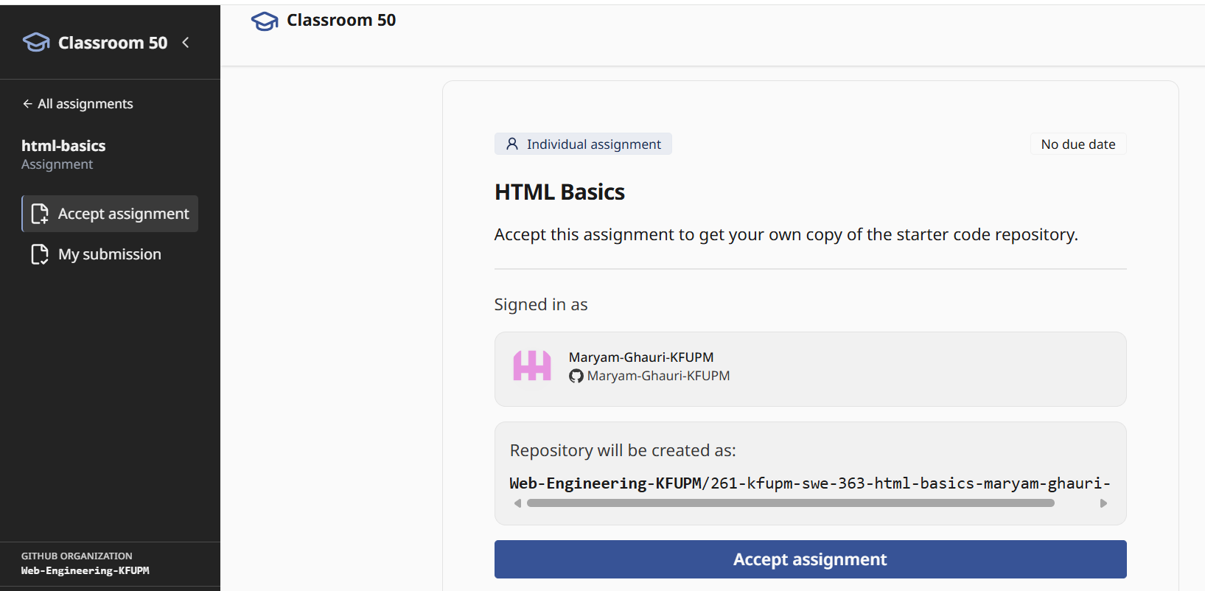
Note: Repository creation can take a short time. Do not repeatedly click Accept assignment.
Step 13 — Open your repository
When the assignment is ready, select Open repository. You can also use Go to my classroom to return to the assignment dashboard.
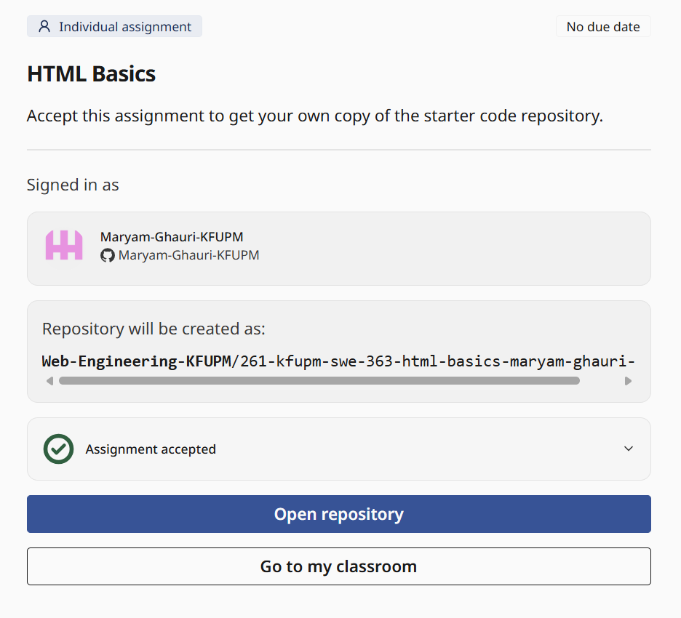
Step 14 — Files in Repository
Your personal repository contains the starter files supplied by the instructor.
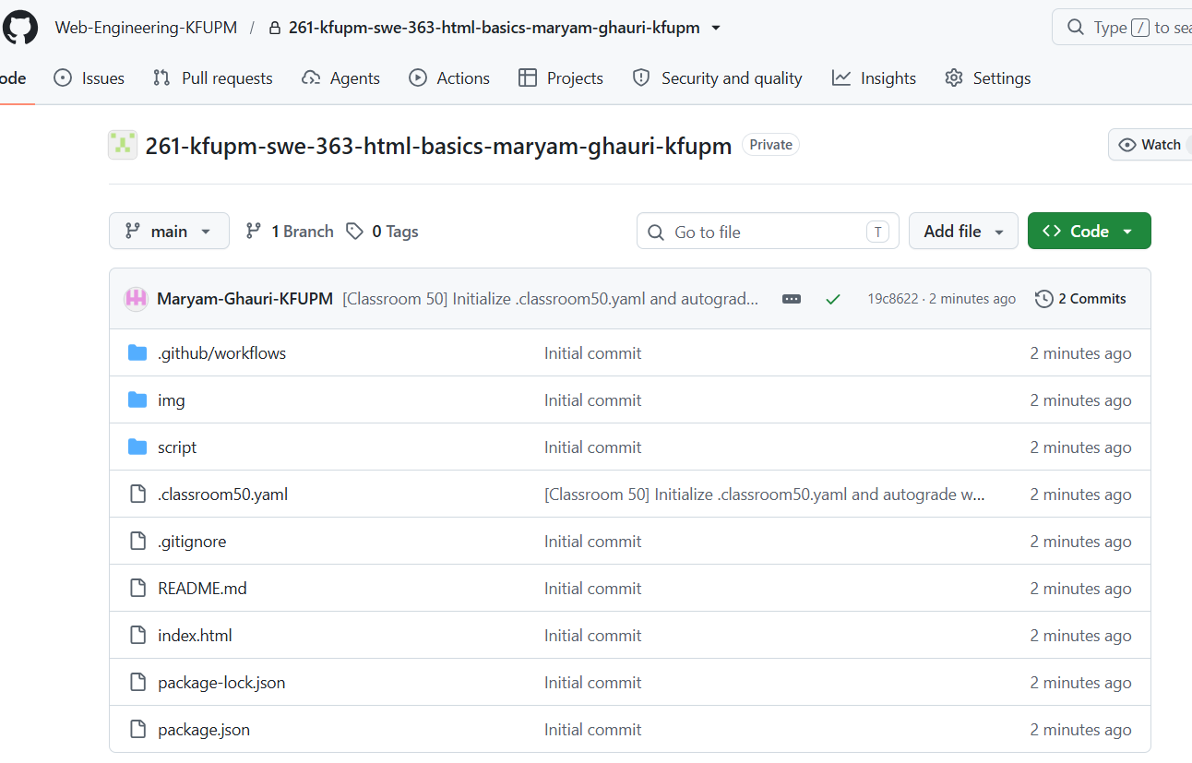
Step 15 — Editing on GitHub.
Open Index.html file to edit the code in the code editor. After editing file click on Commit changes.
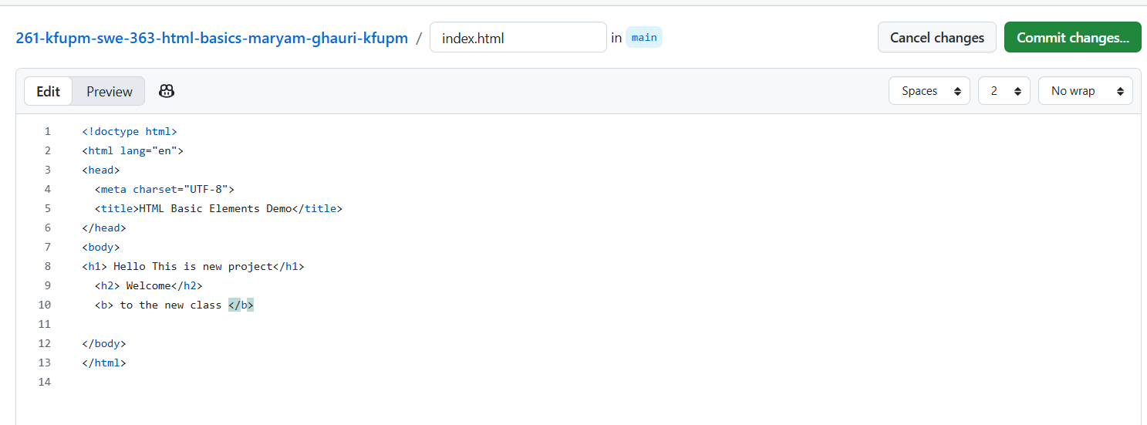
Step 16 — Check My submission
The My submission page shows whether a tagged submission has been received. Before submitting, it may show 0 tagged submissions / Not submitted yet.
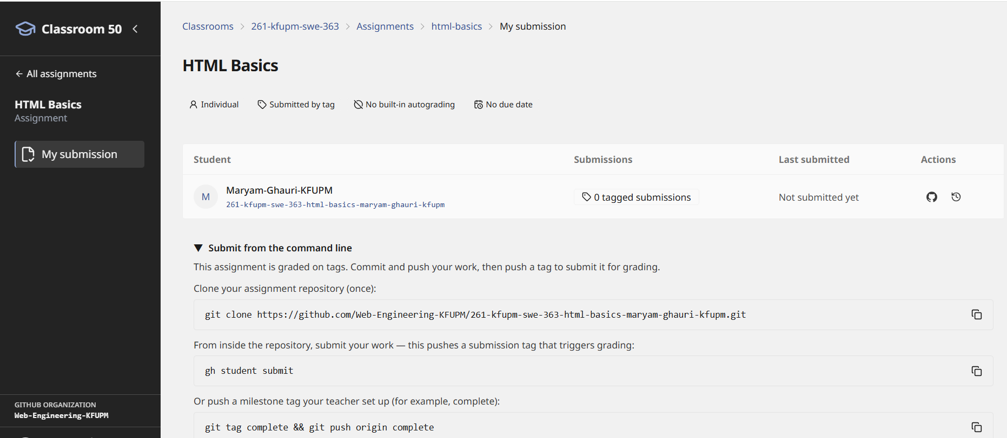
- Part C — Assignment Submission using CMD
Assignment will be submitted using command line interface open cmd and clone your assignment repository.
Step 17 — Copy the clone command
On the assignment page, copy the repository clone command. It will look similar to the following:
git clone https://github.com/<organization>/<your-assignment-repository>.git
Step 18 — Clone the repository
Open Command Prompt and run the clone command. If GitHub asks you to authenticate, complete the sign-in process.
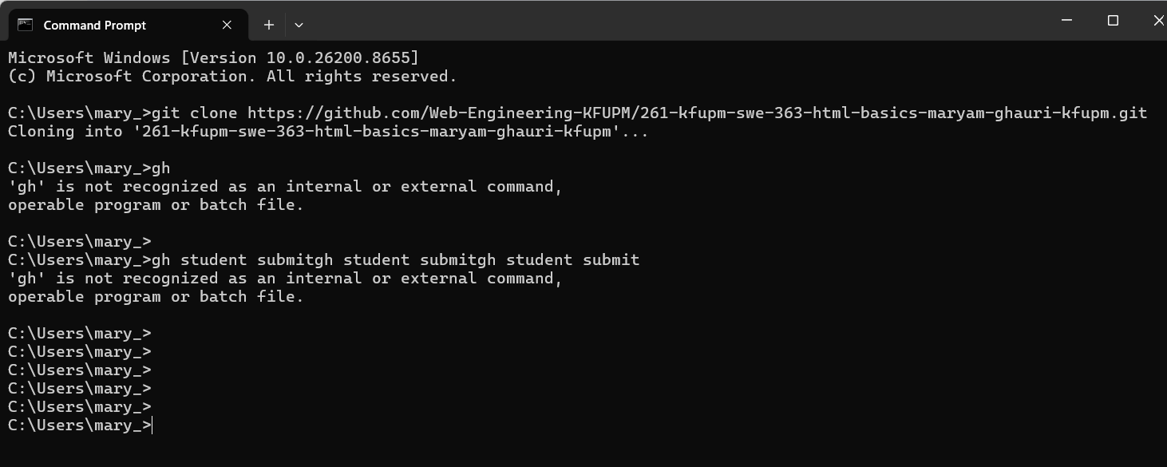
If the cloning takes more time exit it by entering CTRL+C, it means cmd is not connected to github. Sign in first using cmd by entering following cmd:
git ls-remote https://github.com/Web-Engineering-KFUPM/<your -name>.git
Step 19 — Sign in through Git Credential Manager
If the Connect to GitHub window appears, choose Sign in with your browser.
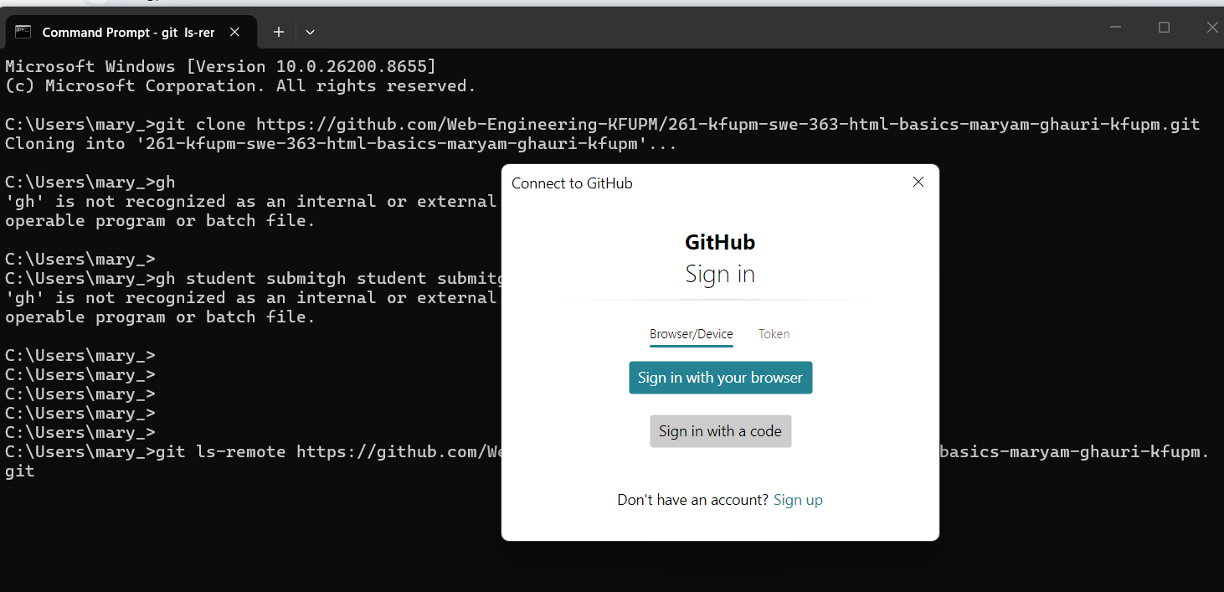
Step 20 — Authorize Git Credential Manager
In the browser, review the permissions and authorize Git Credential Manager for your GitHub account.
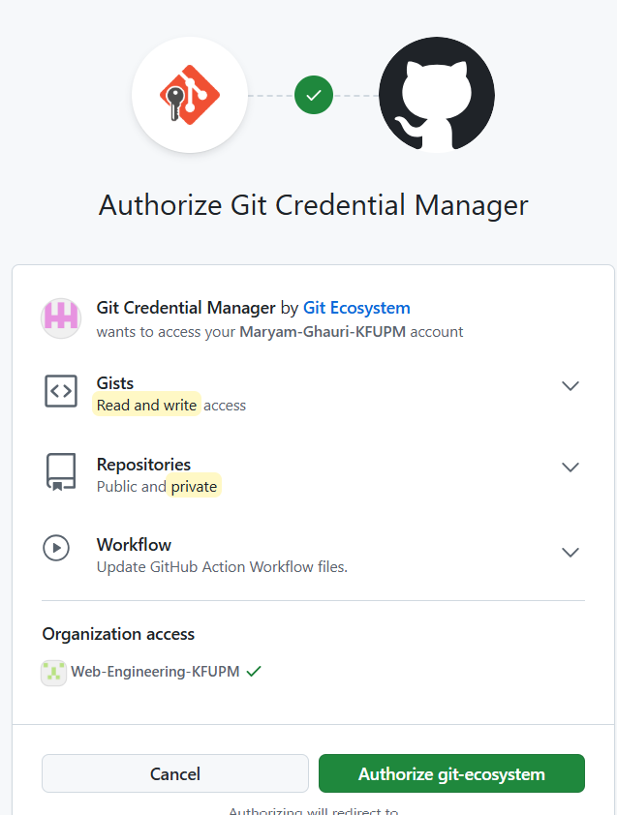
Step 21 — Return to Command Prompt
After Authentication Succeeded appears, close the browser page and return to Command Prompt.
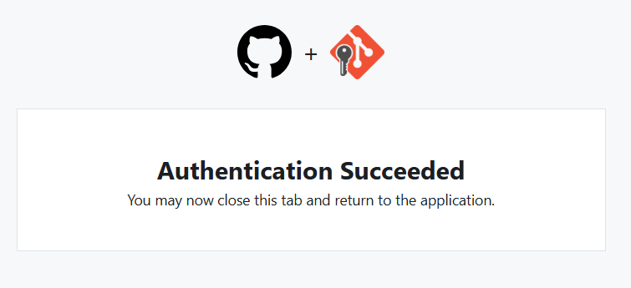
Step 22 — If an interrupted clone left an empty folder
A failed clone can leave an empty folder. Enter the folder, run dir and git status, and verify whether it is a repository. If it is empty and Git reports “not a git repository,” return to the parent folder, remove the empty folder, and clone again.
cd <repository-folder>
dir
git status
cd ..
rmdir <repository-folder>
git clone <repository-url>
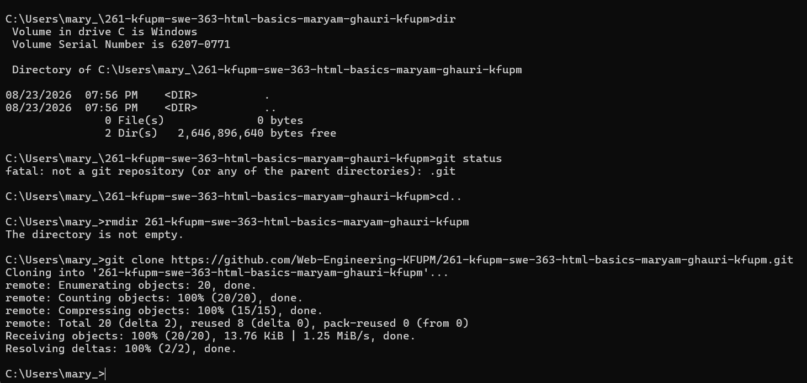
Step 23 — Verify the local repository
After a successful clone, enter the repository and run git status. A clean repository normally reports that branch main is up to date with origin/main.
cd <repository-folder>
git status
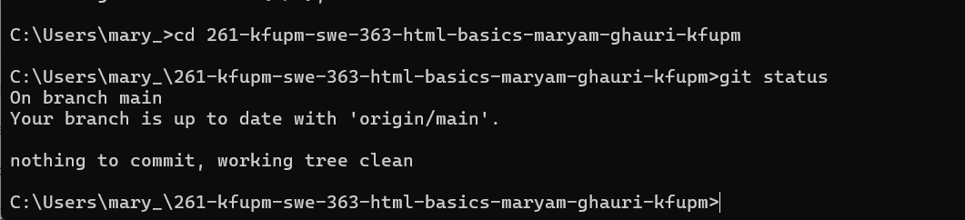
- Part D — Submit the Assignment for Grading
Changes committed directly on github.com are remote changes. Your local computer will not receive them automatically. Pull them before continuing local work.
Step 24 — Pull remote changes
From inside the local repository, run:
git pull origin main
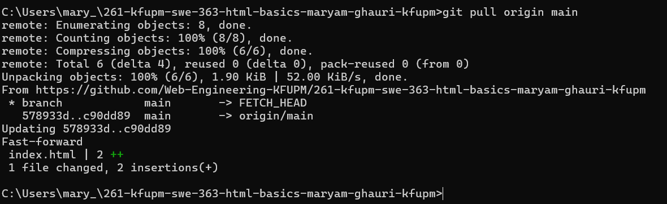
After the pull, git status should report that the local branch is up to date and the working tree is clean.
Step 25 — Submit the Assignment for Grading
This classroom is configured for submission by Git tag. Finish your work, commit it, and push the main branch before creating the submission tag.
Note: Only create the submission tag when you intend to submit the current version for grading. Follow the exact tag name specified by your instructor. The examples below use complete.

Step 26 — Create the submission tag
Create the milestone/submission tag on the current commit:
git tag complete
Step 27 — Push the tag to GitHub
A local tag does not submit anything until it is pushed. Push the tag:
git push origin complete
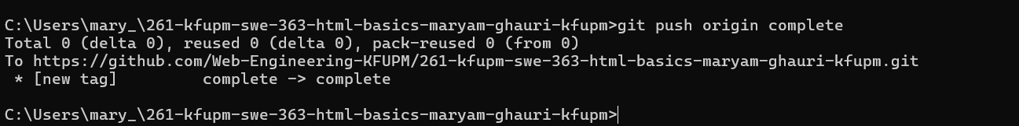
Step 36 — Verify the submission
Refresh GitHub Classroom → My submission. The page should show a tagged submission instead of 0 tagged submissions.
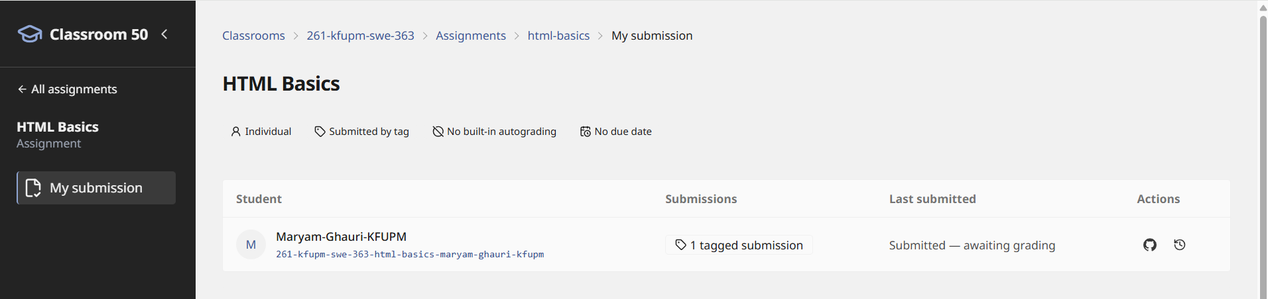

Troubleshooting

Problem: git clone appears stuck
If cloning shows only “Cloning into …” for a long time, Git may be waiting for authentication. Cancel with Ctrl+C if necessary, then test repository access:
git ls-remote <repository-url>
Complete the GitHub browser authentication prompt if it appears, then retry the clone.

Problem: destination path already exists
This usually means an earlier clone attempt created the folder. Check the folder before deleting anything. If it is empty and is not a Git repository, remove it from the parent directory and clone again.

Problem: 'gh' is not recognized
The gh command belongs to GitHub CLI, which is separate from Git. If GitHub CLI is not installed, use the Git tag submission method provided by the assignment (for example, git tag complete followed by git push origin complete).

Problem: git status says working tree clean after I edited a file
- Save the file in your local editor (Ctrl+S).
- Confirm that you opened the same repository folder that Command Prompt is using.
- If you edited the file on github.com, the change is remote; run git pull origin main instead.

Example — Initial clone waiting for authentication
The following screenshot shows a clone that has started but is waiting. If this happens, complete GitHub authentication rather than waiting indefinitely.
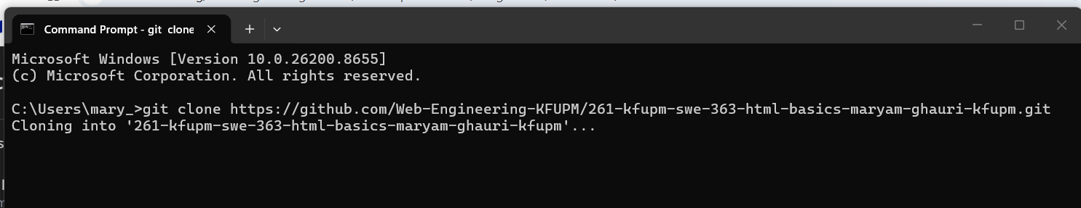

Quick Reference — Commands Students Will Use Most
Purpose | Command
Check repository status | git status
Download remote changes | git pull origin main
Stage changes | git add .
Commit changes | git commit -m "Your message"
Push commits | git push origin main
Create submission tag | git tag complete
Push submission tag | git push origin complete

Recommended Student Workflow
1. Accept the assignment and open the repository.
2. Clone the repository once.
3. Open the local folder in VS Code and complete part of the lab.
4. Save files, then run git status.
5. Run git add ., commit with a meaningful message, and push to main.
6. Repeat commits/pushes as you continue the assignment.
7. When the assignment is complete, make a final commit and push.
8. Create and push the instructor-specified submission tag.
9. Refresh My submission and confirm that the tagged submission is visible.
Security: Do not share passwords, personal access tokens, or authentication codes with anyone. Screenshots in this guide are examples; students should use their own GitHub accounts and repository URLs.

