Software Architecture and Design Specification
Project: Web Based ML Model Evaluator
Version: 1.0
Authors: Team 16 – Parigna P V, Reia S, Divakar K S, Nikhil K R
Date: 04-10-2026
Status: Draft

Revision History
Version | Date | Author | Change Summary
1.0 | 04-10-2026 | Team 16 | Initial draft of the architecture and design specification.

Approvals
Role | Name | Signature/Date
QA Lead | Parigna P V | Parigna P V- 4/9/26
Test Engineer | Divakar K S | Divakar K S- 4/9/26
Developer | Nikhil K R | Nikhil K R- 4/9/26
Product owner | Reia S | Reia S -4/9/26

1. Introduction
1.1 Purpose
This document specifies the architecture and design of the Web Based ML Model Evaluator, a web application that lets users upload datasets, preprocess them, train machine learning models, evaluate them with standard metrics, and compare the results across experiments.
1.2 Scope
Covers the user-facing services of the evaluator: login, dataset upload and validation, preprocessing and train/test split, model selection and training, evaluation, experiment history and comparison, and report generation.
Out of scope: production deployment of trained models, distributed training, and automated hyperparameter search.
1.3 Audience
Developers, QA engineers, security auditors, instructors, and maintenance teams.
1.4 Definitions
ML (Machine Learning), SAD (Software Architecture Document), SRS (Software Requirements Specification), STP (Software Test Plan), RTM (Requirements Traceability Matrix), ADR (Architecture Decision Record), REST (Representational State Transfer), API (Application Programming Interface), TLS (Transport Layer Security), RBAC (Role-Based Access Control).

2. Document Overview
2.1 How to use this document
Provides architectural deliverables including UML diagrams, ADRs, threat models, and API design.
2.2 Related Documents
SRS (Software Requirements Specification), STP (Software Test Plan), RTM (Requirements Traceability Matrix).

3. Architecture
3.1 Goals & Constraints
Goals: accurate and reproducible model evaluation, secure handling of user data, a simple end-to-end workflow, reliable execution of training jobs, and easy addition of new models.
Constraints: delivered as a single web application by Team 16, built on standard Python ML libraries, limited dataset size and training time (controlled sample datasets), and all communication over HTTPS.
3.2 Stakeholders & Concerns
Users (students, analysts): ease of use, clear and correct results, reasonable response time
Administrators: access control, monitoring, maintainability
Instructors / evaluators: traceability to requirements, correctness of metrics, documentation quality
Developers and QA: modularity, extensibility of models and metrics, testability.
Security auditors: protection of uploaded datasets and user credentials.

3.3 Component (UML) Diagram

UML Component Diagram: User → Web Frontend → Backend API → Authentication, Dataset, Model, Evaluation and Experiment Services → ML Engine / Database.

3.4 Component Descriptions
- Web Frontend: user screens, dataset selection and result display.
- Authentication Service: login and access control.
- Dataset Service: upload, validation, profiling and preprocessing.
- Model Service: supported models and parameters.
- ML Engine: training, prediction and evaluation.
- Experiment Service: history, comparison and reports.
- Database: users, experiments, results and logs.

3.5 Chosen Architecture Pattern and Rationale
Layered architecture is chosen because the project is small enough for a single application while still having clear responsibilities. Microservices were not selected because they would add unnecessary deployment and communication complexity.

3.6 Technology Stack & Data Stores
Frontend: JavaScript/React or equivalent. Backend: Python/Django or JavaScript/MERN as selected by Team 16. ML: Python with scikit-learn or equivalent. Data processing: pandas/NumPy or equivalent. Database: relational or document database selected by the team. Communication: REST/JSON and HTTPS.

3.7 Risks & Mitigations
Risk: large datasets or long training → Mitigation: controlled sample datasets for normal tests and status/background handling for longer jobs.
Risk: library/version mismatch → Mitigation: document and pin dependency versions.
Risk: invalid uploads → Mitigation: validate file type, size and contents before processing.

3.8 Traceability to Requirements
ML-F-001 (Login) → Authentication Service
ML-F-002/F-003 (Upload/validation) → Dataset Service
ML-F-010 (Training) → Model Service / ML Engine
ML-F-012/F-013 (Evaluation) → Evaluation Service
ML-F-015/F-016/F-017/F-018 → Experiment Service.

3.9 Security Architecture
STRIDE: Spoofing → authentication; Tampering → server-side validation; Information Disclosure → HTTPS and access control; Denial of Service → input validation/rate limiting; Elevation of Privilege → role-based authorization.

4. Design

4.1 Design Overview
The design separates the presentation, API, service, ML processing and data layers. This makes the workflow easier to test and allows new models to be added without changing the whole application.

4.2 UML Sequence Diagrams
The two main flows of the system are dataset upload/preprocessing and model training/evaluation. They are shown as sequence diagrams in Figures 2 and 3 (Appendix).
Sequence Diagram 1 – Dataset Upload: User → Frontend → Dataset API → Dataset Service → Validation/Preprocessing → Database → Frontend.
Sequence Diagram 2 – Training/Evaluation: User → Frontend → Training API → Model Service → ML Engine → Evaluation → Experiment Service → Database → Frontend.

4.3 API Design
Interface definitions for the Dataset Service and the Model/Evaluation services. All endpoints require an authenticated user (token in the Authorization header) and use JSON over HTTPS unless noted.
Dataset Service
Endpoint: /api/datasets
Method: POST (multipart/form-data)
Request: {file (CSV), name, targetColumn}
Response: {datasetId, rows, columns, columnTypes, missingValues}
Errors: 400 Invalid or empty file, 401 Unauthorized, 413 File too large, 415 Unsupported file type.
Model / ML Engine Service
Endpoint: /api/experiments
Method: POST
Request: {datasetId, preprocessing: {missingValues, scaling, encoding, testSize}, model, parameters}
Response: {experimentId, status}
Errors: 400 Invalid parameters, 401 Unauthorized, 404 Dataset not found, 422 Model not compatible with dataset.
Evaluation / Experiment Service
Endpoint: /api/experiments/{experimentId}/results
Method: GET
Request: experimentId (path parameter)
Response: {status, metrics: {accuracy, precision, recall, f1, confusionMatrix}, trainingTime}
Errors: 401 Unauthorized, 404 Experiment not found, 409 Training still in progress.

4.4 Error Handling, Logging & Monitoring
Use clear error messages and suitable HTTP status codes. Do not write passwords or secrets to logs. Logs should include timestamps, actions and errors. Monitor API failures, training failures, response time and application availability.

4.5 UX Design
The UI should have clear navigation and readable text. Main flow: Dataset → Preprocessing → Model Selection → Training → Evaluation → Comparison → Report. Progress and validation messages should be shown.

4.6 Open Issues & Next Steps
Possible future enhancements include more ML algorithms, hyperparameter tuning, cross-validation, automated model recommendation, explainable AI features and cloud deployment.

5. Appendices
5.1 Glossary: ML, SAD, SRS, STP, RTM, ADR, REST, API, TLS, RBAC, CSV, STRIDE.
5.2 References: IEEE 42010, OWASP, NIST SP 800-160.
5.3 Tools: PlantUML, draw.io, Swagger.
SRS Requirement | Architecture / Design Component | STP Test
ML-F-001 Login | Authentication Service | TC-AUTH-01
ML-F-002/F-003 Upload & validation | Dataset Service | TC-DATA-01 / TC-DATA-02
ML-F-006/F-007 Preprocessing & split | Preprocessing Service | TC-PREP-02 / TC-PREP-03
ML-F-008/F-009/F-010 Model & training | Model Service + ML Engine | TC-MODEL-01 / TC-TRAIN-01
ML-F-012/F-013 Evaluation | Evaluation Service | TC-EVAL-01 / TC-EVAL-02
ML-F-015/F-016/F-017 Comparison/history | Experiment Service + Database | TC-COMP-01 / TC-HIST-01
ML-F-018 Report | Report Service | TC-REP-01
ML-SR-002/SR-003 Security | Authentication + Security Layer | TC-SEC-02 / TC-SEC-03

UML Diagrams
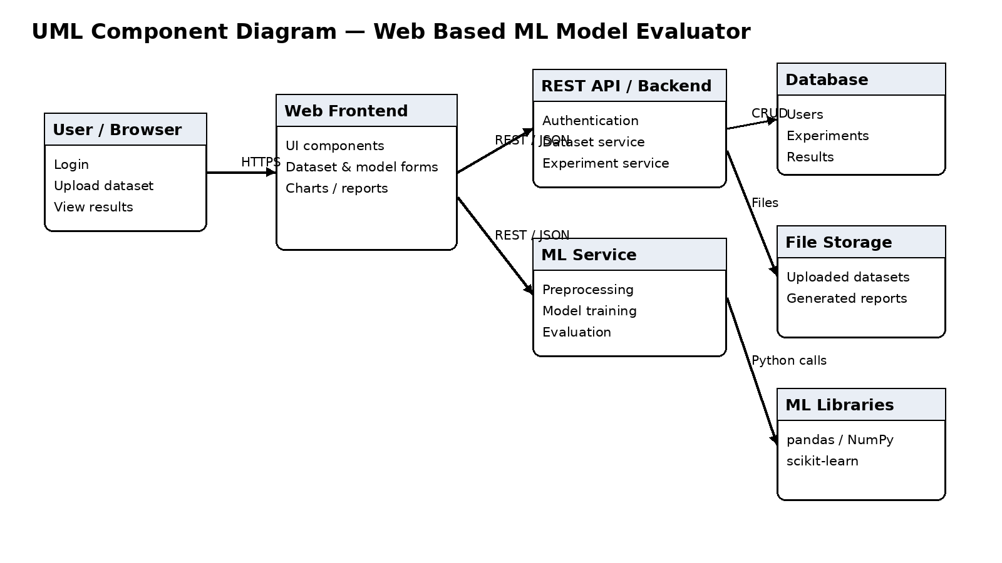
Figure 1. UML Component Diagram
The component diagram shows the major system components and their interfaces.

Sequence Diagram 1: Dataset Upload and Preprocessing
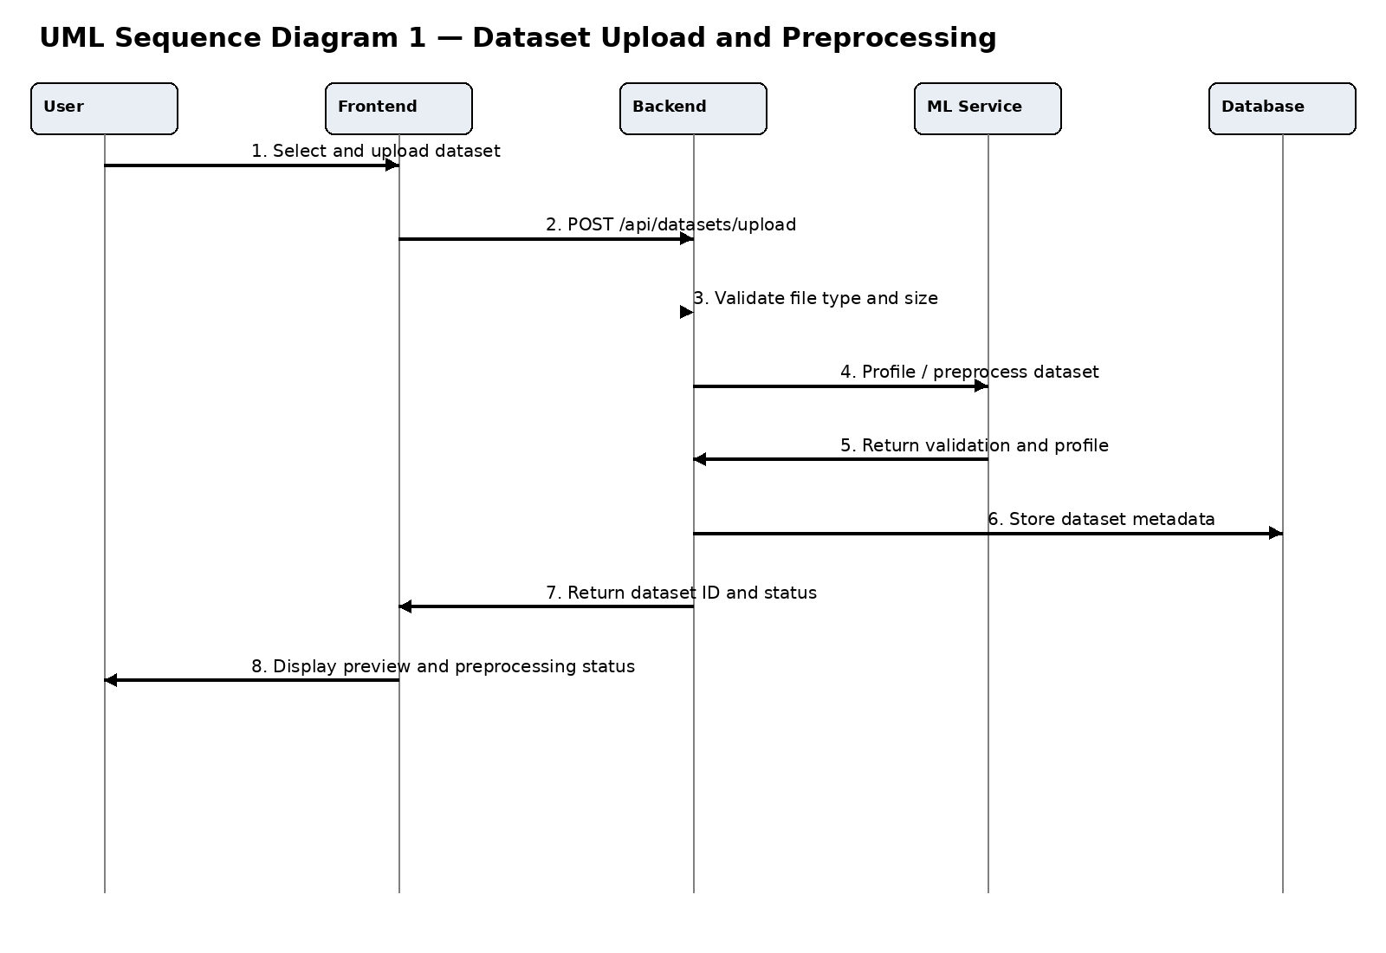
Figure 2. UML Sequence Diagram — Dataset Upload and Preprocessing

Sequence Diagram 2: Model Training and Evaluation
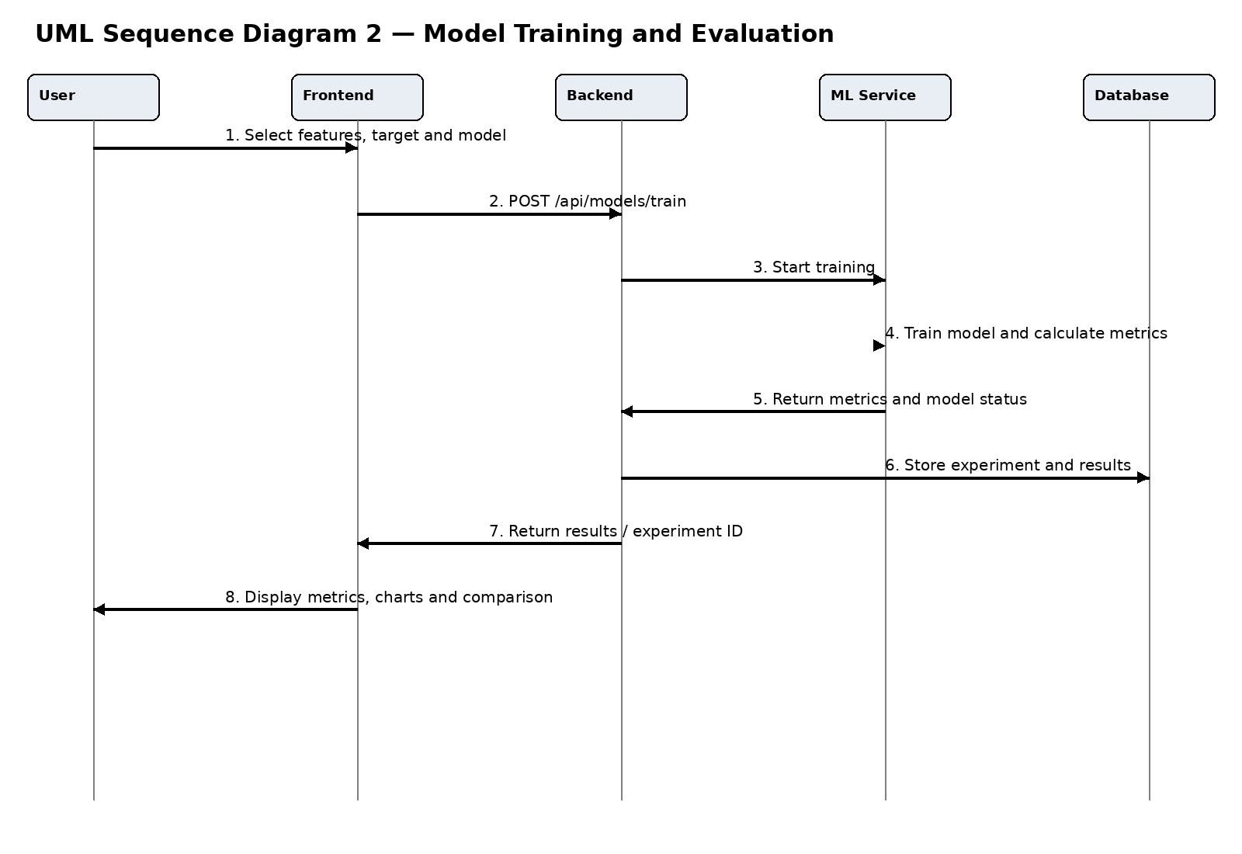
Figure 3. UML Sequence Diagram — Model Training and Evaluation

