Web大作业

小米官网

学 院（系）： 软件学院
专 业： 网络工程
学 生 姓 名： 张善迪
学 号： 20202241153
指 导 教 师： 卢炳先
评 阅 教 师：
完 成 日 期：

大连理工大学
Dalian University of Technology
目 录
1 项目准备 1
2 黑色导航条 2
2.1 HTML部分 2
2.2 CSS部分 2
3 白色导航条 5
3.1 HTML部分 5
3.2 CSS部分 8
4 Banner部分 12
4.1 HTML部分 12
4.2 CSS部分 12
5 广告部分 15
5.1 HTML部分 15
5.2 CSS部分 16
6 手机部分 18
6.1 HTML部分 18
6.2 CSS部分 20
7 视频部分 22
7.1 HTML部分 22
7.2 CSS部分 23
8 页脚部分 24
8.1 HTML部分 24
8.2 CSS部分 24

1 项目准备
https://www.mi.com/shop
下载图片，下载iconfont，初始化css文件
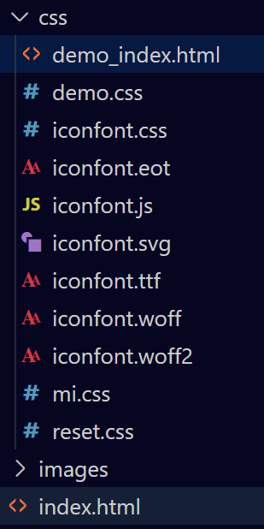

2 黑色导航条

2.1 HTML部分
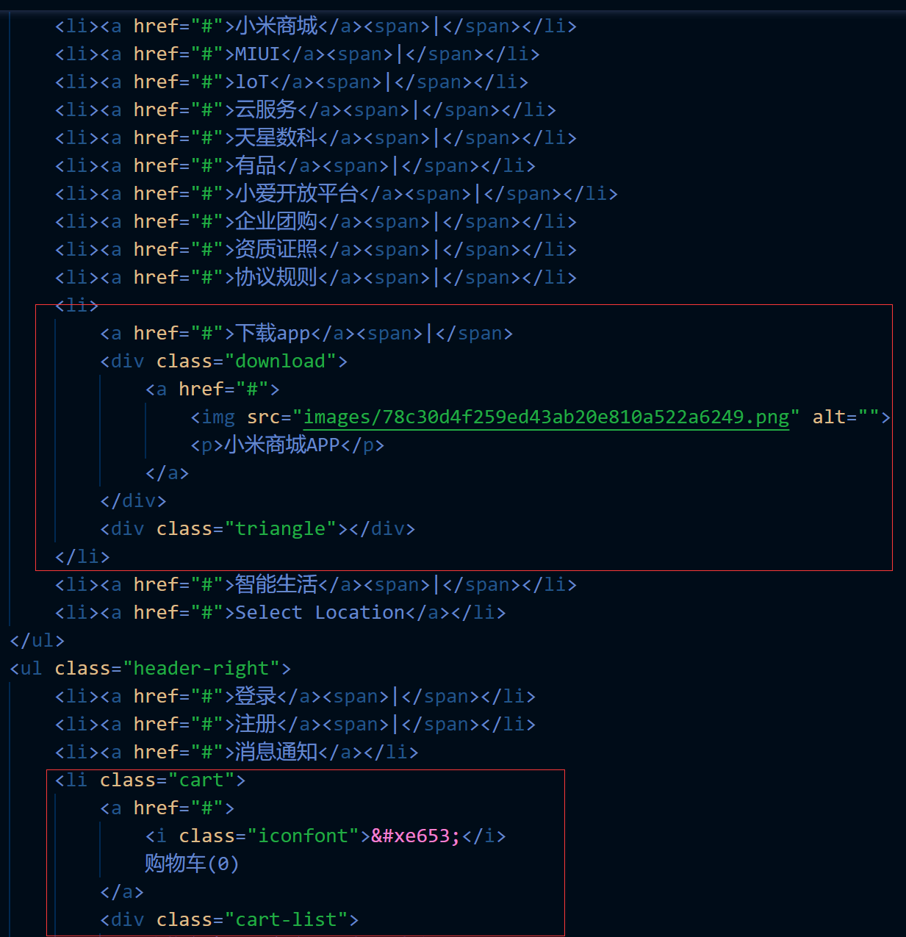

2.2 CSS部分
.black-nav{
width: 100%;
height: 40px;
line-height: 40px;
background-color: #333;
font-size: 12px;
}
.wrap{
width:1226px;
margin: 0 auto;
}
.black-nav-left,.black-nav li{
float: left;
}
.black-nav li{
position: relative;
}
.black-nav a{
color: #b0b0b0;
}
.black-nav a:hover{
color: #fff;
}
.black-nav span{
color: #424242;
margin: 0 3.6px;
}
.black-nav-right{
float: right;
}
.cart{
width: 120px;
height: 40px;
background-color: #424242;
margin-left: 25px;
cursor: pointer;
}
.cart:hover{
background-color: #fff;
}
.cart i{
font-size: 20px;
margin-right: 4px;
}
.cart:hover>a{
color: #ff6700;
}
.triangle{
width: 0;
height: 0;
border-bottom: 8px solid #fff;
border-left: 8px solid transparent;
border-right: 8px solid transparent;
position: absolute;
bottom: 0;
left: 50%;
margin-left: -8px;
display: none;
}
.black-nav li:hover>.triangle,.black-nav li:hover>.code{
display: block;
}
.code{
width: 124px;
height: 0;
background-color: #fff;
box-shadow: 0 1px 5px #aaa;
position: absolute;
top: 40px;
left: 50%;
margin-left: -62px;
overflow: hidden;
transition: all .3s;
z-index: 888;
}
.black-nav li:hover>.code{
height: 148px;
}
.code>img{
width: 90px;
margin: 18px 0 12px;
}
.code>p{
color: #333;
font-size: 14px;
line-height: 14px;
}
.cart-list{
width: 316px;
height: 0;
background-color: #fff;
box-shadow: 0 2px 10px rgba(0,0,0,.15);
position: absolute;
top: 40px;
right: 0;
transition: all .3s;
color: #424242;
overflow: hidden;
z-index: 800;
}
.cart:hover>.cart-list{
height: 100px;
line-height: 100px;
}

3 白色导航条

3.1 HTML部分
<div class="nav">
<div class="wrap">
<div class="logo">
<a href="#">
<img src="images/logo-mi2.png" alt="">
</a>
</div>
<div class="nav-bar">
<ul>
<li>
<a href="#">小米手机</a>
<div class="nav-bar-list">
<div class="wrap">
<ul>
<li>
<a href="#">
<div class="img-box">
<img src="images/a1c45eadcedeb27b1cafca0359422da9.webp" alt="">
</div>
<p class="name1">小米11 Pro</p>
<p class="price1">4499元起</p>
</a>
</li>
<li>
<a href="#">
<div class="img-box">
<img src="images/a1c45eadcedeb27b1cafca0359422da9.webp" alt="">
</div>
<p class="name1">小米11 Pro</p>
<p class="price1">4499元起</p>
</a>
</li>
<li>
<a href="#">
<div class="img-box">
<img src="images/a1c45eadcedeb27b1cafca0359422da9.webp" alt="">
</div>
<p class="name1">小米11 Pro</p>
<p class="price1">4499元起</p>
</a>
</li>
<li>
<a href="#">
<div class="img-box">
<img src="images/a1c45eadcedeb27b1cafca0359422da9.webp" alt="">
</div>
<p class="name1">小米11 Pro</p>
<p class="price1">4499元起</p>
</a>
</li>
<li>
<a href="#">
<div class="img-box">
<img src="images/a1c45eadcedeb27b1cafca0359422da9.webp" alt="">
</div>
<p class="name1">小米11 Pro</p>
<p class="price1">4499元起</p>
</a>
</li>
<li>
<a href="#">
<div class="img-box">
<img src="images/a1c45eadcedeb27b1cafca0359422da9.webp" alt="">
</div>
<p class="name1">小米11 Pro</p>
<p class="price1">4499元起</p>
</a>
</li>
</ul>
</div>
</div>
</li>
<li>
<a href="#">Redmi红米</a>
<div class="nav-bar-list">
<div class="wrap">
<ul>
<li>
<a href="#">
<div class="img-box">
<img src="images/88bb84ff06f0ab467b859aeed36b817a.webp" alt="">
</div>
<p class="name1">小米11 Pro</p>
<p class="price1">4499元起</p>
</a>
</li>
<li>
<a href="#">
<div class="img-box">
<img src="images/a1c45eadcedeb27b1cafca0359422da9.webp" alt="">
</div>
<p class="name1">小米11 Pro</p>
<p class="price1">4499元起</p>
</a>
</li>
<li>
<a href="#">
<div class="img-box">
<img src="images/a1c45eadcedeb27b1cafca0359422da9.webp" alt="">
</div>
<p class="name1">小米11 Pro</p>
<p class="price1">4499元起</p>
</a>
</li>
<li>
<a href="#">
<div class="img-box">
<img src="images/a1c45eadcedeb27b1cafca0359422da9.webp" alt="">
</div>
<p class="name1">小米11 Pro</p>
<p class="price1">4499元起</p>
</a>
</li>
<li>
<a href="#">
<div class="img-box">
<img src="images/a1c45eadcedeb27b1cafca0359422da9.webp" alt="">
</div>
<p class="name1">小米11 Pro</p>
<p class="price1">4499元起</p>
</a>
</li>
<li>
<a href="#">
<div class="img-box">
<img src="images/a1c45eadcedeb27b1cafca0359422da9.webp" alt="">
</div>
<p class="name1">小米11 Pro</p>
<p class="price1">4499元起</p>
</a>
</li>
</ul>
</div>
</div>
</li>
<li><a href="#">电视</a></li>
<li><a href="#">笔记本</a></li>
<li><a href="#">家电</a></li>
<li><a href="#">路由器</a></li>
<li><a href="#">智能硬件</a></li>
<li><a href="#">服务</a></li>
<li><a href="#">社区</a></li>
</ul>
</div>
<div class="search">
<input type="text">
<a href="#" class="iconfont">&#xe63d;</a>
<div class="search-list">
<a href="#">全部商品</a>
<a href="#">全部商品</a>
<a href="#">全部商品</a>
<a href="#">全部商品</a>
<a href="#">全部商品</a>
<a href="#">全部商品</a>
<a href="#">全部商品</a>
<a href="#">全部商品</a>
</div>
</div>
</div>
</div>

3.2 CSS部分
.white-nav{
width: 100%;
height: 100px;
position: relative;
background-color: #fff;
}
.logo{
width: 55px;
height: 100px;
float: left;
}
.nav-bar{
width: 850px;
height: 100px;
float: left;
margin-left: 7px;
margin-right: 18px;
padding-left: 142px;
box-sizing: border-box;
}
.search{
width: 296px;
float: left;
margin-top: 25px;
position: relative;
background-color: red;
}
.logo>a{
display: block;
width: 55px;
height: 55px;
background-image: url("../images/logo-footer.png");
background-size: 55px 55px;
margin-top: 22.5px;
}
.logo>a:hover{
background-image: url("../images/logo.png");
}
.nav-bar>ul>li{
float: left;
height: 100px;
}
.nav-bar>ul>li>a{
color: #333;
padding: 38px 10px;
display: block;
}
.nav-bar a:hover{
color: #ff6700;
}
.search input{
width: 244px;
height: 50px;
border: 1px solid #e0e0e0;
padding: 0 10px;
box-sizing: border-box;
border-right: none;
float: left;
outline: none;
transition: all .2s;
}
.search button{
width: 52px;
height: 50px;
background-color: #fff;
border: 1px solid #e0e0e0;
float: left;
color: #616161;
font-size: 20px;
transition: all .2s;
cursor: pointer;
outline: none;
}
.search button:hover{
background-color: #ff6700;
border-color: #ff6700;
color: #fff;
}
.search input:hover,.search input:hover+button{
border-color: #b0b0b0;
}
.search input:focus,.search input:focus+button{
border-color: #ff6700;
}
<!--下拉列表-->
.hot-word-list{
width: 245px;
height: 300px;
border: 1px solid #ff6700;
box-sizing: border-box;
position: absolute;
left: 0;
top: 50px;
border-top: none;
display: none;
background-color: #fff;
z-index: 700;
}
.search input:focus~.hot-word-list{
display: block;
}
.hot-word-list a{
color: #424242;
font-size: 12px;
}
.hot-word-list li{
text-align: left;
padding-left: 10px;
height: 30px;
line-height: 30px;
}
.hot-word{
height: 50px;
line-height: 50px;
position: absolute;
top: 0;
right: 62px;
text-align: right;
}
.hot-word>a{
color: #757575;
background-color: #eee;
font-size: 12px;
padding: 0 5px;
margin-left: 5px;
transition: all .2s;
}
.hot-word>a:hover{
color: #fff;
background-color: #ff6700;
}
.search input:focus~.hot-word{
display: none;
}
.nav-list{
width: 100%;
height: 230px;
background-color: #fff;
position: absolute;
left: 0;
top: 100px;
display: none;
border-top: 1px solid #e0e0e0;
box-shadow: 0 3px 4px rgba(0,0,0,.18);
z-index: 777;
}
.nav-bar li:hover>.nav-list{
display: block;
}
.nav-list li{
width: 204px;
height: 201px;
padding: 35px 12px 0;
box-sizing: border-box;
float: left;
}
.img-box{
height: 110px;
border-right: 1px solid #e0e0e0;
margin-bottom: 16px;
}
.img-box1{
border-right: none;
}
.name1{
color: #333;
font-size: 12px;
line-height: 20px;
}
.price1{
color: #ff6700;
font-size: 12px;
line-height: 20px;
}

4 Banner部分

4.1 HTML部分
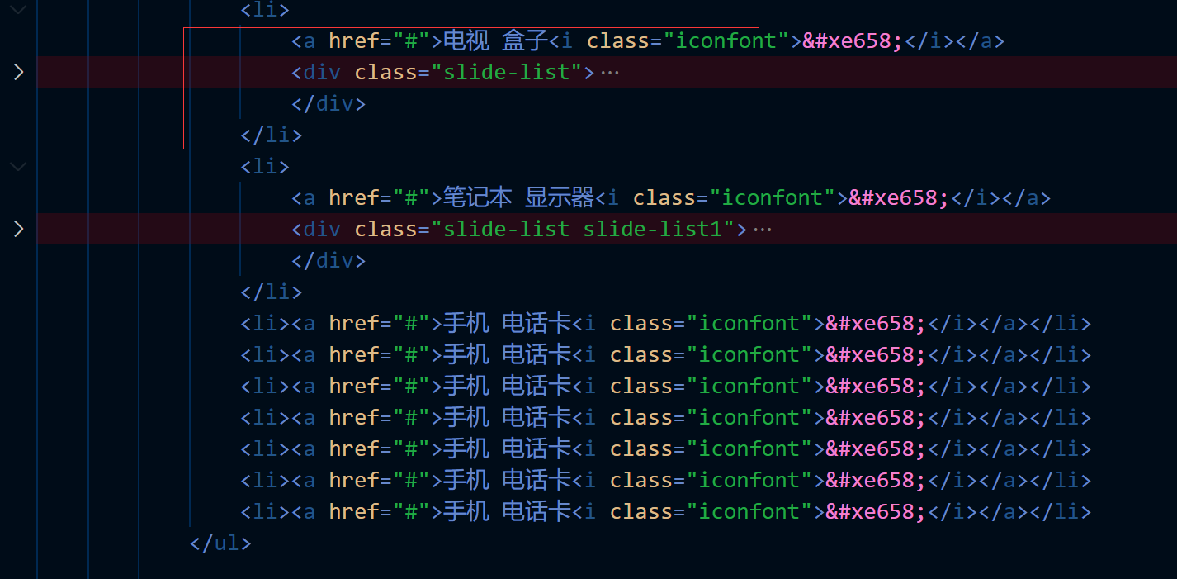

4.2 CSS部分
4.2.1 动画实现幻灯品效果
.banner{
width: 100%;
height: 460px;
}
.banner-box{
width: 1226px;
height: 460px;
background-image: url("../images/793eebbee1dd569fe56a8aaf58f62452.jpg");
background-size: 100%;
animation: banner 6s linear infinite;
}
.banner-box:hover{
animation-play-state: paused;
}
@keyframes banner {
0%{
background-image: url("../images/793eebbee1dd569fe56a8aaf58f62452.jpg");
}
50%{
background-image: url("../images/1c3e97686468231f3f78048d7f2b7fdc.webp");
}
100%{
background-image: url("../images/f22bf70c4dc00ab1ed9b3d71125534f7.webp");
}

}
4.2.2 滑动门效果
.banner>.wrap{
position: relative;
}
.slide{
position: absolute;
left: 0;
top: 0;
width: 234px;
height: 420px;
padding: 20px 0;
background-color: rgba(105,101,101,.6);
}
.slide>ul>li{
height: 42px;
line-height: 42px;
text-align: left;
padding-left: 30px;
}
.slide>ul>li:hover{
background-color: #ff6700;
}
.slide>ul>li>a{
color: #fff;
font-size: 14px;
}
.slide i{
float: right;
margin-right: 20px;
font-size: 12px;
}
.slide-list{
z-index: 700;
display: none;
position: absolute;
top: 0;
left: 234px;
width: 992px;
height: 456px;
background-color: #fff;
border: 1px solid #e0e0e0;
border-left: none;
padding-top: 2px;
box-shadow: 0 8px 16px rgba(0,0,0,.18);
}
.slide li:hover>.slide-list{
display: block;
}
.slide-list>ul{
width: 248px;
float: left;
}
.slide-list li{
width: 100%;
height: 76px;
padding: 18px 0 18px 20px;
box-sizing: border-box;
}
.slide-list img{
margin-right: 12px;
}
.slide-list span{
line-height: 40px;
font-size: 14px;
white-space: nowrap;
overflow: hidden;
text-overflow: ellipsis;
}
.slide-list li:hover span{
color: #ff6700;
}
.slide-list1{
width: 744px;
}

5 广告部分

5.1 HTML部分
<div class="adv">
<div class="wrap">
<div class="adv-aside">
<ul>
<li class="row col">
<a href="">
<i class="iconfont">&#xe733;</i>
<p>米粉卡</p>
</a>
</li>
<li class="row col">
<a href="">
<i class="iconfont">&#xe733;</i>
<p>米粉卡</p>
</a>
</li>
<li class="row">
<a href="">
<i class="iconfont">&#xe733;</i>
<p>米粉卡</p>
</a>
</li>
<li class="col">
<a href="">
<i class="iconfont">&#xe733;</i>
<p>米粉卡</p>
</a>
</li>
<li class="col">
<a href="">
<i class="iconfont">&#xe733;</i>
<p>米粉卡</p>
</a>
</li>
<li>
<a href="">
<i class="iconfont">&#xe733;</i>
<p>米粉卡</p>
</a>
</li>
</ul>
</div>
<div class="adv-img">
<a href="#">
<img src="images/b30177d629bfbe2fb42251c1b8538f7b.jpg" alt="">
</a>
</div>
<div class="adv-img">
<a href="#">
<img src="images/b30177d629bfbe2fb42251c1b8538f7b.jpg" alt="">
</a>
</div>
<div class="adv-img">
<a href="#">
<img src="images/b30177d629bfbe2fb42251c1b8538f7b.jpg" alt="">
</a>
</div>
</div>
</div>

5.2 CSS部分
.adv{
width: 100%;
height: 170px;
margin: 14px 0 26px;
}
.adv-aside{
width: 234px;
height: 170px;
padding: 3px;
box-sizing: border-box;
background-color: #5f5750;
float: left;
}
.adv-img{
width: 316px;
height: 170px;
float: left;
margin-left: 14.6px;
transition: all .2s linear;
}
.adv-img img{
width: 100%;
}
.adv-img:hover{
box-shadow: 0 15px 30px rgba(0,0,0,.1);
}
.adv-aside li{
position: relative;
float: left;
width: 76px;
height: 82px;
padding: 19px 0;
box-sizing: border-box;
}
.adv-aside i{
display: block;
font-size: 22px;
margin-bottom: 4px;
}
.adv-aside a{
display: block;
color: #fff;
font-size: 12px;
opacity: .7;
transition: all .2s;
}
.adv-aside a:hover{
opacity: 1;
}
.row::after,.col::before{
position: absolute;
content:"";
background-color: #665e57;
}
.row::after{
bottom: 0;
left: 6px;
height: 1px;
width: 64px;

}
.col::before{
top: 6px;
right: 0;
width: 1px;
height: 70px;
}

6 手机部分

6.1 HTML部分
<div class="container">
<div class="wrap">
<!--手机开始-->
<div class="phone">
<div class="home-banner-box">
<a href="#">
<img src="images/431e5fd6bfd1b67d096928248be18303.webp" alt="">
</a>

</div>
<h2 class="title">手机
<a href="#" class="more">查看更多 <i class="iconfont">&#xe616;</i></a>
</h2>
<div class="home-box">
<div class="home-box-left home-box-left1">
<a href="#">
<img src="images/c583f2edc613f1be20fa415910b13ce3.webp" alt="">
</a>
</div>
<div class="home-box-right">
<ul>
<li class="items">
<a href="#">
<img src="images/61454401f855cf5ed64747a6ac04bae5.webp" alt="" class="img1">
<p class="name2">Note 10 Pro</p>
<p class="desc2">天玑1100年度旗舰芯，VC液冷散热</p>
<p class="price2">1599元起
<del>1699元</del>
</p>
</a>
</li>
<li class="items">
<a href="#">
<img src="images/61454401f855cf5ed64747a6ac04bae5.webp" alt="" class="img1">
<p class="name2">Note 10 Pro</p>
<p class="desc2">天玑1100年度旗舰芯，VC液冷散热</p>
<p class="price2">1599元起
<del>1699元</del>
</p>
</a>
</li>
<li class="items">
<a href="#">
<img src="images/61454401f855cf5ed64747a6ac04bae5.webp" alt="" class="img1">
<p class="name2">Note 10 Pro</p>
<p class="desc2">天玑1100年度旗舰芯，VC液冷散热</p>
<p class="price2">1599元起
<del>1699元</del>
</p>
</a>
</li>
<li class="items">
<a href="#">
<img src="images/61454401f855cf5ed64747a6ac04bae5.webp" alt="" class="img1">
<p class="name2">Note 10 Pro</p>
<p class="desc2">天玑1100年度旗舰芯，VC液冷散热</p>
<p class="price2">1599元起
<del>1699元</del>
</p>
</a>
</li>
<li class="items">
<a href="#">
<img src="images/61454401f855cf5ed64747a6ac04bae5.webp" alt="" class="img1">
<p class="name2">Note 10 Pro</p>
<p class="desc2">天玑1100年度旗舰芯，VC液冷散热</p>
<p class="price2">1599元起
<del>1699元</del>
</p>
</a>
</li>
<li class="items">
<a href="#">
<img src="images/61454401f855cf5ed64747a6ac04bae5.webp" alt="" class="img1">
<p class="name2">Note 10 Pro</p>
<p class="desc2">天玑1100年度旗舰芯，VC液冷散热</p>
<p class="price2">1599元起
<del>1699元</del>
</p>
</a>
</li>
<li class="items">
<a href="#">
<img src="images/61454401f855cf5ed64747a6ac04bae5.webp" alt="" class="img1">
<p class="name2">Note 10 Pro</p>
<p class="desc2">天玑1100年度旗舰芯，VC液冷散热</p>
<p class="price2">1599元起
<del>1699元</del>
</p>
</a>
</li>
<li class="items">
<a href="#">
<img src="images/61454401f855cf5ed64747a6ac04bae5.webp" alt="" class="img1">
<p class="name2">Note 10 Pro</p>
<p class="desc2">天玑1100年度旗舰芯，VC液冷散热</p>
<p class="price2">1599元起
<del>1699元</del>
</p>
</a>
</li>
</ul>
</div>
</div>
</div>

6.2 CSS部分
.home-banner-box{
width: 100%;
height: 120px;
margin: 22px 0;
}
.title{
color: #333;
font-size: 22px;
font-weight: 200;
text-align: left;
line-height: 58px;
}
.more{
float: right;
color: #424242;
font-size: 16px;
}
.more:hover{
color: #ff6700;
}
.more>i{
display: inline-block;
width: 12px;
height: 12px;
padding: 4px;
background-color: #b0b0b0;
border-radius: 50%;
line-height: 12px;
color: #fff;
margin-left: 8px;
transition: all .4s;
}
.more:hover>i{
background-color: #ff6700;
}
.home-box{
width: 100%;
height: 614px;
}
.home-box-left{
width: 234px;
height: 614px;
float: left;
transition: all .2s linear;
}
.home-box-right{
width: 992px;
height: 614px;
float: left;
}
.items{
width: 234px;
height: 300px;
background-color: #fff;
float: left;
margin-bottom: 14px;
margin-left: 14px;
transition: all .2s linear;
}
.items:hover,.home-box-left1:hover,.last-items>div:hover,.video-items:hover{
box-shadow: 0 15px 30px rgba(0,0,0,.1);
transform: translateY(-2px);
}
.img1{
width: 160px;
margin-top: 20px;
margin-bottom: 18px;
}
.name2,.desc2{
width: 214px;
margin: 0 auto;
white-space: nowrap;
overflow: hidden;
text-overflow: ellipsis;
}
.name2{
height: 21px;
line-height: 21px;
font-size: 14px;
margin-bottom: 2px;
}
.desc2{
height: 18px;
line-height: 18px;
margin-bottom: 10px;
font-size: 12px;
color: #b0b0b0;
}
.price2{
color: #ff6700;
font-size: 14px;
}
.price2>del{
color: #b0b0b0;
margin-left: 7px;
}

7 视频部分

7.1 HTML部分
<div class="video">
<div class="home-banner-box">
<a href="#">
<img src="images/88e35cffc82cd98cd53172460067af17.webp" alt="">
</a>

</div>
<h2 class="title">视频
<a href="#" class="more">查看全部 <i class="iconfont">&#xe616;</i></a>
</h2>
<div class="video-box">
<ul>
<li class="video-items">
<a href="#">
<div class="video-img">
<img src="images/e74c4ff741bcdfc5b28a48a43e4edc6d.webp" alt="">
<div class="play">
<span></span>
</div>
</div>
<p>2021年春季新品发布会第一场</p>
</a>
</li>
<li class="video-items">
<a href="#">
<div class="video-img">
<img src="images/e74c4ff741bcdfc5b28a48a43e4edc6d.webp" alt="">
<div class="play">
<span></span>
</div>
</div>
<p>2021年春季新品发布会第一场</p>
</a>
</li>
<li class="video-items">
<a href="#">
<div class="video-img">
<img src="images/e74c4ff741bcdfc5b28a48a43e4edc6d.webp" alt="">
<div class="play">
<span></span>
</div>
</div>
<p>2021年春季新品发布会第一场</p>
</a>
</li>
<li class="video-items">
<a href="#">
<div class="video-img">
<img src="images/e74c4ff741bcdfc5b28a48a43e4edc6d.webp" alt="">
<div class="play">
<span></span>
</div>
</div>
<p>2021年春季新品发布会第一场</p>
</a>
</li>
</ul>
</div>
</div>

7.2 CSS部分

.video-items{
width: 296px;
height: 285px;
background-color: #fff;
float: left;
margin-bottom: 14px;
margin-right: 14px;
transition: all .2s linear;
}
.video-items:last-child{
margin-right: 0;
}
.video-img{
position: relative;
width: 100%;
height: 180px;
}
.video-items p{
width: 268px;
height: 21px;
margin: 28px auto 6px;
font-size: 14px;
white-space: nowrap;
overflow: hidden;
text-overflow: ellipsis;
}
.play{
position: absolute;
left: 20px;
bottom: 10px;
width: 32px;
height: 20px;
border: 2px solid #fff;
border-radius: 12px;
transition: all .2s;
}
.play>span{
display: block;
width: 0;
height: 0;
border-left: 8px solid #fff;
border-top: 6px solid transparent;
border-bottom: 6px solid transparent;
margin: 4px auto;
}
.video-img:hover>.play{
background-color: #ff6700;
border-color: #ff6700;
}

8 页脚部分

8.1 HTML部分
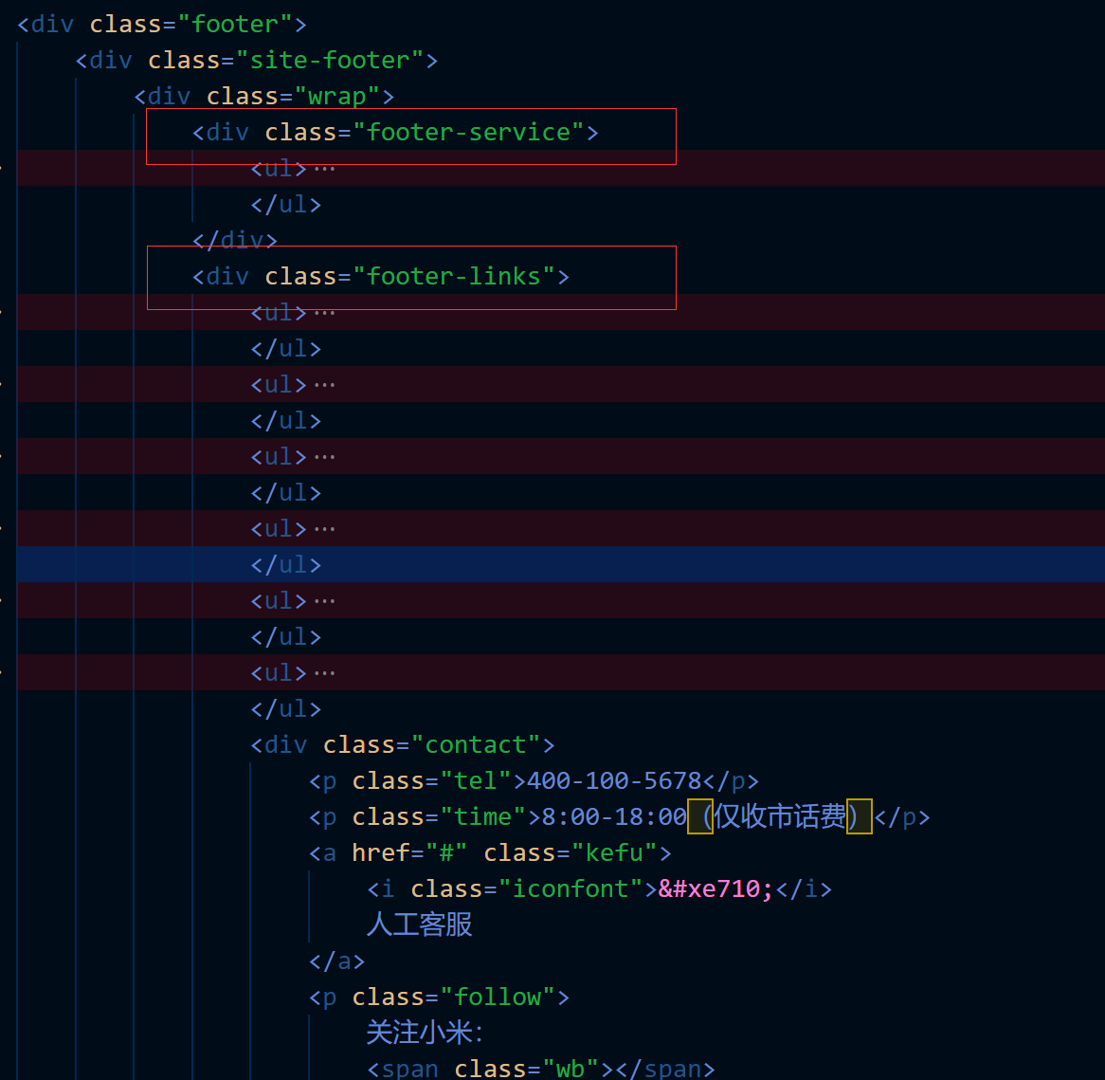

8.2 CSS部分
.site-footer{
width: 100%;
height: 332px;
background-color: #fff;
}
.site-info{
width: 100%;
height: 206px;
padding: 30px 0;
background-color: #fafafa;
}
.footer-service{
width: 100%;
height: 25px;
padding: 27px 0;
border-bottom: 1px solid #e0e0e0;
}
.footer-service li{
float: left;
width: 19.8%;
height: 25px;
line-height: 25px;
border-right: 1px solid #e0e0e0;
}
.footer-service li:last-child{
border-right: none;
}
.footer-service a{
color: #616161;
transition: all .2s;
}
.footer-service a:hover{
color: #ff6700;
}
.footer-service i{
font-size: 24px;
margin-right: 6px;
}
.footer-links{
width: 100%;
height: 172px;
padding: 40px 0;
font-size: 14px;
color: #424242;
}
.footer-links>ul{
float: left;
width: 160px;
text-align: left;
}
.footer-links a{
color: #757575;
font-size: 12px;
}
.footer-links a:hover{
color: #ff6700;
}
.footer-links li{
height: 18px;
line-height: 18px;
margin-top: 10px;
}
.footer-links li:first-child{
height: 17px;
line-height: 17.5px;
margin: -1px 0 26px;
}
.contact{
float: right;
width: 251px;
height: 111px;
border-left: 1px solid #e0e0e0;
}
.tel{
color: #ff6700;
font-size: 22px;
line-height: 22px;
margin-bottom: 5px;
}
.time{
color: #616161;
font-size: 12px;
margin-bottom: 5px;
}
.contact .kefu{
margin: 0 auto;
width: 118px;
height: 28px;
border: 1px solid #ff6700;
display: block;
color: #ff6700;
line-height: 28px;
font-size: 12px;
transition: all .4s;
}
.contact .kefu:hover{
background-color: #ff6700;
color: #fff;
}
.follow{
position: relative;
margin-top: 10px;
font-size: 12px;
color: #616161;
}
.follow>span{
position: relative;
top: 7px;
width: 24px;
height: 24px;
display: inline-block;
background-size: 100%;

}
.wb{
background-image: url("../images/wb.png");
}
.wb:hover{
background-image: url("../images/wb@2x.png");
}
.wx{
background-image: url("../images/wx.png");
}
.wx:hover{
background-image: url("../images/wx@2x.png");
}
.wx-img{
display: none;
width: 126px;
position: absolute;
top: 35px;
left: 100px;
}
.wx:hover+.wx-img{
display: block;
}
.footer-logo{
width: 56px;
height: 56px;
margin-right: 10px;
float: left;
}
.footer-logo>img{
width: 100%;
}
.sites{
float: left;
width: 1160px;
font-size: 12px;
text-align: left;
line-height: 18px;
}
.sites>p:first-child>a{
color: #757575;
}
.sites>p{
color: #b0b0b0;
}
.sites>p:nth-child(2)>a{
color: #b0b0b0;
}
.sites>p>a:hover{
color: #ff6700;
}
.sites img{
height: 28px;
}
.slogan{
margin-top: 30px;
}

