Open-DIS: Open Source DoD Modeling and Simulation Standards
Don McGregor (mcgredo@nps.edu), Don Brutzman (brutzman@nps.edu)

The IEEE Distributed Interactive Simulation (DIS) Protocol is one of the most widely used Department of Defense modeling and simulation networking standards. The Modeling, Virtual Environment, and Simulation (MOVES) Institute at the Naval Postgraduate School (NPS) has created a free open-source implementation of the DIS standard in both C++ and Java. The code carries the non-viral, business-friendly BSD open-source license. Any individual, business, or government entity can use and modify Open-DIS in their simulation application at no cost and without licensing or copyright issues. The project is hosted at sourceforge.net, the world’s leading open-source project repository.

In addition to the binary DIS standard, the Java code can read and write DIS information in an experimental XML-based format called DIS-XML. An XML schema for DIS-XML is included. XML serialization allows the information contained in DIS simulations to be archived as XML, the standard for establishing data interchange. XML is used globally as part of web services, service-oriented architectures, and countless other applications. DIS packets encoded as XML can be successfully passed through firewalls and over multiuser chat channels using the Extensible Messaging and Presence Protocol (XMPP).

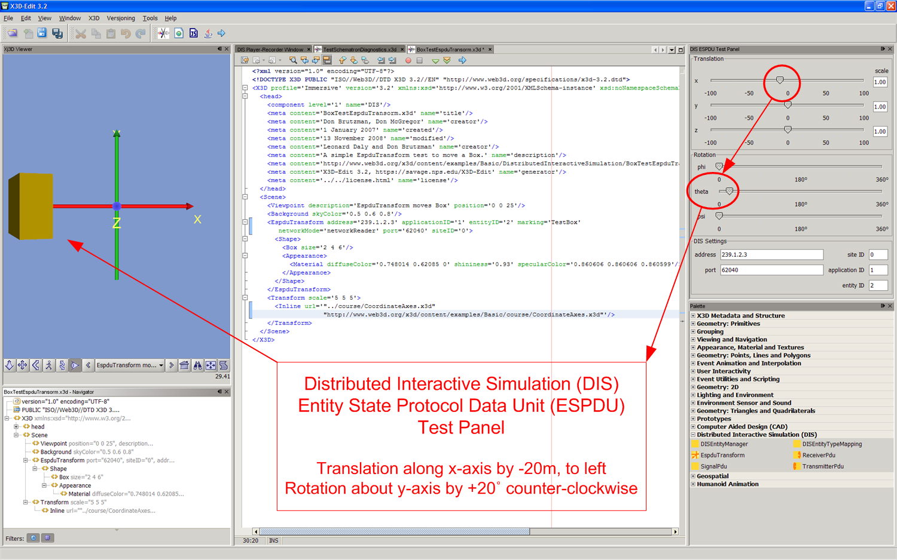

Current work also shows that applying the emerging World Wide Web Consortium (W3C) standard called Efficient XML Interchange (EXI) allows XML documents to be saved in a compact format that rivals or beats legacy binary compression. This approach creates the opportunity to easily extend the information in DIS simulations to other domains, opening the possibility of adopting DIS-XML for future DoD protocols and the XML-based Global Information Grid (GIG).
Further Open-DIS capabilities are also available. Extensible 3D (X3D) graphics is the Web standard for 3D modeling and display, approved by the International Organization for Standardization (ISO) and the non-profit Web3D Consortium. The X3D specification includes a DIS interoperability component to read and write DIS protocol data units (PDUs) as part of a distributed X3D scene graph. We include Open-DIS support in X3D-Edit, an interactive tool for authoring X3D content. Users can also retrieve free open-source models of military vehicles from the Scenario Authoring and Visualization for Advanced Graphical Environments (Savage) model archive, insert them into an X3D scene, and drive them using multicast DIS network traffic.

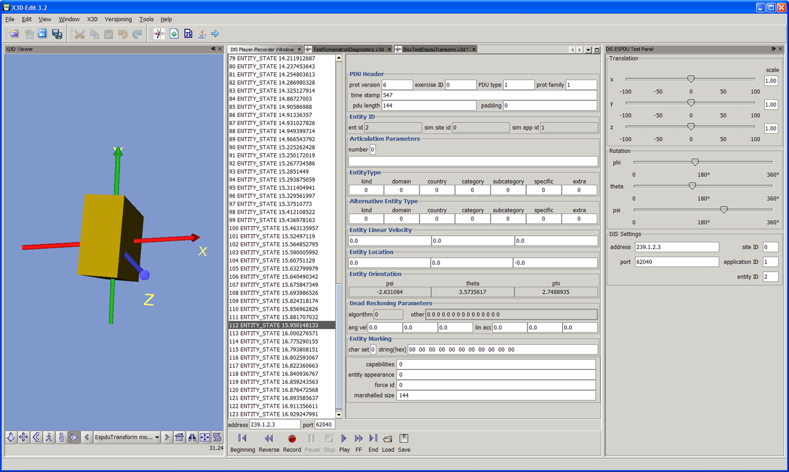

Open-DIS and DIS-XML capabilities were tested satisfactorily as part of the annual Autonomous Underwater Vehicle (AUV) Fest 2008, held in Newport RI and sponsored by ONR and NOAA. DIS and DIS-XML chat were demonstrated by the NPS AUV Workbench, which also exchanged robot-planning communications with the JC3IEDM Tactical Chat (JTC) application, an XMPP-based collaborative mission planner produced by the Naval Undersea Warfare Center (NUWC). Future implementation and testing is underway.

Open source, standards-based software has much to offer the Department of Defense. We hope that Open-DIS can be of use to your project.

Open-DIS Source Repository
https://github.com/open-dis
NPS MOVES Institute
http://www.movesinstitute.org
Web3D Consortium
http://www.web3D.org

Savage 3D Model Archive
https://Savage.nps.edu
SavageDefense FOUO Model Archive
https://SavageDefense.nps.navy.mil
Efficient XML Interchange
http://www.w3.org/XML/EXI

