technology US

Visitor Information
Welcome to Siemens Foundational Technology US, Princeton, NJ

FT US

Information

Located in Princeton, New Jersey USA, Siemens Technology is one of several research and development centers worldwide. Since its founding in 1977, it has helped pioneer a broad range of advancements in major industries, delivering innovations to the Siemens global family as well as government agencies, academic institutions, and other organizations.

Location:
- Address: 755 College Road East, Princeton, NJ 08540.
- Main phone: +1 (609) 734-6500.

Parking
FT US Princeton offers 2 parking lots
- Large parking lot* with solar array – we direct guests who do not have need for accommodation to this lot
- Small visitor lot with handicap access ramp – limited parking for guests needing accommodation for wheelchair/ramp access
*FT US has charging facilities available for e-vehicles

“The deeper the insight we obtain into the mysterious workings of nature's forces... the more we are convinced that we are still standing in the vestibule of science; that an unexplored world still lies before us; and however much we may discover, we know not whether mankind will ever arrive at a full knowledge of nature.” – Werner von Siemens

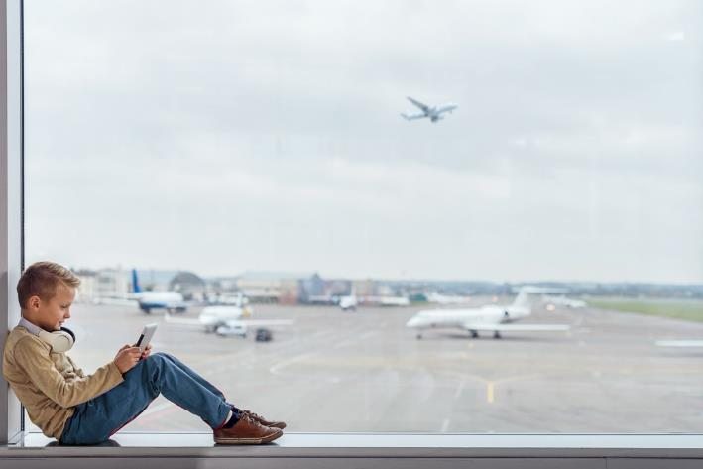
Travel

Travel, Accommodations & Local Information

Local Airports:
- Newark Liberty Airport (EWR) - *preferred
- Philadelphia International Airport (PHL)
- JFK International Airport (JFK)
- Trenton-Mercer Airport (TTN)

Ground Transportation:
Vendor Name | Phone
ASAP Limousine Service | (732) 549-7939
A-1 Limousine | (800) 367-0070
Gem Worldwide Ground Transportation | (732) 596-0900
ABC Taxi | (888) 222-5459
Princeton Economy Taxi | 609-799-9180

Accommodations:
Hotel Name | Address | Phone | website
Crowne Plaza Princeton - Conference Center, an IHG Hotel | 900 Scudders Mill Rd, Plainsboro Township, NJ 08536 | +16099364200• | https://tinyurl.com/jp2ykd2t
DoubleTree by Hilton Hotel Princeton | DoubleTree by Hilton Hotel Princeton | +16094522400 | https://tinyurl.com/4795yv6e
Holiday Inn Princeton, an IHG Hotel | 100 Independence Way, Princeton, NJ 08540 | +16095201200 | https://tinyurl.com/5t3a7xsd
Holiday Inn Express Princeton Southeast, an IHG Hotel | 870 Scudders Mill Rd, Plainsboro Township, NJ 08536 | +16099366600 | https://tinyurl.com/4esad653
The Westin Princeton at Forrestal Village | 201 Village Blvd, Princeton, NJ 08540 | +16094527900 | https://tinyurl.com/5n8396nc
Hyatt Regency Princeton | 102 Carnegie Center Dr, Princeton, NJ 08540 | +16099871234 | https://tinyurl.com/3frd2hkv
Homewood Suites by Hilton Princeton | 3819 US-1, Princeton, NJ 08540 | +16097200550 | https://tinyurl.com/33mjdwnx
Princeton Marriott at Forrestal | 100 College Rd E, Princeton, NJ 08540 | +16094527800• | https://tinyurl.com/4wr4jfn2 •

Directions:
From Newark Airport or Points North:
• Take NJ Turnpike South to Exit 8A. Immediately after the toll booth, bear right onto Route 32 West.
• Take Route 32 West approximately 1 mile to Route 130 South.
• Turn left on 130 South and proceed approximately 1.7 miles to traffic light at Dey Road.
• Turn right on Dey Road and go approximately 4.3 miles to Scudders Mill Road.
• Make a right onto Scudders Mill Road.
• At the second traffic light, turn right onto College Road East.
• Corporate Technology is the first building on the right.

Alternate route:
• Take NJ Turnpike South to Exit 9.
• Follow signs to US 1 South (Trenton).
• Proceed on US 1 approximately 15 miles south to "Princeton Forrestal Center-College Road East."
• Cross over US 1 on the overpass.
• The Princeton Marriott at Forrestal is the second entrance on the right.
• Corporate Technology is 1 mile past the Princeton Marriott at Forrestal, on the left side of the road.

From JFK Airport:
• Take exit road (keep in right lane) to "Belt Parkway - Brooklyn".
• Get off Belt Parkway to go across Verazzano Narrows Bridge.
• Take I-278 to Goethals Bridge and take NJ Turnpike South to Exit 8A or Exit 9.
• Follow directions above for Newark Airport or Points North.

From the Philadelphia Area:
• Take Interstate 95 North into New Jersey, where it becomes 95/295.
• Continue on Route 295 to Route 1 North (Exit 67).
• Take Exit 67 and bear left onto Route 1 North.
• Follow Route 1 North for approximately 6 miles to Scudders Mill Road.
• Turn right onto Scudders Mill Road.
• At the third light, turn left onto College Road East.
• Corporate Technology is the first building on the right.

Local Restaurants:
Restaurant Name | Address | Phone | website | Cuisine
Salt Creek Grille | 1 Rockingham Row, Princeton, NJ 08540 | (609) 419-4200 | https://www.saltcreekgrille.com/ | American
Ruth's Chris Steakhouse | 2 Village Blvd, Princeton, NJ 08540 | (609) 452-0041 | https://ruthschris.com/princeton/ | Steakhouse
Romeo's Pizzaria | 10 Schalks Crossing Rd, Plainsboro, NJ 08536 | (609) 799-4554 | https://romeospizzeria9.godaddysites.com/ | Southern Italian, pizza
On the Border | 3567 Us Highway 1 Princeton, NJ 08540, | (609) 681-5656 | https://www.ontheborder.com/locations/princeton/ | Mexican
Mediterra | 29 Hulfish Street, Princeton, NJ 08540 | (609) 252-9680 | https://www.mediterrarestaurant.com/ | Mediterranean
Cranbury Inn | 21 S Main St., Cranbury, NJ 08830 | (609) 655-5595 | https://thecranburyinn.com/ | American
Eno Terra | 4484 Route 27, Kingston, NJ 08528 | (609) 497-1777 | https://www.enoterra.com/ | Italian, gastro pub
Blue Point Grill | 258 Nassau Street, Princeton, NJ 08540 | (609) 921-1211 | https://www.bluepointgrill.com/ | Seafood
Elements Restaurant | 163 Bayard Lane, Princeton, NJ 08540 | (609) 924-0078 | https://www.elementsprinceton.com/ | American
Witherspoon Grill | 57 Witherspoon Street, Princeton, NJ 08540 | (609) 924-6011 | https://www.witherspoongrill.com/ | Steakhouse, surf n turf
Agricola Eatery | 11 Witherspoon St,Princeton, NJ 08540 | (609) 921-2798 | https://www.agricolaeatery.com/ | Modern farm-to-table
Meeting House | 277 Witherspoon St,Princeton, NJ 08540 | (609) 436-7891 | https://www.meetinghouseprinceton.com/ | American, emphasis on seasonal ingredients
Historic Rocky Hill Inn & Tavern | 137 Washington Ave, Rocky Hill, NJ 08553 | (609) 683-8930 | https://rockyhilltavern.com/ | Gastropub, American
One53 Restaurant Bar | 153 Washington Ave., Rocky Hill NJ 08553 | (609) 921-0153 | https://www.one53nj.com/ | American bistro, farm fresh

Siemens Foundational Technology
755 College Road East
Princeton, NJ 08540

