**Resiliency 2.o: Wellbeing in the Era of COVID-19**

**A Virtual Discussion**

**May 7, 2021 8:30-9:45 PST**

Clinician wellbeing was threatened *before* the pandemic hit, and now many of us have experienced uncertainty, grief, overwhelm, and confusion over the past year. A nurse practitioner wellness expert will present ideas on how to navigate the difficult challenges in this unprecedented moment. Explore how to practice self-leadership, mental agility, and extreme self-care, no matter your circumstances.   Join us for this lively, supportive discussion for nurses to explore strategies to place your own wellbeing at the center of your life.

**Eileen T. O’Grady Ph.D., RN, NP**

[**www.eileenogrady.net**](http://www.eileenogrady.net)

Dr. Eileen O’Grady is a certified Nurse Practitioner and Wellness Coach. She is Founder of *The School of Wellness*, dedicated to infusing the evidence on wellbeing into people and organizations to promote high-level wellness. O’Grady is an expert on intentional change, emphasizing the importance of extreme self-care and how to identify and remedy a life that is off kilter. She is an author and editor of two textbooks, *Advanced Practice Nursing: An Integrative Approach* and *Advancing Caring in Health Care* a how-to book on placing relationships at the center of health care. Her most recent book, *Choosing Wellness: Unconventional Wisdom for the Overwhelmed, the Discouraged, the Addicted, the Fearful or the Stuck,* is her most personal. O’Grady lives in the Washington DC area.

Objectives:

1. Validate current practice realities and specific workplace stressors.
2. Explore tools that more effectively meet complexity and align with human well-being.
3. Review the science of habit formation and the importance of bedrock behaviors.

Evaluation Questions (for CE)

1. The Cynefin Framework: (Answer B)
2. Measures how relaxed you are
3. Identifies the habitat you are in
4. Tells the leader to send help ASAP
5. Identifies problematic co-workers
6. It is always a good idea, when stressed to forgo sleep. T/F (Answer F)
7. Which are the three As which help build resilience: (Answer C)
8. Anger, Absolutism, Absolving
9. Acting, Awarding, Avenging
10. Attention, Agility, Agency
11. Artful, Able, Abolish

Content Outline:

1. Validate Current Reality
   * 1. Cynefin Framework
     2. VUCA World
2. The 3 As of Resilience
   * 1. Attention
     2. Agility
     3. Agency ( claim it!)
3. Habit Science
   1. Chunk it
   2. Stack it
   3. Establish Bedrock Behaviors

For tech person: I want to begin presentation with this poll as I am being introduced: you can show results as I begin speaking

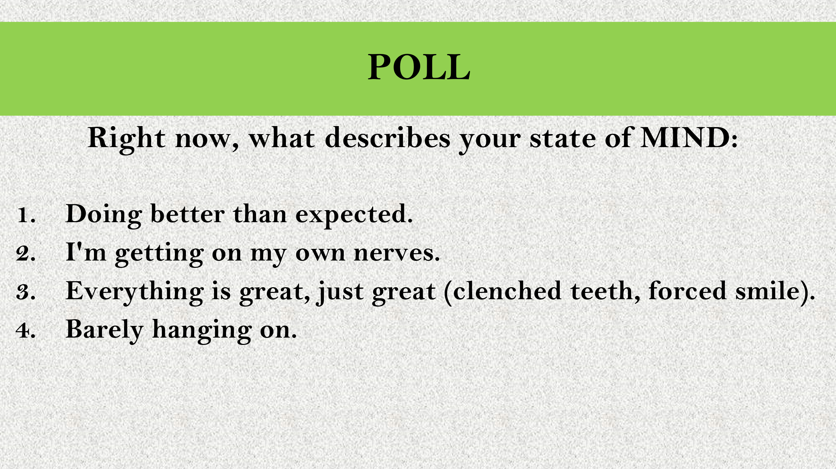

There will be one 10 min breakout room with 4 people per room towards the end.