Trilix Ltd

Company Profile

* Privately owned company headquartered at Zagreb, Croatia – EU, established at 2007.
* Trilix invented Digital Services Distribution System – DSDSTM, a total end to end solution for creation, warehouse management, sales and delivery of advanced digital services from multiple service providers to various delivery devices, through a complex distribution chains.
* Microsoft awarded DSDSTM as the best global solution in High Volume Computing Solution category for 2009.

**Vision and Mission**

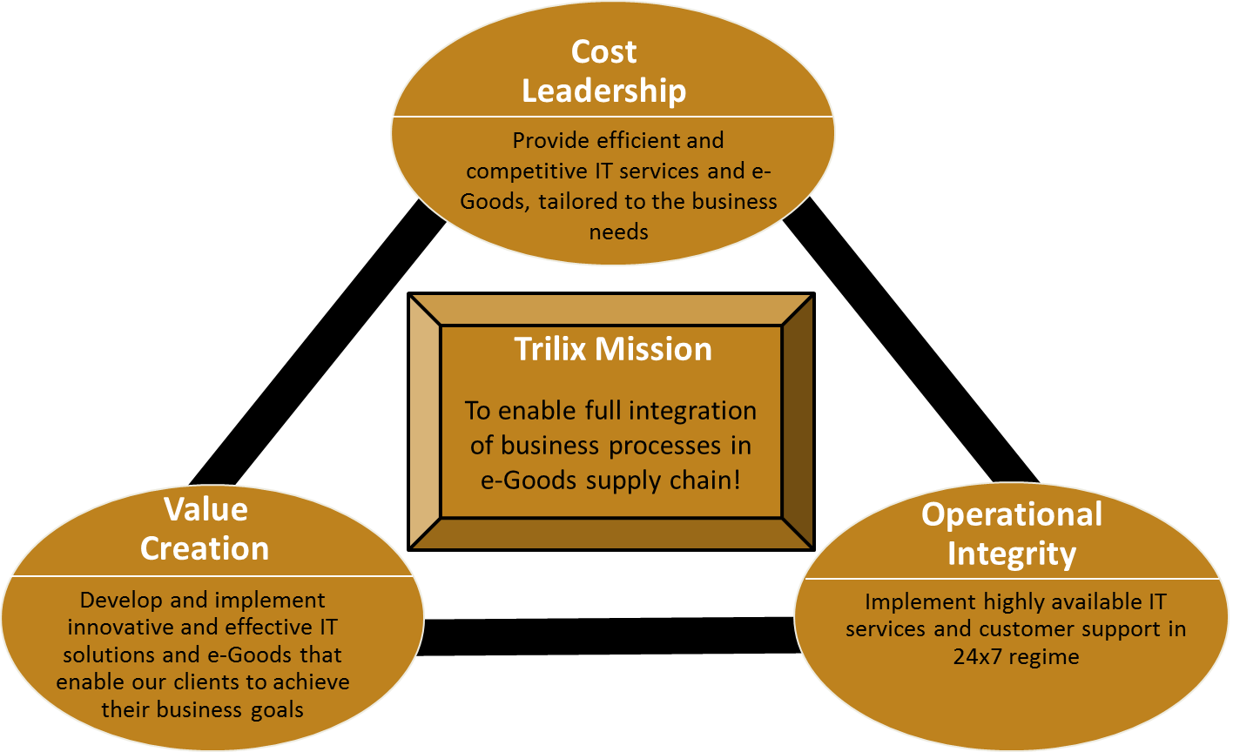

**Customer support is at hart of every project**

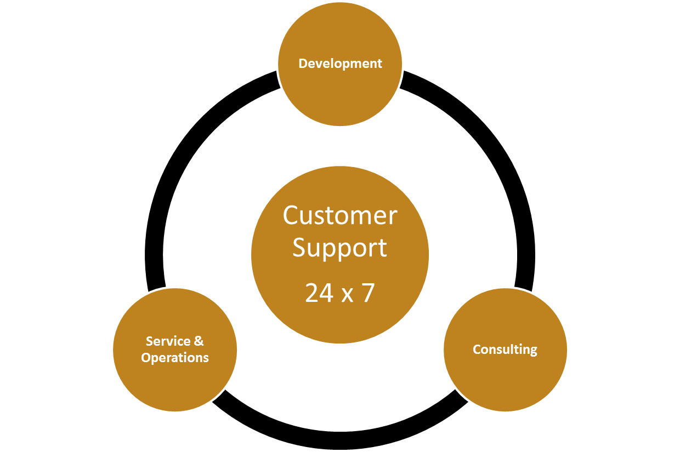

**Operational excellence – we are commited to quality**

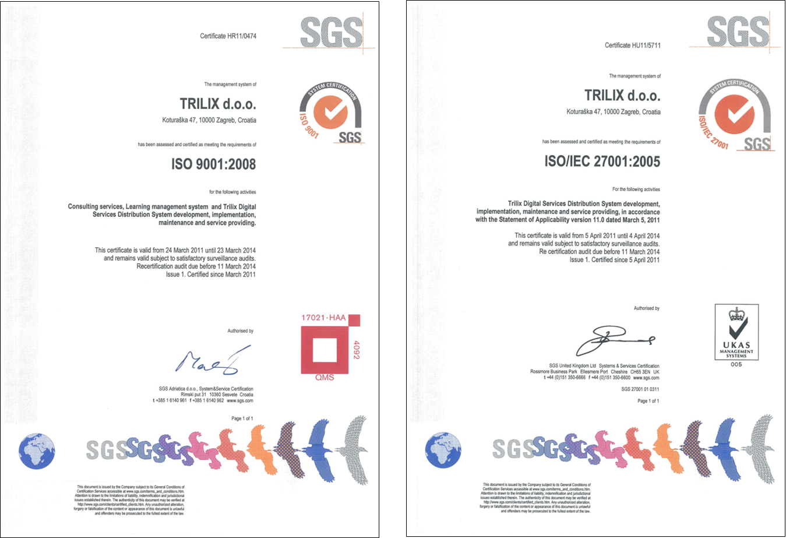

**DSDS™ in brief – Trilix`s Flagship product**

**What is it?**

Trilix Digital Services Delivery Solution (DSDS™) is a total end to end solution for advanced creation, warehouse management, distribution and sales of digital services and e-Goods from multiple service providers to various delivery devices, through a complex distribution chains.

**What does it provide?**

Trilix DSDS™ provides complete solution that covers complete e-Goods lifecycle from creation to final utilization allows users to purchase and/or use e-Goods at any digital device capable to request and receive information in digital form.

**Future?**

In order to protect your investment, Trilix regularly spread DSDS™ functionalities and borders with new technologies like NFC. Trilix is constantly expanding DSDS™ through integrations with different IT/IS systems for automation purpose and access to newest communication channels like social networks.

**Digital distribution channel elements**

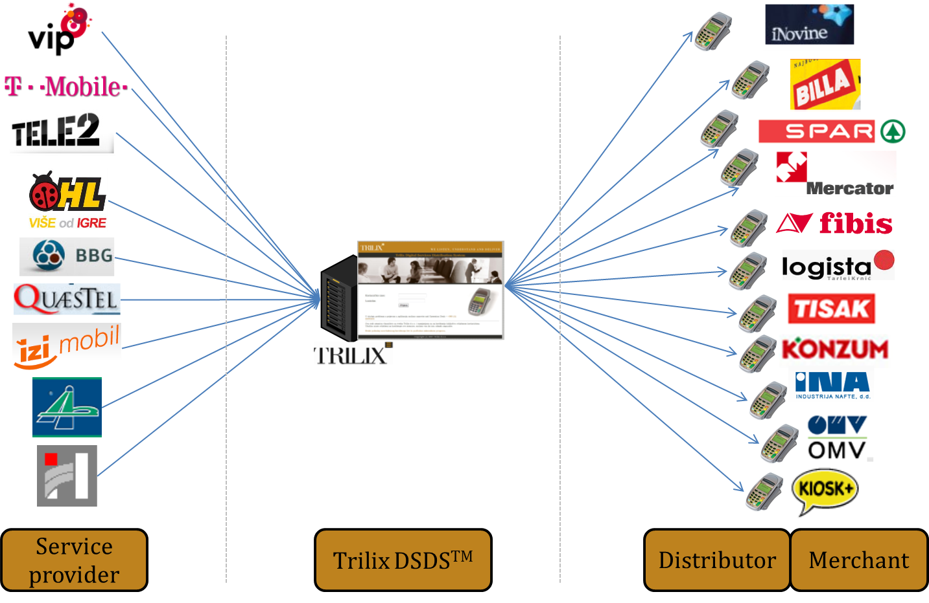

**Domains of expertise**

* Java programming language
* Java EE - enterprise applications
* Spring framework (MVC)
* Grails framework - web development
* MS SQL Server and MySQL Server
* Mobile development: Android, iOS, Windows Phone platforms
* Xamarin – App based mobile development
* PhoneGap – Web based mobile development
* MS SQL Server Reporting Services
* Bazaar version control system
* SFTP servers - Bitwise SSH server
* Open SSL - SSL/TLS protocols
* Python - testing script support
* SPDH
* ISO 8583
* Big ISO
* MDB 3.0

**Trilix Ltd products & services**

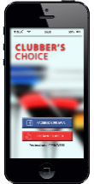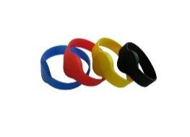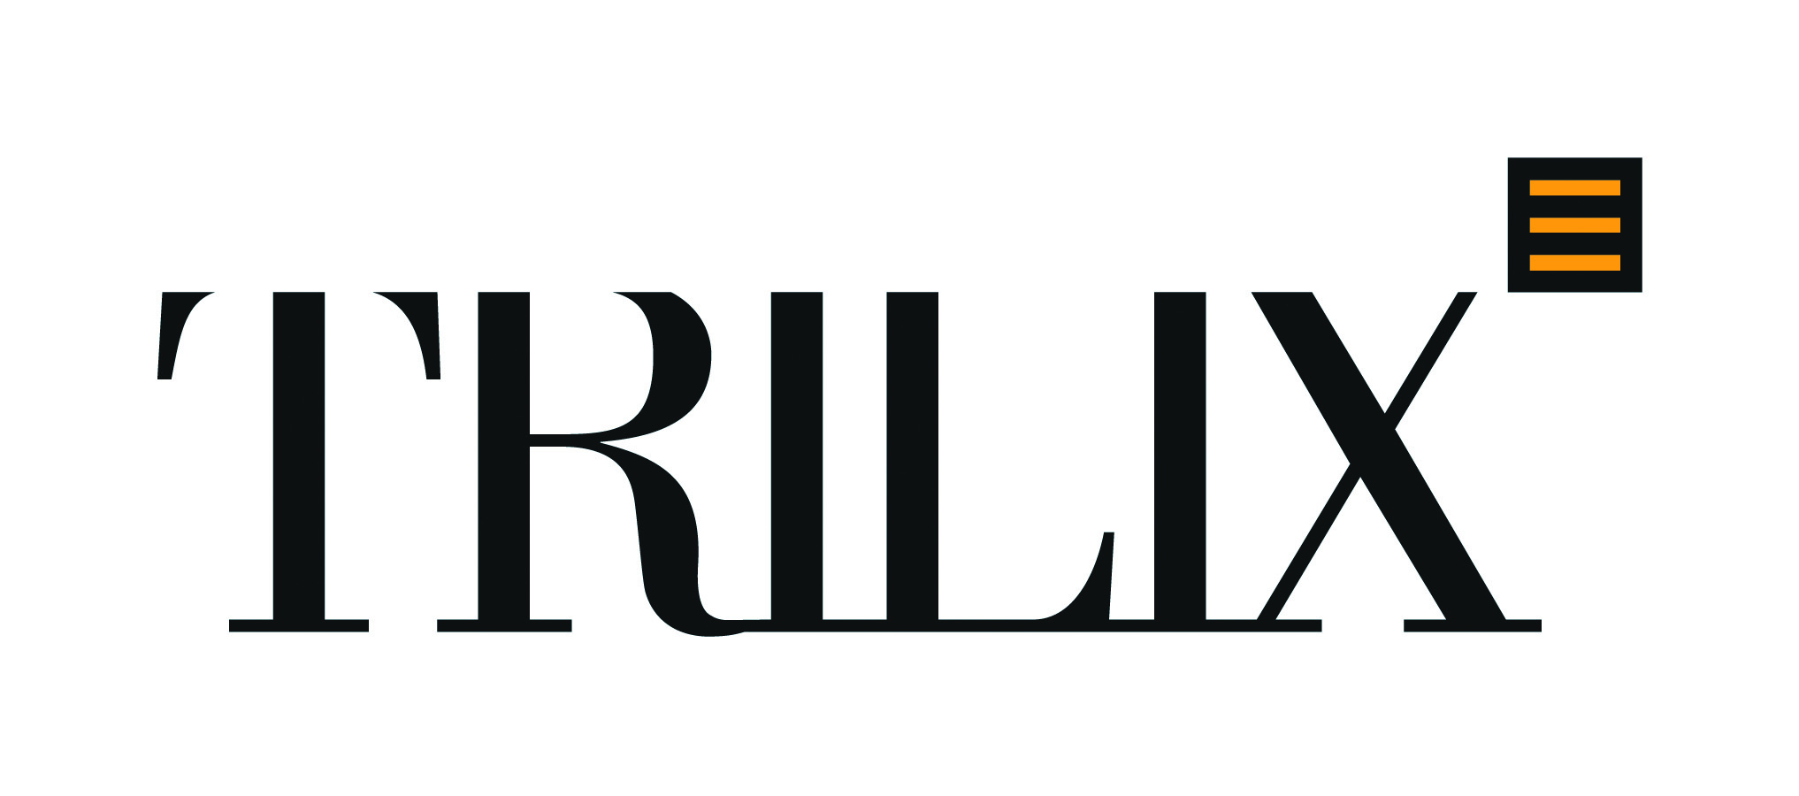

**The best of all is that we easily combine functionalities of our products in single final solution to satisfy every particular Client needs!!!**

**Because we listen, understand and deliver!**