**ACKNOWLEDGEMENT**

We would like to express our gratitude and appreciation to all those who gave us the possibility to complete this report. We are pleased to acknowledge our **Prof. Dr. P. B. Ambhore** for their invaluable guidance during the course of this project work who continuously helped us throughout the project and without his guidance, this project would have been an uphill task. Last but not the least we would like to acknowledge our team for their continuous efforts for the completion of project.

**Raksha Jogi (19007001)**

**Aditya Chandrikapure (19007002)**

**Ankush Chavhan (19007015)**

**INDEX**

|  |  |  |
| --- | --- | --- |
| Sr. no | TITLE | Page no. |
| 1. | Acknowledgement | 1 |
| 2. | Index | 2 |
| 3. | Abstract | 3 |
| 4. | Introduction | 4 |
| 5. | Features | 5 |
| 6. | Deployment Diagram | 6 |
| 7. | Technologies | 7 |
| 8. | Platforms | 22 |
| 9. | Output | 23 |
| 10. | Conclusion | 30 |

**ABSTRACT**

GCOEA NEWS APP is specifically built for the students and faculty of Government College of Engineering, Amravati. It provides platform to the student for their day-to-day notices of college. These will ease the contact between the faculty and students and will help for better management of the college activities. This app will keep its user update with the ongoing events and activities. In-short this app will provide students there own short notice app for there college activities.

**INTRODUCTION**

As world’s technology is rapidly growing, we have fast connection and network to instantly connect to another person. In this fast and information-oriented world we need to stay updated with every incident, notices and news too. This News app is mobile application where user have access to latest news of latest notices, events in colleges, achievements etc…

The main focus of this application is to keep students connected to college in every possible way and deliver news to users as fast as possible in best visualize way.

This news app contains two types of domains, one which would be accessible to students with the help of their particular ID’s and other which will be accessible publicly.

GCOEA News app is a perfect platform for students, teachers for institutional administration. The basic objective of this project is:

• To help students to get news and updates.

• To promote college ongoing activities.

• Users can view the documents without downloading which would help to save storage.

• Users can download as well as can add news or notice in there wishlist or can add to faviroutes.

• Students can join us for data entry which would improve writing and digital literacy of students.

• To keep user notified with the help of notification.

**FEATURES**

The news system will allow user to view comments, news article etc... The main user of the project are students, public and administrator. From an end-users perspective, the GCOEA news app consists of the following functional elements:

• **Dashboard:**

one for common users and other for administrator. For common users login, profile, wishlist, help, setting features will be available and for administrator has same features as common users but have advantage to add, update, and delete news articles.

• **Home:**

It contains features like filter news(ex: filtering news according to branches), Users can view news articles in short via main headings, etc…

• **New article section:**

User can view full articles in one click in this section. It has feature like user can view document without downloading as well as can download if user wants to save it for later. It would contain comment section for the users this feature will vary according to news.

**DEPLOYMENT DIAGRAM**

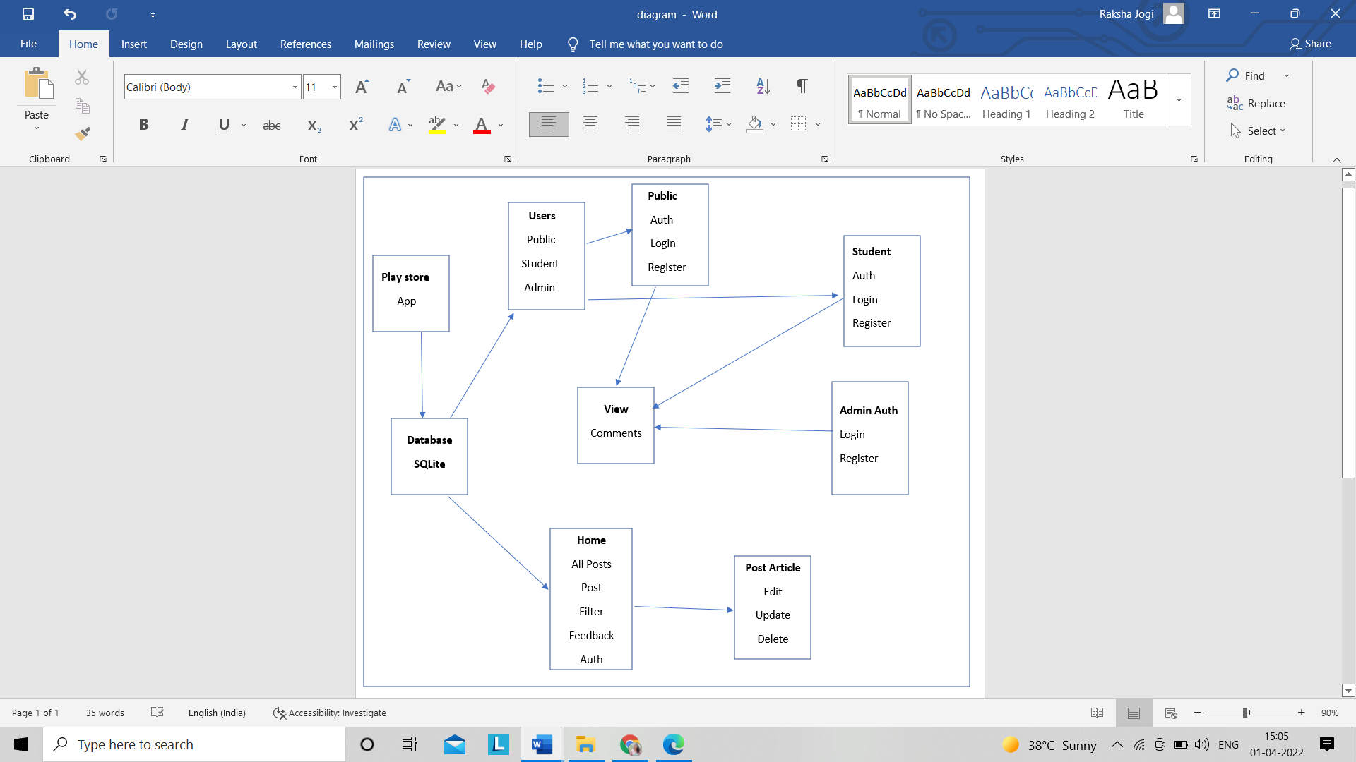

**TECHNOLOGIES**

1. **Languages** to be used: javaScript, python

**JavaScript**

**JavaScript**  often abbreviated **JS**, is a [programming language](https://en.wikipedia.org/wiki/Programming_language) that is one of the core technologies of the [World Wide Web](https://en.wikipedia.org/wiki/World_Wide_Web), alongside [HTML](https://en.wikipedia.org/wiki/HTML) and [CSS](https://en.wikipedia.org/wiki/CSS). Over 97% of [websites](https://en.wikipedia.org/wiki/Website) use JavaScript on the [client](https://en.wikipedia.org/wiki/Client_(computing)) side for [web page](https://en.wikipedia.org/wiki/Web_page) behavior, often incorporating third-party [libraries](https://en.wikipedia.org/wiki/Library_(computing)). All major [web browsers](https://en.wikipedia.org/wiki/Web_browser) have a dedicated [JavaScript engine](https://en.wikipedia.org/wiki/JavaScript_engine) to execute the [code](https://en.wikipedia.org/wiki/Source_code) on [users](https://en.wikipedia.org/wiki/User_(computing))' devices.

JavaScript is a [high-level](https://en.wikipedia.org/wiki/High-level_programming_language), often [just-in-time compiled](https://en.wikipedia.org/wiki/Just-in-time_compilation) language that conforms to the [ECMAScript](https://en.wikipedia.org/wiki/ECMAScript) standard. It has [dynamic typing](https://en.wikipedia.org/wiki/Dynamic_typing), [prototype-based](https://en.wikipedia.org/wiki/Prototype-based_programming) [object-orientation](https://en.wikipedia.org/wiki/Object-oriented_programming), and [first-class functions](https://en.wikipedia.org/wiki/First-class_function). It is [multi-paradigm](https://en.wikipedia.org/wiki/Programming_paradigm), supporting [event-driven](https://en.wikipedia.org/wiki/Event-driven_programming), [functional](https://en.wikipedia.org/wiki/Functional_programming), and [imperative](https://en.wikipedia.org/wiki/Imperative_programming) [programming styles](https://en.wikipedia.org/wiki/Programming_paradigm). It has [application programming interfaces](https://en.wikipedia.org/wiki/Application_programming_interface) (APIs) for working with text, dates, [regular expressions](https://en.wikipedia.org/wiki/Regular_expression), standard [data structures](https://en.wikipedia.org/wiki/Data_structure), and the [Document Object Model](https://en.wikipedia.org/wiki/Document_Object_Model) (DOM).

The ECMAScript standard does not include any [input/output](https://en.wikipedia.org/wiki/Input/output) (I/O), such as [networking](https://en.wikipedia.org/wiki/Computer_network), [storage](https://en.wikipedia.org/wiki/Data_storage), or [graphics](https://en.wikipedia.org/wiki/Computer_graphics) facilities. In practice, the web browser or other [runtime system](https://en.wikipedia.org/wiki/Runtime_system) provides JavaScript APIs for I/O.

JavaScript engines were originally used only in web browsers, but are now core components of some [servers](https://en.wikipedia.org/wiki/Server_(computing)) and a variety of [applications](https://en.wikipedia.org/wiki/Application_software). The most popular runtime system for this usage is [Node.js](https://en.wikipedia.org/wiki/Node.js).

Although [Java](https://en.wikipedia.org/wiki/Java_(programming_language)) and JavaScript are similar in name, [syntax](https://en.wikipedia.org/wiki/Syntax_(programming_languages)), and respective [standard libraries](https://en.wikipedia.org/wiki/Standard_library), the two languages are distinct and differ greatly in design

## **Features Of JavaScript**

JavaScript is divided into two main features, they are as follows –

### **General JavaScript Features**

JavaScript language consists of several different features. Some of the general JavaScript features are as follows –

#### **1. Validating User’s Input**

JavaScript is very useful while using forms. It has the capability to validate user input for errors and also saves time. If the user leaves a required field empty or the information is incorrect, JavaScript checks for them before sending the data over to the server.

#### **2. Simple Client-side Calculations**

Since JavaScript is a client-side technology, it can perform basic calculations on the browser. The browser does not need to ask server time for every task. This is especially helpful when a user needs to perform these calculations repeatedly. In these cases, connecting to the server would take a lot more time than performing the actual calculations.

#### **3. Greater Control**

JavaScript provides greater control to the browser rather than being completely dependent on the web servers. JavaScript provides various browsers with additional functionalities that help reduce server load and network traffic.

#### **4. Platform Independent**

Since browsers interpret JavaScript, it solves the problem of compilation and compatibility. Thus it can run on Windows, Macintosh, and other Netscape-supported systems. Also, it is possible to embed them in any other script like [HTML](https://en.wikipedia.org/wiki/HTML) that keeps JavaScript into use.

#### **5. Handling Dates and Time**

Unlike other programming languages, JavaScript has built-in functions to determine the date and time. Thus it is very easy to code only by using methods like**.getDate().**

#### **6. Generating HTML Content**

JavaScript has very handy features to dynamically generate HTML content for the web. It allows us to add text, links, images, tables, etc after an event occurrence **(e.g. – mouse click).**

#### **7. Detecting the User’s Browser and OS**

JavaScript is very capable in the detection of the user’s browser and OS information. Though JavaScript runs on every platform, there may occur a situation where we need the user’s browser before processing. This can be helpful for writing code that results in different outputs in different browsers.

### **Modern JavaScript Features**

If we dive into some more recently added features of JavaScript that makes it unique from other programming languages. There are a lot more modern features of JavaScript invented after some general features. Some of them are as follows –

#### **1. Let/Const**

JavaScript has introduced the keywords **‘let’ and ‘const’** that are available to replace **‘var’**. Unlike ‘var’, they are important due to their blocked scope i.e we can only access them in the block we defined them in. Whereas ‘var’, even if we initialize it inside a function, we can access it outside of the function.

#### **2. Arrow Functions**

These functions are very useful in simplifying the syntax and tamp down the lines of codes for the web page or web application. Since these are light-weight in syntax, they can be very easily used in anonymous [**functions in JavaScript.**](https://data-flair.training/blogs/javascript-function/)

#### **3. Template Literal**

This is a common feature in other programming languages that allows you to save variables directly into strings. This proves to be an important tool for developers as it permits them to focus more on the development of the application rather than spending the time on syntax.

#### **4. New Array Functions**

Though array functions are not necessary for any programming language, they do simplify things for the developer. This also compacts the code and makes it much easier to understand. A regular array and an associative array, JavaScript supports them both. While a regular array contains integer values for its index, indexes can be strings for an associative array.

#### **5. Default Parameters**

This JavaScript feature helps to avoid collapsing the whole code for a simple mistake. It is very useful when the developer needs to check the working of a function without any parameters.

#### **6. Property Shorthand**

Built-in methods like **.get()** are available for the developer’s use. These methods help avoid writing the same code every time and cut back on various lines of code. These inborn methods are really supportive of cutting back the developing time and cost.

**Python**

**Python** is a [high-level](https://en.wikipedia.org/wiki/High-level_programming_language), [interpreted](https://en.wikipedia.org/wiki/Interpreter_(computing)), [general-purpose programming language](https://en.wikipedia.org/wiki/General-purpose_programming_language). Its design philosophy emphasizes [code readability](https://en.wikipedia.org/wiki/Code_readability) with the use of [significant indentation](https://en.wikipedia.org/wiki/Off-side_rule).

Python is [dynamically-typed](https://en.wikipedia.org/wiki/Type_system#DYNAMIC) and [garbage-collected](https://en.wikipedia.org/wiki/Garbage_collection_(computer_science)). It supports multiple [programming paradigms](https://en.wikipedia.org/wiki/Programming_paradigm), including [structured](https://en.wikipedia.org/wiki/Structured_programming) (particularly [procedural](https://en.wikipedia.org/wiki/Procedural_programming)), [object-oriented](https://en.wikipedia.org/wiki/Object-oriented_programming) and [functional programming](https://en.wikipedia.org/wiki/Functional_programming). It is often described as a "batteries included" language due to its comprehensive [standard library](https://en.wikipedia.org/wiki/Standard_library).

[Guido van Rossum](https://en.wikipedia.org/wiki/Guido_van_Rossum) began working on Python in the late 1980s as a successor to the [ABC programming language](https://en.wikipedia.org/wiki/ABC_(programming_language)) and first released it in 1991 as Python 0.9.0. Python 2.0 was released in 2000 and introduced new features such as [list comprehensions](https://en.wikipedia.org/wiki/List_comprehension), [cycle-detecting](https://en.wikipedia.org/wiki/Cycle_detection) garbage collection, [reference counting](https://en.wikipedia.org/wiki/Reference_counting), and [Unicode](https://en.wikipedia.org/wiki/Unicode) support. Python 3.0, released in 2008, was a major revision that is not completely [backward-compatible](https://en.wikipedia.org/wiki/Backward_compatibility) with earlier versions. Python 2 was discontinued with version 2.7.18 in 2020.

Python consistently ranks as one of the most popular programming languages

### **Features in Python**

There are many features in Python, some of which are discussed below –

**1. Easy to code:**  
Python is a high-level programming language. Python is very easy to learn the language as compared to other languages like C, C#, Javascript, Java, etc. It is very easy to code in python language and anybody can learn python basics in a few hours or days. It is also a developer-friendly language.

**2. Free and Open Source:**  
Python language is freely available at the official website and you can download it from the given download link below click on the **Download Python** keyword.  
  
Since it is open-source, this means that source code is also available to the public. So you can download it as, use it as well as share it.

**3. Object-Oriented Language:**  
One of the key features of python is Object-Oriented programming. Python supports object-oriented language and concepts of classes, objects encapsulation, etc.

**4. GUI Programming Support:**  
Graphical User interfaces can be made using a module such as PyQt5, PyQt4, wxPython, or Tk in python.  
PyQt5 is the most popular option for creating graphical apps with Python.

**5. High-Level Language:**  
Python is a high-level language. When we write programs in python, we do not need to remember the system architecture, nor do we need to manage the memory.

**6. Extensible feature:**  
Python is a **Extensible** language. We can write us some Python code into C or C++ language and also we can compile that code in C/C++ language.

**7. Python is Portable language:**  
Python language is also a portable language. For example, if we have python code for windows and if we want to run this code on other platforms such as Linux, Unix, and Mac then we do not need to change it, we can run this code on any platform.

**8. Python is Integrated language:**  
Python is also an Integrated language because we can easily integrated python with other languages like c, c++, etc.

**9. Interpreted Language:**  
Python is an Interpreted Language because Python code is executed line by line at a time. like other languages C, C++, Java, etc. there is no need to compile python code this makes it easier to debug our code. The source code of python is converted into an immediate form called **bytecode**.

**10. Large Standard Library**  
Python has a large standard library which provides a rich set of module and functions so you do not have to write your own code for every single thing. There are many libraries present in python for such as regular expressions, unit-testing, web browsers, etc.

**11. Dynamically Typed Language:**  
Python is a dynamically-typed language. That means the type (for example- int, double, long, etc.) for a variable is decided at run time not in advance because of this feature we don’t need to specify the type of variable.

1. **Software requirements**: react native, python Django, redux, Cloud, SQLite, hosting- heroku, python anywhere and playstore.

**React Native**

**React Native** is an [open-source](https://en.wikipedia.org/wiki/Open-source_software) [UI](https://en.wikipedia.org/wiki/User_interface) [software framework](https://en.wikipedia.org/wiki/Software_framework) created by [Meta Platforms, Inc.](https://en.wikipedia.org/wiki/Meta_Platforms) It is used to develop applications for [Android](https://en.wikipedia.org/wiki/Android_(operating_system)), [Android TV](https://en.wikipedia.org/wiki/Android_TV), [iOS](https://en.wikipedia.org/wiki/IOS), [macOS](https://en.wikipedia.org/wiki/MacOS), [tvOS](https://en.wikipedia.org/wiki/TvOS), [Web](https://en.wikipedia.org/wiki/Website), [Windows](https://en.wikipedia.org/wiki/Microsoft_Windows) and [UWP](https://en.wikipedia.org/wiki/Universal_Windows_Platform)by enabling developers to use the [React](https://en.wikipedia.org/wiki/React_(JavaScript_library)) framework along with native platform capabilities. It is also being used to develop virtual reality applications at [Oculus](https://en.wikipedia.org/wiki/Oculus_(brand)).

**Implementation**

The working principles of React Native are virtually identical to [React](https://en.wikipedia.org/wiki/React_(JavaScript_library)) except that React Native does not manipulate the [DOM](https://en.wikipedia.org/wiki/Document_Object_Model) via the [Virtual DOM](https://en.wikipedia.org/wiki/React_(JavaScript_library)#Virtual_DOM). It runs in a [background process](https://en.wikipedia.org/wiki/Background_process) (which interprets the [JavaScript](https://en.wikipedia.org/wiki/JavaScript) written by the developers) directly on the end-device and communicates with the native platform via [serialized data](https://en.wikipedia.org/wiki/Serialization) over an [asynchronous](https://en.wikipedia.org/wiki/Asynchrony_(computer_programming)) and [batched](https://en.wikipedia.org/wiki/Batch_processing) bridge.

React components wrap existing native code and interact with native APIs via React's [declarative UI paradigm](https://en.wikipedia.org/wiki/Declarative_programming) and [JavaScript](https://en.wikipedia.org/wiki/JavaScript).

While React Native styling has a similar syntax to CSS, it does not use [HTML](https://en.wikipedia.org/wiki/HTML) or [CSS](https://en.wikipedia.org/wiki/CSS). Instead, messages from the JavaScript thread are used to manipulate native views. With React Native developers have to write native code in the languages of the aimed platform such as [Java](https://en.wikipedia.org/wiki/Java_(programming_language)) or [Kotlin](https://en.wikipedia.org/wiki/Kotlin_(programming_language)) for [Android](https://en.wikipedia.org/wiki/Android_(operating_system)), [Objective-C](https://en.wikipedia.org/wiki/Objective-C) or [Swift](https://en.wikipedia.org/wiki/Swift_(programming_language)) for [iOS](https://en.wikipedia.org/wiki/IOS), and [C++/WinRT](https://en.wikipedia.org/wiki/C%2B%2B/WinRT) or [C#](https://en.wikipedia.org/wiki/C_Sharp_(programming_language)) for [Windows 10](https://en.wikipedia.org/wiki/Windows_10).

Microsoft builds and maintains [React Native for Windows](https://github.com/microsoft/react-native-windows/) and [React Native for macOS](https://github.com/microsoft/react-native-macos/).

A [Hello World](https://en.wikipedia.org/wiki/%22Hello,_World!%22_program) program in React Native looks like this:

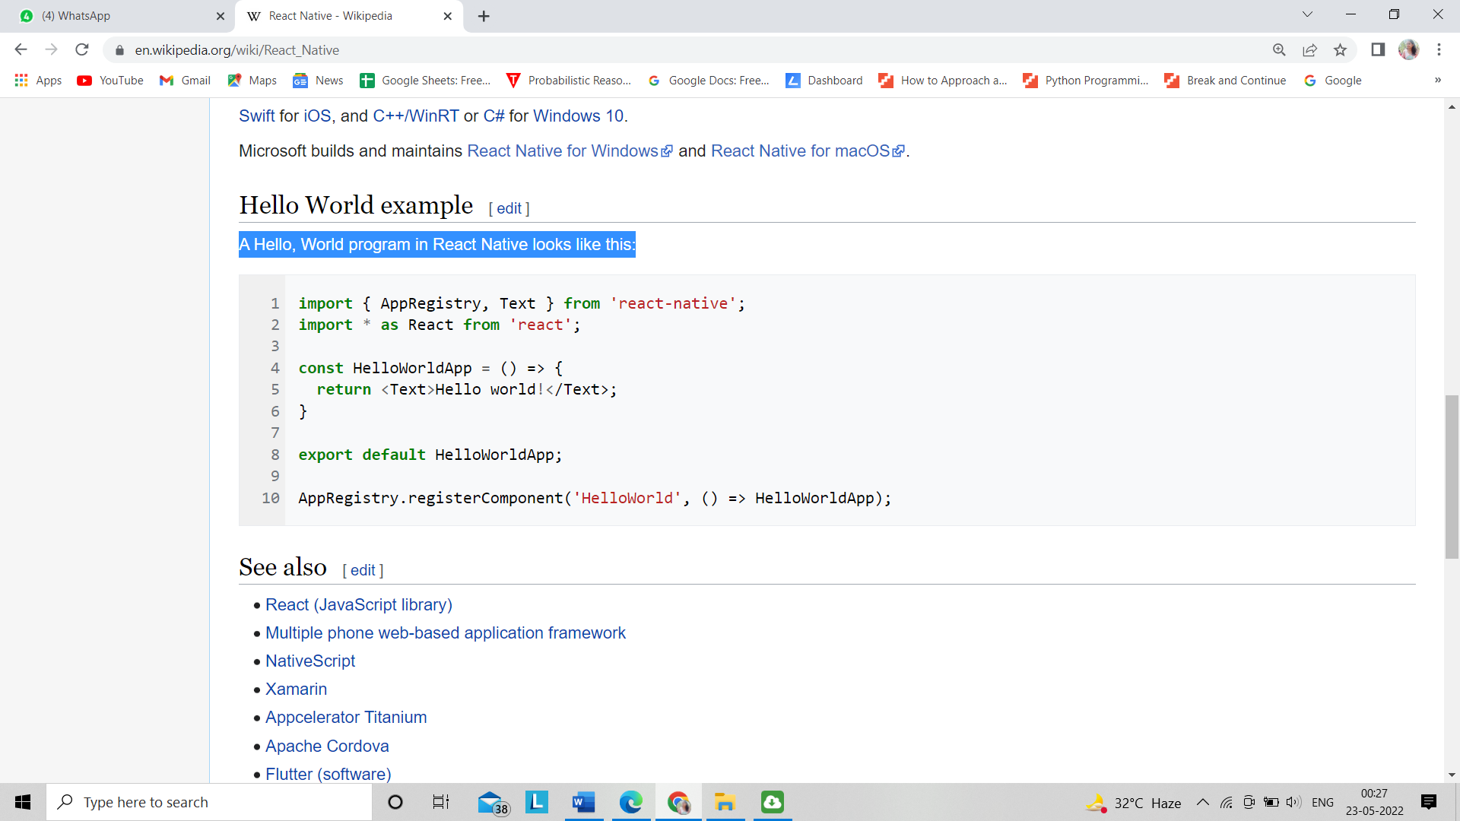

React Native lets you build mobile apps using only JavaScript. It uses the same design as React, letting you compose a rich mobile UI from declarative components. With React Native, you don't build a mobile web app, an HTML5 app, or a hybrid app; you build a real mobile app that's indistinguishable from an app built using Objective-C or Java. React Native uses the same fundamental UI building blocks as regular iOS and Android apps. You just put those building blocks together using JavaScript and React.

## **React Native Features**

Following are the features of React Native −

* **React** − This is a Framework for building web and mobile apps using JavaScript.
* **Native** − You can use native components controlled by JavaScript.
* **Platforms** − React Native supports IOS and Android platform.

## **React Native Advantages**

Follow are the advantages of React Native −

* **JavaScript** − You can use the existing JavaScript knowledge to build native mobile apps.
* **Code sharing** − You can share most of your code on different platforms.
* **Community** − The community around React and React Native is large, and you will be able to find any answer you need.

## **React Native Limitations**

Following are the limitations of React Native −

* **Native Components** − If you want to create native functionality which is not created yet, you will need to write some platform specific code.

**Django**

**Django**  is a [Python](https://en.wikipedia.org/wiki/Python_(programming_language))-based [web framework](https://en.wikipedia.org/wiki/Web_framework), [free and open-source](https://en.wikipedia.org/wiki/Free_and_open-source_software), that follows the model–template–views (MTV) [architectural pattern](https://en.wikipedia.org/wiki/Architectural_pattern_(computer_science)). It is maintained by the [Django Software Foundation](https://en.wikipedia.org/wiki/Django_Software_Foundation) (DSF), an independent organization established in the US as a [501(c)(3)](https://en.wikipedia.org/wiki/501(c)(3)) non-profit.

Django's primary goal is to ease the creation of complex, database-driven websites. The framework emphasizes [reusability](https://en.wikipedia.org/wiki/Reusability) and "pluggability" of components, less code, low coupling, rapid development, and the principle of [don't repeat yourself](https://en.wikipedia.org/wiki/Don%27t_repeat_yourself). Python is used throughout, even for settings, files, and data models. Django also provides an optional administrative [create, read, update and delete](https://en.wikipedia.org/wiki/Create,_read,_update_and_delete) interface that is generated dynamically through [introspection](https://en.wikipedia.org/wiki/Type_introspection) and configured via admin models.

Some well-known sites that use Django include [Instagram](https://en.wikipedia.org/wiki/Instagram), [Mozilla](https://en.wikipedia.org/wiki/Mozilla_Foundation), [Disqus](https://en.wikipedia.org/wiki/Disqus), [Bitbucket](https://en.wikipedia.org/wiki/Bitbucket),[]](https://en.wikipedia.org/wiki/Django_(web_framework)#cite_note-13) [Nextdoor](https://en.wikipedia.org/wiki/Nextdoor)and [Clubhouse](https://en.wikipedia.org/wiki/Clubhouse_(app)).

## **Popularity**

Django is widely accepted and used by various well-known sites such as:

* Instagram
* Mozilla
* Disqus
* Pinterest
* Bitbucket
* The Washington Times

## **Features of Django**

* Rapid Development
* Secure
* Scalable
* Fully loaded
* Versatile
* Open Source
* Vast and Supported Community

## **Rapid Development**

Django was designed with the intention to make a framework which takes less time to build web application. The project implementation phase is a very time taken but Django creates it rapidly.

## **Secure**

Django takes security seriously and helps developers to avoid many common security mistakes, such as SQL injection, cross-site scripting, cross-site request forgery etc. Its user authentication system provides a secure way to manage user accounts and passwords.

## **Scalable**

Django is scalable in nature and has ability to quickly and flexibly switch from small to large scale application project.

## **Fully loaded**

Django includes various helping task modules and libraries which can be used to handle common Web development tasks. Django takes care of user authentication, content administration, site maps, RSS feeds etc.

## **Versatile**

Django is versatile in nature which allows it to build applications for different-different domains. Now a days, Companies are using Django to build various types of applications like: content management systems, social networks sites or scientific computing platforms etc.

## **Open Source**

Django is an open source web application framework. It is publicly available without cost. It can be downloaded with source code from the public repository. Open source reduces the total cost of the application development.

## **Vast and Supported Community**

Django is an one of the most popular web framework. It has widely supportive community and channels to share and connect.

## **Key Advantages of Django**

Here are the main advantages of Django:

* Django is easy to set up and run. It offers a variety of options to get started
* It provides a ready-to-use user interface for administrative activities
* It enables multilingual websites by using its built-in internationalization system
* Helps you to meet the massive traffic demands quickly
* Django is used to build all types of content management systems, social networks as well as scientific computing platforms.
* Django helps you to provide end-to-end application testing
* Helps you to document your API with an HTML output
* REST Framework has rich support for several authentication protocols
* Permissions and throttling policies
* It is widely used for rate limiting API requests from a single user.

1. **Designing Tool**: Figma, Canva.

**Figma**

**Figma** is a [vector graphics editor](https://en.wikipedia.org/wiki/Vector_graphics_editor) and [prototyping](https://en.wikipedia.org/wiki/Software_prototyping) tool which is primarily [web-based](https://en.wikipedia.org/wiki/Web_application), with additional offline features enabled by desktop applications for [macOS](https://en.wikipedia.org/wiki/MacOS) and [Windows](https://en.wikipedia.org/wiki/Microsoft_Windows). The Figma mobile app for [Android](https://en.wikipedia.org/wiki/Android_(operating_system)) and [iOS](https://en.wikipedia.org/wiki/IOS) allow viewing and interacting with Figma prototypes in real-time mobile devices. The feature set of Figma focuses on use in [user interface](https://en.wikipedia.org/wiki/User_interface_design) and [user experience](https://en.wikipedia.org/wiki/User_experience_design) design, with an emphasis on real-time collaboration.

**The Power of Figma as a Design Tool**

Figma has a familiar interface that makes it easy to adopt.

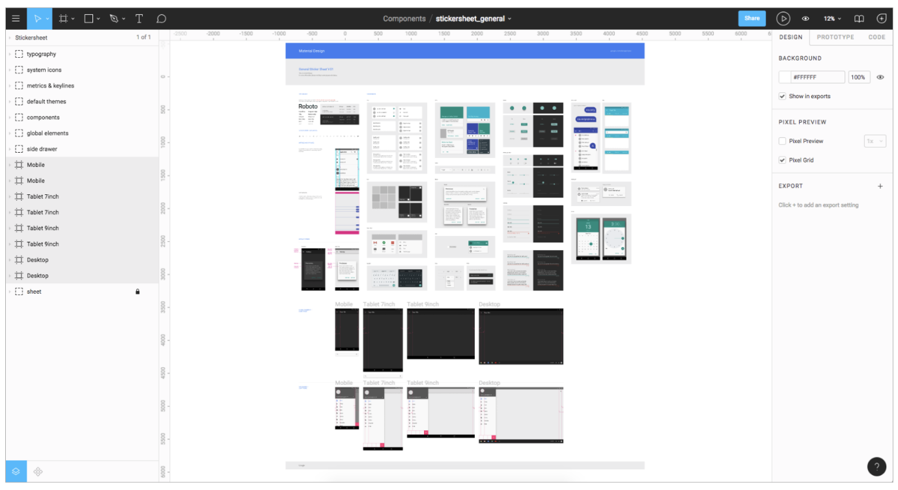

**1. Figma Works on Any Platform:**

Figma works on any operating system that runs a web browser. Macs, Windows PCs, Linux machines, and even Chromebooks can be used with Figma. It is the only design tool of its type that does this, and in shops that use hardware running different operating systems, **everyone** can still share, open, and edit Figma files.

**2. Figma Uses Slack for Team Communication**

Figma uses [Slack](http://www.slack.com/) as its communication channel. When a [Figma channel is created in Slack](https://help.figma.com/hc/en-us/articles/360039829154-Receive-Comment-Notifications-in-Slack), any comments or design edits made in Figma are “slacked” to the team. This functionality is crucial when designing live because changes to a Figma file will update every other instance where the file is embedded (a potential headache for developers). Changes to a mockup, warranted or not, are immediately vetted, and the feedback channel is live.

**3. Figma Sharing Is Uncomplicated and Flexible**

Figma also allows [permissions-based sharing](https://help.figma.com/hc/en-us/articles/360040530793-Adjust-permissions-on-a-file) of any file, page, or frame (called an artboard in other design tools). When a share link is created to a frame on a page, the person clicking on that link will open a browser version of Figma, and a zoomed-in view of the frame is loaded.

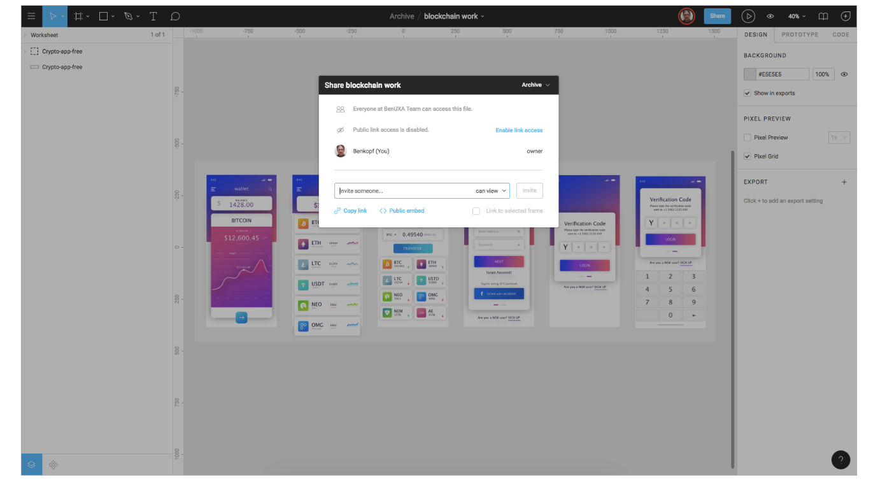Figma shares projects, files, pages, and frames with anyone that has permission.

This form of selective sharing, from file down to frame, lets [designers](https://www.toptal.com/designers/ui), product owners, and developers share exactly what is needed in bug tracking tools and community software like [Confluence](https://www.atlassian.com/software/confluence) or [SharePoint](https://www.toptal.com/sharepoint/why-use-sharepoint-business-benefits).

**4. Embedded Figma Files Provide Real-time Updating**

Figma also shares live embed code snippets to paste an iFrame in third-party tools. For example, if Confluence is used to display embedded mockup files, those files are not “updated” by saving a Figma file—those embedded files ARE the Figma file.

If a change is made to the mockup by anyone in Figma, that change can be seen live in the embedded Confluence mockup. (You can read more about Figma and Confluence integration [here](https://medium.com/@benkopf20/figma-and-live-embedding-in-confluence-4269e3c550ef).)

The effect of this feature on the UX process is illustrated in the following diagram:

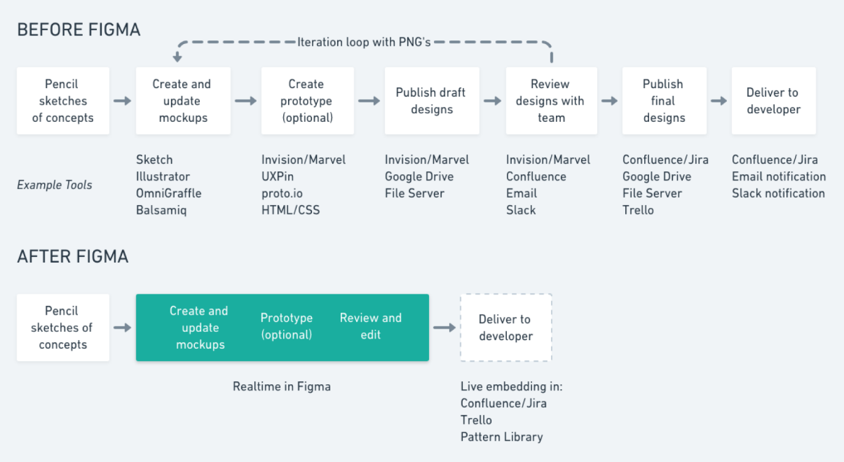Figma eliminates the need for dedicated apps for prototyping and commenting.

**Before Figma,** several other tools were used to facilitate the exchange of design mockups and updates. The iteration cycle was a series of back and forth file updates, so teams could review and implement the current design.

**After Figma,** third-party tools are no longer necessary (but could be used if desired). Since Figma handles the functionality of the [third-party tools](https://medium.com/cube-dev/why-your-design-team-should-consider-switching-to-figma-3d8962d08a5d) described previously, there is only one step in the process—move from sketches to Figma and all groups have the latest mockups. There is no “handoff” in the strictest sense of the word.

**5. Figma Is Great for Design Review Feedback**

Figma supports [in-app commenting](https://help.figma.com/hc/en-us/articles/360039825314-Getting-started-with-comments) in both design and prototyping modes, and the comment thread is tracked in Slack and/or email. There’s no need to publish PNG files or perform constant updates to get feedback from a team using a third-party tool like [InVision](https://www.toptal.com/designers/invision) or [Marvel](https://www.toptal.com/designers/marvel).

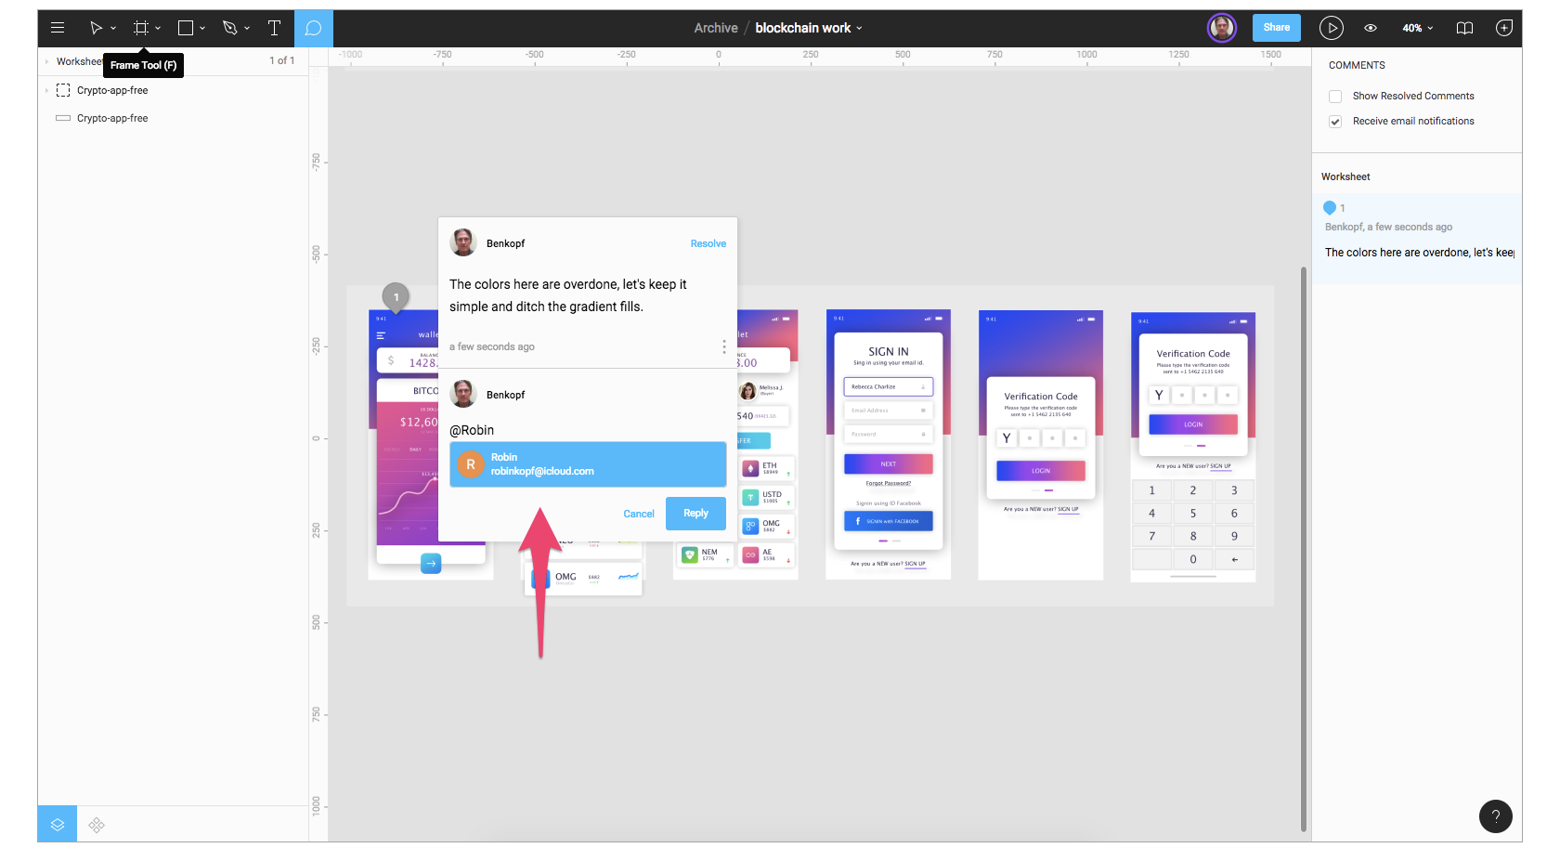Designers can make comments during reviews by opening the same Figma file.

During design reviews, team designers can discuss their work on a large screen, record comments, and fix issues—all in Figma. This form of live feedback is not possible with Sketch, which requires uploading to a cloud service to get team input.

**Canva**

**Canva** is an Australian [graphic design](https://en.wikipedia.org/wiki/Graphic_design) platform, used to create [social media](https://en.wikipedia.org/wiki/Social_media) graphics, [presentations](https://en.wikipedia.org/wiki/Presentations), [posters](https://en.wikipedia.org/wiki/Posters), [documents](https://en.wikipedia.org/wiki/Documents) and other visual content. The app includes templates for users to use.

The platform is free to use and offers paid subscriptions such as Canva Pro and Canva for Enterprise for additional functionality. The [subscription](https://en.wikipedia.org/wiki/Subscription_business_model) price for Canva Pro is $119.40 per year for up to 5 people.

Canva Pro can be provided to nonprofit organizations for free if they meet the guidelines. The subscription price for Canva for Enterprise is $30 per month per person. In 2021, Canva launched a video editing tool. Users can also pay for physical products to be printed and shipped.

In June 2020, Canva raised A$60 million at a valuation of A$6 [billion](https://en.wikipedia.org/wiki/1,000,000,000); almost doubling its 2019 valuation. In September 2021, Canva raised US$200 million and announced a valuation of US$40 billion.

### **Data breach**

In May 2019, Canva experienced a [data breach](https://en.wikipedia.org/wiki/Data_breach) in which data of roughly 139 million users were hacked. The exposed data included real names of users, usernames, addresses and geographical information, and password hashes for some users. Canva's handling of the breach from a technical perspective was largely commended, but it faced criticism for an initial email to customers, which buried the details below self-congratulatory marketing content.

|  |  |
| --- | --- |
| [Operating system](https://en.wikipedia.org/wiki/Operating_system): | Web, Windows, Mac, Android, iOS |
| Available in: | 100 languages |
| [Type](https://en.wikipedia.org/wiki/Software_categories#Categorization_approaches): | [Graphics software](https://en.wikipedia.org/wiki/Graphics_software) |

**PLATFORMS**

Websites Following websites will be referred to create this project report:

* <https://www.sqlite.org>
* <https://www.javascript.com>
* <https://www.python.org>
* <https://reactnative.dev>
* <https://developer.mozilla.org>
* <https://www.djangoproject.com>
* <https://redux.js.org>
* <https://www.heroku.com>
* <https://www.pythonanywhere.com>
* [**https://www.ieee.org**](https://www.ieee.org)
* <https://www.springeropen.com>
* <https://www.etw.de>
* <https://www.figma.com>
* <https://www.canva.com>

**OUTPUT**

1st user entry Admin Profile

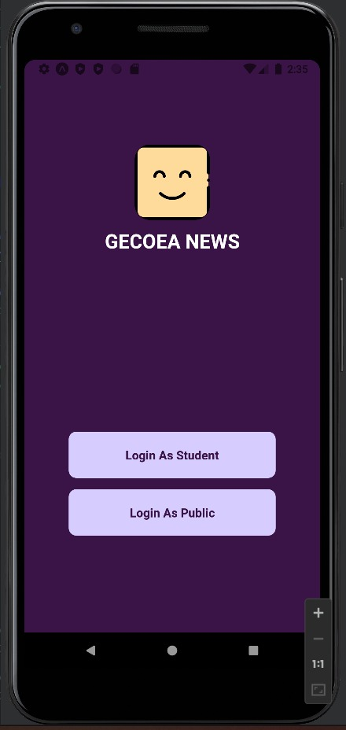 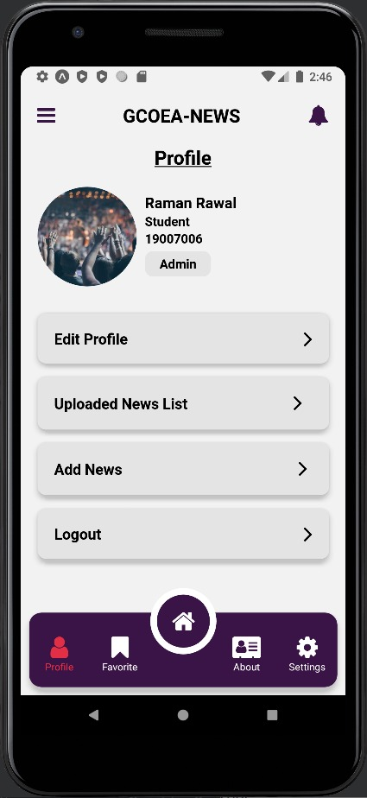

Student Login and Register

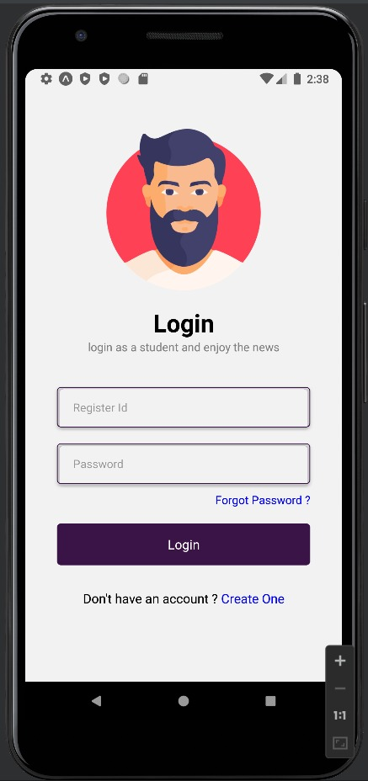 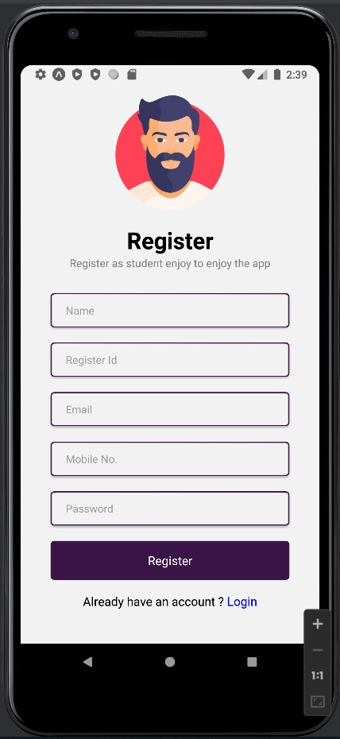

Public Login and Register

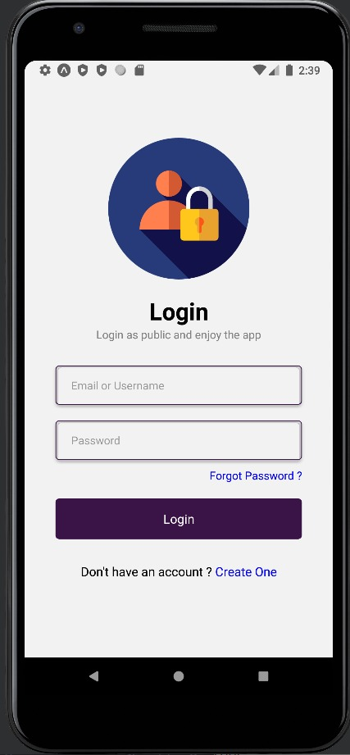 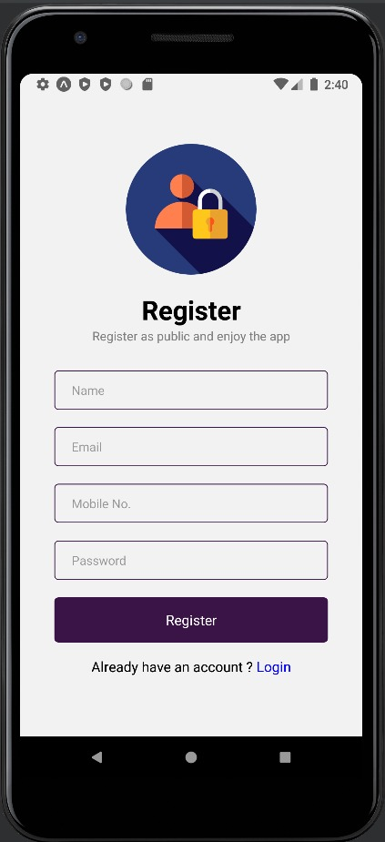

Home Page Detail News Page

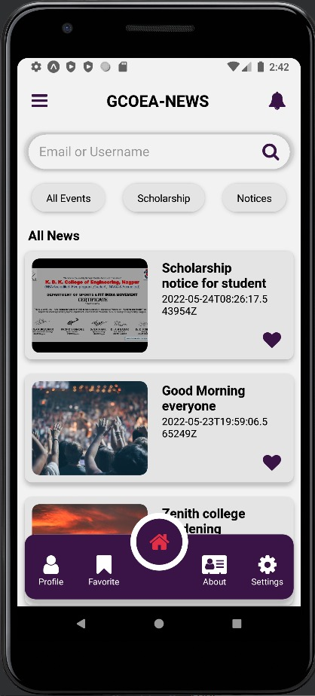 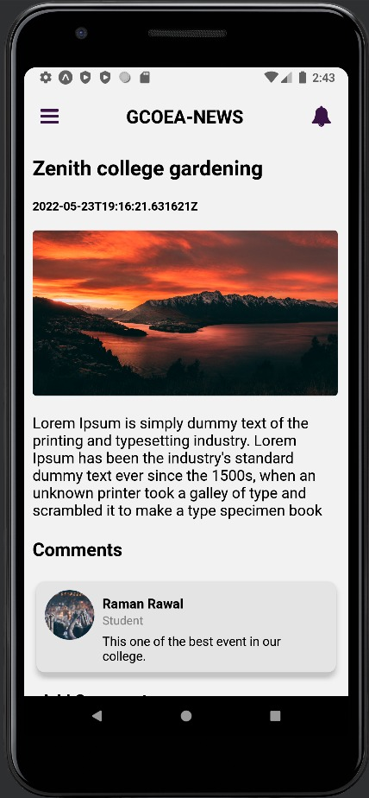

Comment User’s Profile

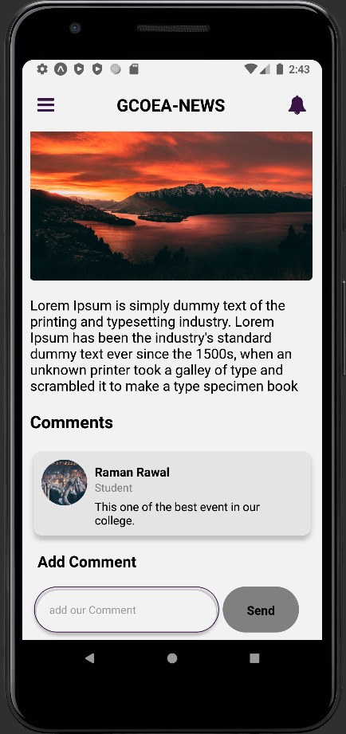 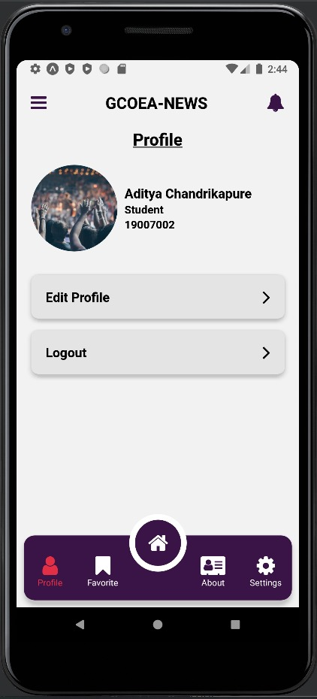

Favourite Setting

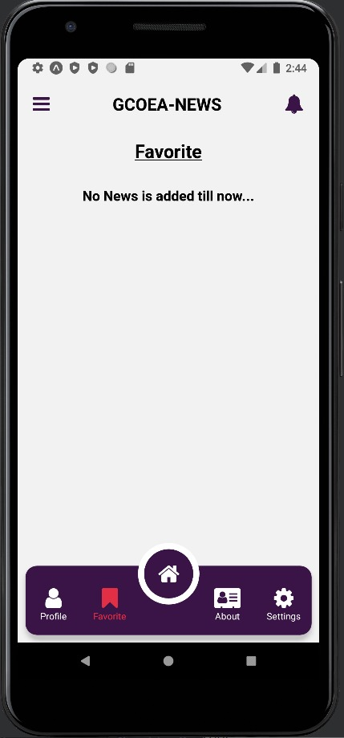 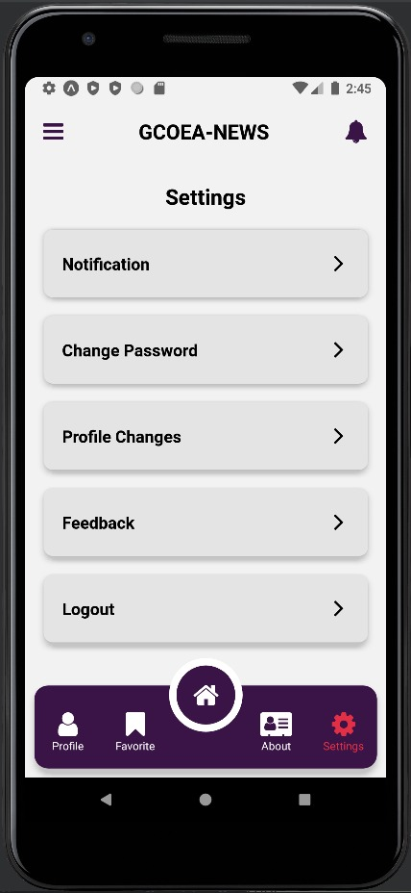

Upload News Add News

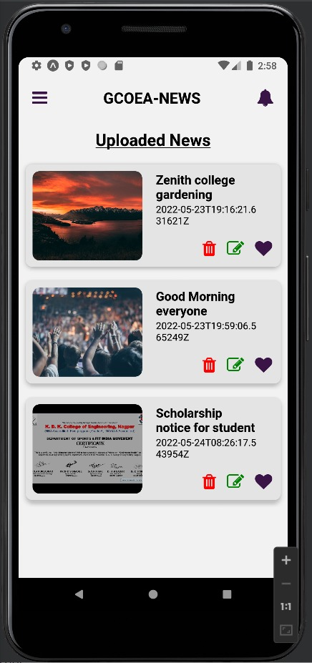 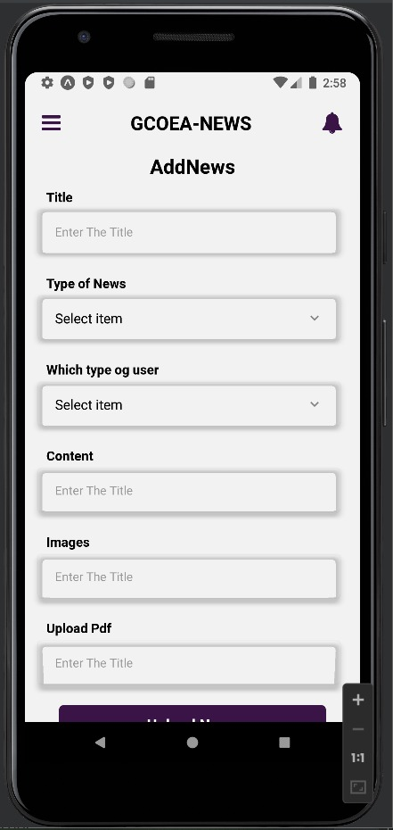

**CONCLUSION**