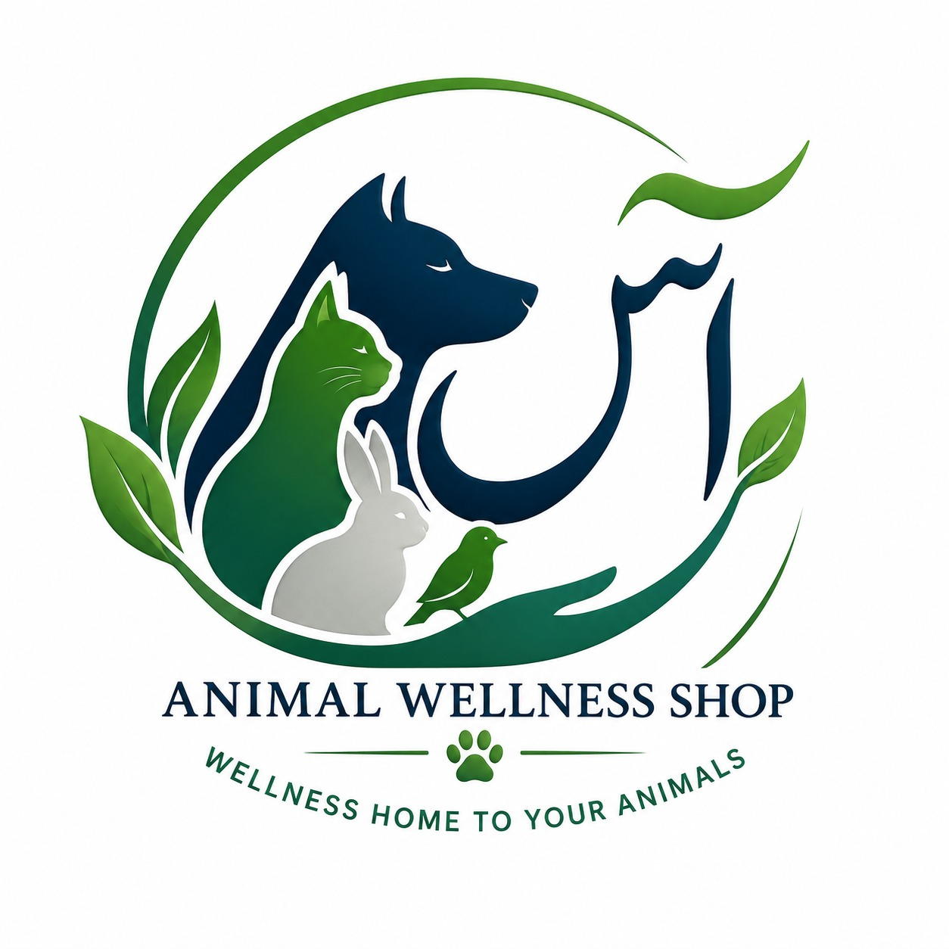
CERTIFICATE OF APPRECIATION
ANIMAL WELLNESS SHOP | UAE – PAKISTAN DIGITAL ANIMAL-HEALTH PLATFORM
Monis Raza
This certificate confirms the website/platform registration record for
Animal Wellness Shop
https://app.animalwellness.shop/
Animal Wellness Shop is presented as a digital platform supporting animal wellness, veterinary services, and access to animal-health products and resources. This certificate is an editable platform-issued record template and does not constitute government incorporation, domain ownership verification, regulatory approval, or a licence to practise veterinary medicine.
 | CERTIFICATE / RECORD NO.  AWS-WEB-2026-001 |  | REGISTRATION / ISSUE DATE  25 October 2026
 | REGISTERED PLATFORM  Animal Wellness Shop |  | WEBSITE ADDRESS  app.animalwellness.shop
  Ghazala Yasmeen  Signature / Authorised Representative |  | ANIMAL WELLNESS SHOP  Platform Administration  UAE 🇦🇪 | Pakistan 🇵🇰

