The Technical Task

- Purpose of Document

This document aims to :

- Provide a scope for this technical task.
- A Technical Overview.
- User Guide.
- Address future development opportunities.

- Scope of Technical Task

The main object is to calculate C for all items in the RawData.txt file.

Here is an overview to perform this calculation:

A. Read the parameter file and rawdata files.
B. Loop each rawdata array item and apply the following, but not in the exact order:
- Apply Formula 1 (Y = (m*X) + c)
- Apply Formula 2 (B = A + Y then b = mean(B) (or 1 / Count of Rawdata values).
- Apply Formula 3: A = 1 / X
- Apply Formula 4 (C = X + b)
- Repeat loop until all items have been processed in the rawdata file.
D. Display the array for C.

- Technical Overview

This application involves:
- A Home Page where you can change images.
- A Calculation Page which will allow a user to do the following:
- Click a button which either shows as "Show Calculation" or "Hide Calculation". This will Show or hide a div with more information on the formula..
- 2 buttons to Export to Excel and Export to CSV
- A table with the following fields ID, RawData, m, c and Calculated. Calculated should be the correct final figure required.

It is an MVC C# app which has the following:
- A model
- A repository which does the actual calculation and provides a method to get the new Calculated data.
- Two controllers (Home and Calculation).
- Two Razor .cshtml views to deliver the data.

3. User Guide

- Home page:

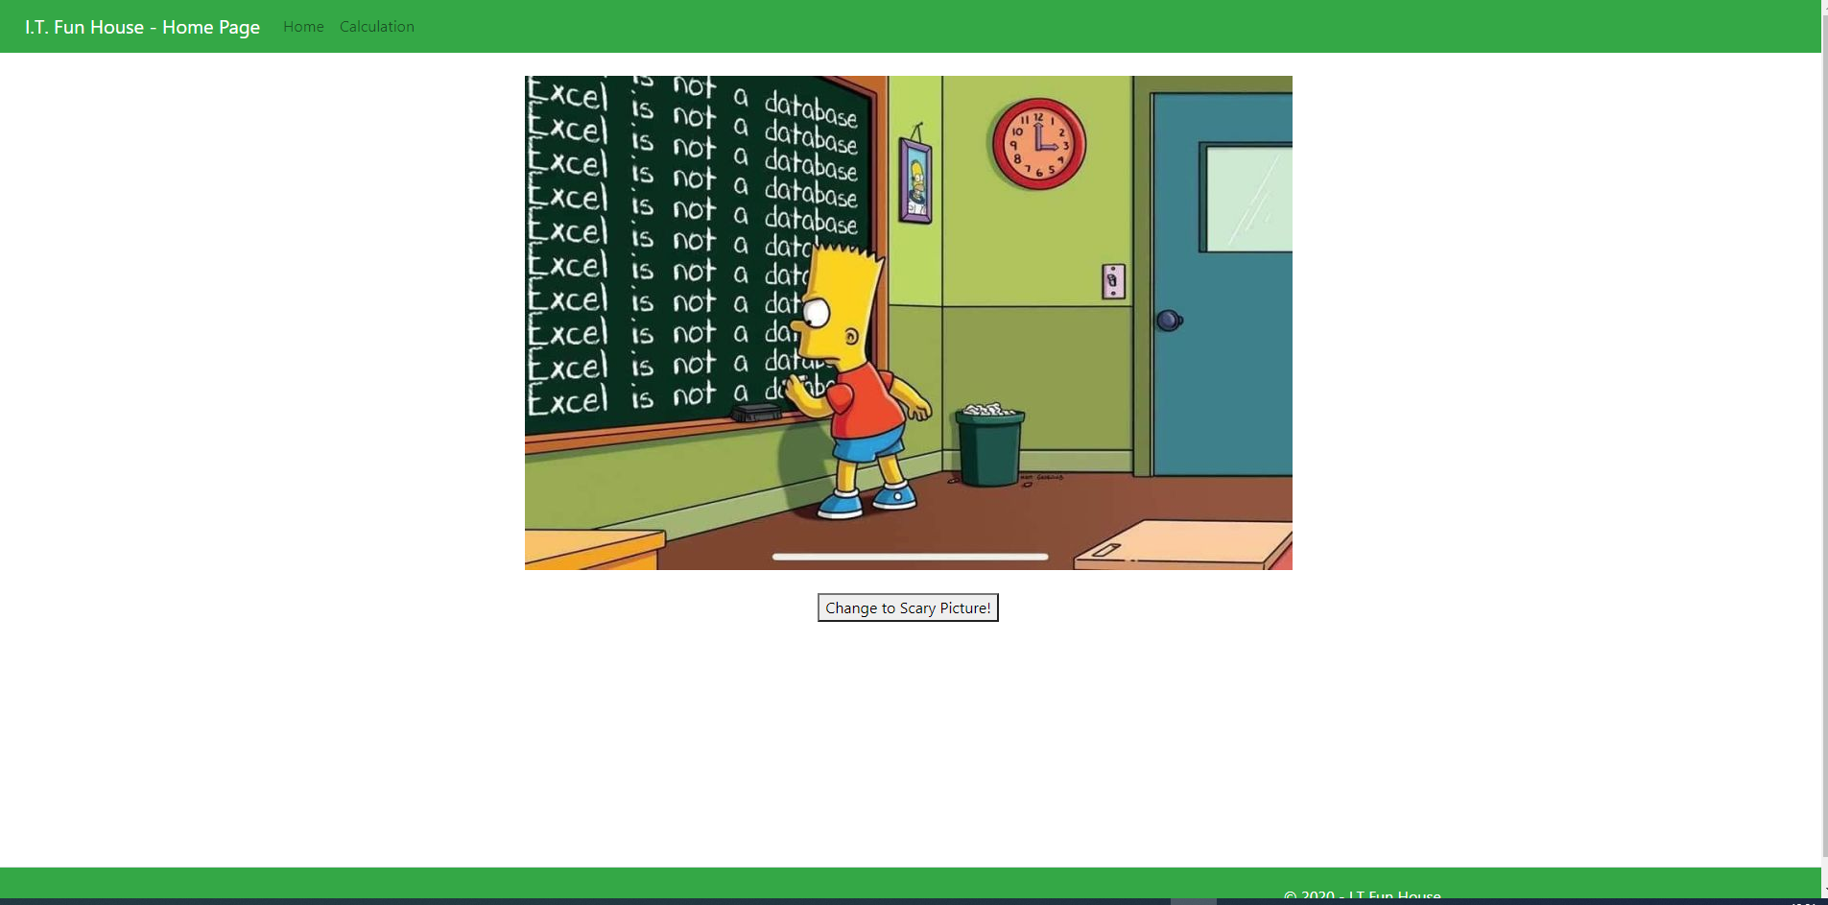
You can change the image, it also fades in as it loads the webpage.
You can either choose Calculation from the menu or click on the image to get to the Calculation webpage.

- Calculation webpage

The main purpose of the Calculation webpage is to deliver the calculated values for each item from the RawData.txt file.

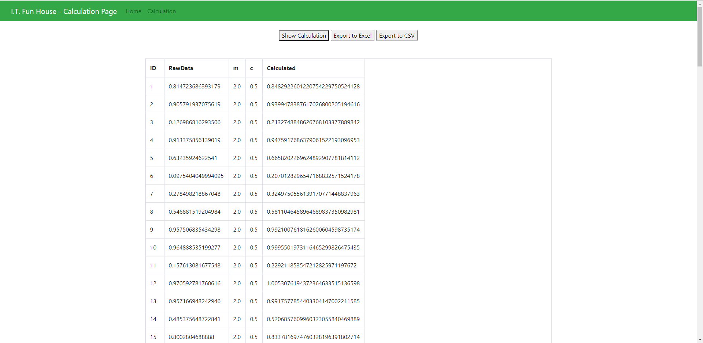
There are 3 available buttons:

- Show Calculation button which shows a div with a summary of the calculation and changes the text of the “Show Calculation” button.
- Export to Excel: This uses a nuget package called ClosedXML to export the repository method GetAllCalculatedDataRepository to Excel.
- Export to CSV: Similar to Excel, but output is in a CSV format which is avaialble for most computes.

4. Future Development Opportunities

- Need to create test scripts for this application.
- More work is required on the user interface with more CSS / HTML design. Eg. a better menu, different fonts for text, move all of HTML styles to CSS, etc.
- Remove the hard coded locations of files and put them in a JSON file.
- Add more content to the webpages.
- Create a SQL database and use Entity Framework to interface with the repository. Include update and delete functionality with LINQ queries to retrieve specific records if needed.
- Configure the view for the Calculated list to have pages rather than one whole list.
- Move this to AWS / Google Cloud or Azure.

