Please remove .txt from the server.js.txt and
assets/js/productList.js.txt filenames
Steps to start the application::::
* Run npm install
* Run npm server.js

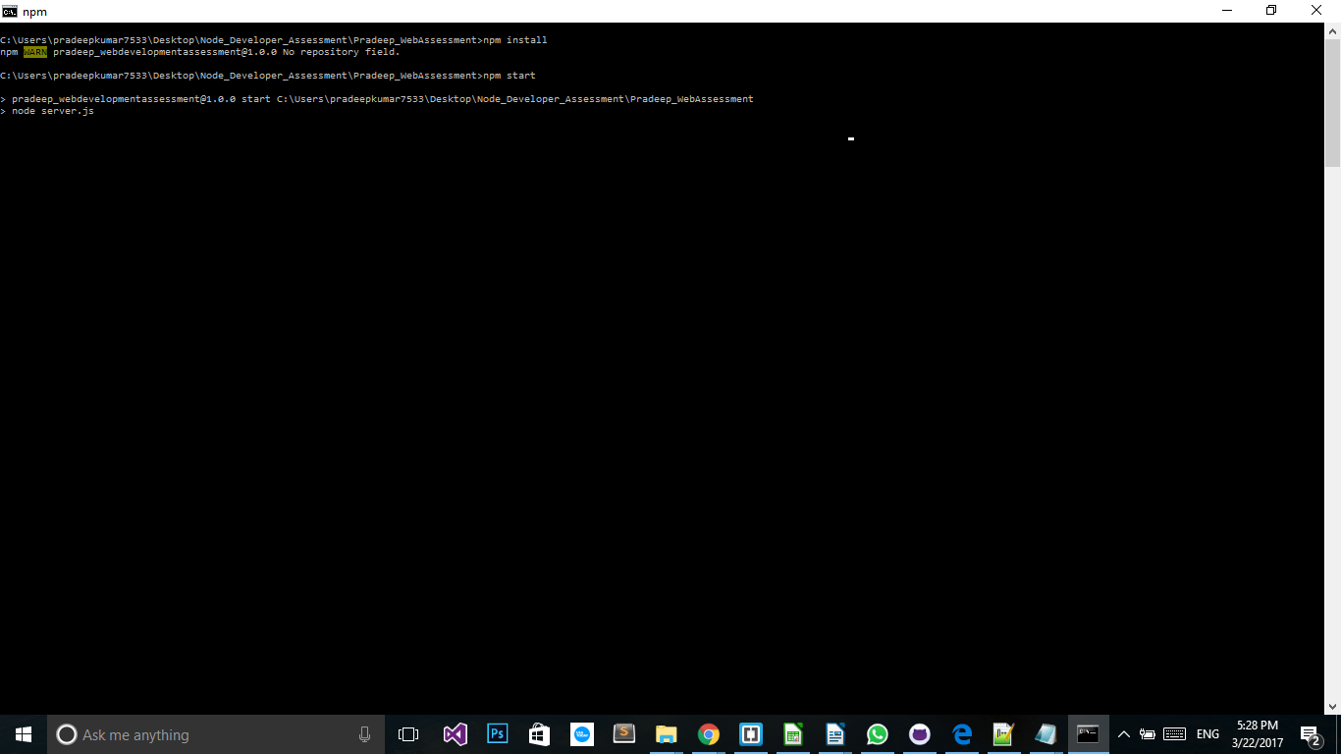

* Load localhost:3000 in browser to load the page

