LAB ASSIGNMENT V : HEURISTIC EVALUATION
SYSTEM EVALUATED : 99acres Replica (Bengaluru) – https://99acres-replica.vercel.app/
Figma : https://www.figma.com/design/8FgFJA8IVJoePg6EDZIXMB/Untitled
Group member NAME : Amey Tarmale (1032232006)
Evaluated by (other group) : Akshwaj Rao, Vishwajit Chavan, Samay Gandhi
Severity scale: 0 = no problem, 5 = most severe. Total out of 75 (lower is better).
EVALUATION 1 : AKSHWAJ RAO
PART I : Heuristic evaluation (Nielsen's principles)
No. | Heuristic | Violation (if any) | Severity (0-5) | Ways to improve
1 | User Control | Filter chips, 'More filters' and sort do nothing; new search reloads same 3 results. | 4 | Make filters and search actually update results.
2 | Human Limitations | Search box pre-filled with real text; some text only 10–11 px. | 2 | Use placeholder; min 12–13 px text.
3 | Accommodation | 'Rent' shows Buy results; 'List property' is a dead link. | 3 | Separate Rent page; simple listing form.
4 | Linguistic Clarity | 'Saved' opens a property page, 'My Activity' opens Compare. | 3 | Point nav items to the right pages.
5 | Aesthetic Integrity | Clean look; contact page switches to dark header + orange 'A' logo. | 1 | Same header and logo on all pages.
6 | Simplicity | Simple, uncluttered layout. | 1 | Keep as is.
7 | Predictability | 'Call Rhea' shows 'request sent' instead of calling; every card opens Cedar House. | 4 | Each card → own page; Call shows number.
8 | Accuracy | Owner 'Rhea Menon' vs 'Rakesh K.'; '2 hrs' vs '2 days ago'; 184 vs 42 homes, 3 shown. | 4 | Use one data source for all pages.
9 | Technical Clarity | Sharp images; map is a static picture with one pin. | 2 | Interactive map with all listing pins.
10 | Fulfillment | Can browse/compare but can't filter, save or book a visit. | 3 | Make key flows work end-to-end.
11 | Consistency | Logo 'H' vs 'A'; Call button blue vs green; search page has no footer. | 3 | One logo, one button colour, same footer.
12 | User Support | Footer Help/About/Safety/Privacy all '#'; no FAQ. | 3 | Add Help/FAQ and tooltips.
13 | Precision | No exact budget, area or locality input. | 4 | Range sliders and locality picker.
14 | Forgiveness | Can't cancel contact request; 'Remove' does nothing. | 3 | Add cancel/undo; fix Remove.
15 | Responsiveness | Save heart gives no message; search gives no feedback. | 3 | Toast on save; show 'Results for …'.
 | Total Score |  | 43 / 75
PART II : Other observations (other than Nielsen's principles)
No. | Observations | Comments
1 | No mobile menu below 700 px. | Add hamburger menu.
2 | Clarity tracking without consent notice. | Add cookie/consent banner.
3 | No login, yet 'Saved' and 'My Activity' exist. | Add login or local saves.
4 | Empty 44 px dark strip above header. | Remove or use it.

EVALUATION 2 : VISHWAJIT CHAVAN
PART I : Heuristic evaluation (Nielsen's principles)
No. | Heuristic | Violation (if any) | Severity (0-5) | Ways to improve
1 | User Control | Search ignored, filters inactive, 'Schedule Visit' goes nowhere. | 3 | Wire filters/search; add date picker.
2 | Human Limitations | Low info load; small grey text on listings and fine print. | 2 | Increase size/contrast of small text.
3 | Accommodation | Mobile (<700 px) hides nav with no hamburger; Rent shows buy prices. | 4 | Add mobile menu; separate Rent listings.
4 | Linguistic Clarity | Wrong nav targets; contact says '24 hours' and '1 hour' on same page. | 3 | Fix nav; one response-time message.
5 | Aesthetic Integrity | Good type and spacing; badge text clipped in Figma hi-fi. | 2 | Fix badge clipping.
6 | Simplicity | Each screen has one clear main action. | 1 | No change needed.
7 | Predictability | Any card opens Cedar House; 'Call' shows a request page. | 4 | Unique detail pages; real call action.
8 | Accuracy | Nila 'New launch' vs 'Aug 2026' (past); identical amenities for all 3. | 3 | Correct listing data per property.
9 | Technical Clarity | Crisp visuals; crossed-out heart looks like 'disabled'. | 2 | Outline heart that fills when saved.
10 | Fulfillment | Compare table useful, but flows stop halfway. | 3 | Complete the main flows.
11 | Consistency | Contact header differs; logo and button colours change. | 3 | Shared header/button/footer components.
12 | User Support | Help links dead; 'verified' not explained. | 4 | Help page + info tooltip on badge.
13 | Precision | No price/BHK selection; sort can't change. | 4 | Dropdowns; sort by price/newest.
14 | Forgiveness | Contact can't be undone; no list to manage saves. | 3 | Cancel/undo; working Saved page.
15 | Responsiveness | Hover/focus states good; no confirmation on save/search. | 2 | Short confirmation toasts.
 | Total Score |  | 43 / 75
PART II : Other observations (other than Nielsen's principles)
No. | Observations | Comments
1 | Save button nested inside card link. | Separate for screen readers.
2 | Search page missing footer. | Add common footer.
3 | No sign-in for Saved / My Activity. | Add account or demo note.
4 | Fast load, 0 JS errors in Clarity. | Positive – keep it light.

EVALUATION 3 : SAMAY GANDHI
PART I : Heuristic evaluation (Nielsen's principles)
No. | Heuristic | Violation (if any) | Severity (0-5) | Ways to improve
1 | User Control | Chips, More filters, sort, 'Share' and 'Remove' look clickable but don't respond. | 4 | Make them work or hide them.
2 | Human Limitations | Very low cognitive load; one purpose per page. | 1 | Keep the clean layout.
3 | Accommodation | No real path for renters or owners listing a property. | 3 | Add rent listings and list-property flow.
4 | Linguistic Clarity | Clear short copy; minor clipping ('verifie', 'Beng') in Figma. | 2 | Fix text clipping.
5 | Aesthetic Integrity | Professional look; only contact header looks off. | 1 | Match contact header.
6 | Simplicity | Simple, uncluttered UI. | 1 | No change needed.
7 | Predictability | Search doesn't change results; all cards → same page; Call → request page. | 5 | Own page per listing; live search/filters.
8 | Accuracy | 4,280+ / 184 / 42 homes but 3 shown; Whitefield under 'Indiranagar, HSR'. | 4 | Consistent counts and locations.
9 | Technical Clarity | Static map with one ₹1.92 Cr pin; confusing save icon. | 3 | Real map with all pins; new icon.
10 | Fulfillment | Looks good but no task can be fully finished. | 3 | One full flow: search → save → contact.
11 | Consistency | Logo 'H' vs 'A'; Call button colour changes. | 2 | One logo and button style.
12 | User Support | No help/FAQ; only the search hint helps. | 3 | Help/FAQ and filter tooltips.
13 | Precision | Filter values fixed; no exact budget/area/locality. | 3 | Editable ranges, locality select.
14 | Forgiveness | No undo for contact; Remove doesn't remove. Breadcrumbs help. | 3 | Undo/cancel; fix Remove.
15 | Responsiveness | No message on save; search reload shows no change. | 3 | Toasts/loading; 'Results for …'.
 | Total Score |  | 41 / 75
PART II : Other observations (other than Nielsen's principles)
No. | Observations | Comments
1 | No mobile navigation menu. | Add hamburger menu.
2 | Search value pre-filled, not placeholder. | Use placeholder text.
3 | Clarity runs without telling user. | Add privacy notice.
4 | Compare page is a strong feature. | Keep; link to user's shortlist.
SUMMARY
No. | Evaluator | Total Severity
1 | Akshwaj Rao | 43 / 75
2 | Vishwajit Chavan | 43 / 75
3 | Samay Gandhi | 41 / 75
 | Average | 42.3 / 75

SCREENSHOTS
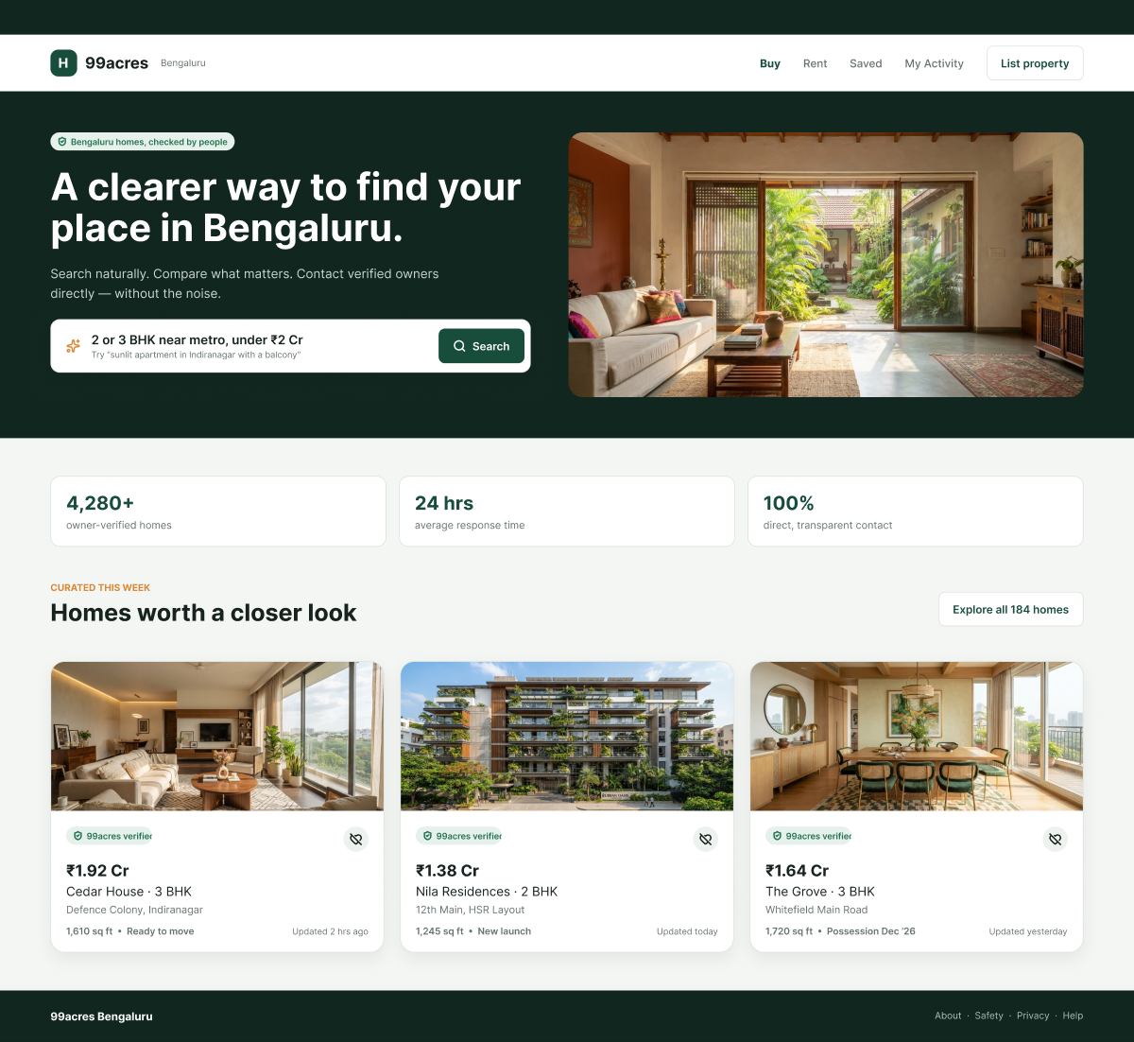
Fig 1: Home – 'Saved'/'My Activity' lead to wrong pages; crossed-heart save icon.
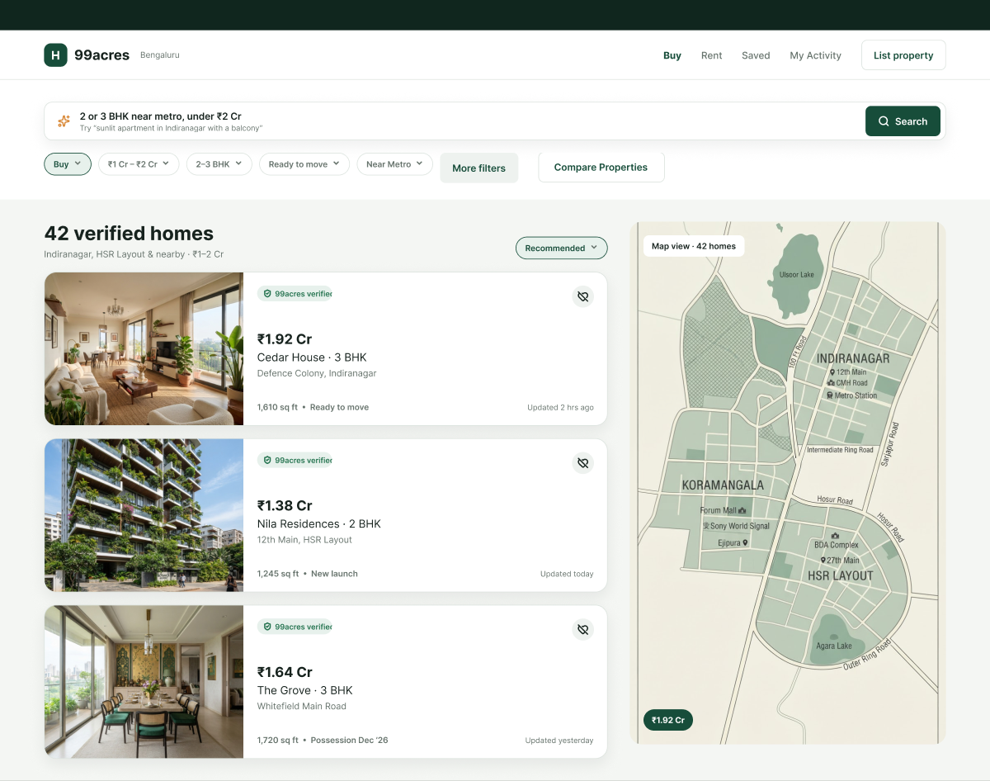
Fig 2: Search – filters/sort don't work; '42 verified homes' but 3 shown; static map.
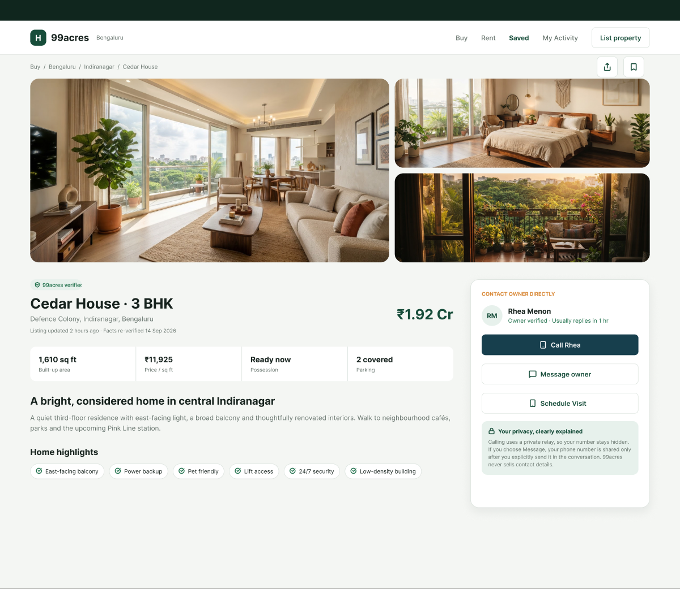
Fig 3: Detail – owner 'Rhea Menon' (Compare: 'Rakesh K.'); 'Schedule Visit' dead.
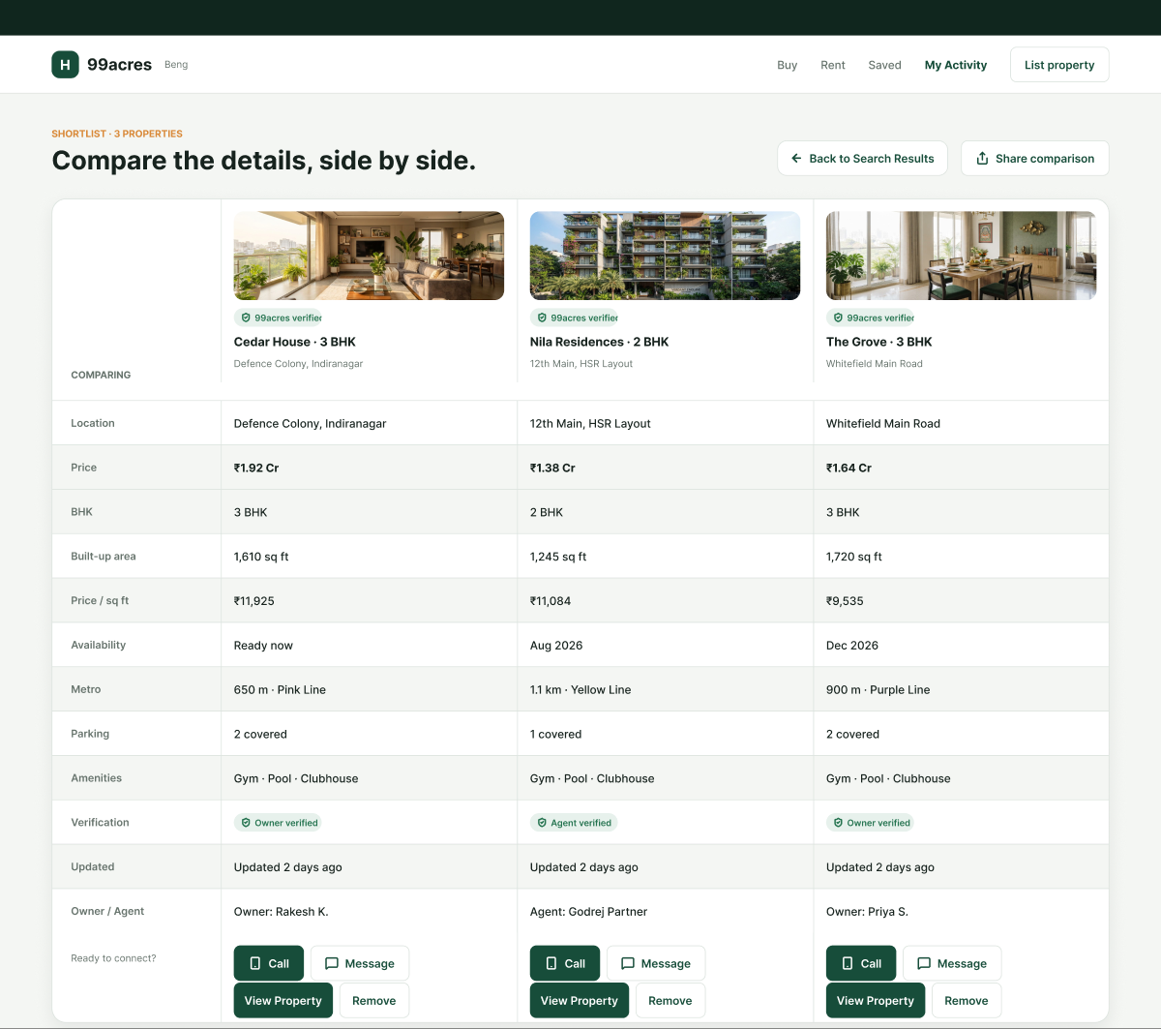
Fig 4: Compare – '2 days ago' vs '2 hrs ago'; same amenities; Remove/Share inactive.
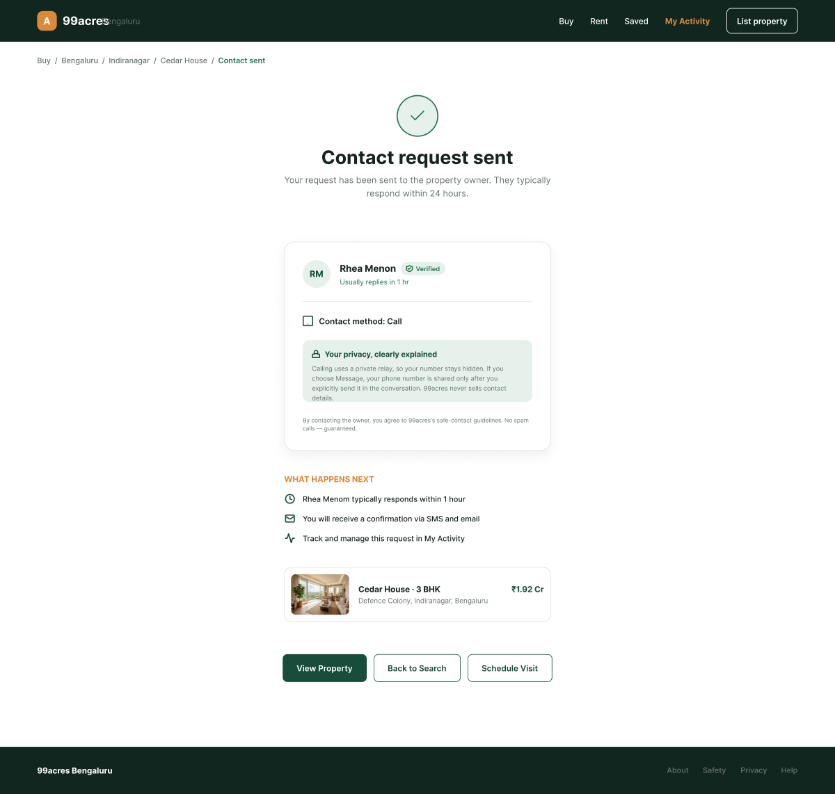
Fig 5: Contact – different header/'A' logo; '24 hours' vs '1 hour'.
Students Evaluation Team : Akshwaj Rao, Vishwajit Chavan, Samay Gandhi

