Critical Analysis of Interface (99acres Website)

Learnability
The homepage has four separate top menu tabs (Buyers, Tenants, Owners, Dealers), and each one opens its own Insights, Articles, and Tools submenu with mostly the same links reworded slightly. A new visitor has to work out which tab is even meant for them before doing anything.

Usability
Prices are usually shown upfront on property cards, that part's fine. But the phone number is always behind a "View Number" click, on basically every card. The one thing you actually want to do, contact someone, always costs an extra step.

Consistency
Some cards show a price trend percentage and offer badges, some don't. Land listings naturally show different fields than BHK apartments, that's fair, it's a different property type. But the general clutter varies a lot from card to card, which makes comparing listings harder than it should be.

Use of Metaphors
Outside of a RERA tag and a "Free" badge, there's barely any visual system to tell listing types apart quickly. Mostly small text labels.

Navigation Structure
This is the biggest issue, and it's worse than it first looks. A small "Insights" promo block (Understand localities, Read Resident Reviews, Check Price Trends, Tools & More) shows up under nearly every single dropdown in the top menu, repeated roughly 15 to 17 times on one page. On top of that, the full footer (Top Cities, Commercial Spaces, Testimonials, Curated Quick Links) is separately duplicated in full, back to back, further down the same page. Both are confirmed directly in the page itself, not a guess.
It gets worse when you actually follow where that Insights menu points. I opened each of its seven links directly, and three of them, "Locality Insights," "Ratings & Reviews," and "Registry Records," lead to a page that plainly says "The Page is gone...!" (a proper dead-page response, not a slow load or a redirect). The other four (Price Trends, Home Loan Tools, Area Converter, Builders in India) work fine. So nearly half of one of the site's core navigation menus is broken, and because that same menu is repeated 15+ times across the homepage, this isn't three dead links, it's the same three dead links showing up dozens of times over.

Visual Hierarchy
With new launches, upcoming projects, testimonials, and news articles all stacked on the homepage, nothing tells you what to look at first.

Accessibility
No visible high contrast or font size controls on the homepage itself. They might exist somewhere in account settings, but nothing surfaces on the page a regular visitor lands on.

Responsiveness
The homepage is extremely long even on desktop, given how much is stacked and repeated. On mobile that likely means a lot of scrolling before reaching real listings.

Efficiency of Interaction
Every attempt to open an actual search results page was stopped by a "suspicious activity, complete the captcha" security check before showing any listings. I want to be careful here, this happened through an automated check, so I can't say for certain a normal person browsing in a regular browser hits the same wall every time. But it's worth flagging, because that kind of aggressive bot-detection can also catch real users on VPNs, office networks, or privacy browsers. I couldn't verify the real listing or comparison experience beyond this point.

Feedback and System Status
Clicking "View Number" or "Get preferred options" gives no immediate confirmation of what happens next.

Error Prevention and Recovery
Three of the seven links in the repeated Insights menu lead straight to a dead page with no redirect, no suggested alternative, just a flat "The Page is gone...!" message. Since I couldn't get past the search page's security wall to test further, I can't confirm what happens on an empty search result, but the dead links alone show a real gap in basic link maintenance.

Aesthetic and Minimalist Design
The homepage is dense with promotional blocks, new launch banners, testimonials, quick links, city tiles, plus the repeated Insights widget and footer, all stacked with little breathing room. The site lacks a light or dark mode option, and frequent popups create significant user inconvenience.

Content Readability
Small text prices, dense percentage tags, and long unbroken lists of city links make scanning the page tiring.

Search and Discoverability
Couldn't verify filtering by amenities, possession date, or verified status past the security wall, so I can only speak to the basic location and keyword search on the homepage. There is a notable lack of a property comparison feature to allow side-by-side evaluation of listings.

Performance Perception
Between the Insights widget repeated 15+ times, the duplicated footer, and a large number of images and project cards, this is a genuinely heavy homepage.

Trust and Credibility
99acres shows RERA tags and "verified by 99acres team" badges, a genuine plus on the interface. But real, 99acres-specific reviews (not real estate reviews in general) repeatedly describe a flood of sales calls pushing paid packages after listing a property for free. That's a real trust problem behind an interface that looks trustworthy on its face.

Personalization
There's a "My Activity" section tracking recent searches and shortlists, a genuine plus, but it's buried in a header dropdown rather than being easy to find.

User Satisfaction
Getting past the repeated menus and duplicated sections takes real patience even before searching, and the search itself couldn't be tested properly due to the security check.

Specific Real Issues Found
- The same "Insights" promotional widget is repeated roughly 15 to 17 times across the homepage, appearing under nearly every top navigation dropdown.
- Three of the seven links inside that Insights menu, "Locality Insights," "Ratings & Reviews," and "Registry Records," lead to a dead page ("The Page is gone...!"), confirmed by opening each one directly. Since the menu itself repeats 15+ times, these three broken links effectively appear dozens of times across the homepage.
- The full footer block is separately duplicated in full, back to back, on the same homepage.
- Phone numbers are gated behind a "View Number" click on essentially every card, even though prices are usually shown upfront.
- Every attempt to reach an actual search results page was blocked by a security check, so the real listing and filter experience couldn't be verified. Flagged honestly as a limitation, not a confirmed bug, since it happened through automated access.
- A cookie consent banner sits at the very bottom of the page, easy to miss.
- Real, 99acres-specific reviews repeatedly describe a flood of sales calls after posting a free listing, and unresponsive support after paying for a package.

Parameter Table
Parameter | Rating | Observation
Learnability | 3/10 | Four near identical top menus make the entry point unclear
Usability | 4/10 | Prices visible, but contact numbers always need an extra click
Consistency | 4/10 | Promotional trim varies a lot card to card
Use of Metaphors | 4/10 | Only RERA and Free tags, little other visual system
Navigation Structure | 1/10 | Insights widget repeated ~15-17 times, 3 of its 7 links dead, plus a duplicated footer
Visual Hierarchy | 3/10 | Too many competing sections, nothing clearly primary
Accessibility | 4/10 | No contrast or font size controls visible
Responsiveness | 3/10 | Very long homepage, heavy scrolling likely on mobile
Efficiency of Interaction | 2/10 | Couldn't verify past a security wall on search attempts
Feedback and System Status | 3/10 | Contact buttons give no clear indication of what happens next
Error Prevention and Recovery | 2/10 | 3 of 7 Insights menu links are confirmed dead pages
Aesthetic and Minimalist Design | 3/10 | Dense with promotional and repeated blocks
Content Readability | 3/10 | Small text prices and dense tags throughout
Search and Discoverability | 2/10 | Couldn't verify filtering beyond basic homepage search
Performance Perception | 3/10 | Heavy page weight from repeated sections and many images
Trust and Credibility | 3/10 | Verification badges look good, but reviews describe unwanted sales calls
Personalization | 4/10 | My Activity tracking exists but is buried in a dropdown
User Satisfaction | 2/10 | Real friction before search, and search itself was blocked

Golden Rules (Shneiderman)
- Strive for Consistency: Cards don't share one set of fields, and the same promo widget appears over a dozen times instead of once.
- Seek Universal Usability: No accessibility controls, and a security check aggressive enough to block a simple page load.
- Offer Informative Feedback: "View Number" doesn't clearly tell you what's about to happen.
- Design Dialogs to Yield Closure: No visible confirmation after contacting an agent or owner.
- Prevent Errors: Inconsistent card fields make it easy to misjudge a listing before clicking in.
- Permit Easy Reversal of Actions: Couldn't verify this past the security wall.
- Keep Users in Control: The repeated widget and duplicated footer pull attention from the actual task.
- Reduce Short Term Memory Load: Content repeated over a dozen times, no comparison tool found.

Summary of Problems
- Insights promo widget repeated roughly 15 to 17 times on the homepage
- 3 of the 7 links in that same Insights menu lead to dead pages, repeated across every instance of the menu
- Full footer separately duplicated on the same page
- Four near-identical top menus
- Contact numbers hidden behind an extra click on nearly every card
- Search results pages blocked by a security check, real listing experience unverified
- Cookie banner easy to miss at the bottom
- Real reviews describe a pattern of unwanted sales calls after free listings
- Unnecessary and repeated popups create inconvenience
- No light or dark mode option available
- Lack of any property comparison feature

Recommendations
- Fix or remove the three dead links in the Insights menu (Locality Insights, Ratings & Reviews, Registry Records), and fix the repeated widget itself so it shows once, not fifteen-plus times, this looks like a template bug
- Remove the separately duplicated footer
- Merge the four buyer, tenant, owner, dealer menus into one cleaner structure
- Show at least partial contact info directly instead of gating it entirely
- Review how aggressively the security check triggers, since it may also block real users
- Cut down the stacked promotional sections and prioritize actual search
- Move the cookie notice somewhere more visible
- Take the sales-call complaints seriously as a real trust problem, not just bad reviews

my notes:
for 99acres add issues real like
Unnecessary popups
on the homepage the same insights widget (understand localities, read reviews, check price trends) repeats after literally every single menu dropdown, buyers tenants owners dealers all have it copy pasted
out of that same insights menu, 3 of the 7 links are straight up dead, locality insights, ratings & reviews and registry records all just say "the page is gone"
the whole footer section (top cities, commercial spaces, testimonials, quick links) shows up twice on the same homepage, back to back
phone numbers are never shown directly, always behind a "view number" click, even though the price is right there
No light or dark mode option
when you try to open an actual search results page it throws a captcha / suspicious activity check before showing any listings
four separate menus for buyers, tenants, owners, dealers but they all basically repeat the same insights and articles links with different names
no comparison feature anywhere to put two properties side by side
cookie banner is tucked all the way at the bottom of the page instead of a proper popup, easy to miss completely
card design isn't consistent, some show price trend %, some show offer tags, some don't, makes it harder to scan and compare quickly
no visible font size or contrast option anywhere on the site unlike what some other portals offer
my activity / saved searches option exists but it's hidden inside a header dropdown instead of being easy to find

Images not loading properly on some places on home page :

Same popups multiple time on site creating inconvenience:
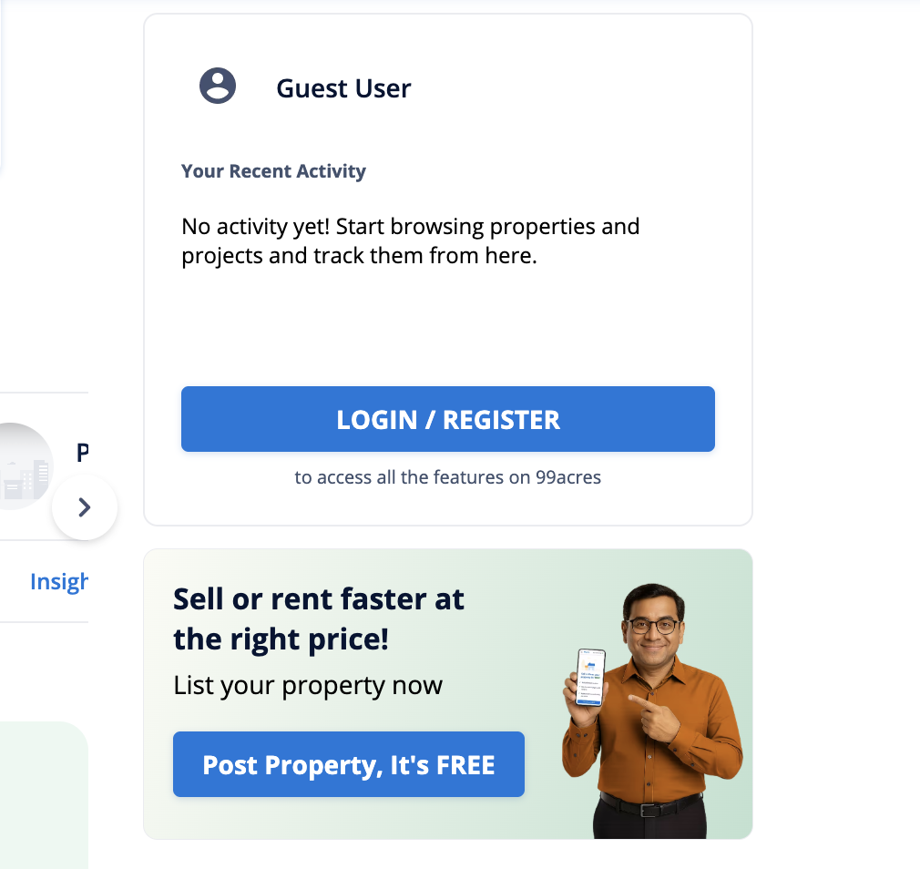

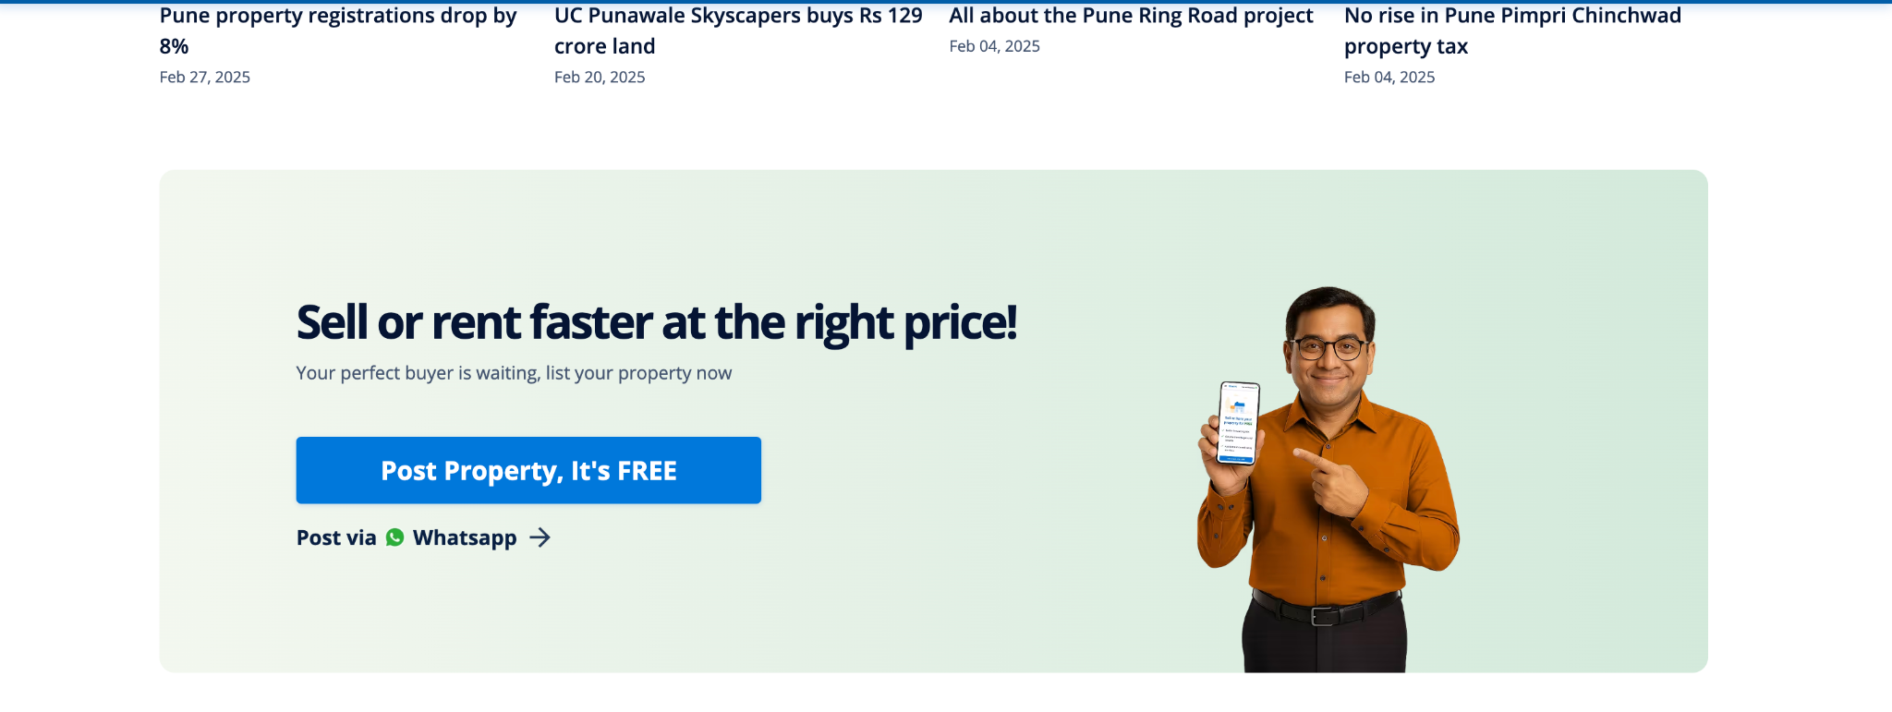
Login requires email and phone both even after providing both options as different :
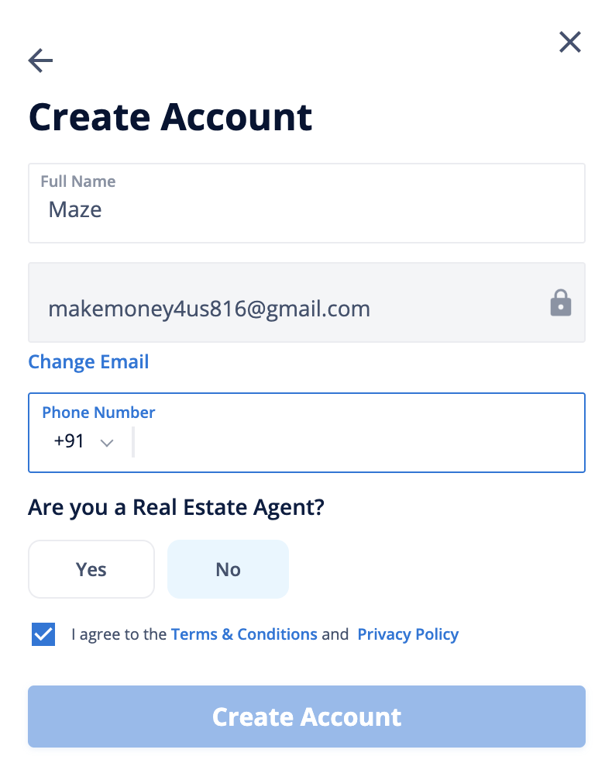
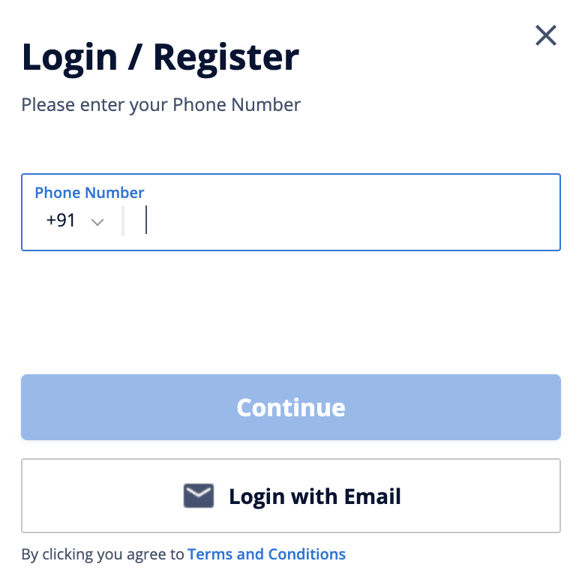
For tenants buyers option given multiple times on navbar and sidebar :
