LAB ASSIGNMENT V : HUERISTIC EVALUATION
SYSTEM EVALUATED : 99acres Replica (Bengaluru) – https://99acres-replica.vercel.app/ | Figma: https://www.figma.com/design/8FgFJA8IVJoePg6EDZIXMB/Untitled
Groups members NAME : Amey Tarmale (1032232006)
Evaluated by : Akshwaj Rao
**Evaluation to be done by other Group
PART I : HUERISTIC EVALUATION BASED ON NIELSEN'S 10 GENERAL PRINCIPLES FOR INTERACTION DESIGN. (0 is lowest and 5 is highest)
S.No. | Heuristic Evaluation Parameter | Mention Violation if any | Severity 0-5 (0- minimum and 5 is maximium) | Ways to improve
1 | User Control: Interface will allow the user to perceive that they are in control | Filter chips (Budget, BHK, Ready to move, Near Metro), 'More filters' and the 'Recommended' sort do nothing when clicked. Typing a new search and pressing Search reloads the same 3 results. | 4 | Make filter chips open dropdowns that actually filter the list; make the search query change the results and show 'Results for …'.
2 | Human Limitations: Interface will not overload the users cognitive, auditory and motor skills | Mostly fine. Search box comes pre-filled with '2 or 3 BHK near metro, under ₹2 Cr' as real text, so user has to delete it before typing. Some text is very small (10–11 px on listing meta and fine print). | 2 | Use placeholder text instead of a pre-filled value; keep body text at least 12–13 px.
3 | Accommodation: The interface will fit the way each user group works and thinks (personas) | Works for a buyer persona, but 'Rent' opens the same Buy results (Buy chip stays active). 'List property' for owners is a dead link (#). | 3 | Give Rent its own results page with rent prices; add a basic 'List your property' form for owners.
4 | Linguistic Clarity: Interface will communicate as efficiently as possible | Nav labels don't match where they go: 'Saved' opens a property detail page, 'My Activity' opens Compare. In the Figma screens the badge text is cut off as '99acres verifie'. | 3 | Rename/redirect: Saved → saved homes list, My Activity → contact requests. Fix badge width so full text shows.
5 | Aesthetic Integrity :The interface will have an attractive and appropriate design | Clean modern look, good photos and green colour palette. Contact page suddenly switches to a dark header with an orange 'A' logo. | 1 | Keep the same header and logo on every page.
6 | Simplicity: The interface will have a simple design | Layout is simple and not crowded. No major violation. | 1 | Keep it this way while adding features.
7 | Predictability :The interface will behave in such a manner that the user can accurately predict what will happen next | Clicking 'Call Rhea' does not call; it shows 'Contact request sent'. 'Message owner' also shows 'Contact method: Call'. Every property card opens Cedar House. | 4 | Each card should open its own property. Call should show a number/relay, Message should open a message box.
8 | Accuracy: Interface will be free from errors | Data contradicts itself: Cedar House owner is 'Rhea Menon' on detail page but 'Owner: Rakesh K.' on Compare; 'Updated 2 hrs ago' vs 'Updated 2 days ago'; 184 homes (home) vs 42 homes (search) but only 3 shown. | 4 | Pull all pages from one data source so names, counts and dates match.
9 | Technical Clarity: Interface will have the highest possible fidelity. | Images are sharp and high quality. Map on search page is a static picture with only one price pin. | 2 | Use an interactive map (Google Maps / Leaflet) with a pin for every listing.
10 | Fulfillment : The interface will provide a satisfying user experience | Browsing and comparing feels good, but I could not actually filter, save or book a visit, so the task is not fully completed. | 3 | Make the key actions (filter, save, schedule visit) work end-to-end.
11 | Consistency: Interface will be consistent | Logo letter changes ('H' on most pages, 'A' on contact page). 'Call Rhea' button is dark blue while other primary buttons are green. Search page has no footer. | 3 | Use one logo, one primary button colour and the same footer on all pages.
12 | User Support: Interface will provide additional assistance as needed or requested | Footer links About, Safety, Privacy, Help all go to '#'. No FAQ or help for first-time buyers. Privacy explainer box is a good touch. | 3 | Add a real Help/FAQ page and tooltips (e.g. what 'verified' means).
13 | Precision: The interface will allow the users to perform a task exactly | User cannot set an exact budget, area or locality; filters are fixed labels only. | 4 | Add range sliders for price and area, and a locality picker.
14 | Forgiveness: Interface will make action recoverable | No way to cancel a contact request. 'Remove' on Compare does nothing. Breadcrumbs and 'Back to Search' help recovery. | 3 | Add 'Cancel request' and an undo toast; make Remove work.
15 | Responsiveness: The interface will inform users about the results of their actions and their interface status | Heart (save) button only changes its background slightly, no message. Search gives no feedback that the query was applied. | 3 | Show a toast like 'Saved to your list' and a filled heart; show the applied query above results.
 | Total Score |  | 43 / 75 | Severity total (lower is better)

Screenshots
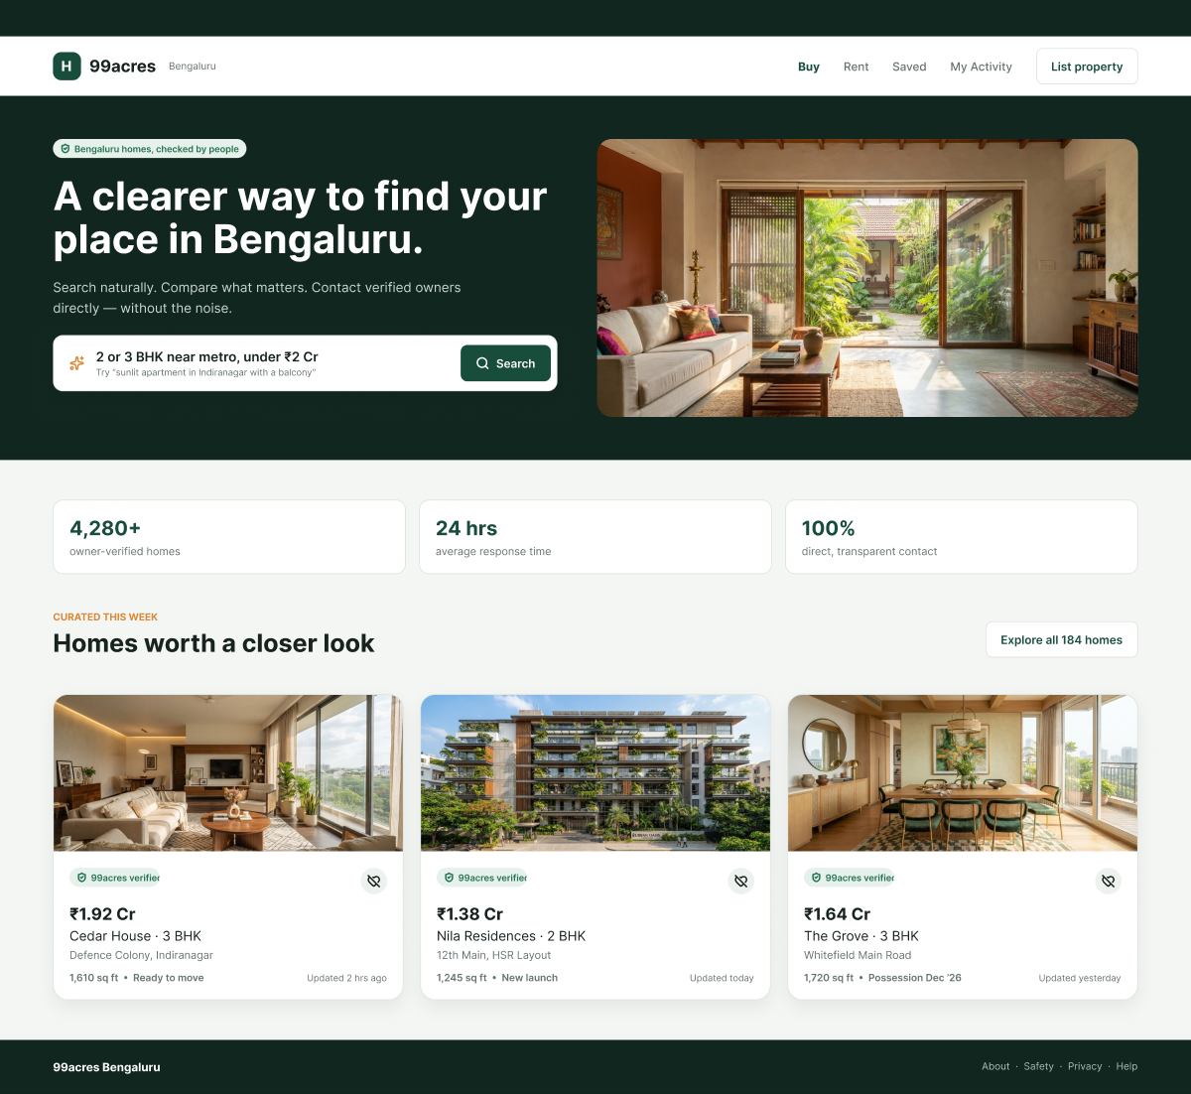
Fig 1: Home – nav labels 'Saved'/'My Activity' lead to wrong pages; badge clipped in Figma; crossed-heart save icon.
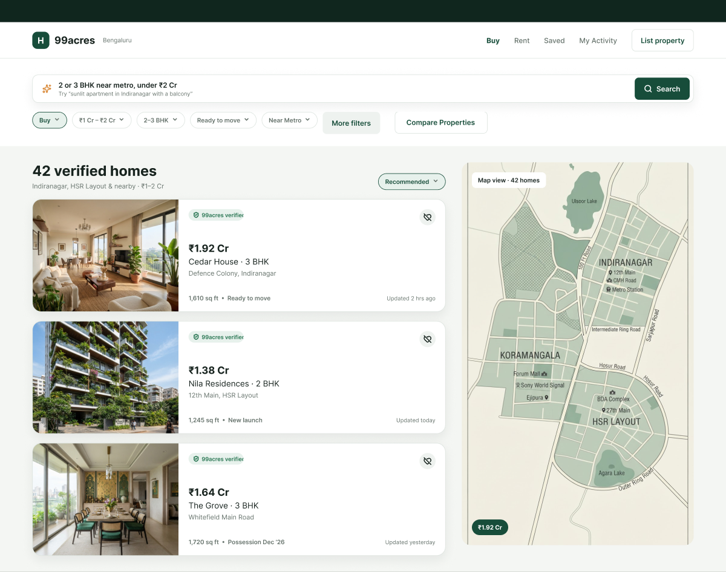
Fig 2: Search results – filter chips, 'More filters' and sort don't work; '42 verified homes' but only 3 shown; static map.
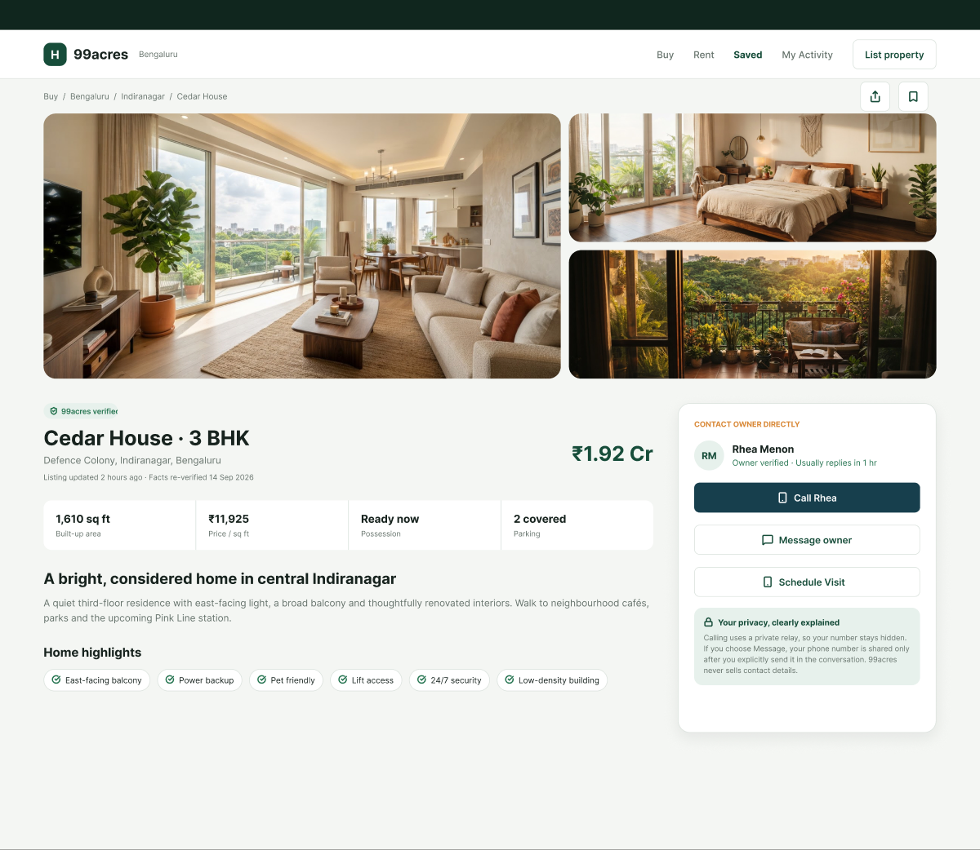
Fig 3: Property detail – owner 'Rhea Menon' (Compare says 'Rakesh K.'); 'Schedule Visit' dead; Call button in blue.
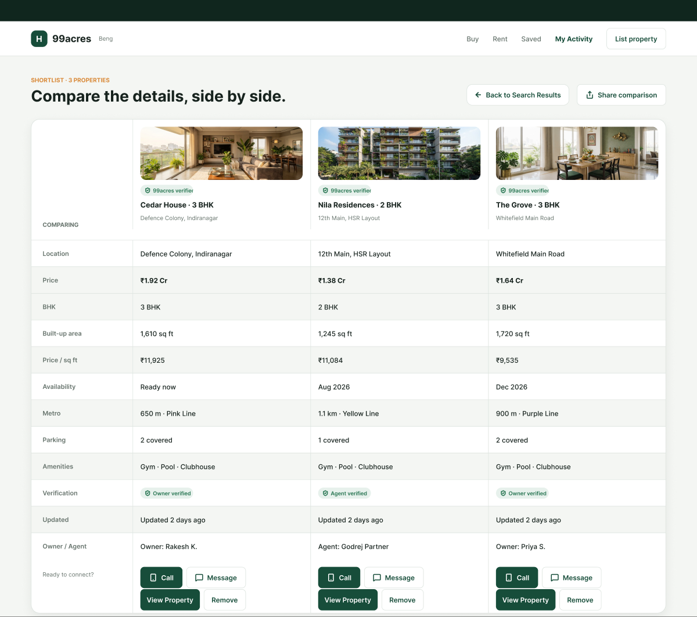
Fig 4: Compare – 'Updated 2 days ago' vs '2 hrs ago' elsewhere; same amenities for all; 'Remove'/'Share' don't work.
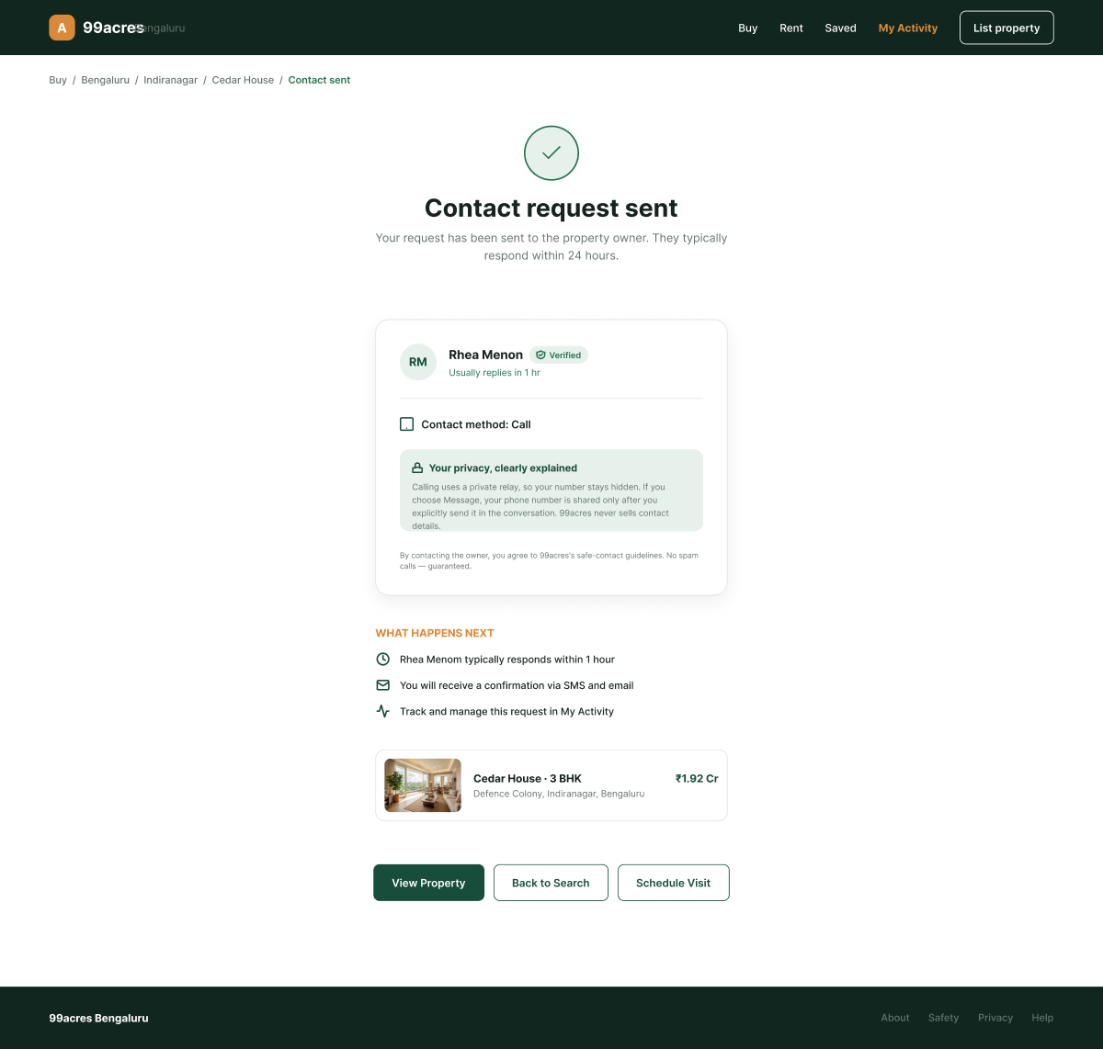
Fig 5: Contact sent – different header & 'A' logo; '24 hours' vs '1 hour'; 'Contact method: Call' even after Message.

PART II : List out any other points that you may have missed out . (Other than Nielsen’s Principles)

S.NO | OBSERVATIONS | COMMENTS
1 | Mobile view (<700 px) hides Buy, Rent, Saved and My Activity with no hamburger menu. | Mobile users cannot navigate; add a menu icon.
2 | Microsoft Clarity records sessions but there is no cookie/consent notice. | Add a small consent banner before tracking.
3 | No login or account, but the nav has 'Saved' and 'My Activity'. | Add login or store saves locally so these pages make sense.
4 | Empty dark strip (~44 px) above the header on every page. | Remove it or use it for a useful message.

Students Evaluation Team : Akshwaj Rao

