LAB ASSIGNMENT V : HUERISTIC EVALUATION
SYSTEM EVALUATED : 99acres Replica (Bengaluru) – https://99acres-replica.vercel.app/ | Figma: https://www.figma.com/design/8FgFJA8IVJoePg6EDZIXMB/Untitled
Groups members NAME : Amey Tarmale (1032232006)
Evaluated by : Samay Gandhi
**Evaluation to be done by other Group
PART I : HUERISTIC EVALUATION BASED ON NIELSEN'S 10 GENERAL PRINCIPLES FOR INTERACTION DESIGN. (0 is lowest and 5 is highest)
S.No. | Heuristic Evaluation Parameter | Mention Violation if any | Severity 0-5 (0- minimum and 5 is maximium) | Ways to improve
1 | User Control: Interface will allow the user to perceive that they are in control | Most controls on the search page look clickable but don't respond (chips, More filters, sort). 'Share comparison' and 'Remove' on Compare also do nothing. | 4 | Either make these controls work or remove them until they do.
2 | Human Limitations: Interface will not overload the users cognitive, auditory and motor skills | Very little cognitive load; each page has one clear purpose. | 1 | Keep the clean layout.
3 | Accommodation: The interface will fit the way each user group works and thinks (personas) | Good for a family looking to buy, but no option for people who want to rent or list a property; 'Rent' and 'List property' don't lead anywhere useful. | 3 | Add rent listings and a simple list-property flow.
4 | Linguistic Clarity: Interface will communicate as efficiently as possible | Copy is short and clear ('Compare what matters', privacy box). Minor (Figma): badge reads '99acres verifie' (clipped), city label shows 'Beng' on the Compare header in Figma. | 2 | Fix text clipping in badges and header.
5 | Aesthetic Integrity :The interface will have an attractive and appropriate design | Looks professional and close to a real product. Only the contact page header looks like a different site. | 1 | Match contact page header with the rest.
6 | Simplicity: The interface will have a simple design | Simple, uncluttered UI. | 1 | No change needed.
7 | Predictability :The interface will behave in such a manner that the user can accurately predict what will happen next | Results don't change after search; every card leads to the same property; Call leads to a 'request sent' page. User can't predict what happens next. | 5 | Give each listing its own page and make search/filters update results.
8 | Accuracy: Interface will be free from errors | Numbers don't match: 4,280+ verified homes, 'Explore all 184 homes', '42 verified homes' but only 3 cards. The Grove (Whitefield) is shown under 'Indiranagar, HSR Layout & nearby'. | 4 | Keep counts and locations consistent with the actual listings.
9 | Technical Clarity: Interface will have the highest possible fidelity. | Map is a static image with one '₹1.92 Cr' pin, not an actual map. Crossed-heart save icon is confusing. | 3 | Use a real map with all pins; replace the icon.
10 | Fulfillment : The interface will provide a satisfying user experience | Nice to look at and compare, but I couldn't finish anything real (filter, save to list, schedule a visit). | 3 | Make at least one full flow (search → filter → save → contact) work.
11 | Consistency: Interface will be consistent | Mostly consistent cards and colours, but logo ('H' vs 'A') and Call button colour change between pages. | 2 | Use one logo and one primary button style.
12 | User Support: Interface will provide additional assistance as needed or requested | No help, FAQ or onboarding; footer links are placeholders. The search hint 'Try sunlit apartment…' helps a bit. | 3 | Add Help/FAQ and short tooltips on filters.
13 | Precision: The interface will allow the users to perform a task exactly | Can't enter exact budget, area or locality; filter values are fixed. | 3 | Add editable ranges and locality selection.
14 | Forgiveness: Interface will make action recoverable | No undo for contact request; 'Remove' doesn't remove. Breadcrumb navigation is good for going back. | 3 | Add undo/cancel and make Remove work.
15 | Responsiveness: The interface will inform users about the results of their actions and their interface status | Save toggle has no message; search reload gives no sign it worked. | 3 | Show toasts / loading state and 'Showing results for …'.
 | Total Score |  | 41 / 75 | Severity total (lower is better)

Screenshots
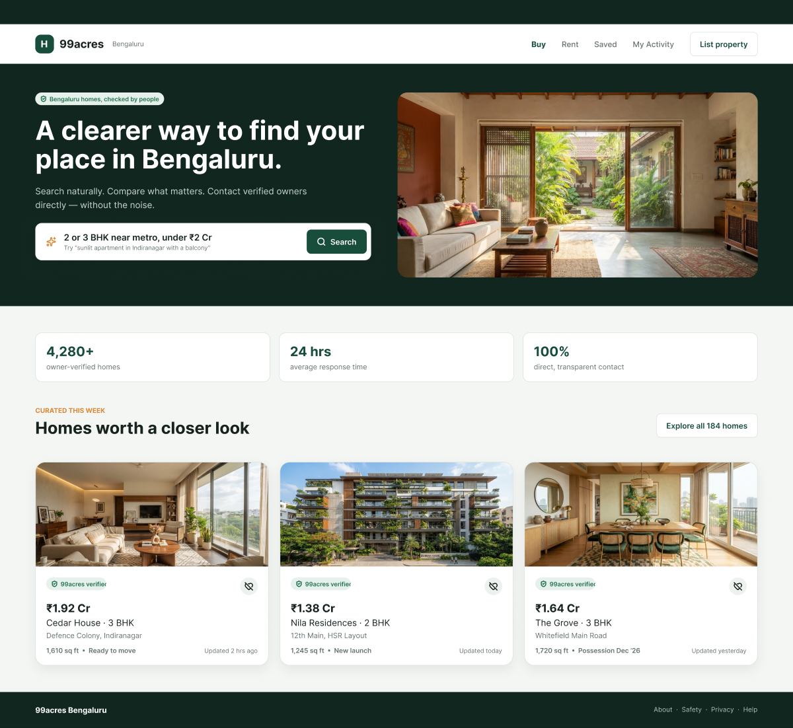
Fig 1: Home – nav labels 'Saved'/'My Activity' lead to wrong pages; badge clipped in Figma; crossed-heart save icon.
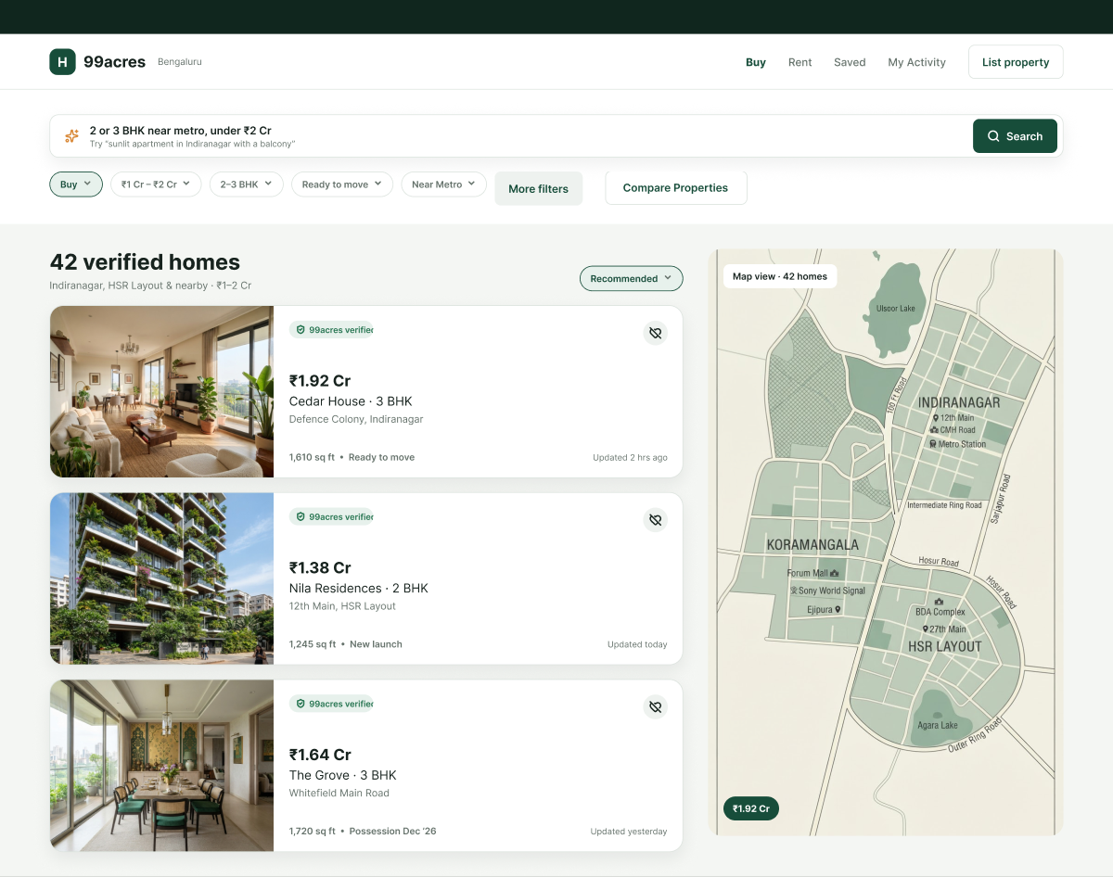
Fig 2: Search results – filter chips, 'More filters' and sort don't work; '42 verified homes' but only 3 shown; static map.
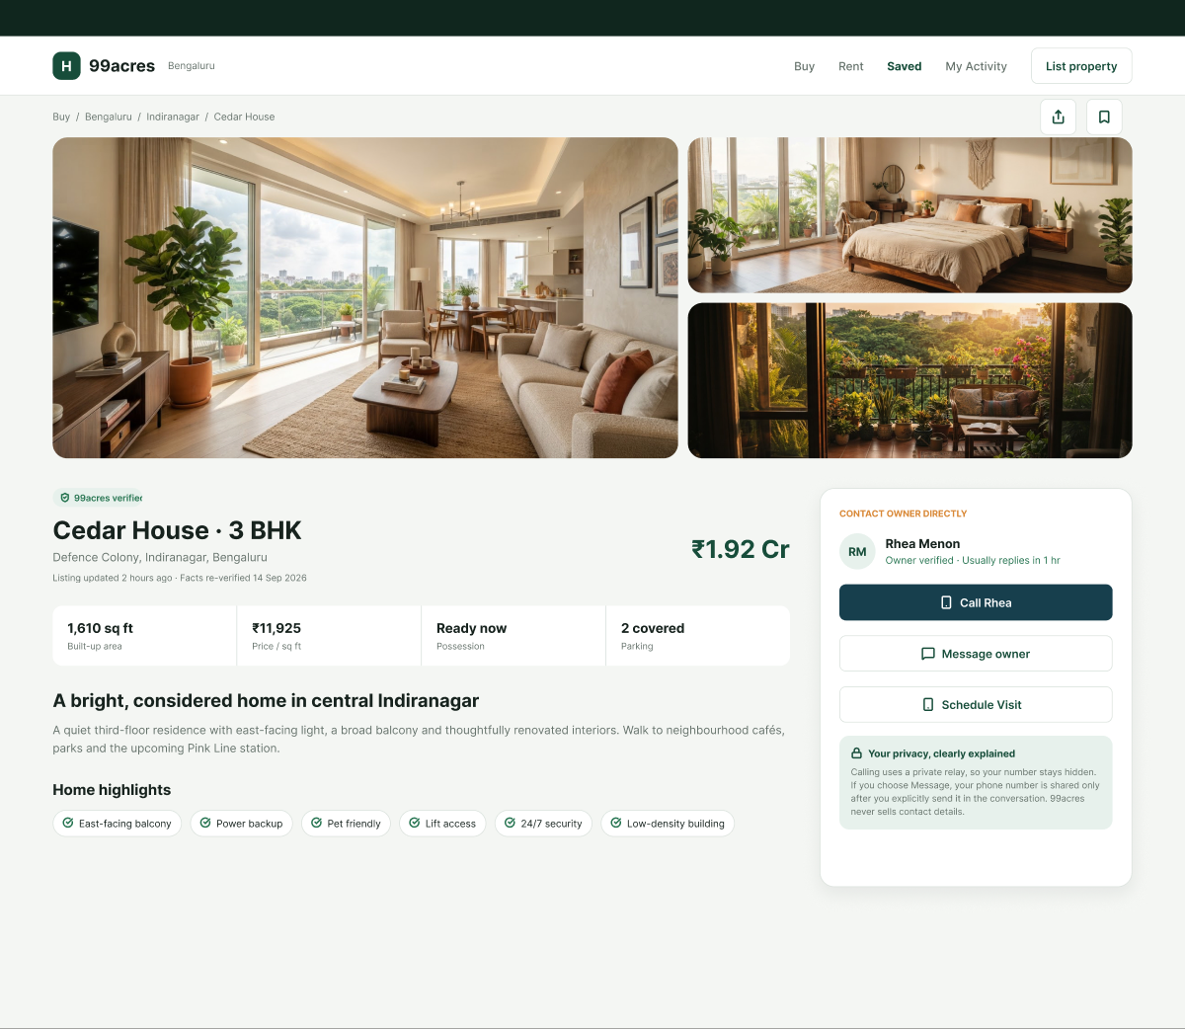
Fig 3: Property detail – owner 'Rhea Menon' (Compare says 'Rakesh K.'); 'Schedule Visit' dead; Call button in blue.
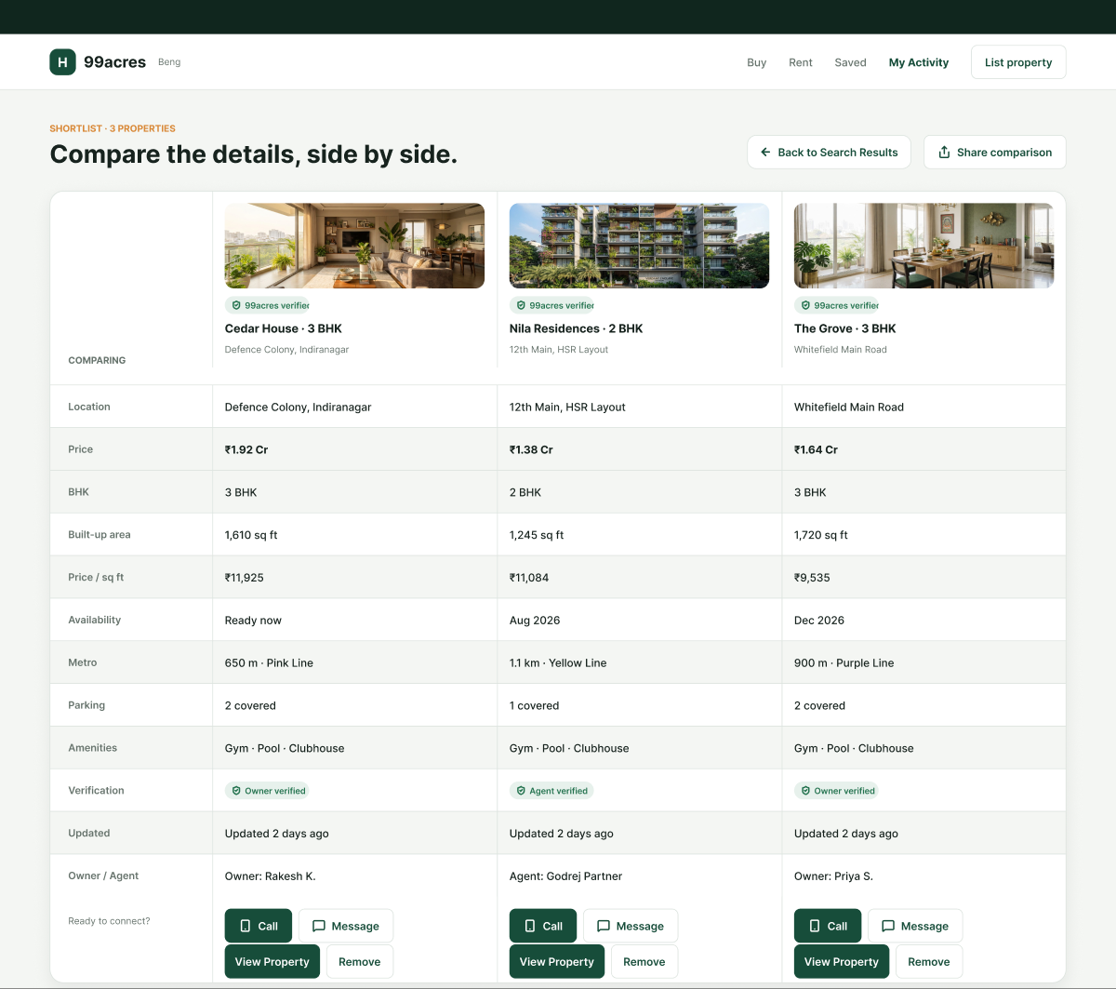
Fig 4: Compare – 'Updated 2 days ago' vs '2 hrs ago' elsewhere; same amenities for all; 'Remove'/'Share' don't work.
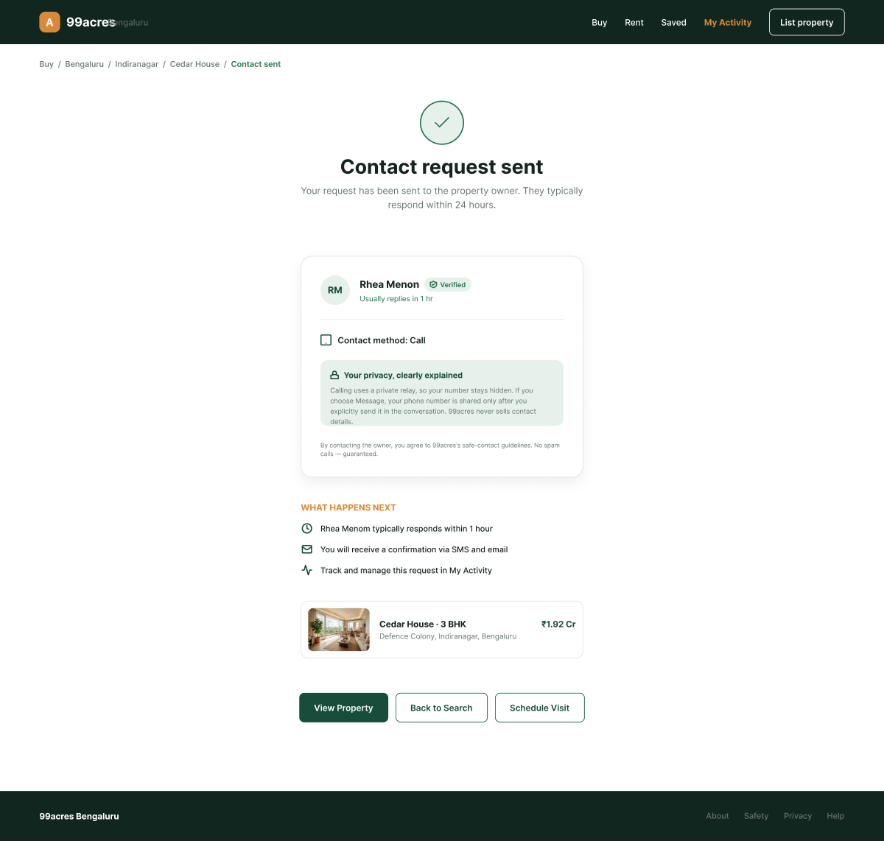
Fig 5: Contact sent – different header & 'A' logo; '24 hours' vs '1 hour'; 'Contact method: Call' even after Message.

PART II : List out any other points that you may have missed out . (Other than Nielsen’s Principles)

S.NO | OBSERVATIONS | COMMENTS
1 | No mobile navigation menu on small screens. | Add a hamburger menu.
2 | Search box value is pre-filled instead of a placeholder. | User must clear it before typing; use placeholder.
3 | Tracking script (Clarity) runs without telling the user. | Add a privacy/cookie notice.
4 | Compare is a strong feature that the real 99acres doesn't show this clearly. | Positive – keep and make it work with the user's own shortlist.

Students Evaluation Team : Samay Gandhi

