LAB ASSIGNMENT V : HUERISTIC EVALUATION
SYSTEM EVALUATED : 99acres Replica (Bengaluru) – https://99acres-replica.vercel.app/ | Figma: https://www.figma.com/design/8FgFJA8IVJoePg6EDZIXMB/Untitled
Groups members NAME : Amey Tarmale (1032232006)
Evaluated by : Vishwajit Chavan
**Evaluation to be done by other Group
PART I : HUERISTIC EVALUATION BASED ON NIELSEN'S 10 GENERAL PRINCIPLES FOR INTERACTION DESIGN. (0 is lowest and 5 is highest)
S.No. | Heuristic Evaluation Parameter | Mention Violation if any | Severity 0-5 (0- minimum and 5 is maximium) | Ways to improve
1 | User Control: Interface will allow the user to perceive that they are in control | Search query is ignored and filter buttons have no action, so the user feels the page is not responding to them. 'Schedule Visit' link goes nowhere. | 3 | Wire up the filters and search; open a date/time picker for Schedule Visit.
2 | Human Limitations: Interface will not overload the users cognitive, auditory and motor skills | Pages are light on information, no overload. Listing text like 'Updated 2 hrs ago' and the fine print on contact page are small and grey. | 2 | Increase size/contrast of small grey text.
3 | Accommodation: The interface will fit the way each user group works and thinks (personas) | On mobile (<700 px) all nav links except 'List property' are hidden and there is no hamburger menu, so mobile users can't reach Buy/Rent/Saved. Rent shows buy prices. | 4 | Add a hamburger menu for mobile; separate Rent listings.
4 | Linguistic Clarity: Interface will communicate as efficiently as possible | 'Saved' and 'My Activity' labels lead to the wrong pages. Contact page says owner replies 'within 24 hours' and 'within 1 hour' on the same screen. | 3 | Fix nav targets and use one consistent response-time message.
5 | Aesthetic Integrity :The interface will have an attractive and appropriate design | Good typography (Inter), consistent spacing and nice imagery. In the Figma hi-fi the verified badge text is clipped on every card. | 2 | Fix badge clipping; otherwise keep the visual style.
6 | Simplicity: The interface will have a simple design | Simple and focused screens with a clear main action on each. | 1 | No change needed.
7 | Predictability :The interface will behave in such a manner that the user can accurately predict what will happen next | Clicking any of the 3 cards always opens Cedar House. Clicking 'Call' shows a 'request sent' page instead of calling, which I did not expect. | 4 | Link each card to its own detail page; make Call behave like a call.
8 | Accuracy: Interface will be free from errors | Nila Residences shows 'New launch' on cards but 'Aug 2026' availability on Compare (already past). All three homes list exactly the same amenities. Owner name differs between Detail and Compare. | 3 | Check and correct the listing data; show real amenities per property.
9 | Technical Clarity: Interface will have the highest possible fidelity. | Photos and icons render crisply. The save icon is a crossed-out heart, which looks like 'unsave/disabled'. | 2 | Use a normal outline heart that fills when saved.
10 | Fulfillment : The interface will provide a satisfying user experience | Compare table is genuinely useful and the detail page is informative, but core actions stop halfway. | 3 | Complete the main flows so the user can finish a task.
11 | Consistency: Interface will be consistent | Header style changes on contact page (dark vs white), logo letter changes, button colours differ (blue Call vs green). | 3 | Create common components for header, buttons and footer.
12 | User Support: Interface will provide additional assistance as needed or requested | Help/About/Safety/Privacy links are dead. No explanation of what '99acres verified' means. | 4 | Add a help page and an info tooltip on the verified badge.
13 | Precision: The interface will allow the users to perform a task exactly | No price range or BHK selection controls; 'Recommended' sort can't be changed. | 4 | Add dropdowns with options and sort by price / newest.
14 | Forgiveness: Interface will make action recoverable | Contact request can't be undone; save can be toggled back but there's no list to manage saves. Breadcrumbs are present. | 3 | Add cancel/undo on contact; a Saved page to manage saved homes.
15 | Responsiveness: The interface will inform users about the results of their actions and their interface status | Hover states and focus outline exist, which is good. But saving and searching give no confirmation message. | 2 | Add short confirmation toasts.
 | Total Score |  | 43 / 75 | Severity total (lower is better)

Screenshots
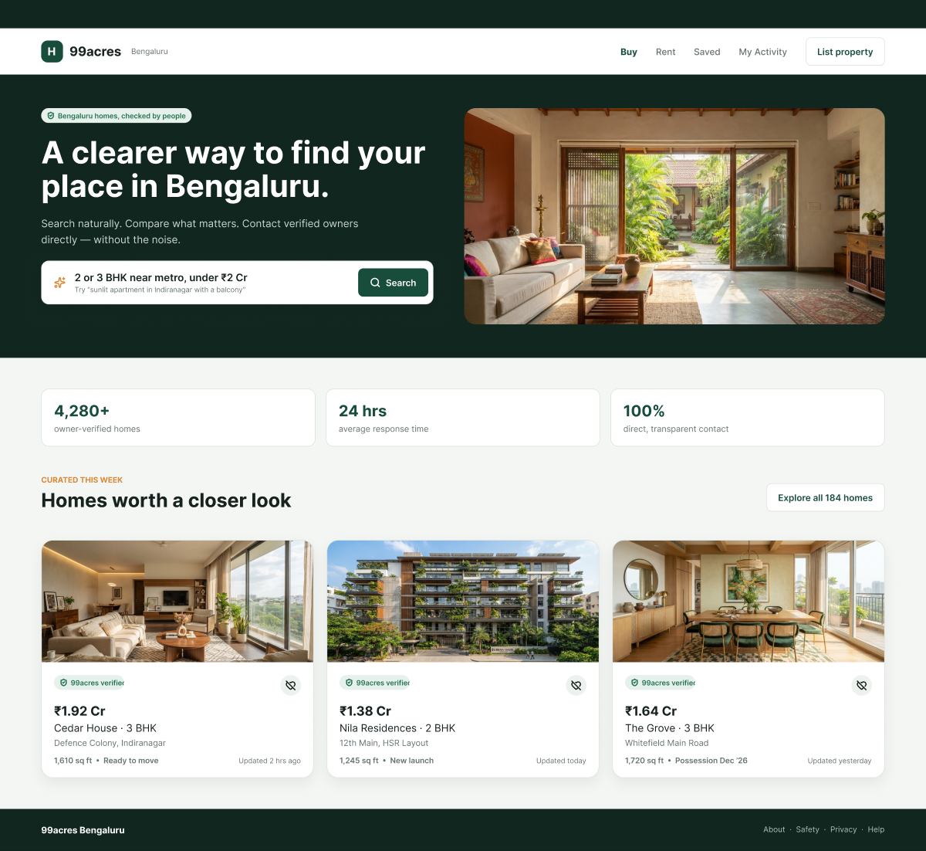
Fig 1: Home – nav labels 'Saved'/'My Activity' lead to wrong pages; badge clipped in Figma; crossed-heart save icon.
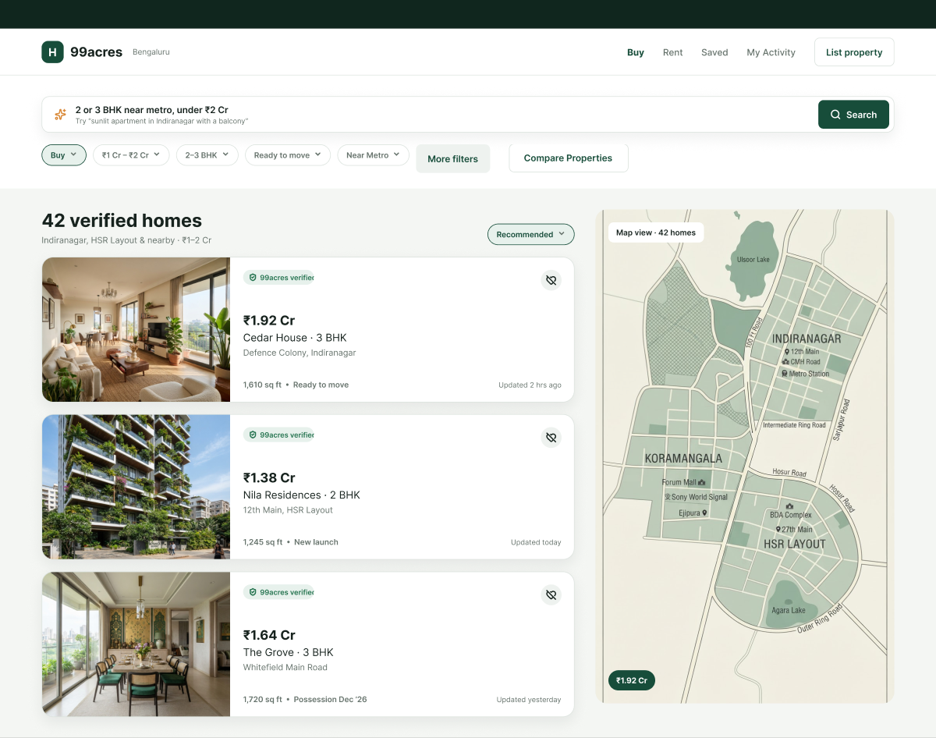
Fig 2: Search results – filter chips, 'More filters' and sort don't work; '42 verified homes' but only 3 shown; static map.
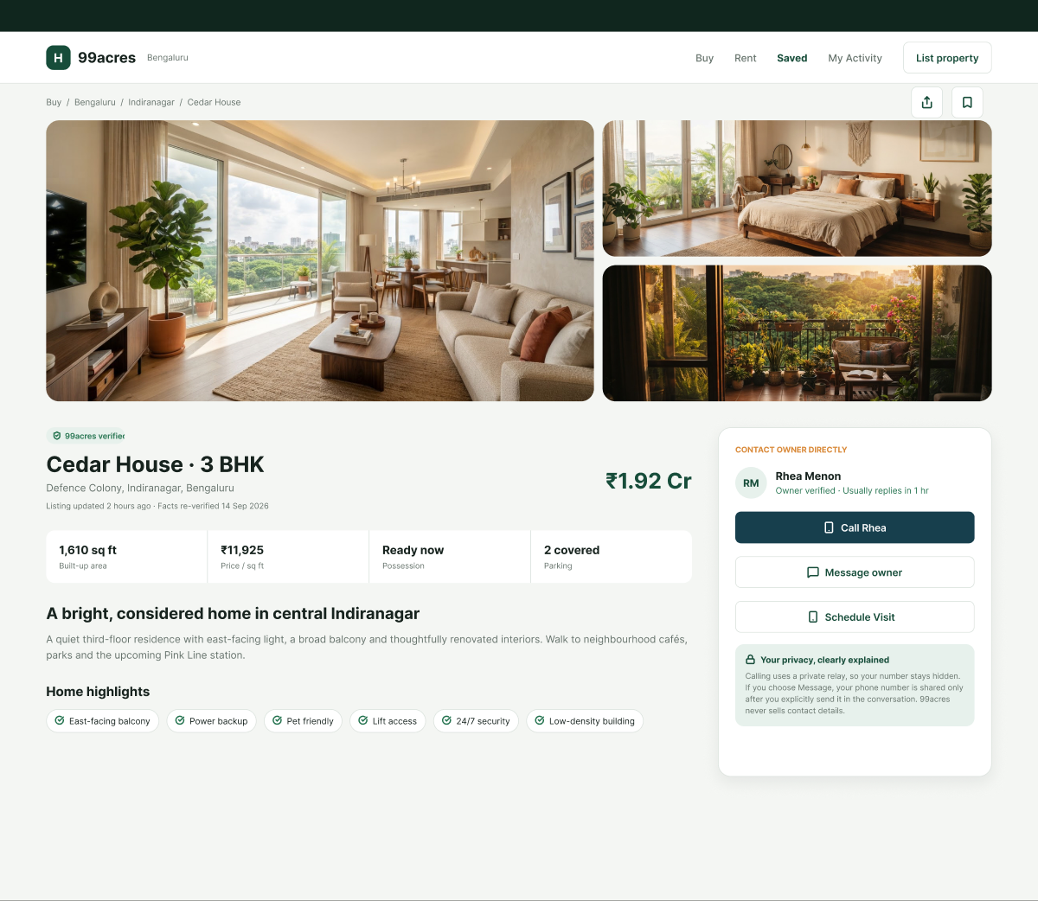
Fig 3: Property detail – owner 'Rhea Menon' (Compare says 'Rakesh K.'); 'Schedule Visit' dead; Call button in blue.
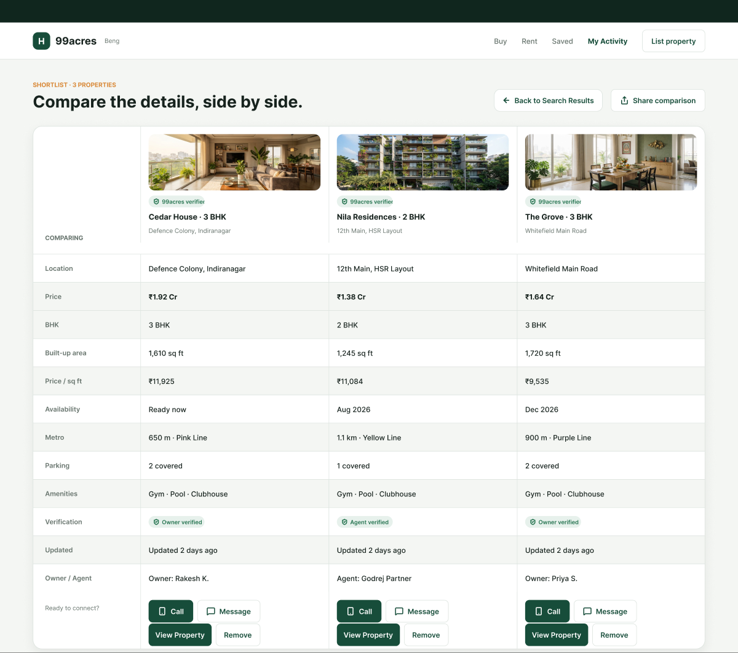
Fig 4: Compare – 'Updated 2 days ago' vs '2 hrs ago' elsewhere; same amenities for all; 'Remove'/'Share' don't work.
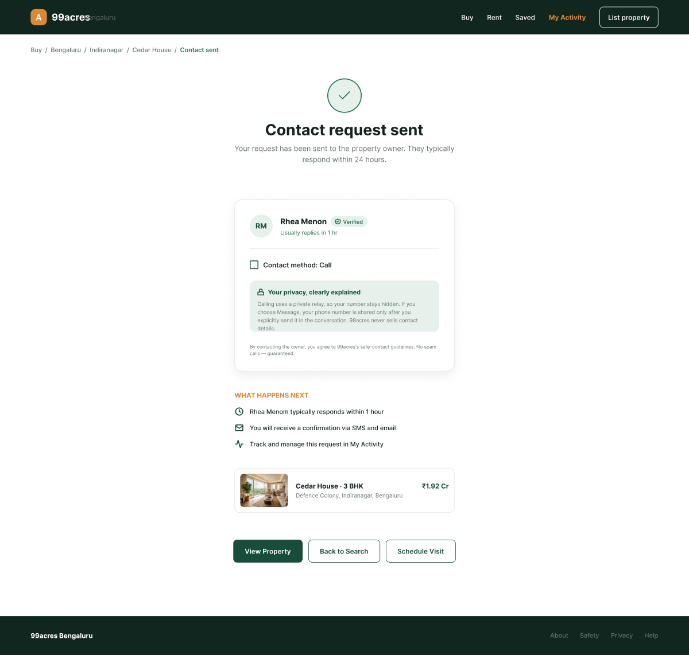
Fig 5: Contact sent – different header & 'A' logo; '24 hours' vs '1 hour'; 'Contact method: Call' even after Message.

PART II : List out any other points that you may have missed out . (Other than Nielsen’s Principles)

S.NO | OBSERVATIONS | COMMENTS
1 | Property card is a link that contains the Save button (nested interactive elements). | Can confuse screen readers; separate the button from the link.
2 | Search page has no footer while other pages do. | Add the common footer for consistency.
3 | No sign-in, yet 'Saved' and 'My Activity' are in the nav. | Add an account or explain these are demo pages.
4 | Page load is fast and Clarity shows 0 JavaScript errors. | Positive – keep pages light.

Students Evaluation Team : Vishwajit Chavan

