|  |  |
| --- | --- |
| Document Status | Final |
| Document Owner | Jeremy Freeman |
| Developers | You’se Guys |
| QA | Jeremy Freeman |

## **Text Editor**

## Web Develop Boot Camp Project 2

### **Goals**

The goal of this development effort is to create a text editor that can be used to interact with text files. The required technologies for this project are either VB.Net with Windows Forms OR C#.Net with Windows Forms.

The application must allow for the user to perform common word processing tasks including:

* Find
* Find and Replace
* Font Selection
* Font Style Selection
* Font Size Selection
* Font Color Selection
* File Open
* File Save
* File Save As

### **Design Sample**

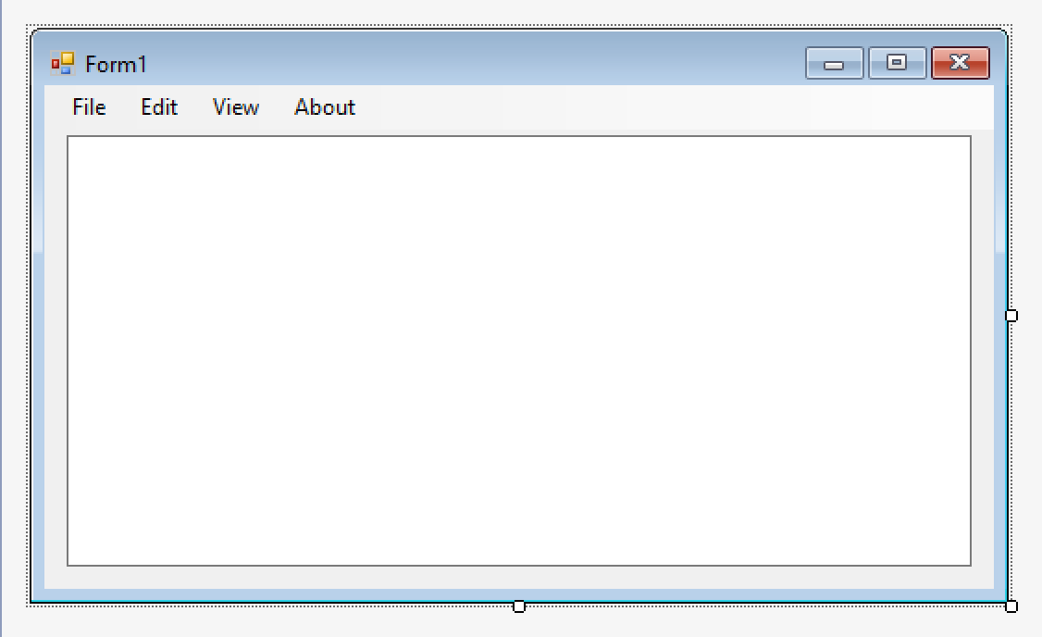

### **Requirements**

|  |  |  |
| --- | --- | --- |
| # | Item | Description |
| 1.0 | File Menu options:  Open  Save  Save As | Open   * Allows users to navigate the file system and open files. * The opened file should filter to only *.txt files. * Opening a file will open the file within the text area of the editor   Save   * Clicking Save will write the updates from the text box to the file name that is already opened * If no file is already open and the user clicks Save, the Save As box should open to prompt the user to save their file   Save As   * Clicking Save As prompts the user for a file name * Once the file name is entered the user can click “Save” within that same window and the file is saved |
| 2.0 | Edit Menu options:  Font  Font Size  Font Style  Font Color  Find  Find and Replace | Font   * User should be presented with a list of fonts to select from * Minimum fonts required: Times New Roman, Calibri, Harrington, Arial * Current font should display as preselected   Font Size   * User should be able to adjust the font size shown in the editor box * Minimum font sizes required: 8, 10, 12, 14, 16   Font Style   * The font styles of Bold, Underline, and Italics are required   Font Color   * User should be able to select a font color * Any new text typed should display in selected font color * Minimum font colors required: Black, Red, Blue, Green * Default font color is black   Find   * User can supply a text string, if the string is found, the user’s cursor is placed at the beginning of the string in the text box   Find and Replace   * Follows the same logic as Find * The replace feature is added in addition to Find, the user can supply a text string to replace the Find text. When the user confirms the matches found all of the found text string is replaced with the new text |
| 3.0 | View Menu options:  Window Theme  Word Wrap | Window Theme   * There is a default window theme that displays for all users * Users should have the option to select from three different window themes * Window themes should change the color and style of the window * Selections for window themes will be left up to the developer   Word Wrap   * If the user selects this option, word wrap in the text box is turned on. This should add a checkbox to the menu item. Selecting this again should turn word wrap off, and the check box should be cleared. |
| 4.0 | About Menu options:  Program Information | Dialogue box must contain:   * Description of the program not to exceed 250 characters * Original Author * Version Number * Course Name |
| 5.0 | Window Requirements | * The text area should expand with the size of the window. For example, if a user expands the text editor window to full screen, the text area should expand proportionately to fill the application window. * The title bar of the form should display the file name that has been opened * The window should have scroll bars. Once the text expands past the bottom of the text area a vertical scroll bar should display to allow the user to navigate the page up and down. * If word wrap is on, the horizontal scroll bar should not display, if word wrap is off, a horizontal scroll bar should display to allow the user to navigate the page left and right. |
| 6.0 | Program Delivery and Presentation | * The final program must be delivered via a Github repo. * Multiple commits to this repo are expected with a minimum of 5 checkpoints for the program, each should provide a complete feature and a working program * Programs will be tested for accuracy and presented to the class |

### 